Petunias Notified as Genetically Modified in Australia – as at 29 June 2017

Images | Name and Source of GM Status Confirmation
  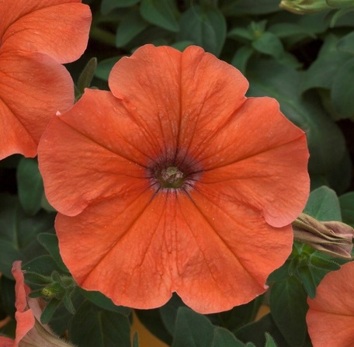 | African Sunset  GM Status: Confirmed by United States Department of Agriculture (USDA) Animal and Plant Health Inspection Service (APHIS), Finnish Food Safety Authority Evira, Horticultural Trade Association (United Kingdom) (UK HTA) and the German Federal Office of Consumer Protection and Food Safety (BVL)
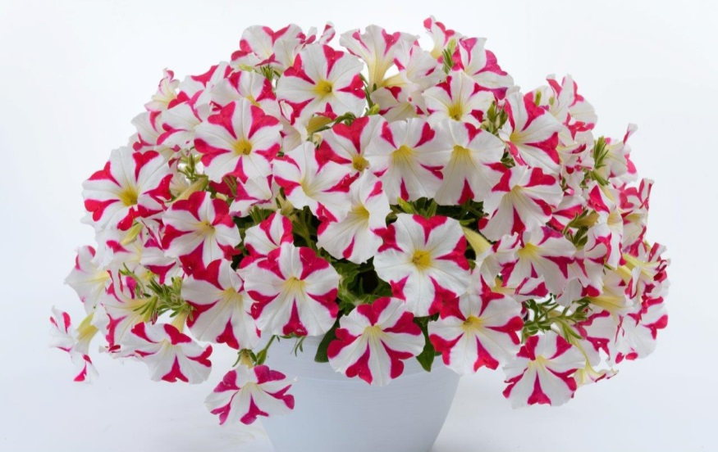   | Amore Mio  GM Status: Confirmed by USDA APHIS
   | Capella Red  GM Status: Confirmed by USDA APHIS and BVL
   | Cascadias Red Lips  GM Status: Confirmed by USDA APHIS and BVL
  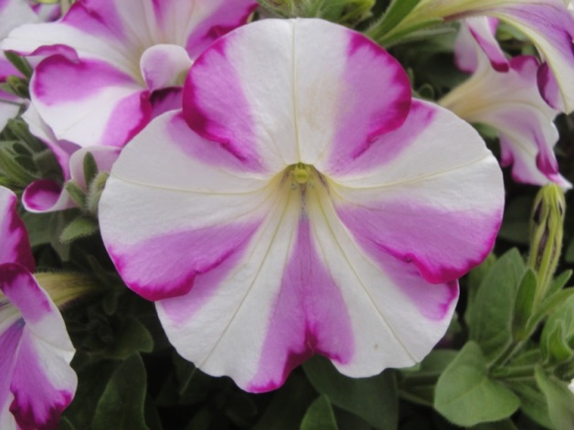 | Colourworks Homare  GM Status: Confirmed by BVL
 | Crazytunia Cherry Cheesecake  GM Status: Confirmed by USDA APHIS and BVL
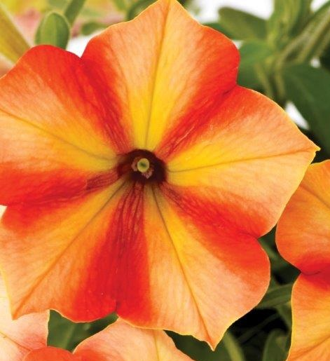 | Crazytunia Citrus Twist  GM Status: Confirmed by UK HTA and BVL
 | Crazytunia Star Jubliee  GM Status: Confirmed by USDA APHIS and BVL
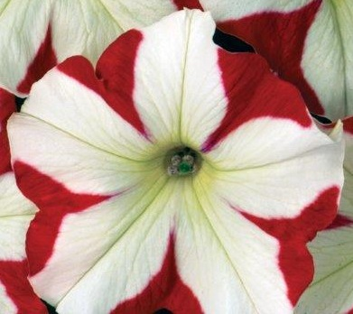 | Crazytunia Swiss Dancer  GM Status: Confirmed by USDA APHIS and BVL
 | Hells Bells Fruit Punch  GM Status: Confirmed by USDA APHIS and BVL
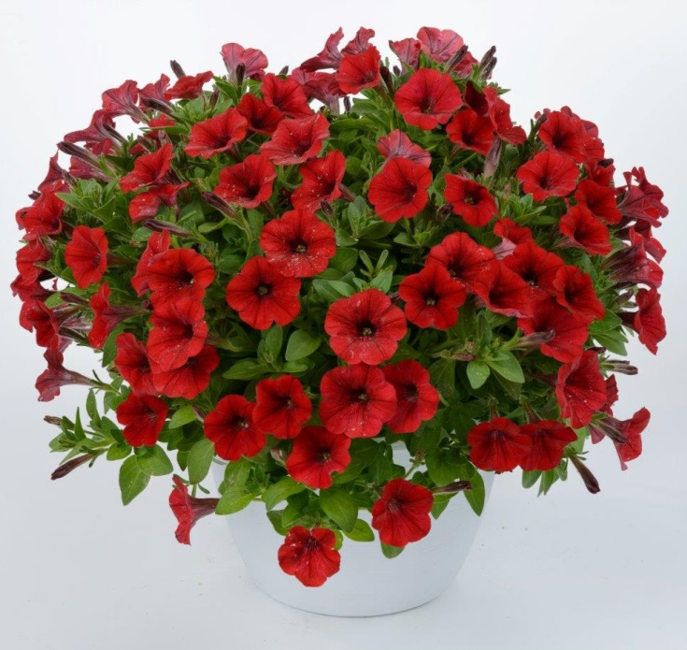  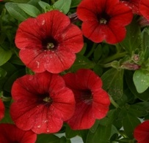 | Littletunia Red Fire  GM Status: Confirmed by USDA APHIS
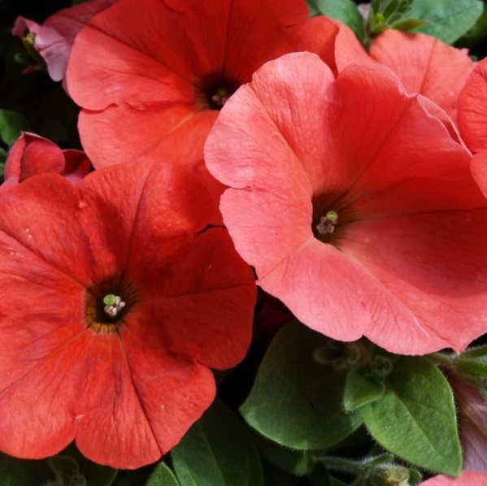 | Potunia Plus Papaya  GM Status: Confirmed by Finnish Food Safety Authority Evira, UK HTA and BVL
 | Potunia Plus Red  GM Status: Confirmed by USDA APHIS and BVL
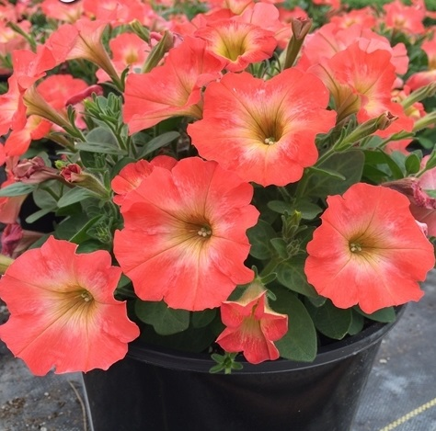 | Salmon Ray (also known as Pegasus Orange Morn)  GM Status: Confirmed by USDA APHIS, Finnish Food Safety Authority Evira, UK HTA and BVL
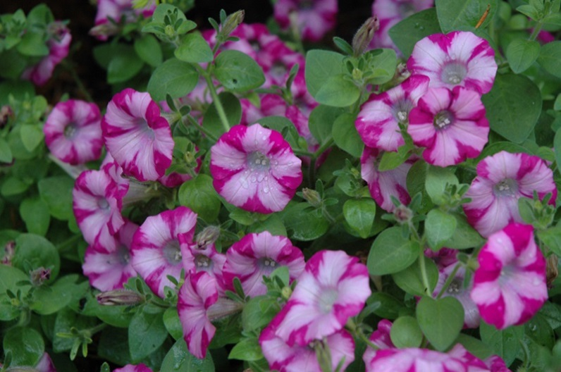  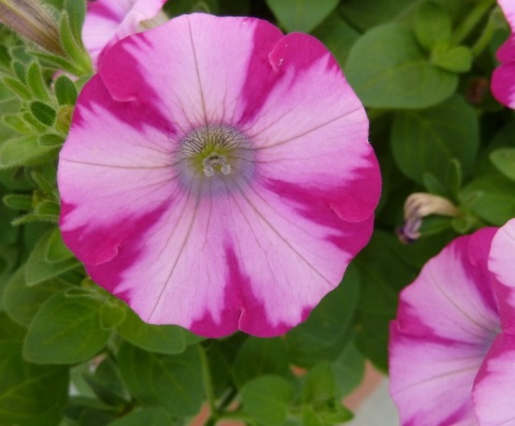 | Supertunia Candy Blast (also known as Supertunia Rose Blast Charm and Mini Rose Blast)  GM Status: Confirmed by USDA APHIS and UK HTA
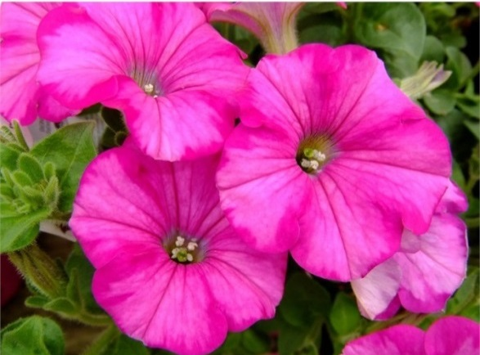   | Supertunia Raspberry Blast (also known as Raspberry Blast and Hoobini Pink)  GM Status: Confirmed by USDA APHIS, UK HTA and BVL
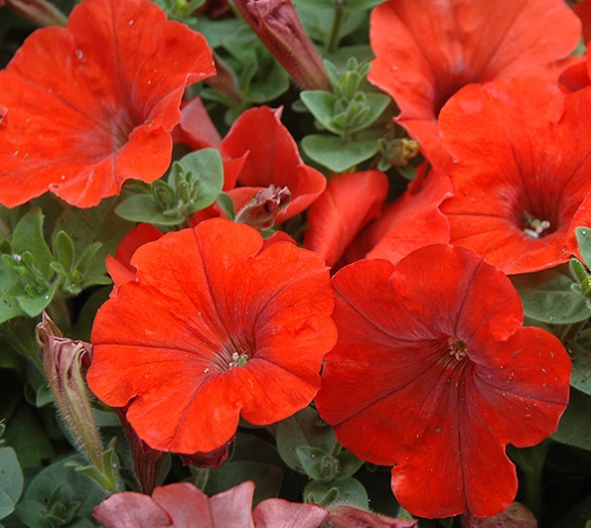 | Sweetunia Orange Flash  GM Status: Confirmed by USDA APHIS
  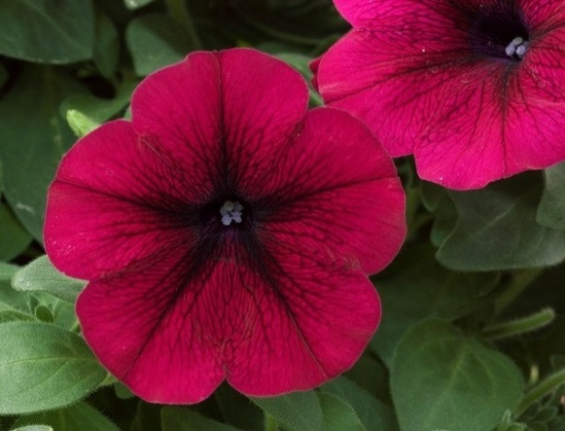 | Trilogy Deep Purple  GM Status: Confirmed by USDA APHIS and UK HTA
  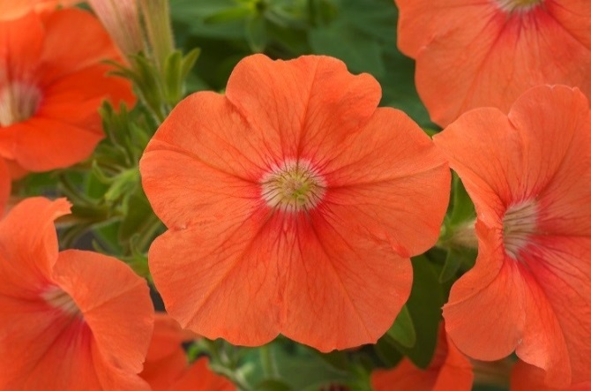 | Trilogy Mango  GM Status: Confirmed by USDA APHIS and UK HTA
  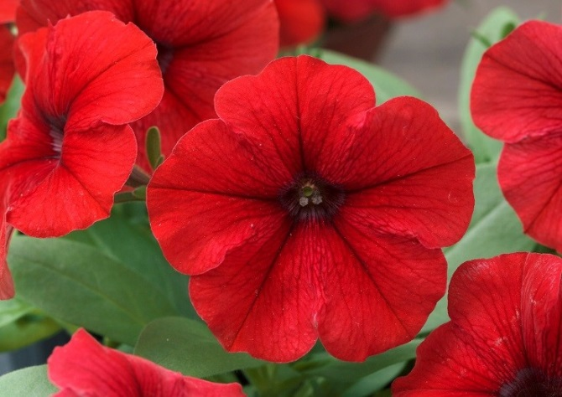 | Trilogy Red  (may also be present in Trilogy’76 Mix – Liberty Mix)  GM Status: Confirmed by USDA APHIS and UK HTA

Link to United States Department of Agriculture (USDA) Animal and Plant Health Inspection Service (APHIS) guidance on genetically modified petunias (last updated 21/6/17)

Link to Finnish Food Safety Authority (Evira) guidance on genetically modified petunias (last updated 24/4/17)

Link to Horticultural Trade Association (United Kingdom) guidance on genetically modified petunias (last updated 22/6/17)

Link to the German Federal Office of Consumer Protection and Food Safety guidance on genetically modified petunias (last updated 21/6/17)

