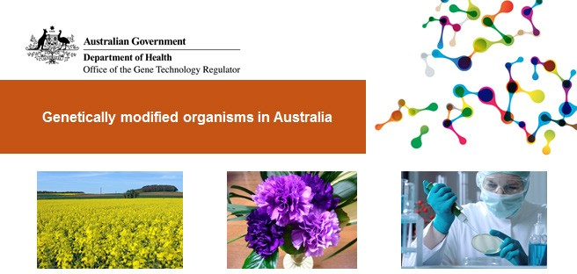

Gene technology is widely used in Australia: in agriculture, in research, in health and medicine, in education, and in industry.

When gene technology is used to create a genetically modified plant, animal or other living thing (an organism), the use of this genetically modified organism (GMO), for example growing GM canola, is regulated by the Gene Technology Regulator to protect people and the environment.

You may not create, use or import a GMO in Australia unless you have the appropriate approval.

The Gene Technology Regulator (the Regulator) is appointed by the Governor General of Australia to administer the national regulatory system for gene technology. The Regulator is assisted by the Office of the Gene Technology Regulator (OGTR).

OGTR factsheets explain what GMOs are, how they’re used in Australia, how to get permission to import or use them, and how the regulatory system works to protect Australia.

# Using GMOs in Australia

The current uses of genetically modified organisms in Australia include the following.

* Three genetically modified (GM) crops are grown in Australia: canola, cotton and safflower. Other crops are undergoing field trials. Read more [about GM crops in agriculture](https://www.ogtr.gov.au/resources/publications/genetically-modified-gm-crops-australia).
* GM blue-flowered carnations are grown in Australia and imported from overseas
* Researchers use genetically modified bacteria, plants, animals and other organisms in their

research. They use a range of techniques including adding, modifying or turning off genes to study what the genes do.

* Genetic modification is widely used to make medicines such as insulin, and vaccines such as Gardasil. [A small clinical trial of an oral cholera vaccine was held recently in Australia.](https://www.ogtr.gov.au/resources/publications/oral-trial-cholera-vaccine-australia)

Other factsheets

What is gene technology?

Who needs to apply to import or use (deal with) a GMO

Information for importers of grain and laboratory/research supplies

GM kits in schools

Biohacking and community science

Public participation in assessing gene technology

Reporting misuse of genetically modified organisms

Don’t import glowing fish unless you have authorisation

Oral trial of cholera vaccine in Australia

How we regulate the intentional release of GM crops and other GMOs into the environment

* Genetic modification is also used to make medicines and vaccines for animals such as the Hendra vaccine for horses.
* [Schools use GMOs in biology classes](https://www.ogtr.gov.au/resources/publications/gmos-schools)
* [Individuals are starting to use GMOs for personal research](https://www.ogtr.gov.au/resources/publications/biohacking-and-community-science).

# Importing GMOs

Internationally, genetically modified organisms are more widely used than in Australia. For example, about 80 GM crops are grown around the world.

You may not import any live GM plants, animals, and other organisms unless you have approval under the relevant biosecurity and gene technology legislation. For example, you need permission from the Gene Technology Regulator to import GM grain and you may also require an import permit from the [Department of Agriculture and Water Resources](http://www.agriculture.gov.au/). You will also need permission from the Regulator to import GM bacteria for research, or GM ‘glow in the dark’ aquarium fish. Some approvals are delegated to institutional biosafety committees and are then reported to the Regulator.

# Regulating GM products

[Food Standards Australia New Zealand](http://www.foodstandards.gov.au/) is responsible for the safety assessment of genetically modified

foods. The use of GM products as human therapeutics is regulated by the [Therapeutic Goods Administration](https://www.tga.gov.au/). The [Australian Pesticides and Veterinary Medicines Authority](http://apvma.gov.au/) regulates the use of GM products as pesticides or animal medicines.

|  |  |
| --- | --- |
| Version 1 | June 2018 |
| Version 2 | September 2018 |
| Version 3 | November 2021 |

