* 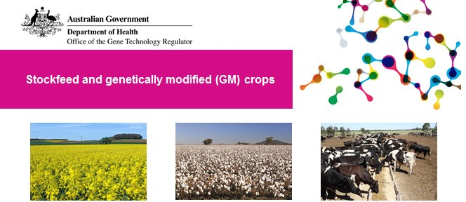Stockfeed made from approved Australian-grown GM crops may be fed to livestock
* Stockfeed made from approved imports of GM grain may be fed to livestock
* Livestock may not be fed material from GM crop trials, except as part of research that has been specifically approved by the Regulator

# Domestic GM stockfeed

Several types of GM canola and GM cotton are grown commercially in Australia. GM safflower was approved for commercial production in Australia in 2018.

These approved crops have been assessed by the Gene Technology Regulator (the Regulator) to be as safe as their conventional counterparts and may be used in the same manner, including for stockfeed.

Some crops, whether GM or not, are not appropriate for use as animal feed in all situations. For example, cottonseed should not be fed to non-ruminant animals because it naturally contains the toxin gossypol.

# Imported GM stockfeed

Occasionally grains such as canola, maize (corn) and soybean are imported in bulk into Australia for processing and stockfeed use. All grain imports must be approved by the Australian Government’s agriculture department.

If a bulk grain shipment contains GM grains not approved for commercial release in Australia, authorisation from the Regulator is required. Authorisation is by a licence for ‘GMO Dealings Not involving Intentional Release’ (DNIR). DNIRs take place under specified physical containment conditions.

The Regulator prepares a risk assessment and risk management plan (RARMP) for each DNIR application to identify any risks to human health and safety and the environment. The Regulator may impose conditions to manage any identified risks.

To date, the Regulator has issued five licences for import into Australia of GM soy (two), maize (two) and canola (one) grain destined for processing and subsequent stockfeed use. Licence conditions were imposed to prevent accidental release of live and viable GMOs to the environment. They included: precautions against spillage; transport of the grain in sealed vehicles; and processing of the grain to render it incapable of germination.

# Labelling and marketing

There are no legal requirements for labelling of stockfeed containing authorised GM grains. Marketing issues regarding the GM/non-GM status of stockfeed, including labelling, are generally managed by industry. Further information

should be obtained from the relevant rural industry organisation.

A number of States and Territories have specific legislative requirements in relation to the marketing of GM crops and grains. It is important to note that these requirements do not relate to protection of human health or the environment and are a matter for state and territory governments, not the Regulator. Further information should be obtained from the relevant state or territory agriculture department.

For more detail

Genetically modified (GM) canola in Australia

Controlling genetically modified (GM) canola on roadsides

Genetically modified (GM) wheat trials

Genetically modified (GM) safflower in Australia Genetically modified (GM) cotton in Australia

Further reading

Genetically modified organisms in Australia

Genetically modified (GM) crops in Australia

How are genetically modified organisms (GMOs) regulated in Australia?

|  |  |
| --- | --- |
| Version 1 | December 2008 |
| Version 2 | June 2018 |
| Version 3 | September 2018 |

