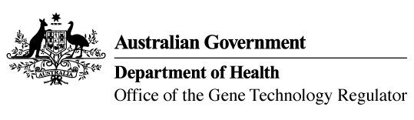

Invitation to comment on a field trial
of genetically modified wheat and barley
The Gene Technology Regulator is assessing an application from The University of Adelaide to conduct a field trial of wheat and barley genetically modified for yield enhancement and improved abiotic stress tolerance. The trial is proposed to take place at two sites, with a total area of 2 ha per year across both sites. One site will be in Light Regional Council (SA) and the other site will be in the Shire of Merredin (WA). The GM wheat and barley grown in this field trial would not be used for human food or animal feed.
The Regulator has prepared a Risk Assessment and Risk Management Plan (RARMP) for this application and welcomes written submissions on issues relating to the protection of human health and safety and the environment prior to making a decision on whether or not to issue the licence. The consultation RARMP and related information can be obtained via the contacts below. Submissions should reference DIR 186 and be received by 14 January 2022.
Office of the Gene Technology Regulator
MDP 54 GPO Box 9848 CANBERRA ACT 2601
Telephone: 1800 181 030 OGTR Website
E-mail: ogtr@health.gov.au

