

|  |
| --- |
| **Community attitudes towards gene technology**  **June 2021**  Prepared For Office of the Gene Technology Regulator  Consultants David Donnelly, Craig Cormick, Danica Jobson, Zhinan Li  Reference J3090  **www.instinctandreason.com** |

SYDNEY

Suite 302, 410 Elizabeth Street, Surry Hills

NSW, 2010 Australia

+61 (2) 9283 2233

CANBERRA

103/ 11 Trevillian Quay, Kingston

ACT, 2604 Australia

+61 (2) 6231 0350

DARWIN

Level 16, Charles Darwin Centre

19 Smith St Mall, Darwin

NT, 0800 Australia

+61 (8) 8963 5633

LONDON

Suite 1,   
7 Ridgmount Street

WC1 E7AE United Kingdom

+44 (0) 203 355 4454

Contents

Glossary 4

Key findings 5

Trends since 1999 8

Implications 11

Background, objectives, and methodology 12

Objectives 13

Methodology 13

Stage 1 – Inception and planning 13

Stage 2 – Survey design 14

Stage 3 – Survey fieldwork 15

Stage 4 – Survey analysis and reporting 15

Stage 5 – Final reporting 16

Main findings 17

Awareness and understanding of biotechnologies 17

Perceptions of whether genetic modification will improve our way of life 19

Support for genetic modification 20

Confidence in the genetic modification of crops and food 24

Perceptions of types of genetic modification crops grown across Australia 31

Attitudes to genetically modified crops and genetic modification technology in food production 33

What does the community want to know about genetic modification and where is the information coming from? 39

Awareness and trust in organisations providing information about genetic modification 43

Conclusions 47

Appendix 1 – Sample size 48

# Glossary

|  |  |
| --- | --- |
| **Term** | **Definition** |
| APVMA | Australian Pesticides and Veterinary Medicines Authority |
| Biotechnology | A broad term to cover the application of the science of living things. It can include genetic modification but does not necessarily involve the use of genes. |
| Cloning | A form of assisted reproduction which allows an exact genetic copy of an animal to be created, which is essentially an identical twin. |
| CSIRO | Commonwealth Scientific and Industrial Research Organisation |
| DNA | Deoxyribonucleic acid – the double helix of genetic instructions for all organisms. |
| Herbicide | Substances used to control unwanted plants |
| FSANZ | Food Standards Australia New Zealand |
| Gene editing | A laboratory technique to make small precise changes to genes. It does not involve the transfer of genes from living thing to another. |
| Genome editing | Another word for gene editing |
| GM | Genetically modified |
| GM product | A thing (other than a GMO) derived or produced from a GMO |
| GMO | Genetically modified organism |
| OGTR | Office of the Gene Technology Regulator |
| Organism | Any living matter |
| NHMRC | The National Health and Medical Research Council |
| Pesticide | Also known as insecticides, substances used to control unwanted pest insects |
| Regulations | Gene Technology Regulations 2001 |
| Regulator | The Gene Technology Regulator |
| Synthetic biotechnology | A new form of biotechnology where the principles of engineering are used to build new biotechnology structures that might not otherwise have existed, such as creating new organisms to use in medicine or to clean up oil spills. |
| TGA | Therapeutic Goods Administration |
| Therapeutic uses | Used for medical benefits |

# Key findings

The Office of the Gene Technology Regulator needs to further its understanding of community attitudes in Australia to GMOs, gene technology and its regulation. The key objective for this research is to provide an analysis of current attitudes and also analyse the longitudinal data to examine if and/or how community attitudes have changed over time. Key findings for the community attitude’s survey undertaken in 2021 are:

**Stability and general support**

In broad terms, the Australian community attitudes and beliefs about genetic modification have changed little since the last survey in 2019. Similarly, understanding of genetic modification is unchanged. However, in 2021, we see a significantly smaller proportion of the community feeling they have a high level of understanding of genetic modification or GMOs (22%) and cloning of animals (25%) than the average since 2015. Additionally, more people are unsure of their understanding of genetic modification or GMOs (6%), and synthetic biology (9%) in 2021.

Since 2019, more people now say that GMOs will improve our way of life (up 9% since 2019), while support for genetic modification in general is up (by 6%), including for: medical uses (up 8%), animal cloning (up 5%), using genetic modification to assist growing food (up 9%), and its use in modification of plant genes (up 8%).

This image says 'Stable results: In general, the 2021 findings are comparable to 2019. So, there appears no immediate large impact from the COVID-19 pandemic 
– but some very apparent nuances, in conjunction with, some sizable positive shifts in support for gene technology'. [This image says 'understanding of genetic modification stable, but down in the long-term: There were no significant changes in understanding of gene technology since 2019. Though since 2015, trends suggest a reduction in understanding of the concepts over time, particularly for genetic modification or GMOs, and animal cloning.'
This image hyperlinks to 'Figure 5: Awareness of genetic modification terminology and understanding – by year'.](#Figure5) **[This image says 'GMOs will improve our way of life: 54% now say GMOs will improve our way of life in the future (up 9 points), and now only 23% say it will make things worse in the future'.
This image hyperlinks to 'Figure 8: Perceptions on whether or not genetic modification technologies will improve our way of life – by year'.](#Figure8)**

[This image says 'General genetic modification support up: Stronger support for gene technology in general in 2021, it has risen to 39% (up on the 33% who strongly supported in 2019).'
This image hyperlinks to 'Figure 10: Levels of support for genetic modification and gene technology – by year'.](#Figure10) [This image says 'Support for medical uses is also up: There has been growth in support for genetically modified therapeutics or medicines (51% now very supportive agree – up 8% since 2019)'.
This image hyperlinks to 'Figure 12: Support for biotechnology development: sciences and technologies – by year'.](#Figure12) [This image says 'Cloning support up: 36% say cloning of animals will improve our way of life in the future (up 5 points since 2019)'.
This image hyperlinks to 'Figure 8: Perceptions on whether or not genetic modification technologies will improve our way of life – by year'.](#Figure8) [This image says 'Growing GM food support up: There has been growth in support for foods and crops grown with assistance from gene technology (44%; up 9 points since in 2019). There is also growth  in support for modification of plant genes for producing food. Up 8% to 38%'.
This image hyperlinks to 'Figure 10: Levels of support for genetic modification and gene technology – by year'.](#Figure10)

**COVID-19 pandemic environment**

Conducting the survey during the time of COVID-19 has led to some interesting findings, expected as the wider environment often impacts people’s attitudes in some way. Firstly, it is apparent that like attitudes to COVID-19 being polarised along pro- and anti-science lines, the findings of the survey show an increased influence of pro- and anti-science influences. A study of segmentation relationship using CHAID analysis[1] shows that that if people believe science and technology cause more problems than they solve, then their concerns about genetic modification technologies have increased. Also, unlike the variations in support for different genetic modification applications, trust in OGTR has been high and constant with the most recent wave hitting the highest level of trust measured since 1999 (71%). This is possibly a reflection of the perceived role that science has had during handling of the COVID-19 pandemic – with political messaging in Australia repeatedly citing scientific experts, and the reliance on vaccine science to provide some solution to the pandemic.

Conversely, those with an inherent distrust of science do not agree that being unvaccinated poses a risk to others – something that has been reported in the wider community. Indeed, those with anti-science beliefs say their attitudes have firmed as a result of the COVID-19 pandemic experience.

When asked specifically whether the pandemic had influenced their opinions towards use of genetic modification, each age group and gender reported becoming more polarised on the issue, each demonstrating both an increased and a decreased level of concern. All segments had a greater proportion of people with increased concerns due to COVID-19 than they did people with decreased concerns. For instance, almost half of 16-30 year-olds (47%) reported their views being influenced by the pandemic, with over a third (34%), saying their concerns had increased, and 13% saying they had decreased. Of note though, this change in stated concern may be more reflection of an overall rise in general concerns due to COVID-19, as the survey findings showed that people were not more concerned about genetic modification technologies compared to previous surveys, and across most indicators are more supportive.

Also of interest, only 5% of females attributed a decrease in concern about GM products to COVID-19 (and an 28% increase), whereas it was 13% for males, with an increase figure very similar to females (26%) – consistent with trends that show women not only report more concerns on most topics than men, but their concerns can be deeper and less likely to be changed.

Overall, the key points in the survey are as follows:

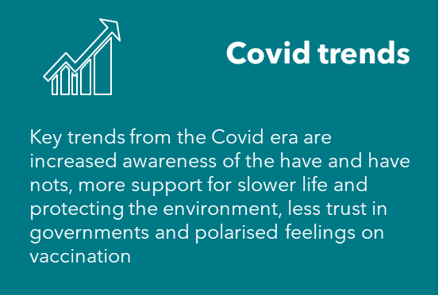 **[This image says 'Science is questioned: 29% say science causes more problems than it solves (up 6 points) and 49% say that technological change is happening too fast to keep up with (up 7 points)'.
This image hyperlinks to 'Figure 11: Perceptions towards scientific technology – random samples A + B, by year'.](#Figure11) [This image says 'COVID has hit youth harder: More Covid impact has occurred with the young. Notably, more support for use of vaccines for animals, such as vaccines against disease and food, and a significant increase in the view that scientific advances benefit the rich over the poor, and that people should not tamper with nature'.
This image hyperlinks to the supporting section discussing this information, titled 'Support for genetic modification'.](#_Support_for_genetic)**

**Trust findings and support for specific applications**

Compared to 2019, significantly more people in 2021 did believe the rules that regulate the use of genetic modification are sufficiently rigorous (up 9 points to 40%) and are complied with (up 9 points to 42%)

The survey shows increases in trust in regulation and in the ideas that the use of genetic modification improves crops. The results show that genetic modification support is garnered when people believe genetic modification technology produces safe, healthy and sustainable food in terms of production (food security being the benefit) and environment (fewer pesticides needed).

**[This image says 'Trust in regulation: Compared to 2019, significantly more people in 2021 did believe the rules that regulate the use of genetic modification are sufficiently rigorous (up 9 points to 40%) and are complied with (up 9 points to 42%)'.
This image hyperlinks to 'Figure 44: genetic modification rules and regulations – by year'.](#Figure44) [This image says 'Youth show increased concern: Increase in concern for genetic modification with 16-30 yo due to pandemic (47% report their views changing due to pandemic, 13% down, 34% increase in concern)'.
This image hyperlinks to 'Figure 22: Concern over genetic modification of foods and crops - by gender and age (2021)'.](#Figure22) [This image says 'Why is support for medical genetic modification so high? Genetic modification for medical purposes is most supported (61%).  Support is partly explained because  of a belief in good regulation (44% now strongly agree – up 8% since 2019). Also, that rules that regulate the use of genetic modification for medical research are rigorous is also up to 41% who strongly agree (up 6% on 2019)'.
This image hyperlinks to the supporting section discussing this information, titled 'Support for genetic modification'.](#_Support_for_genetic)**

**[This image says 'Support for food crops up: 44% support growing foods and crops with assistance of genetic modification; up from 35% in 2019. Critics are now down to only 1 in 5 of the population'.
This image hyperlinks to 'Figure 10: Levels of support for genetic modification and gene technology – by year'.](#Figure10) [This image says 'Plant modification support up: 38% feel strongly that plant modification is acceptable, up from 30% in 2015 and 2019. Only 19% are strongly against the idea, down from 28% of people in 2015'.
'Figure 12: Support for biotechnology development: sciences and technologies – by year'.](#Figure12) [This image says 'What is underpinning support? Support for genetically modified technologies to produce food is led by a belief that use of genetic modification improves crops. More support is garnered when gene technology is seen to produce safe, healthy and sustainable food in terms of production & environment'.
This image hyperlinks to 'Figure 14: Support for the use of genetic modification in food and crops – (2021)'.](#Figure14)**

**Regulation and Interesting facts**

The Australian community is more trusting of OGTR, although no more aware of its existence in previous surveys. There are also significant improvements in the view that there are sufficient genetic modification regulations, and that the genetic modification industry is complying with those regulations.

The results highlight high levels of awareness and concern about fake news which many Australians believe they have been exposed to and many feel unsure they can always identify fake news when it is broadcast.

[This Regulation summary image says 'Awareness of OGTR is 15% when prompted. Dept of Agriculture has overtaken CSIRO as the most recognised organisation, by 78%. The TGA and NHMRC have both improved by 8% and 6% respectively since 2019'.
This image hyperlinks to 'Figure 42: Prompted awareness of organisations that are responsible for regulation of gene technology – by year.](#Figure42) [This Regulation summary image says 'OGTR is seen as responsible for the regulation of gene technology in Australia for 26%, when prompted. It is the Department of Agriculture, FSANZ, Health and CSIRO seen as the top four organisations responsible, by over 30%.'
This image hyperlinks to 'Figure 41: Prompted awareness of responsibility of organisations for regulation of gene technology– by year'.
](#Figure41) [This Regulation summary image says 'Trust trends: Trust in information about the risks and benefits of genetic modification or gene technology has improved significantly in 2021. Trust in OGTR amongst people aware of it has jumped from 60%, to 74% (strongly trust)'.
This image hyperlinks to 'Figure 43: Levels of trust in what organisations say about gene technology (2021)'.](#Figure43) 

[This Interesting facts summary image says 'Concern about fake news: Over half of those surveyed are highly concerned about fake news and misinformation (38% highly concerned). Most people report being exposed to it (60% rate their exposure as 6-10 where 10 is constantly exposed)'.
This image hyperlinks to 'Figure 40: Concerns regarding fake news and information'.](#Figure40) [This Interesting facts summary image says '65% only sometimes are able to determine when news is inaccurate. Only 11% feel they are always able to identify if something is fake news / misinformation'.
This image hyperlinks to 'Figure 40: Concerns regarding fake news and information'.](#Figure40) [This Interesting facts summary image says 'Males are significantly more likely to eat processed / GM / preservative foods than women. Willingness to eat processed / GM /preservative foods declines with age for all GM foods tested'.
This image hyperlinks to 'Figure 17: Willingness to eat genetic modification food – by age (2021)'.](#Figure17) 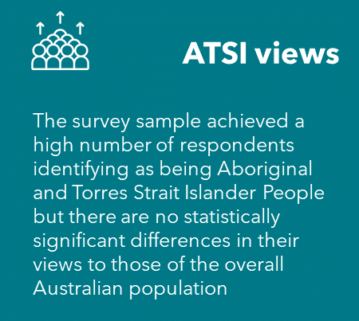

## Trends since 1999

Support for various uses of biotechnology and genetic modification has varied considerably since 1999 when measurements began. In contrast, knowledge of genetic modification and the ability to explain to others what genetic modification is, has not varied much. In the absence of knowledge, public support rises and falls in response to other stimuli, most likely when attention is focused on the issue by media and special interest groups – either positively or negatively.

When forming personal views about whether to support a new field of science like biotechnology and genetic modification, people interpret information through the filter of their values, feelings, and past experiences. Hence, survey responses are assertions of a mixture of facts, opinions, beliefs, or prejudices.

Ideally, OGTR want community members to base their support for genetic modification on verifiable facts by searching for the evidence. However, facts about genetic modification need to be contextualised and conclusions provided about the benefits being delivered to give these facts meaning. At present, the context for genetic modification is missing for a community with low levels of knowledge, increasingly distrustful of science, and a growing belief that science benefits the rich.

As such, support for many forms of genetic modification applications has been quite variable since 1999. In recent years genetic modification technology used to make plants more resilient has been shown to have very stable levels of support (at just over 70% of the community).

However, it should be noted that the way the scores were compiled was different after 2015. Since 2015 support is grouped as scores 7-10 whereas in previous waves support was scored at 5 and above.

Perhaps the best example of the wide variation in support is with using genetic modification in food and drinks (which has been measured since 1999) which has finished just below the level of support when measurements began in 1999. After strong support in the early 2000s (71% in 2007), support declined markedly through to 2015 when only 49% supported its use. This has then been followed by a steady but small rise in support since 2015 (now at 56%).

Figure : Attitudinal changes towards biotechnology and genetic modification over time

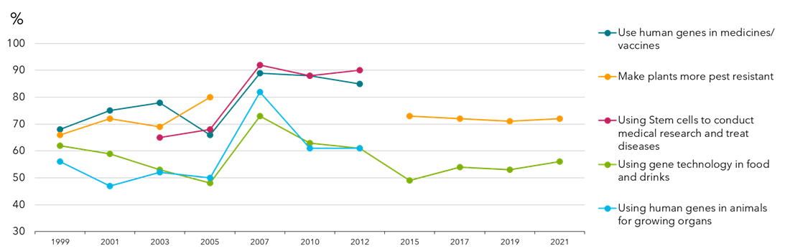

In contrast to the variation in support for various genetic modification applications, trust in OGTR has been high and constant with the most recent wave hitting the highest level of trust measured since 1999 (up to 74%, from 71%). This is possibly a reflection of the perceived role that vaccine science has had during the COVID-19 pandemic. Interestingly, awareness of OGTR is only 15%, which is showing slight improvement since 2015 (13%).

Figure : Changes in awareness and trust in the OGTR

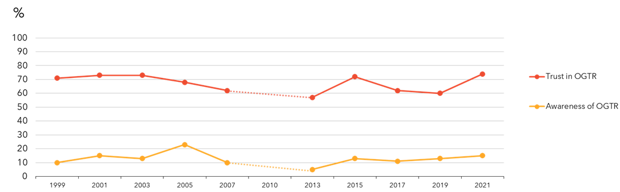

Support is also different for different applications. The community show greatest support for its use in generating therapeutics or medicines (51% support). This is followed by its use in crops (44% support), food (42%), gene editing (40%) and finally in the cloning of animals (32%).

For all applications, support has risen since 2019 (and since 2015).

Figure : Support for genetic modification from 2015-2021  
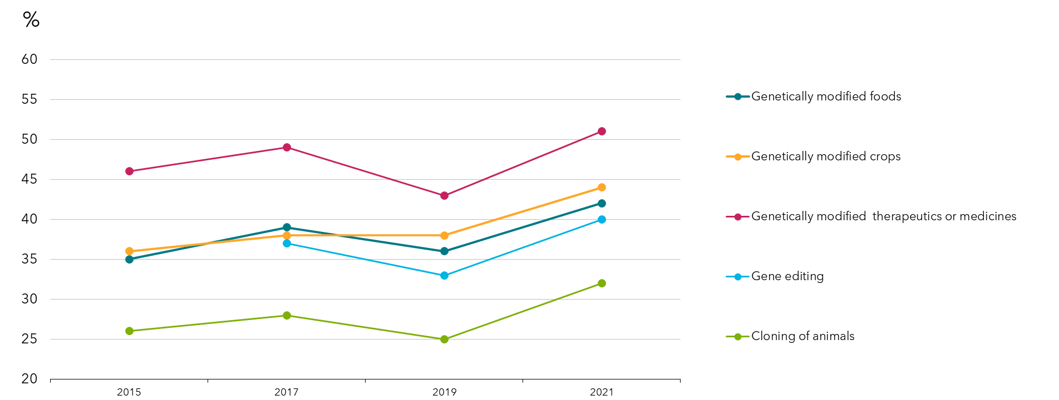

As support for genetic modification technologies can be influenced by global and national trends, it is most likely that lower support for most applications in 2019 was tied to the global lack of trust in governments and institutions in that time.

Figure : Support for genetic modification by those aware of the OGTR in 2021

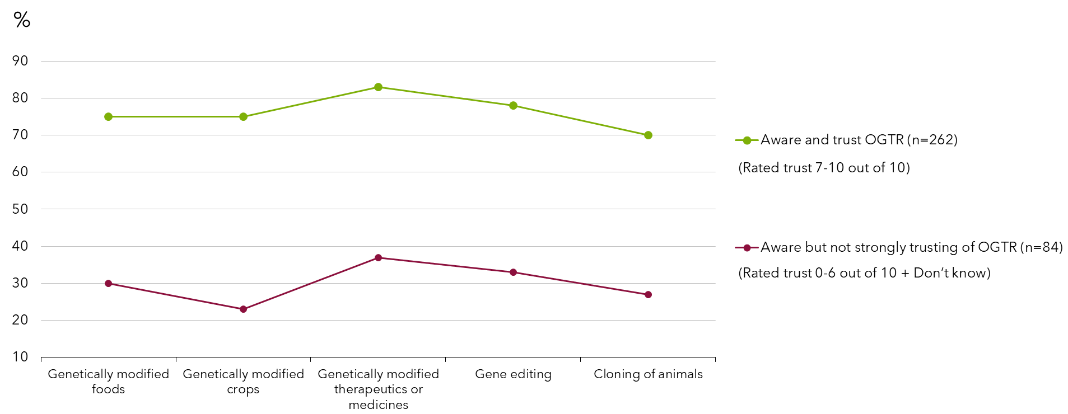

Those who state they are aware of the OGTR can be categorised as the highly engaged, and it is worth noting that the highly engaged divide into those who are highly trusting of OGTR and those who do not strongly trust OGTR – which correlates with levels of support for different applications of gene technology and biotechnology. This means that those who strongly support different applications are much more likely to trust OGTR and those who do not support different applications are more likely to not trust OGTR, indicating that oppositional values govern trust.

## Implications

The community have varying views on genetic modification and the way it is used. In broad terms, the Australian community can be seen as having four distinct mind-sets or world views when it comes to genetic modification, regardless of application.

About one in five (18%) hold a very supportive position when it comes to genetic modification. What is critical to understand is that they know enough to explain genetic modification to a friend and believe that the technology will improve our way of life. Furthermore, as this group focuses on the issues and the benefits, their support rises, and concerns diminish. Having the ability to understand the technology enough to explain genetic modification appears a pre-requisite for solid support.

The majority of Australians conservatively support genetic modification and its applications (52%). The foundation stone of their support is a solid belief that science is a force for good and will deliver a better life for everyone in the future. It is not knowledge of genetic modification that supports their view but rather a more general belief in science and its contribution to their lives. As such, there remains some questions in their mind about genetic modification that are not fully resolved, and they feel and report some concern about genetic modification. In the absence of enough knowledge, they are reliant on the regulator to ensure that genetic modification is used safely and appropriately. However, knowledge of the benefits that genetic modification delivers appears to shore up their support. The broad communication or information strategy required to reach this group is promotion of the role of the regulator and reinforcement of genetic modification benefits.

One in five (19%) start the survey quite opposed to genetic modification but as they progress and become aware of genetic modification benefits, their level of support rises, and concerns diminish. This indicates that those in this group with more moderate opposition can be persuaded with knowledge of the role of regulators and information about the benefits of the technologies. As time passes and technologies are proven to help in the medical sphere, in food security and in the environment, it is possible that some will gradually come to support more genetic modification applications. The broad strategy for this group is more genetic modification education, showing the benefits that exist, particularly using case studies of people they can identify with.

There is a group strongly and comprehensively opposed to genetic modification (11%). They have a distrust for science in general and believe that science will not provide them with a better life in the future. Their distrust of genetic modification stems from a strongly held belief that people (and science) should not meddle with nature. They are unwilling to eat any ‘genetic modification-tainted’ foods as a result of concern about the technology and what it may have done to their food. The distrust of science includes their views on vaccination where they do not agree that being unvaccinated poses a risk to others – and all these views, they say, have firmed as a result of the COVID-19 pandemic experience.

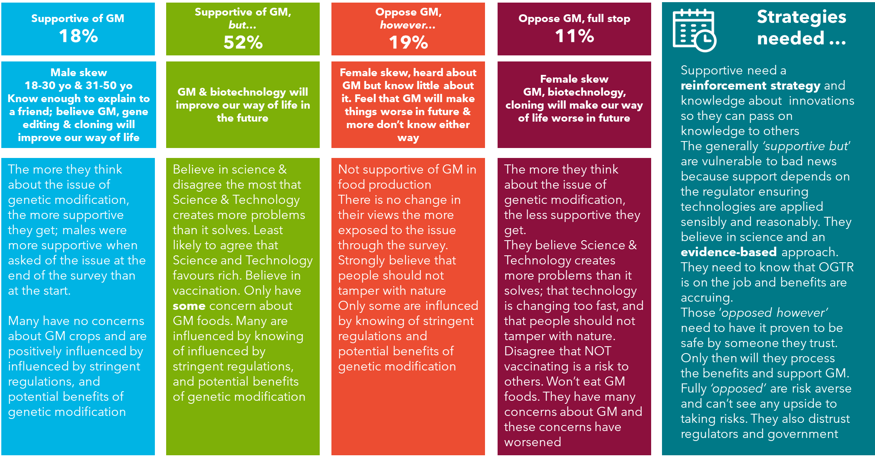

# Background, objectives, and methodology

The Gene Technology Regulator (the Regulator) administers *the Gene Technology Act 2000* to protect the health and safety of people and environment by identifying risks posed by or as a result of gene technology and manages risks by regulating dealings with genetically modified organisms (GMOs).

Gene technology is a form of biotechnology. Biotechnology includes the use of biology in agriculture, environment, and pharmaceutical development. It also refers to the production of GMOs and the manufacture of products from them. Recent activity in biotechnology involves directly modifying genetic material of living things, referred to as genetic modification, recombinant DNA technology, or genetic engineering. Other types of biotechnology include using enzymes and bacteria in applications such as waste management, industrial and food production, and remediation of contaminated land. The largest sub-sector of biotechnology companies in Australia work on therapeutics, such as pharmaceutical development and medical procedures. Other sub-sectors are agricultural applications, and diagnostics.

Community support is crucial to the development of the Australian biotechnology sector. If Australians are not in favour of an application, research and development in this area will be constrained and a host of potential benefits in fields ranging from medicine to textiles could be missed, resulting in a lost opportunity for individuals, industry and the nation as a whole. Public attitudes help shape both industry uptake of emerging technologies and the underlying regulatory framework for them.

Over recent years, there have been a number of surveys of community attitudes towards biotechnology that have helped gauge the state of Australian public awareness, identify knowledge gaps and track changes in awareness and attitudes over time. The findings have been used to develop strategies to engage with the community on these issues including increasing public awareness of developments in emerging technologies. This study continues to track those community attitudes and behaviours.

## Objectives

The research objectives for this study were:

* To track current awareness, attitudes and understanding towards general science and technology, specific biotechnology issues and specific applications and controllers of the technology
* Explore differences in awareness, perceptions and attitudes according to key demographic variables such as age, gender, location and education, and in terms of mindsets to determine segments in the community
* Understand what influence the COVID-19 pandemic has had on attitudes towards genetic modification

In this 2021 wave, some minor additions were made:

* There has been a big expansion in how gene technology is used therapeutically since the survey started; initially it would have been seen more as a production step but is now increasingly a GMO of itself. The difference in therapeutic and industrial use of genetic modification are asked separately
* Nanotechnology has been removed
* Attitudes towards genetic modification in livestock expanded to include heat tolerance and disease resistance

The COVID-19 coronavirus pandemic:

* Level of concern about genetically modified food and crops, and whether that has been affected by the pandemic, and if so, how?

## Methodology

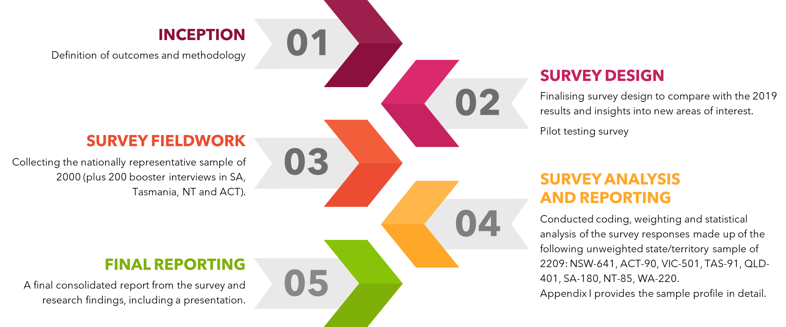

### Stage 1 – Inception and planning

An initial online meeting was held with the Office of the Gene Technology Regulator (OGTR) to define the outcomes sought and assess the best options to deliver the project in the timeframe specified. OGTR shared the existing body of knowledge about past and current community attitudes and areas of concern, including past and current strategies and initiatives, and the effectiveness of these.

External factors affecting perceptions of gene technology, innovations and its regulation and also the social, technological, political, economic and legislative contexts affecting these were discussed.

The survey methodology was agreed upon, replicating the survey methodologies of previous years and eliminating the impact of externalities as well as the expansion of the survey to 2209 respondents

### Stage 2 – Survey design

Survey questions ensured accurate and reliable tracking from previous years and additional questions were asked based on the COVID-19 pandemic. Care was taken in the survey design to manage the tendency of respondents to favour a ‘risk’ response which could easily distort findings and make concerns appear higher than they actually are. The survey covered the following areas: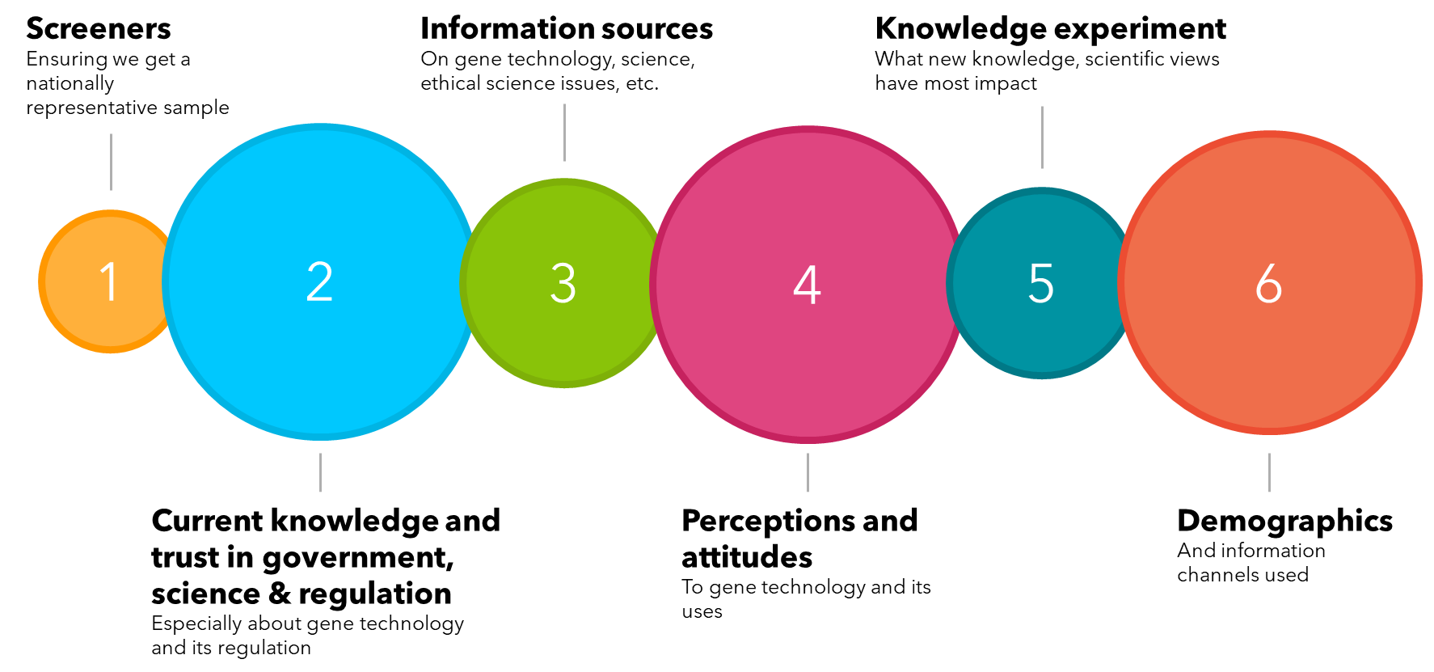

Cognitive testing of the draft survey was undertaken in 2019 to ensure respondents understood what they were being asked, and only minor changes have been made, no additional piloting was necessary. The final survey was approved by OGTR.

The following definitions were provided to survey respondents:

This table shows definitions provided to survey respondents for terms used. They include: Genetic modification or GM is using laboratory techniques to basically, “cut and paste” a gene from one living thing to another, or modifying or removing a gene within an organism. Something that has been modified by GM can be called a genetically modified organism (GMO). 
Gene editing also known as genome editing, is a laboratory technique to make small, targeted changes to the genes of an organism. It does not involve the transfer of a gene from one living thing to another. One of the most common techniques used to edit genes is CRISPR (clustered regularly interspaced short palindromic repeats).
Biotechnology is a broader term that covers the application of the science of living things, and is used widely in agriculture, beer and wine production, food processing and medical treatments. Biotechnology sometimes uses genetic modification, but also includes processes that do not involve the use of genes. 
Cloning of animals another form of assisted reproduction in animal husbandry which allows livestock breeders to create an exact genetic copy of superior breeding animals to produce essentially an identical twin for the purpose of healthier offspring. Cloning does not manipulate the animal’s genetic make-up nor change an animal’s DNA. 
Synthetic biology is a new form of biotechnology, where the principles of engineering are used to build new biological structures that might not otherwise have existed, such as creating new organisms to use in medicines or to clean up oil spills.

### Stage 3 – Survey fieldwork

The 21-minute survey was completed between May and June 2021 using an online survey to ensure a nationally representative sample of 2209 Australians (the core sample of 2000 was boosted to ensure analysable samples from the smaller jurisdictions of Tasmania, NT, South Australia, and the ACT). Quotas were set for states and territories, rural and metropolitan, and gender. Recruitment for the online survey was taken from a reputable research-only panel.

The male to female ratio was 50:50 with 1,100 males and 1,100 females and represented a similar age profile to that of the 2019 study. The combination of a representative national sample with quotas and weighting, delivered a sample that could be directly compared to the previous research and accurately identify changes in the views and attitudes of the Australian community.

While the people sampled in this survey were not the same individuals sampled in previous surveys, they were drawn from similar demographic areas, so the responses obtained, while not indicating individual changes of attitudes, captured the movement of attitudes across the broader population.

### Stage 4 – Survey analysis and reporting

Data cleaning and coding was conducted on the survey responses. The results were weighted to the Australian population based on 2016 ABS data by State/Territory, age and gender. The unweighted state/territory sample was NSW-641, ACT-90, VIC-501, TAS-91, QLD-401, SA-180, NT-85, WA-220.

Appendix I provides the sample profile in detail. The analysis included frequency counts and cross tabulations, significance testing, mean calculations and cluster analysis. The survey results were presented to the OGTR.

**Weighting of the data** – The actual sample profile provides the unweighted responses. The results presented in the rest of the report are weighted to the Australian population based on 2016 ABS data by state/territory, age and gender.

**Statistical significance** – 5% at 95 percent level of confidence – All tests for statistical significance have been undertaken at the 95 percent level of confidence, and unless otherwise noted, any notation of a ‘difference’ between subgroups means that the differences discussed are significant compared to the sample average at the 95 percent level of confidence. The report only notes those differences that are statistically significant, and these differences are marked in the graphs and tables by a pink circle/oval or a green square/rectangle where they are different to the aggregate sample, compared with other segments. The legends on the charts denote whether the responses being compared are by year (2021 and 2019 or 2021, 2019, 2017 and 2015), age, gender and geographical location. For significance testing by gender, the sample base of “other non-binary” genders is too small, and significant differences were compared between males and females.

**Treatment of means** – Where responses are scale variables, for example 1 to 5 where 1 is disagree strongly and 5 is agree strongly, the mean is also calculated with the removal of don’t know and reported and also compared for statistical significance at the 95% level of confidence.

**Rounding of figures** – may result in anomalies of +/- 1% - All results have been rounded to the nearest whole percentage figure and anomalies of about +/- 1% may occur in charts i.e. in the chart above, total percentages for each bar add to 99%, or 100% or 101% due to rounding error.

Net figures are also rounded, which may also result in anomalies. Net results are also rounded after summing the separate proportions rather than simply summing two rounded figures (e.g. ‘% total agree’). For this reason, anomalies of about 1% sometimes occur between net results and rounded results shown in charts. For example, a proportion of 33.3% ‘agree’ rounds to 33%, and a proportion of 12.4% ‘strongly agree’ rounds to 12%. However, when combined to derive the total agree (i.e. agree plus strongly agree), 33.3% plus 12.4% equals 45.7%, which would be rounded to 46%. In this case, the results would be shown in a chart as 33% agree and 12% strongly agree, but the proportion reported as ‘total agree’ would be 46%.

### Stage 5 – Final reporting

The following provides a final and consolidated report from the survey results.

# Main findings

## Awareness and understanding of biotechnologies

Since 2015, the proportion of the population that feel they know enough about genetic modification technologies to explain them to a friend has decreased, yet on average, more people feel they know a little about it than they did in 2015. This is particular true of genetic modification or GMOs, of which only 22% of people are confident in their understanding of the technology.

Similarly, having enough knowledge of animal cloning to explain it to a friend has significantly decreased since 2015, with a quarter in 2021 feeling knowledgeable enough to explain the technology to a friend. The percentage of people surveyed that haven’t heard of cloning of animals at all has risen to 13% in 2021.

Regarding synthetic biology, in 2021, more people were unsure of whether they had heard of the technology or not (9%).

Figure : Awareness of genetic modification terminology and understanding – by year

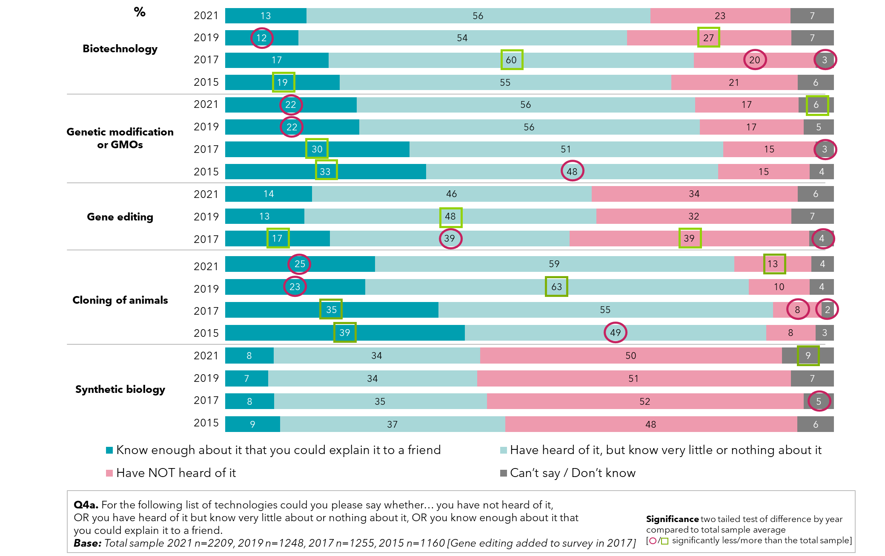

The proportion of Australian residents aware of the use of genetic modification in the production of vegetable oils has grown to over a third in 2021 (34%, up from 31% in 2015), with a similar percentage (33%) now aware that most of the cotton grown in Australia is genetically modified.

A significant minority of people surveyed in 2021 incorrectly believe that most of the fresh fruit and vegetables grown in Australia are genetically modified (29% - which is up from 2019). Similarly, an incorrect belief that most of the processed foods in Australian supermarkets contain genetically modified ingredients has risen to 38%, from 32%.

The largest response, however, continues to be ‘don’t know’.

Figure : Awareness of the levels of genetic modification in Australia – by year

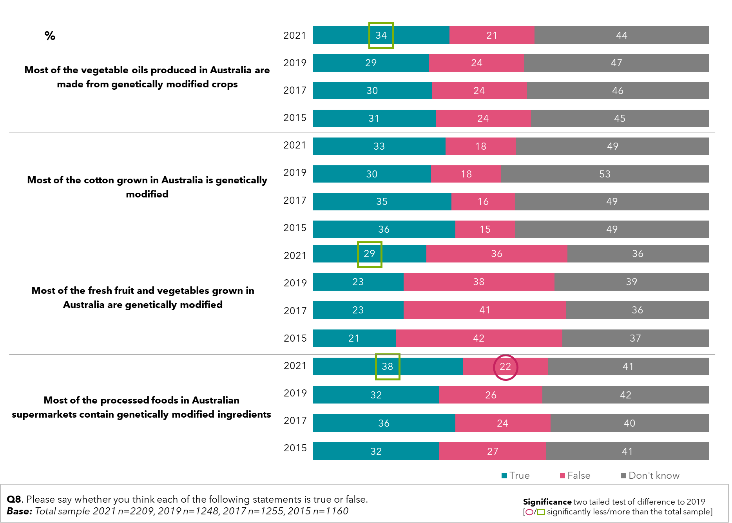

Younger people are more likely to believe that produce is genetically modified, with 39% of younger people saying they are aware that most of the cotton grown in Australia is genetically modified, and similarly, 41% believe that most of the vegetable oils produced in Australia are made from genetically modified crops.

Though the younger cohort surveyed are more likely to correctly believe vegetable oils and cotton grown in Australia are mostly genetically modified, they also incorrectly assume this is the case with most fresh foods and vegetables grown in Australia (40%). It is interesting to note that this cohort is also more willing to consume them.

People aged 51-75 are significantly more likely to disagree with the statement that most fresh fruit and vegetables grown in Australia are genetically modified, and also less likely to be willing to consume them, as found previously.

Figure : Awareness of the levels of genetic modification in Australia – by age (2021)

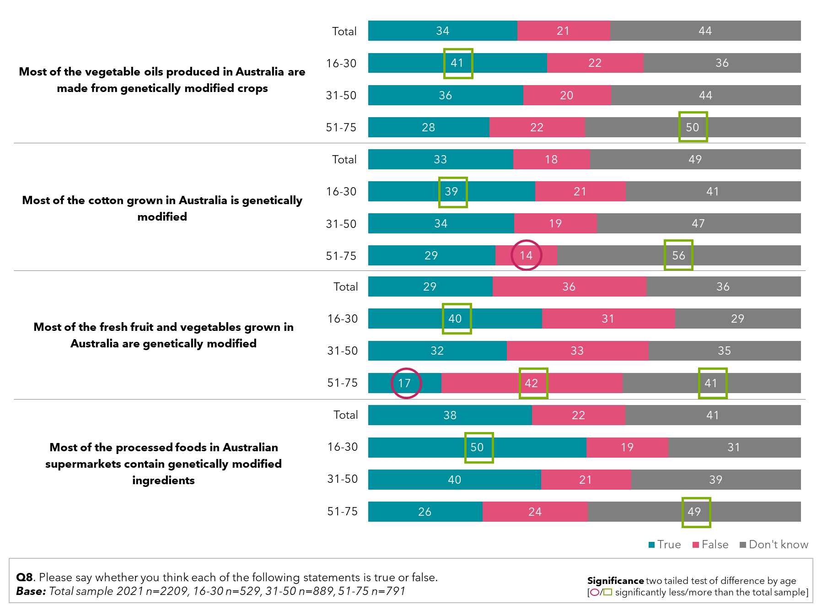

## Perceptions of whether genetic modification will improve our way of life

In 2021, the belief has become more widespread that genetic modification and cloning of animals will improve our way of life in the future (54% agree regarding genetic modification, up from 45% in 2019, and 36% regarding animal cloning, up from 31%) among those aware of the technologies. This is a statistically significant shift. Despite animal cloning being the most familiar concept, it was still felt to have the least positive impact of the five technologies surveyed, as has been shown in previous studies. Amongst those that have heard of the technologies, it is felt that biotechnology will provide the greatest benefit to the Australian way of life in the future, agreed by 64%.

There has been a statistically significant improvements in the belief that a number of genetic modification technologies will improve our way of life. While the belief that biotechnology itself will improve our way of life hasn’t shifted in the last two years in any statistically significant sense it remains the technology where the most Australians think improvements to our way of life will come from.

However, several other technologies have increased in their likely contribution to a better way of life. Namely, GMOs 54% (up 9 points on 2019) and in the cloning of animals 36% (up 5 points on 2019). Other technologies measured moved indicatively in the positive direction although the shifts are not statistically significant.

Figure : Perceptions on whether or not genetic modification technologies will improve our way of life – by year

This chart shows perceptions in 2015, 2017, 2019 and 2020 of whether different GM technologies will improve our way of life


## Support for genetic modification

There has been a statistically significant increase in support for the use of genetic modification in 2021 on average compared to the 2015 measure, with a mean score of 5.83 out of an 11-point rating. A quarter of people are neither for nor against the use of genetic modification, causing this to remain the dominant attitude. Full support for genetic modification has risen back to 11%. Additionally, only 7% were completely against genetic modification.

Figure : Support for the use of genetic modification in general

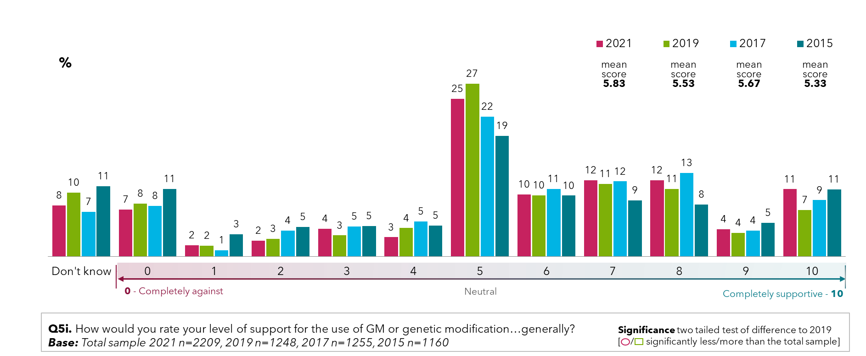

Support for genetic modification generally is stronger, having risen to 39% in 2021, from 33% in 2019. However, there has been considerable growth in support for genetically modified foods and crops, supported strongly by 44% (up from 35% in 2019), with critics down to only 20%. When considering specific uses of genetic modification, genetic modification for medical purposes remains the most acceptable use, with strong support from 61% of people surveyed).

The use of genetic modification for industrial uses is high with 58% strongly supporting it in 2021. Additionally, few people do not believe in genetic modification being used in this way, with detractors remaining at 8%. Support for ornamental uses has improved substantially, from fewer than a third of people strongly supporting the idea, to 38%. This is a statistically significant shift.

Use of genetic modification for livestock uses such as vaccines against disease have gained significant support since 2019, from 50% to 57% of people supporting it. For livestock uses such as modifying feed to reduce greenhouse gases/methane production, support has also increased, to 47% (up from 41%). Both these shifts are statistically significant.

Figure : Levels of support for genetic modification and gene technology – by year

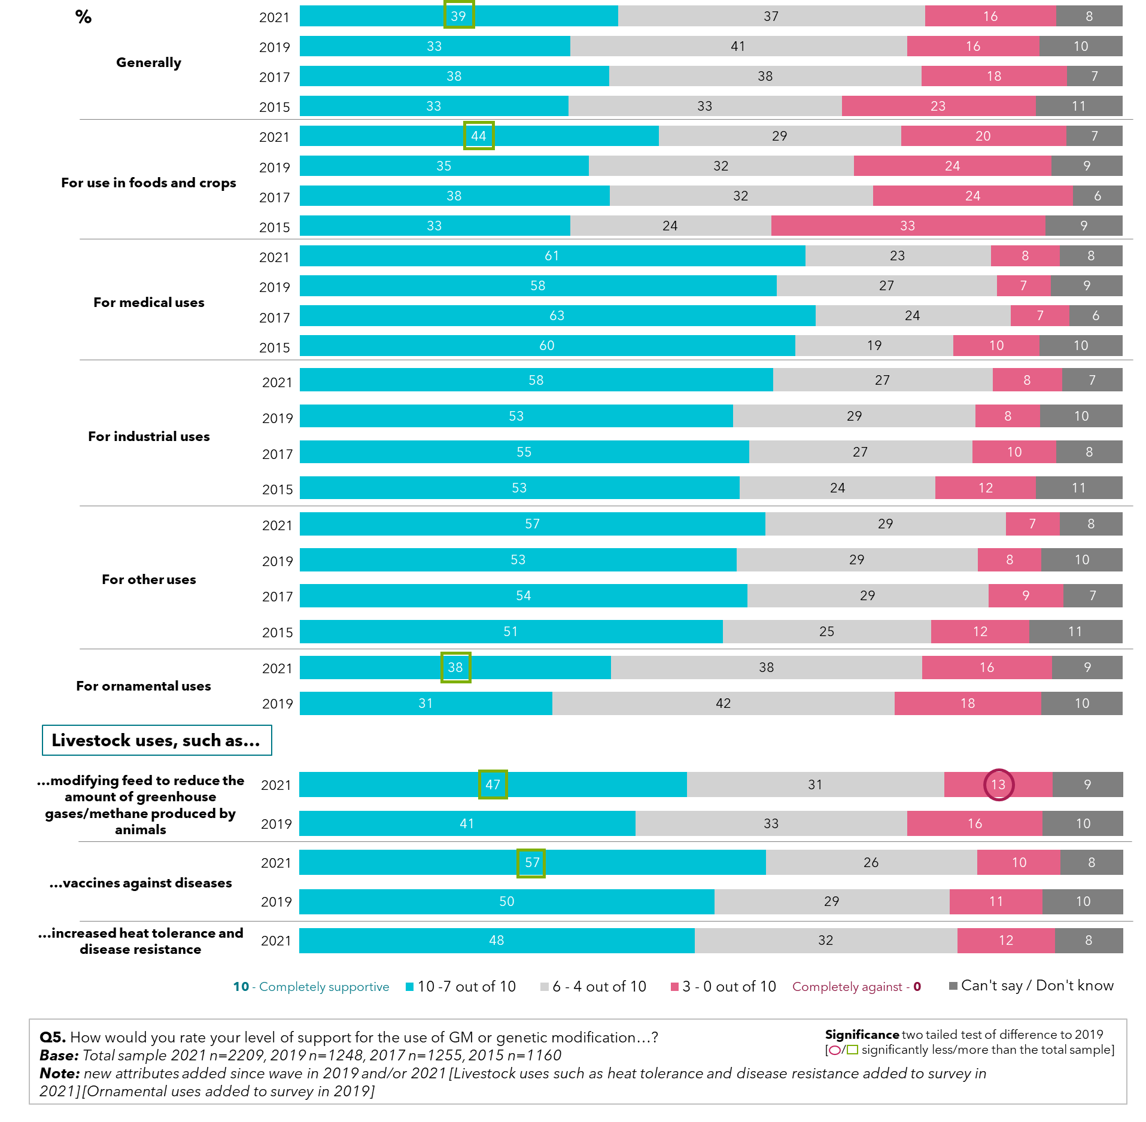

When asked about attitudes towards a range of scientific technologies, those asked at the start of the survey did not feel notably different to those asked at the end of the survey, who would have given the topic more thought and learned about new uses of genetic modification through the survey. In 2021, both samples felt scientific advances benefit the rich more than the poor, at significantly higher rates than in 2019. There may be have been some impact here from COVID-19, highlighting the disparity between access to healthcare and health technologies in rich and poor countries. Overall, 46% of people felt this was true, and at both points, almost half also felt nature shouldn’t be tampered with either.

Almost half (49%) of people surveyed in 2021 feel that technological change happens too fast for them to keep up with, a significant increase from 42% in 2019. The largest shift in response to the idea was the reduction in people feeling indifferent to it, similar between those asked at the start of the survey (Sample A), and the end (Sample B). Though still the minority, more people in 2021 are unconcerned about the risk of unvaccinated children, more than doubling in Sample A to 9% from 4% in 2019. There is also a rising feeling that science and technology creates more problems than it solves (29% agree in 2020; up from 23% in 2019). A statistically significant shift.

Figure : Perceptions towards scientific technology – random samples A + B, by year

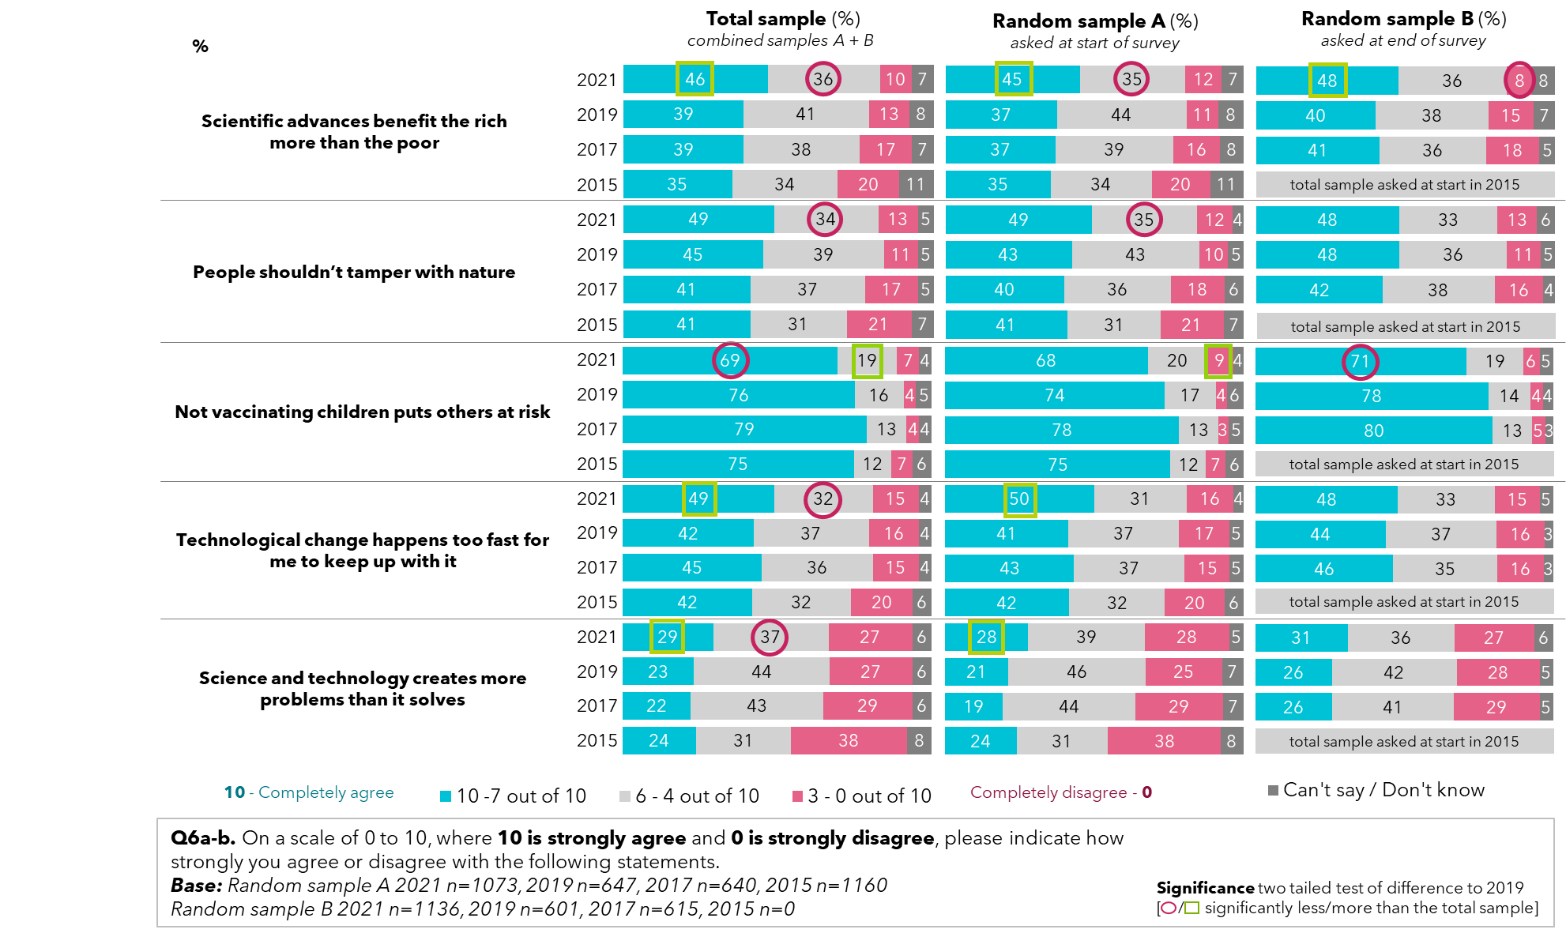

Support for all six science and technology developments surveyed have increased substantially since 2015. The highest level of support is for genetically modified therapeutics or medicines, with half the population strongly in favour in 2021 (51%). With this growing support has come a decline in people that are both unsupportive and uncertain of how they feel about science and technology developments, particularly for genetically modified crops or foods.

Figure : Support for biotechnology development: sciences and technologies – by year

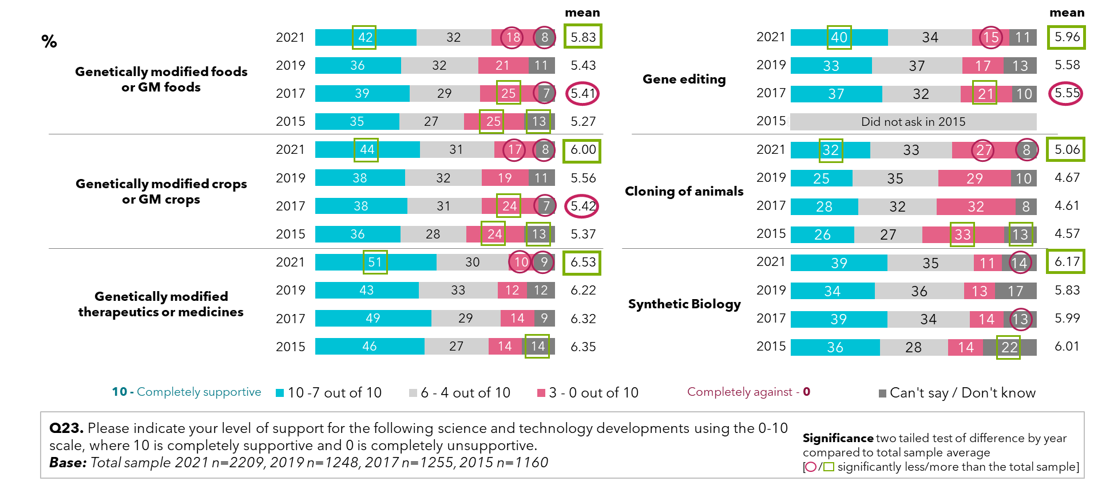

When it comes to how decisions about genetically modified foods and crops are based, fewer people surveyed are apathetic towards the issue in 2021 compared with 2019, with a significant shift in support towards basing these decisions on science and safety over either economics or morals.

Figure : Support for basis of genetic modification food and crop decisions – by year

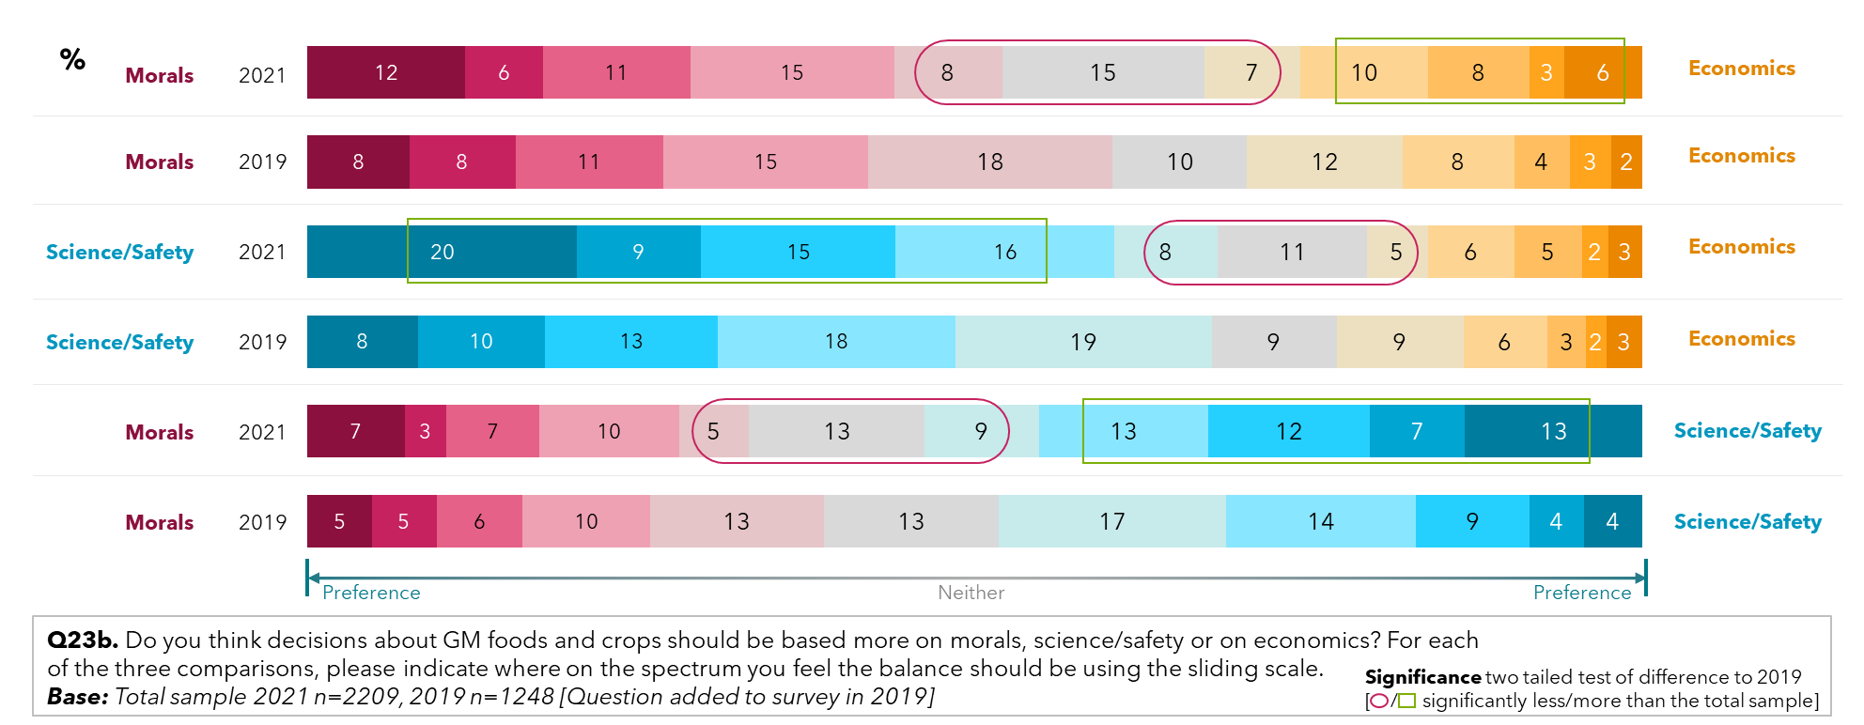

## Confidence in the genetic modification of crops and food

There has been a shift towards supporting genetic modification in foods and crops in 2021. A third of people surveyed (33%) rated their level of support very highly, scoring 7-10 out of 10, compared with a quarter (25%) in 2019. While the greatest percentage of people sitting at the neutral centre-point of the scale, being neither supportive nor are against genetic modification in the use of food and crops (16%). Overall, the level of support has increased to a mean score of 5.84 in 2021, the highest support since measures began in 2015.

Figure : Confidence in food and the support of the use of gene technology in food and crops – by year

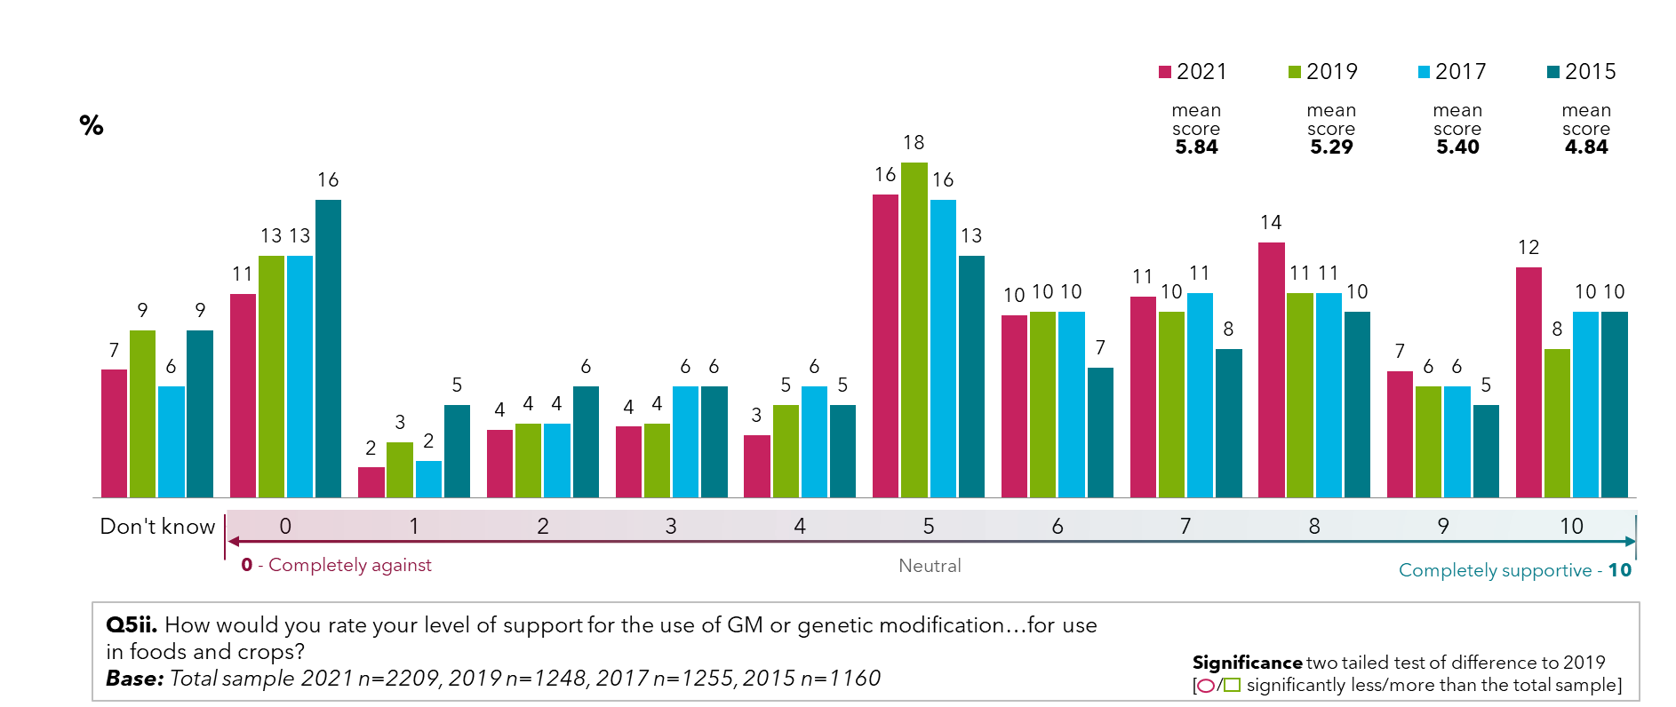

Males surveyed are both more supportive of genetic modification and less unsupportive of genetic modification for use in food and crops than females. 39% of males rated their support very high at levels of 7-10 out of 10, compared with only 26% of women. Women are more likely to be unsure of whether or not they support genetic modification for use in food and crops (8% compared to 5% for males) or sitting in the middle (19% compared to 14%).

Figure : Support for the use of genetic modification in food and crops – (2021)

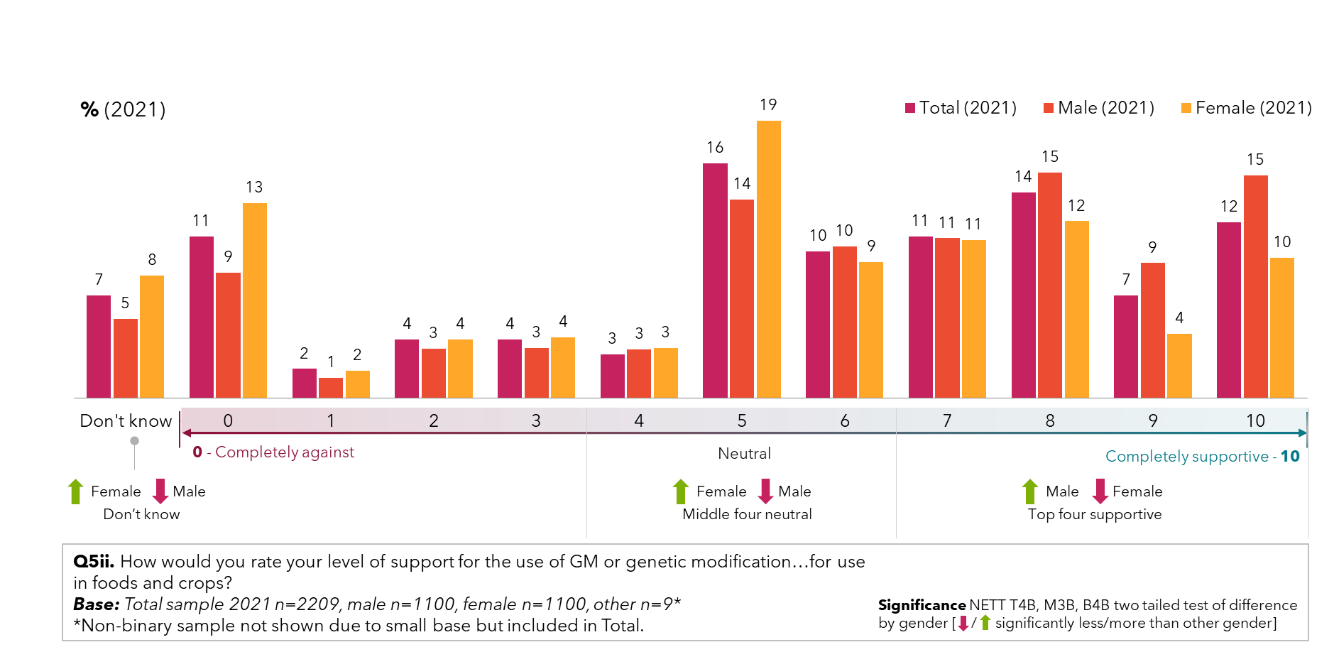

Confidence in food containing preservatives has risen statistically significantly from 30% in 2019 to 34% in 2020. When it comes to consuming organic food and food grown with pesticides, 28% would be very willing to consume them Organic food was still, by far, the most accepted food surveyed, at 57% in 2021.

Though there are no statistically significant shifts in confidence for foods grown with pesticides or processed foods, 36% surveyed report high willingness to eat processed breads and soy milk from genetic modification crops and meat/animal products fed with genetic modification stock feed.

There are no statistically significant shifts in confidence for most of the above products, although willingness to eat processed foods increased to 37%, significantly higher than the 31% of people willing to eat them in 2019.

36% of Australians surveyed reported a high willingness to consume processed cakes/biscuits with small genetically modified ingredients, and 35% were highly willing to consume genetically modified fruits and vegetables.

Figure : Willingness to eat genetic modification food – by year

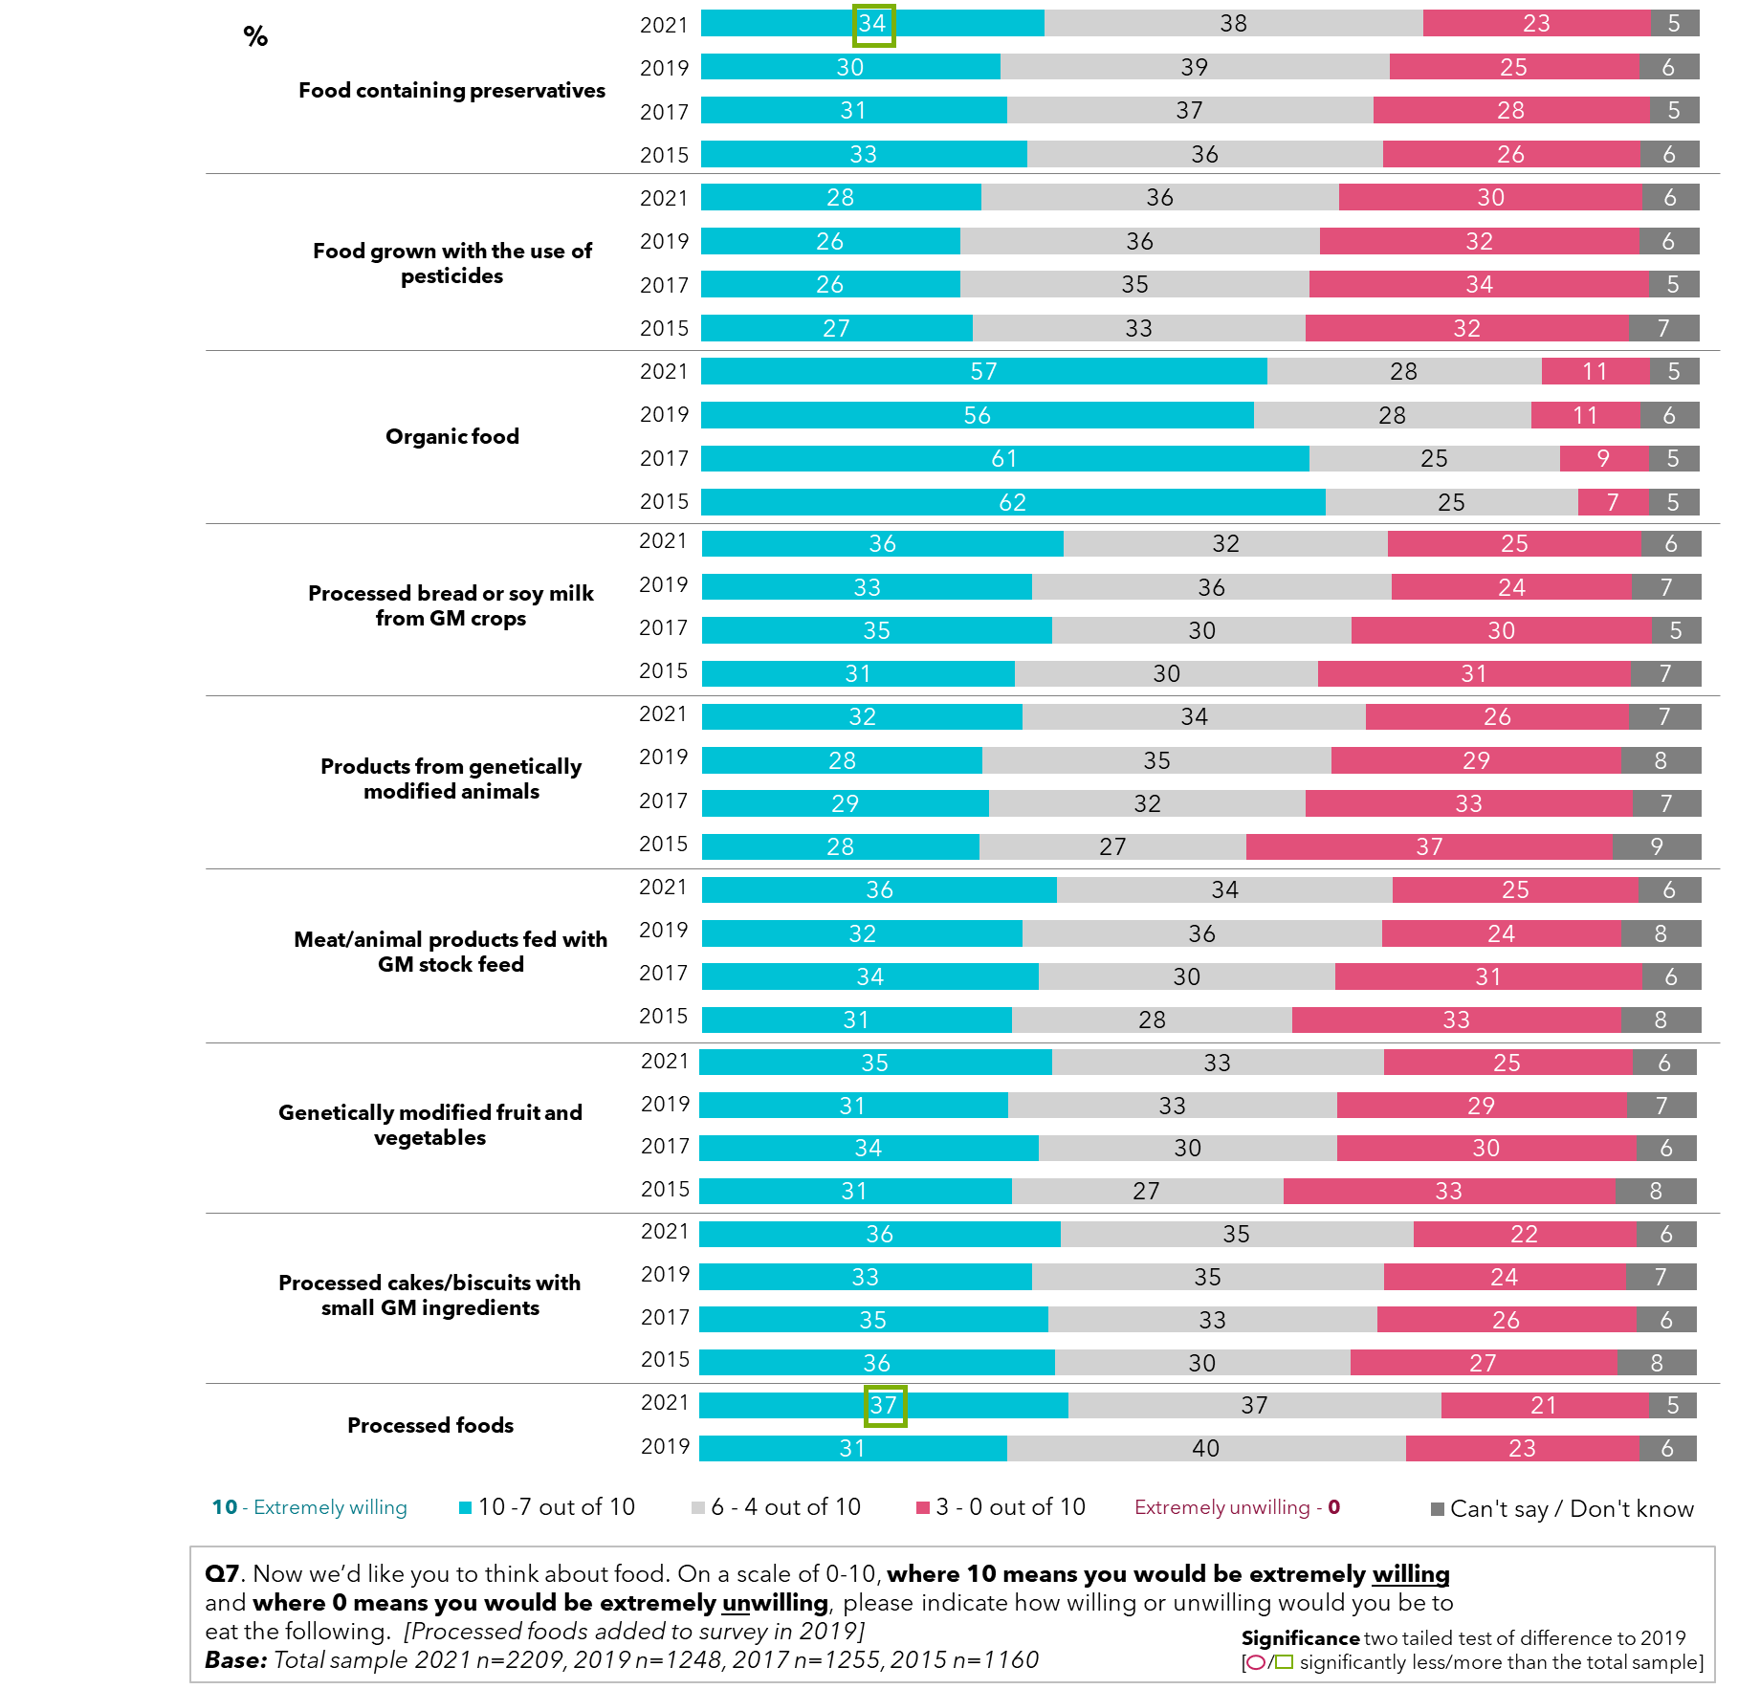

Young people aged 16 to 30 are significantly more willing to consume a range of modified foods, including foods containing preservatives (44% very willing) and foods grown with the use of pesticides, (36% very willing). In contrast only 26% and 21% respectively were willing to eat these for people aged 51-75 years.

Notably, when it comes to processed and genetically modified foods, people aged 16-30 are far more willing to consume them. For processed bread and soy, 42% of young people are very willing to consume them, and this only slightly decreases to 38% when considering consuming products from genetically modified animals. Again, willingness decreases consistently as we look at older age groups.

The trend of younger people having greater confidence in modified foods in 2021 continues when looking at genetically modified fruit and vegetables and processed cakes/biscuits with a small amount of genetically modified ingredients. When it comes to processed foods in general, almost half of people aged 16-30 would be very willing to consume them (47%), compared with 39% of people aged 31-50, and 28% of people aged 51-75.

Figure : Willingness to eat genetic modification food – by age (2021)

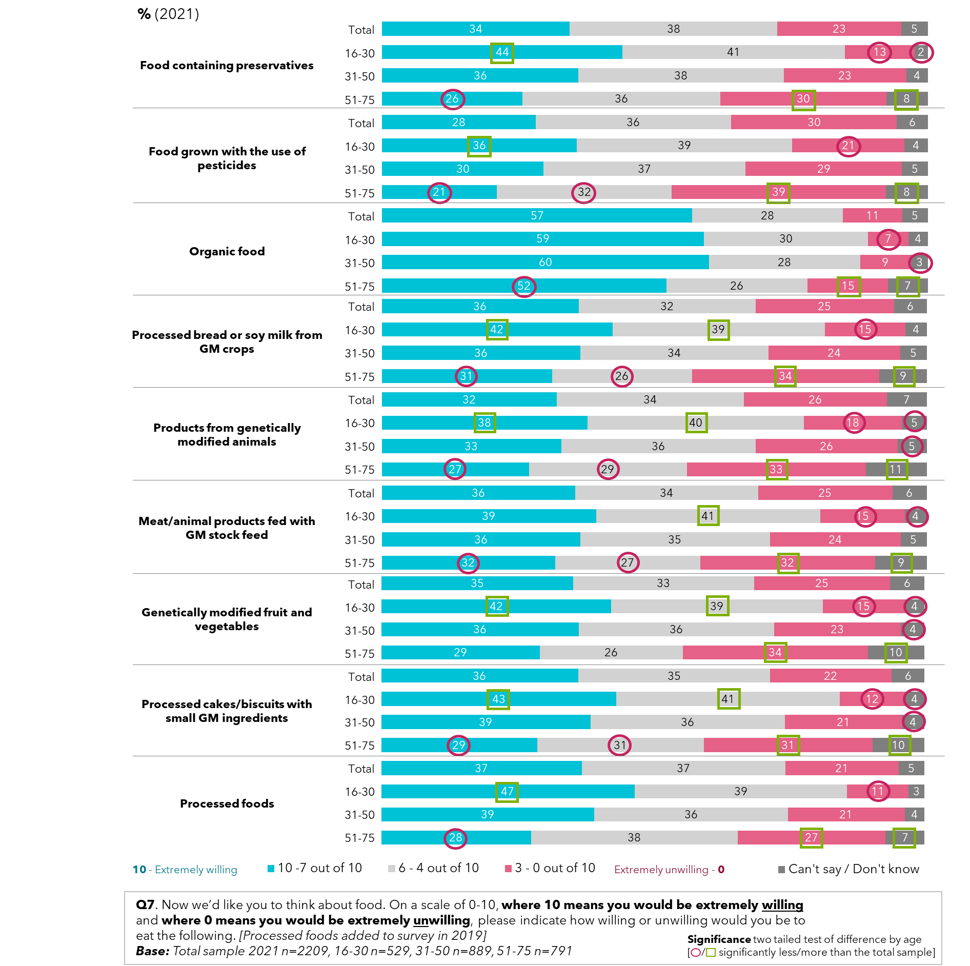

Males surveyed in 2021 were significantly more willing to consume modified foods than women, across genetically modified foods, foods with preservatives, and processed foods. Confidence in organic food was the highest for all surveyed, with 57% of all surveyed very willing to consume it.

Figure : Willingness to eat genetic modification food – by gender (2021)

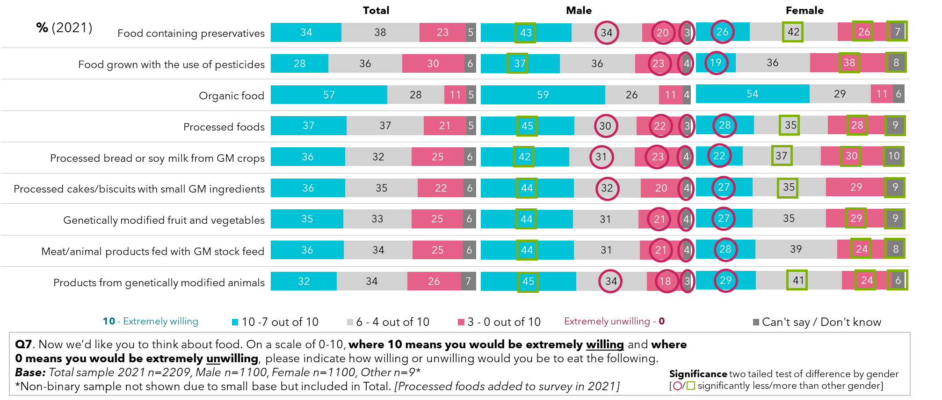

Between states, there were no statistically significant differences in willingness to eat foods such as those containing preservatives, grown with the use of pesticides, genetically modified or processed foods.

There was an overall greater concern about foods grown with pesticides than any other food type surveyed, including all types of genetically modified foods.

Willingness to consume modified foods does not vary significantly between residents of capital cities and those living outside of them, with slight preferences over some forms of modification over others in each areas. The exception to this is that residents of capital cities are more willing to consume meat and animal products fed with genetically modified stock feed than residents outside capital cities.

Since 2019, there has been a significant shift towards survey respondents finding modification of plant genes acceptable for the purpose of producing food. 38% of people surveyed now strongly feel this is acceptable, up from 30% in 2015 and 2019, and only 19% are strongly against the idea, down from 28% of people in 2015.

Figure : Attitudes towards modifying genes of plants to produce food – by year

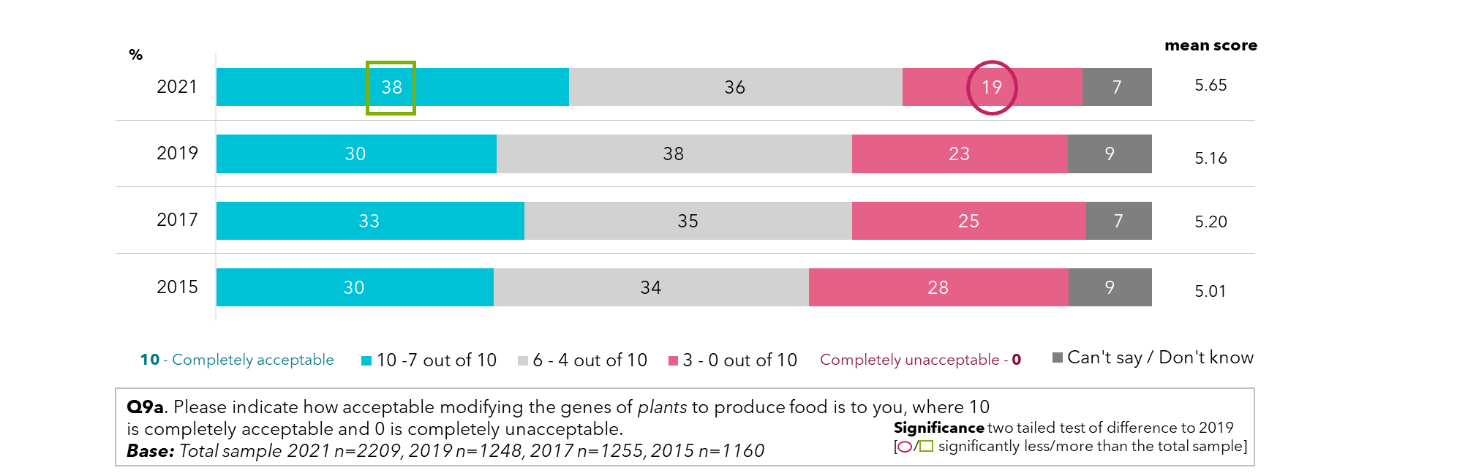

When exploring views by age group, younger people again expressed greater confidence in gene modification for the production of food than older people surveyed. Over 4 in 10 people aged 50 or younger feel it is very appropriate to modify genes of plants to produce food, with a confidence rating of 7-10 out of 10.

Figure : Attitudes towards modifying plant genes to produce food (2021)

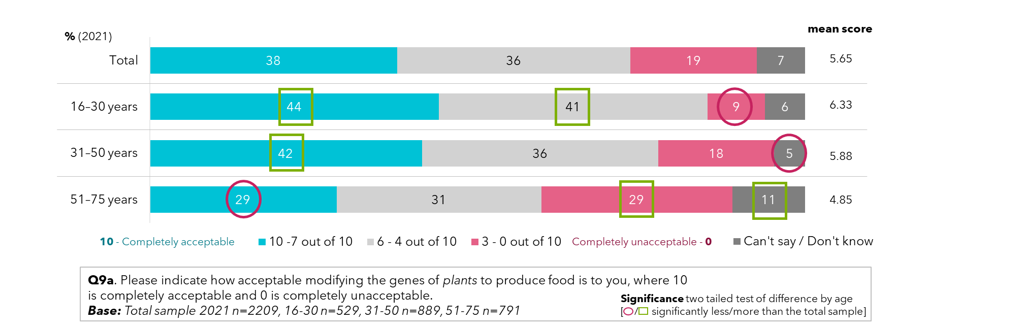

Almost half of the male population surveyed say they find genetic modification very acceptable for food production (46%), while less than a third of females (29%) agree, as well as stating they are more likely to feel indecisive or unsure about the use of genetic modification for food production.

Figure : Attitudes towards modifying plants genes to produce food – by gender

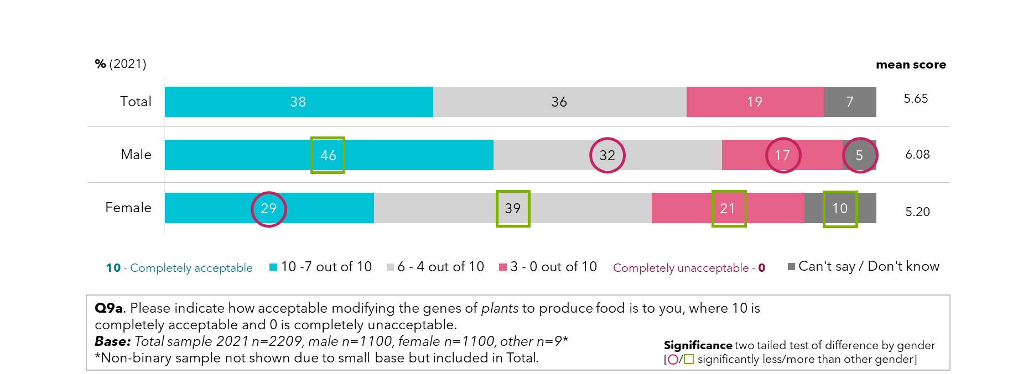

77% of people surveyed have at least some concern about genetically modified foods and crops. Males and those aged between 16 and 30 are significantly more likely not to be concerned. The COVID-19 pandemic has increased these concerns for 27% of people surveyed. Almost half of 16 to 30 year-olds (47%) reported their views being influenced by the pandemic, with over a third saying it has increased their concerns of genetic modification, yet their support remains higher than previous studies across most indicators, and concerns overall are at a lower level than any other age group. For females, only 5% attributed a decrease in concern about genetically modified products to COVID-19 whereas it is 13% for males.

Figure : Concern over genetic modification of foods and crops - by gender and age (2021)

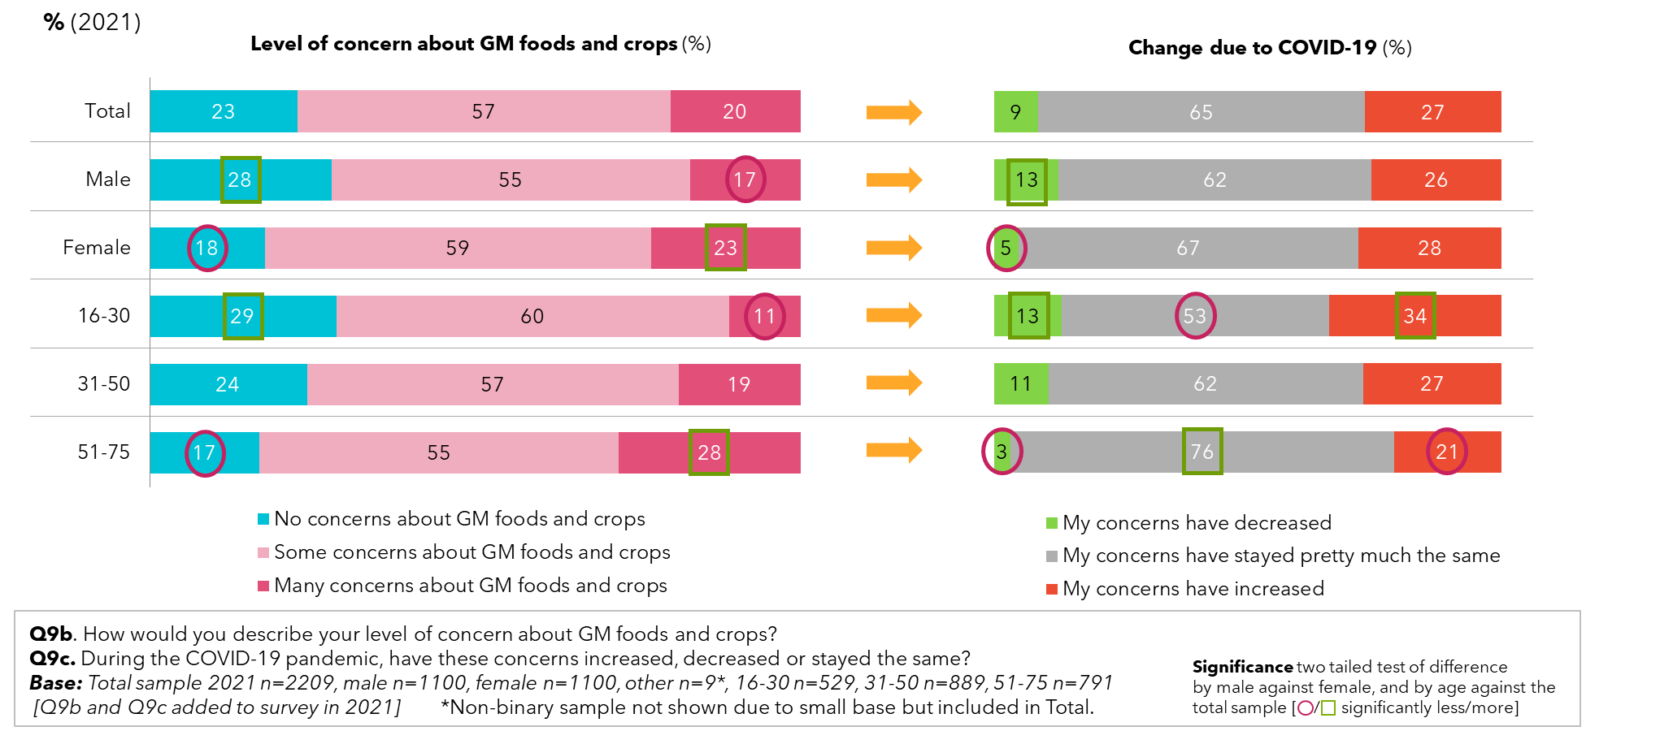

In general, the more radical the genetic modification the less support it will have. Introducing new genes to a plant from a plant of the same species has reasonable levels of support at 44%. This is a statistically significant change since 2019 when it was 36%. But introducing genes from a different species, was supported by only 35% - but this is also a statistically significant change since 2019 when it was 29%.

‘Switching on’ or ‘off’ genes is strongly supported by 37% of people surveyed. Less so is the introduction of genes from bacteria (27%) or animals (26%).

Figure : Attitudes towards genetic modification in food production – by year

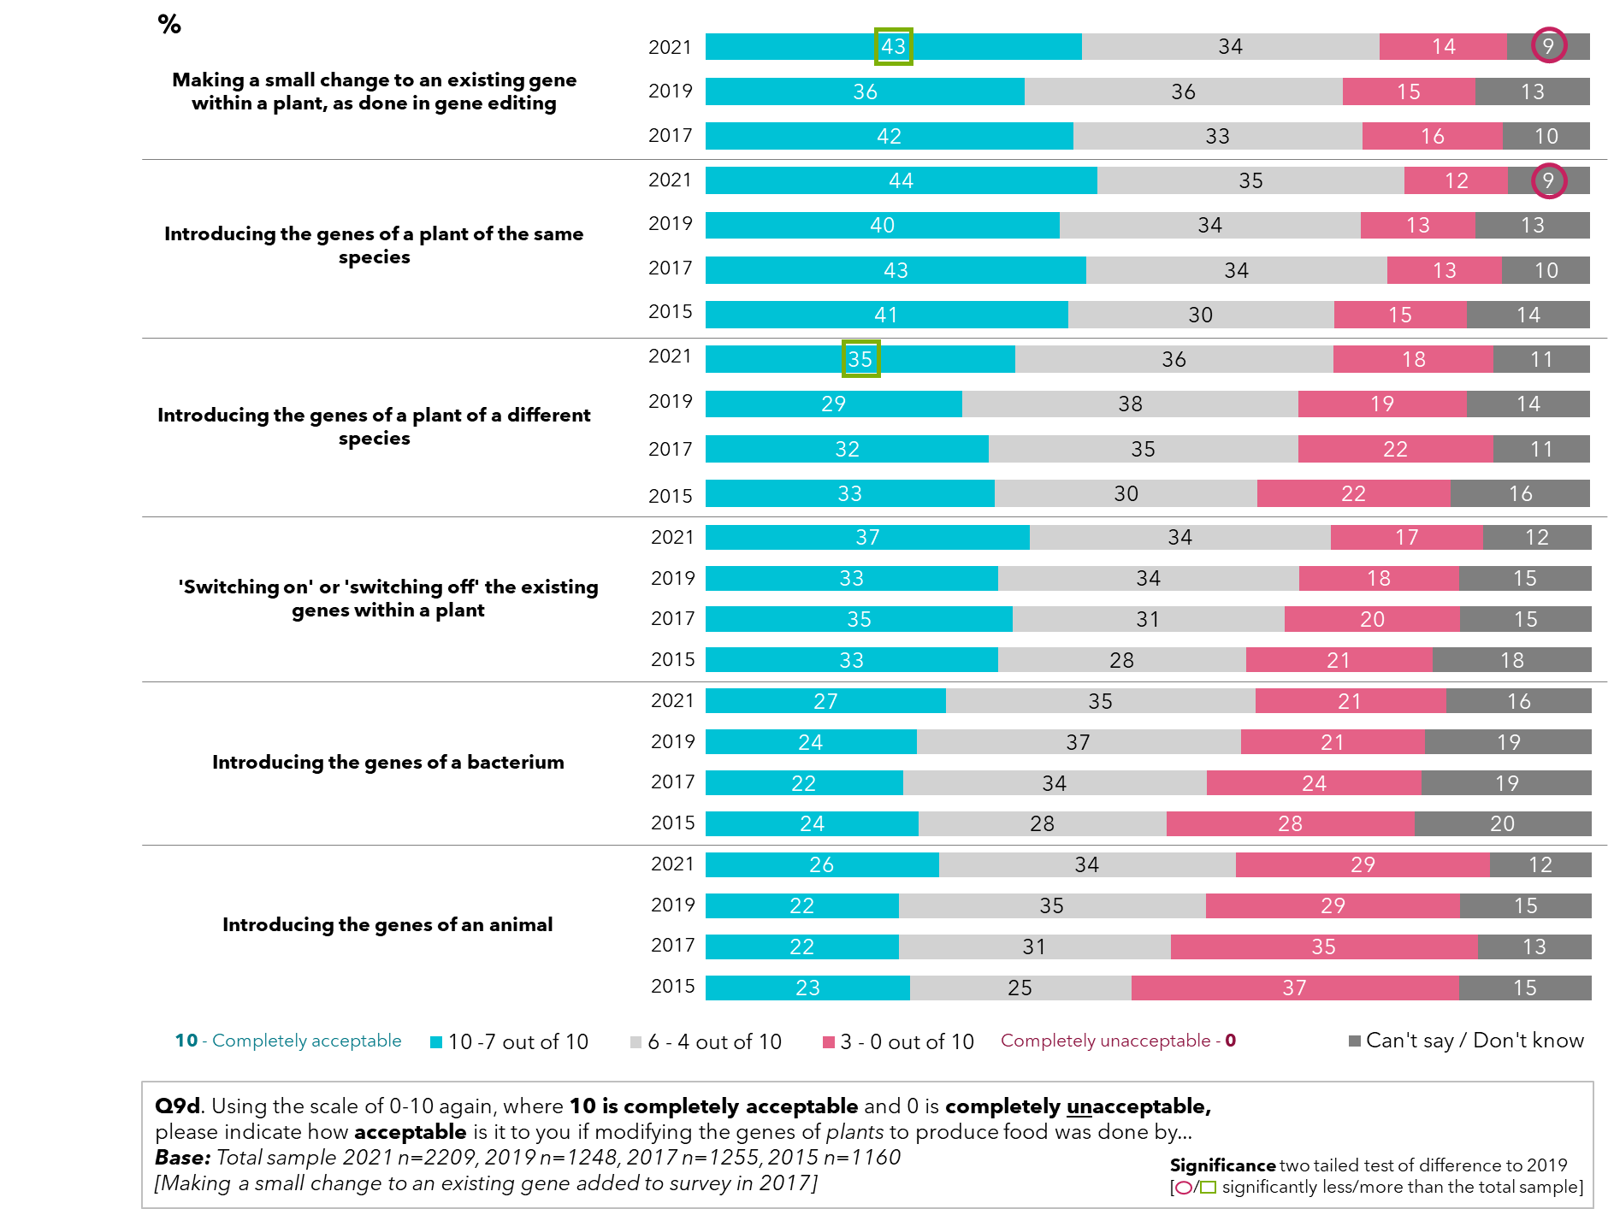

## Perceptions of types of genetic modification crops grown across Australia

Approximately a third of the Australian adult population believe genetically modified crops are allowed to be grown in the state/territory they reside in. Among those that believe it is allowed, canola and cotton are well recognised as genetically modified crops, yet several other crops, not yet commercially available in Australia, were mentioned without prompting, such as wheat (still in the trial phase of genetic modification research) and corn. This perception most likely comes from international stories about genetic modification, indicating that genetic modification news has a low and undistinguished awareness amongst many people rather than a more detailed awareness.

Figure : Awareness of genetic modification crops being grown in their state/territory

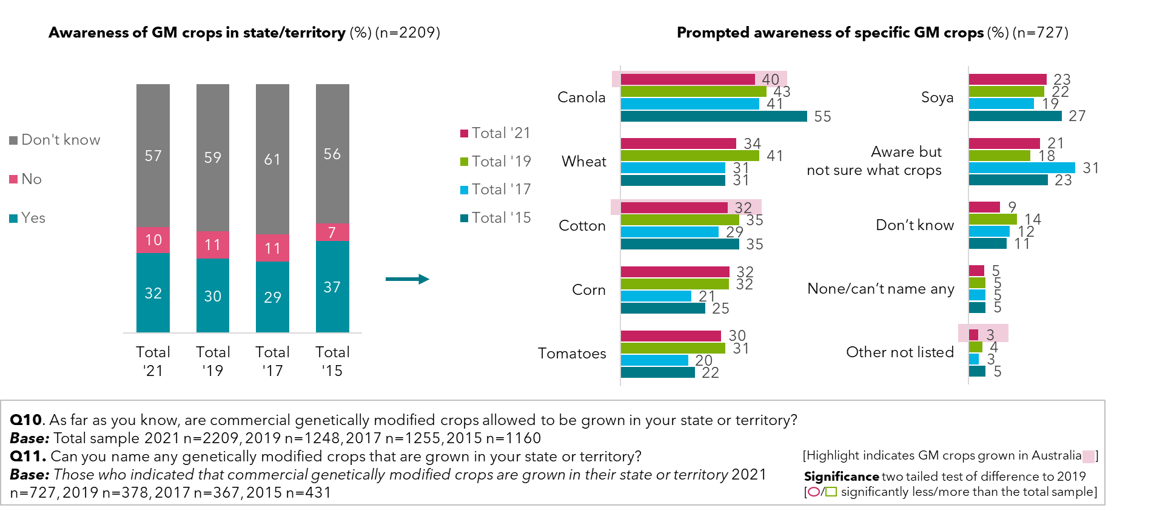

Across the states and territories, the proportion of people who feel genetically modified crops are allowed to be grown follow a similar pattern; most people report being unsure if the regulations allow genetically modified crops in their state, followed by a fifth to a third believing it is allowed, and finally, a minority thinking it is banned. This awareness does not appear to be influenced by the actual state-wide regulations in place. Again, supporting only a general soft awareness of genetic modification issues.

Figure : Awareness of genetic modification crops in state/territory – by state (2021)

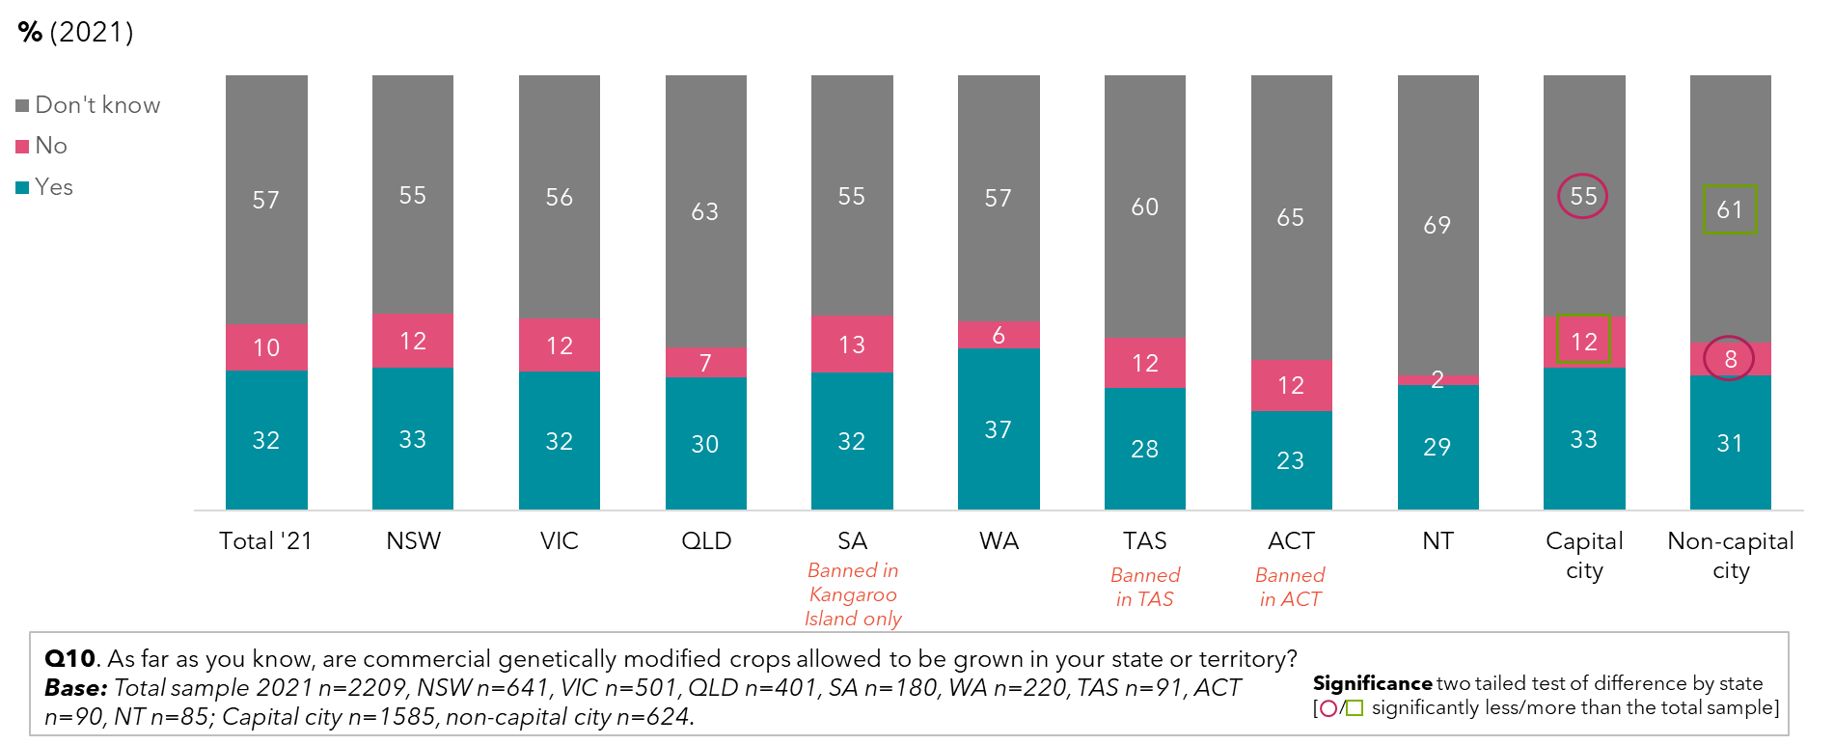

The knowledge gap is high across the country in terms of what genetically modified crops are grown in each state and territory. Queenslanders are significantly more likely to say they know genetically modified crops are allowed to be grown, but that they aren’t sure which ones they are.

Figure : Prompted awareness of specific genetic modification crops – by state (2021)

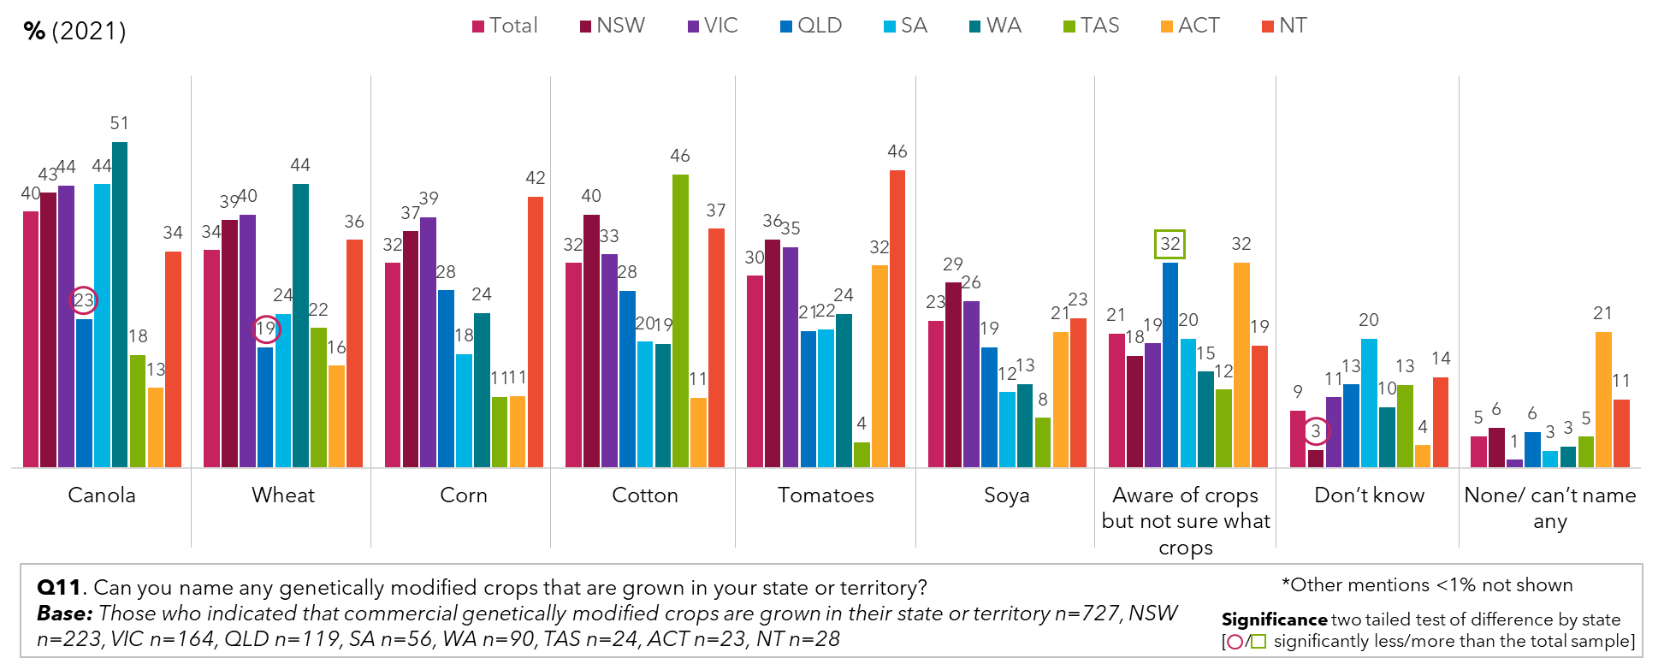

## Attitudes to genetically modified crops and genetic modification technology in food production

There is no significant difference in attitudes towards growing genetically modified crops across the states and territories of Australia. Nor are there significant differences between residents of capital cities and those outside of capital cities. However, Northern Territorians are most supportive of genetically modified crops in their territory, with 1 in 2 in favour (52%).

Of interest, in all states and territories except South Australia, more people were in favour of growing genetic modification crops in their state or territory.

Figure : Attitudes towards growing genetic modification crops in state/territory – by year, state and capital city and non-capital city

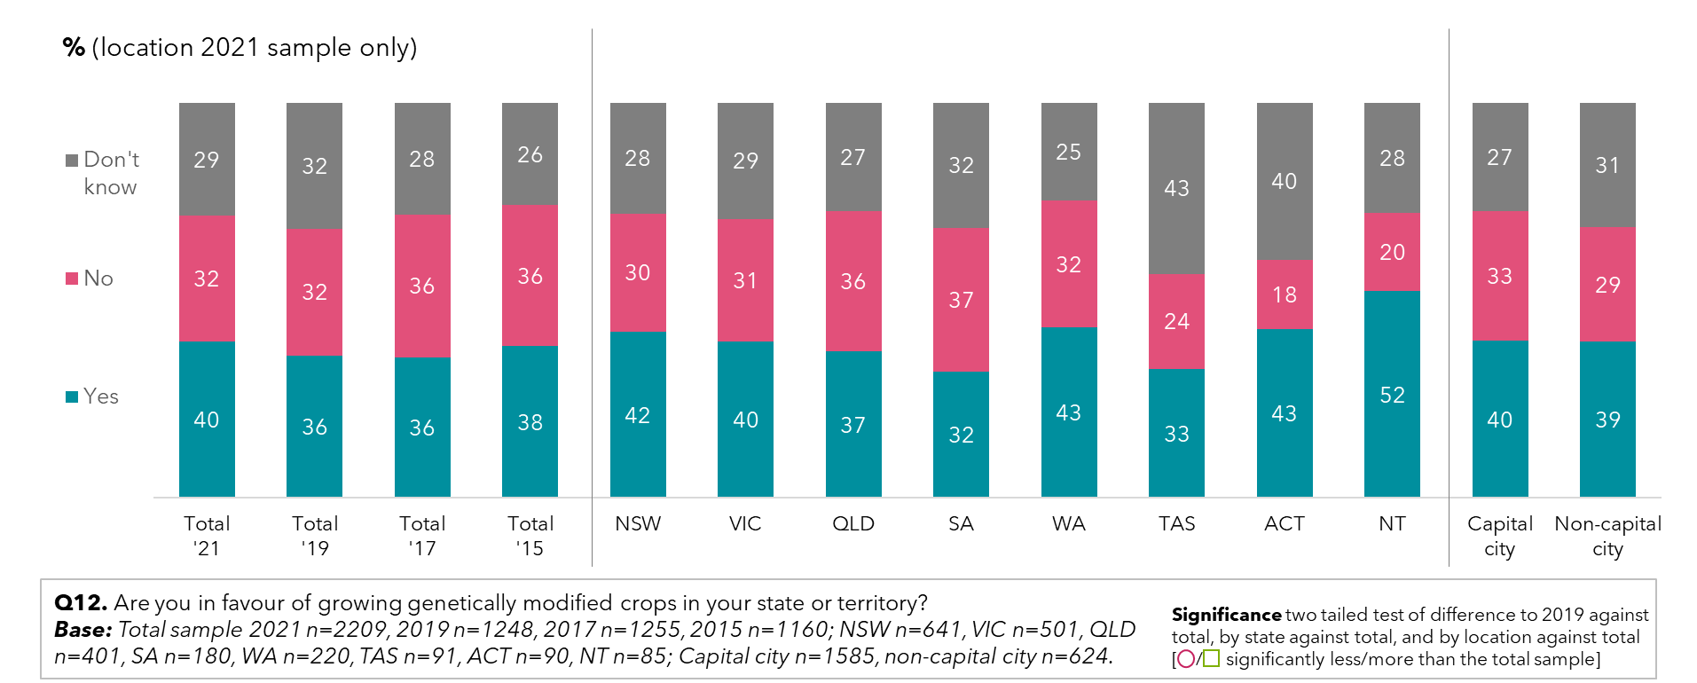

Of those unsupportive of genetically modified crops in their state, or unsure, there is support for genetic modification if given reassurance of stringent regulations and evidence of the benefits of modifying crops. The factor that would influence this support the most was learning of potential positive benefits for human health of genetically modified crops.

In general, support was significantly higher within residents that live outside Australian capital cities in regional areas than those in capital cities.

Figure : Support for genetic modification crops if given reassurance – by capital city and non-capital city

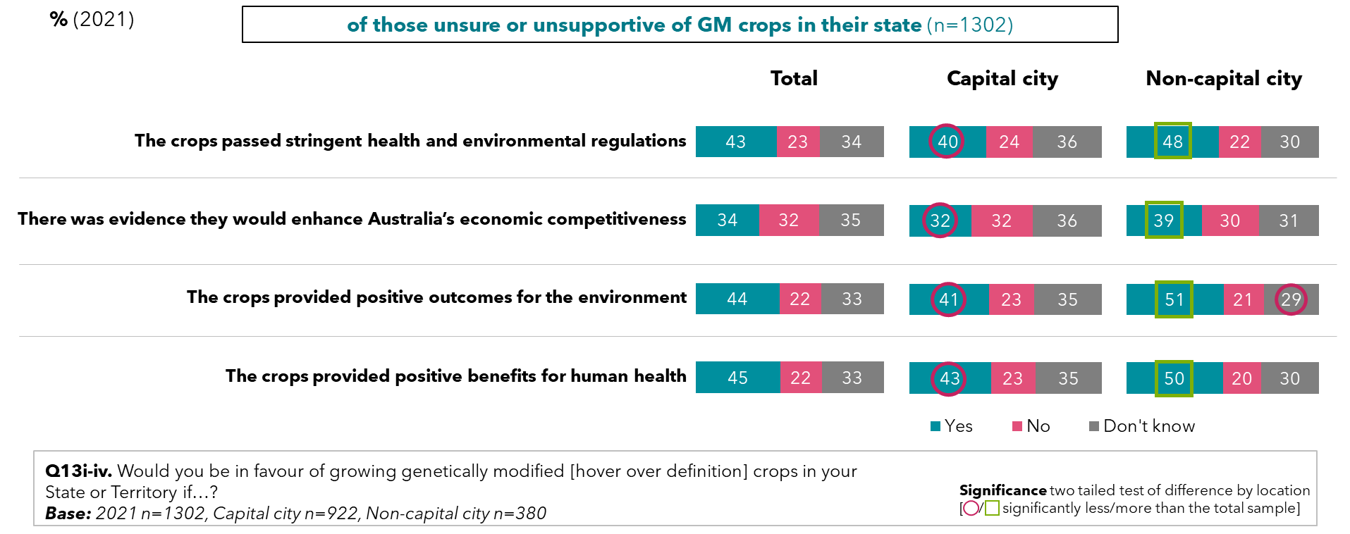

Compared with previous years, there is less concern in 2021 about genetically modified crops being grown in their state, if passed stringent health and environmental impacts (down 6%).. In 2021, 45% felt that genetically modified crops provided positive benefits for human health, and fewer people were unsure how they felt.

Figure : Support for genetic modification crops if given reassurance – by year

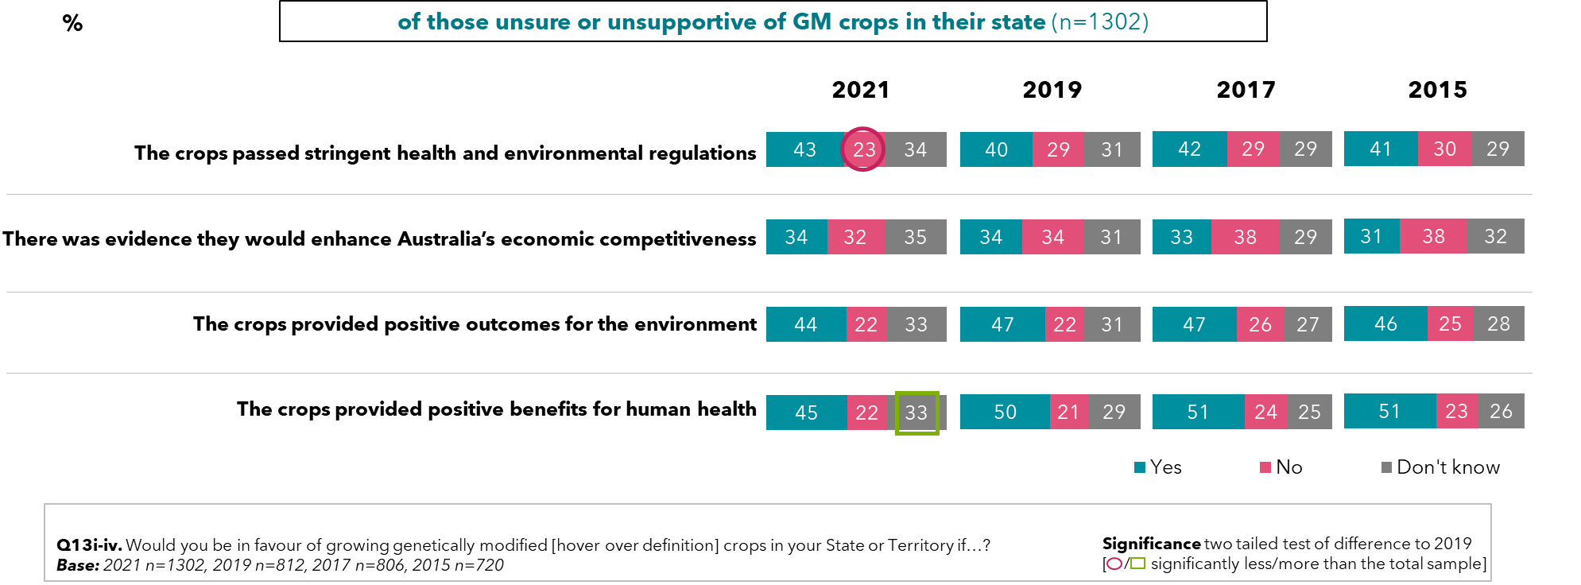

70% of adult Australians are supportive of using genetically modified technology to produce food, although 1 in 2 people require reassurance before being satisfied that it is safe (52%).

Figure : Public opinion on using genetic modification technology to produce food – by year

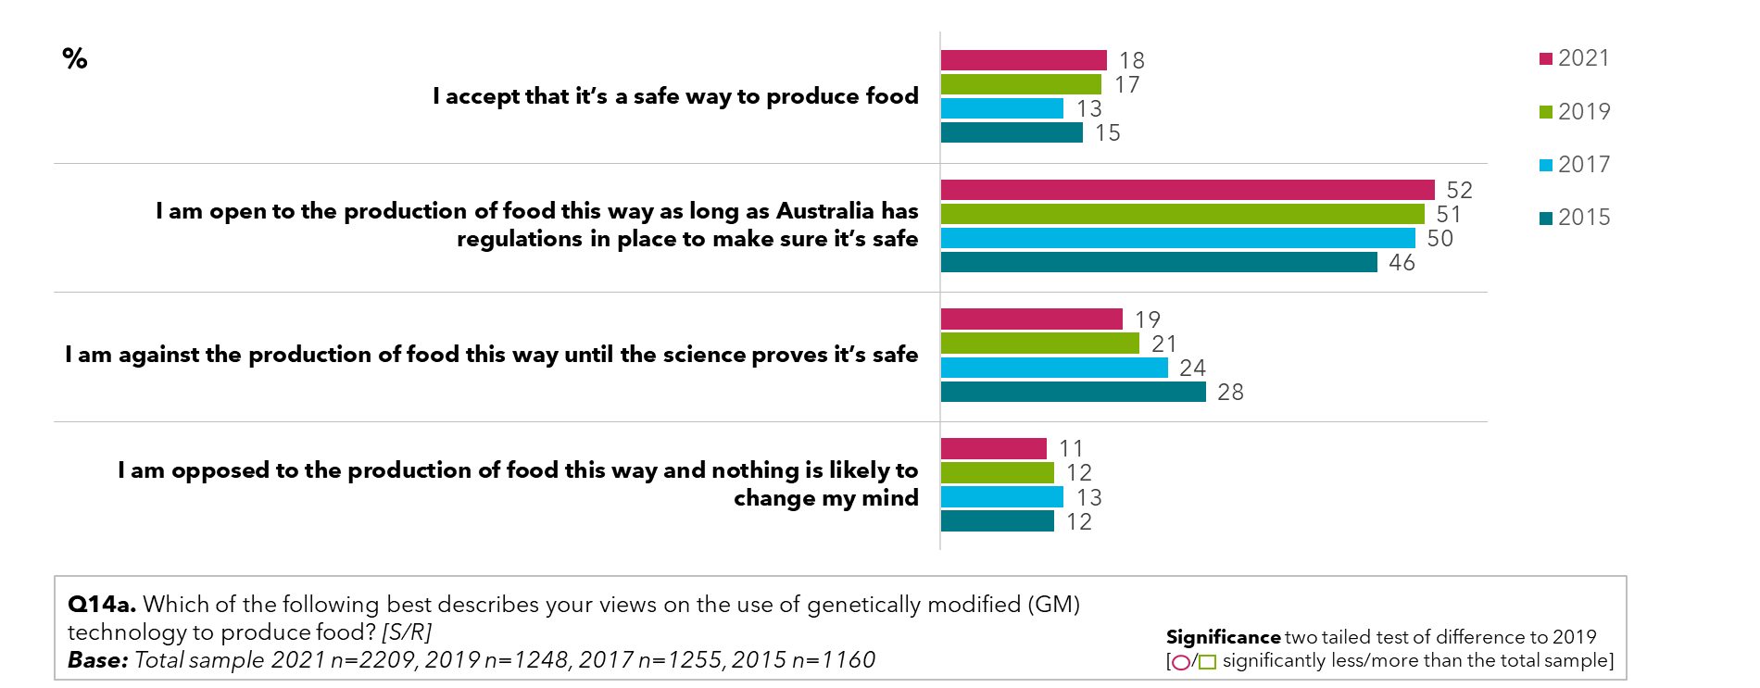

When prompted to consider why they support genetically modified technologies to produce food, adult Australians cited an understanding and belief that the use of genetic modification can improve crops led to their support (28%). Furthermore, support is garnered when genetic modification technology is seen to produce food that is safe (13%), is healthy (12%) and is sustainable in terms of long-term production and looking after the environment. Some common responses were:

* *“Changing the structure of the genome doesn't "change" the food. The DNA of the food consumed doesn't alter our DNA from just from eating it.”*
* *“It gives us an opportunity to help our society when in need or also help other countries when they are in need.”*
* *“It's the logical future of utilizing technological advances in order to more sustainably feed the world.”*
* *“I trust the science behind it.”*
* *“More efficient therefore potential to increase yields, decrease environmental footprint, potentially increase health benefits of food.”*
* *“In agricultural production, in order to improve weed control and prevent plants from pests and diseases, transgenic technology has been applied to crops.”*
* *“We have been using genetically modified technologies to produce food for a very long time… This is not well known but has been much safer to use than pesticides.”*
* *“I believe it will produce more drought tolerant ingredients making the cost of foods less both environmentally and financially.”*

Figure : Reasons for favouring the use of genetic modification technology to produce food – 2021 sample supportive of genetic modification food production

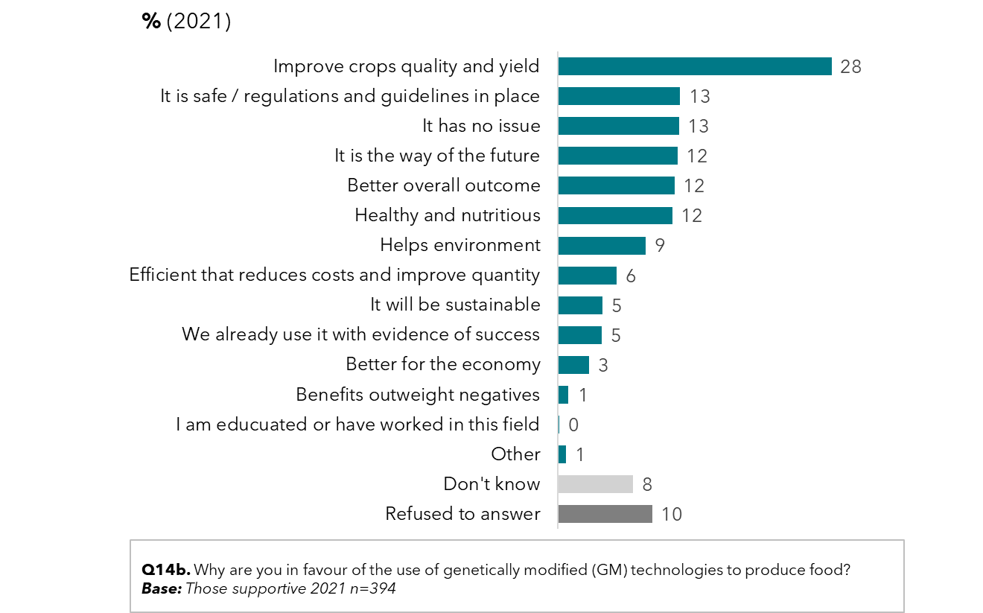

Amongst sceptics of using genetically modified technologies for food production, the most reported reason for mistrust is the belief that humans should not intervene with nature. There is also concern about potential health issues and concerns over long-term side effects. For some, it is a lack of knowledge about genetic modification and how it is used.

Some common reasons for opposing genetic modification for food production were:

* *“It is playing with nature and there are always unintended consequences.”*
* *“Because we have not seen the outcome of these changes over a long period of time, will it be safe in 100 years in the future and how will it affect people that have been eating these crops, or how will it affect pests that eat these crops?”*
* *“It causes cancer.”*
* *“I think wheat has been changed and this leads to obesity. genetic modification is not tested and could have side effects and health implications.”*
* *“genetic modification foods are owned and controlled by Big Pharma and can only be germinated by them. This is making it impossible for people to grow their own food eventually. Control the food and control the people.”*

Figure : Reasons for opposing the use of genetic modification technology to produce food – 2021 sample opposed to genetic modification food production

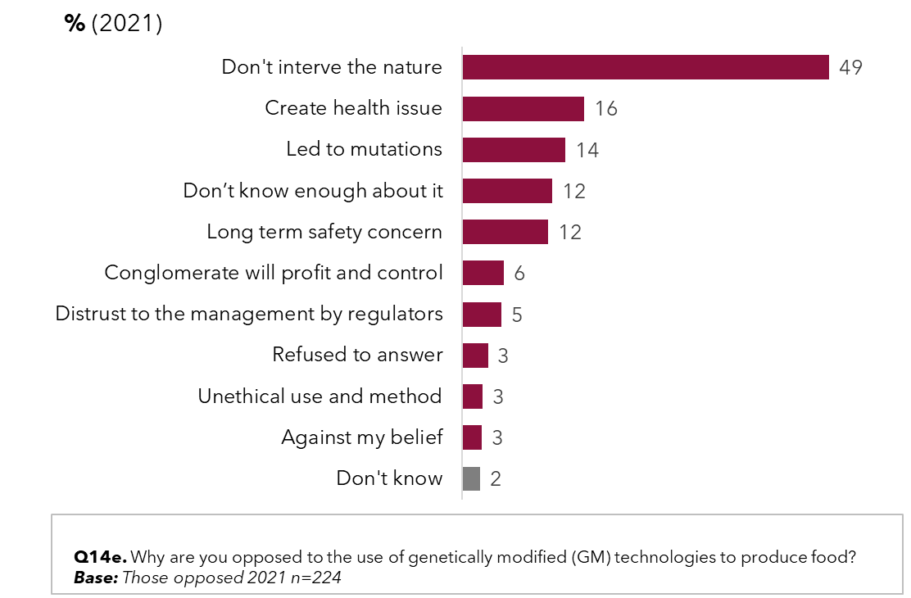

Drought resistance, healthier food and pest resistance are seen as the top 3 benefits of genetic modification of plants to produce food. Over 70% of people see each of these factors as valuable in the discussion around genetic modification. Other benefits of genetic modification were seen as cheaper food, removing allergens and longer-lasting food.

Figure : Value placed on various genetic modification outcomes and goals (2021)

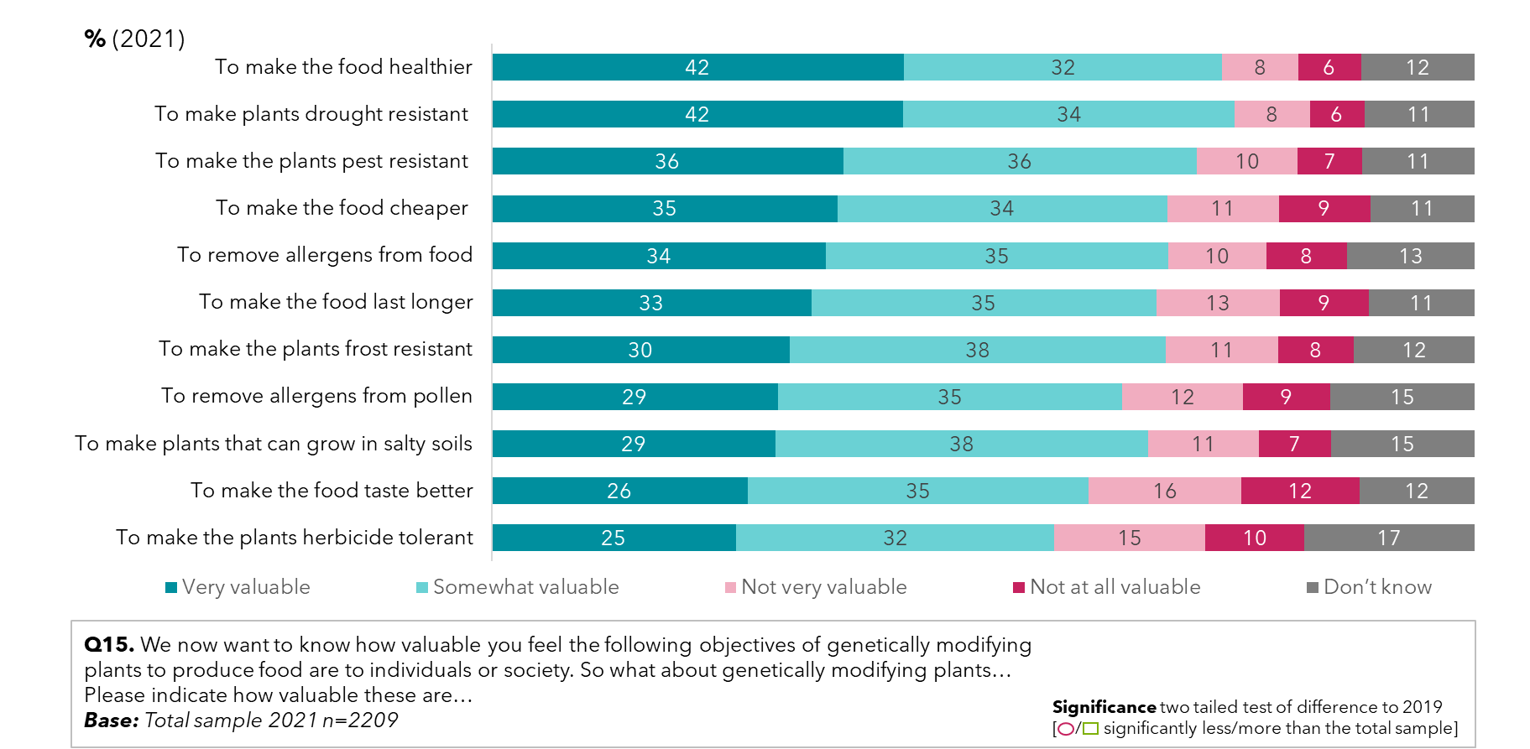

When it comes to the most valued objectives of plant gene modification for food production, attitudes have remained largely unchanged since 2015.

Figure : Value placed on various genetic modification outcomes and goals – by year

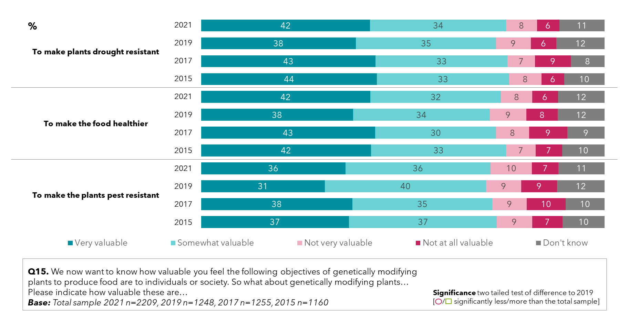

Support the use of genetic modification for industrial and therapeutic uses is high, particularly if there are regulations in place to make sure it is safe, of which 77% of people surveyed are supportive. In differentiating the two uses in 2021, genetic modification for industrial uses was seen as safe by 24%, and genetic modification for therapeutic uses was seen as safe by 20% of people surveyed.

Figure : Attitudes to genetic modification for industrial or therapeutic uses – by year

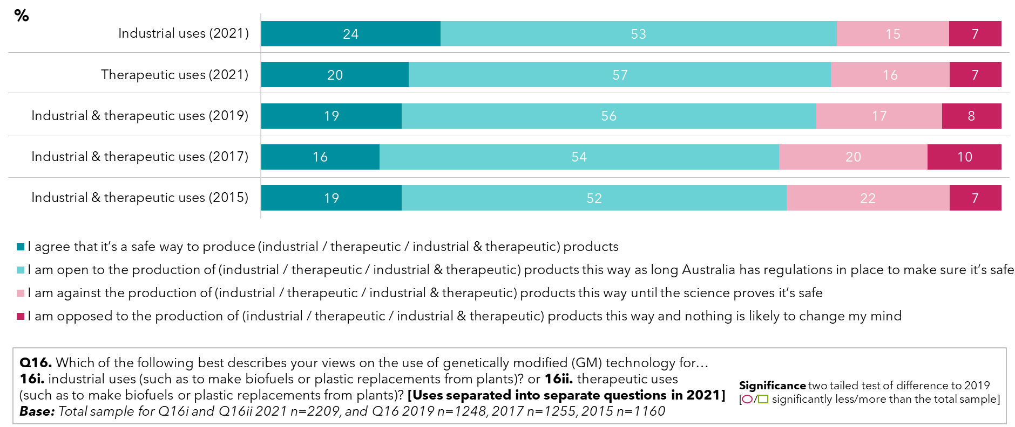

## What does the community want to know about genetic modification and where is the information coming from?

Of those supportive of genetic modification but seeking reassurance from the regulator that the technology is safe to produce food, information on potential negative health consequences were the primary concern. Clearer information was also mentioned as a helpful way to communicate that genetic modification technologies are safe to produce food. Specific information that would reassure includes:

* *“Checking on progress, updates on checks, reports to show health and economic benefits, proved independence from the regulator.”*
* *“Honest reporting not sensationalized by the media, long term trial before given to the public.”*
* *“Whether there are backups of non-genetically modified plants or animals, for example seeds of original plants stored safely in case problems or negative impacts of modified plants are detected in the future.”*
* *“That they will not harm humans that consume them, and that the nutrients levels are the same as normal food, as our bodies need proper nutrition, especially children”*
* *“Substantial Equivalence of Genetically-Modified Foods in addition to long-term accumulated experience, the latest science and technology must also be used to evaluate the safety of food we eat every day.”*

Figure : Regulator reassurance to increase support for genetic modification food production – by 2021 sample supportive but seeking regulator assurance to reassure genetic modification technologies are safe (2021)

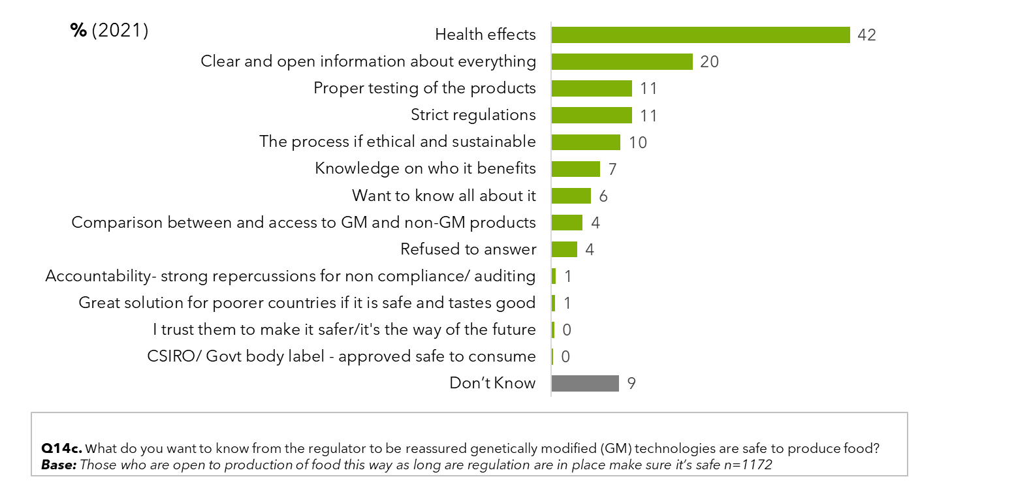

Of genetic modification sceptics surveyed, if evidence of the safety of genetic modification was provided in a scientific, clear manner, they may become supportive of the technology for food production. Clear, open information and transparency may help to reduce concerns such as:

* *“Valid independence scientific researchers that are not paid by any parties involved in manufacturing, production, distribution, marketing and funding the genetic modification technologies to produce food. i.e. trustworthy science that is free from conflicts of interests.”*
* *“Many countries still ban genetic modification foods and the science community is still not fully in agreement, so until it is proven completely safe I am wary.”*
* *“Whether modified crops have any unintended side effects when consumed, whether they may impact other crops or affect farmers in negative ways.”*
* *“Who the scientists are, their qualifications, and who is paying for the research. And then that the research is done over time, is thorough, and considers as many factors as possible.”*
* *“It is ‘playing’ with natural selection and natural development of life on earth, and we DON'T know what the long term effect on this planet will be.”*

Figure : Scientific reassurance to increase support for genetic modification food production – by 2021 sample unsupportive however seeking scientific reassurance that genetic modification technologies are safe (2021)

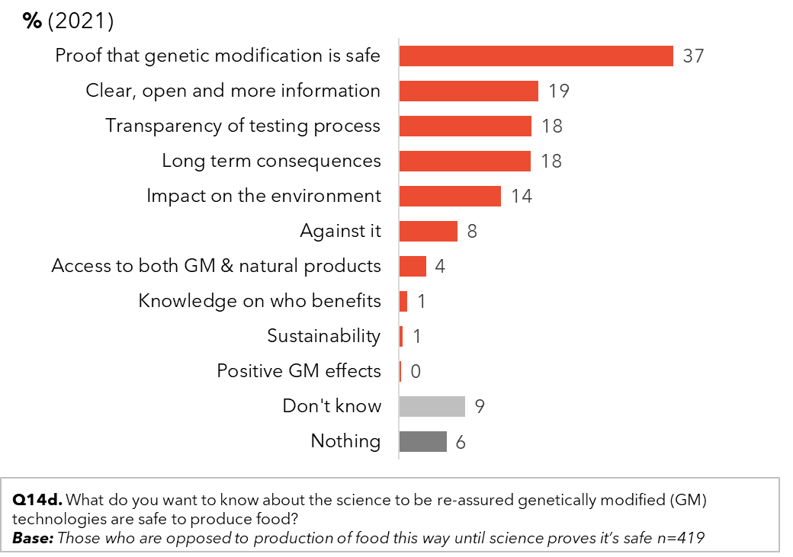

When asked where people get their information from, nearly half of the public list a general Google search as their source. Other information sources reportedly used are documentaries, news stories and current affairs shows on television – which collectively make the television the largest source of passive information. Online news sites (26%) and online stories (19%) – also generally passive information – outranked or equalled newspapers (19%). Since 2019, there has been a 9% increase in using Facebook as a source, and a 3% increase in learning of gene technology and similar technologies from friends and family.

Figure : Where the public get information about gene technology (2021)

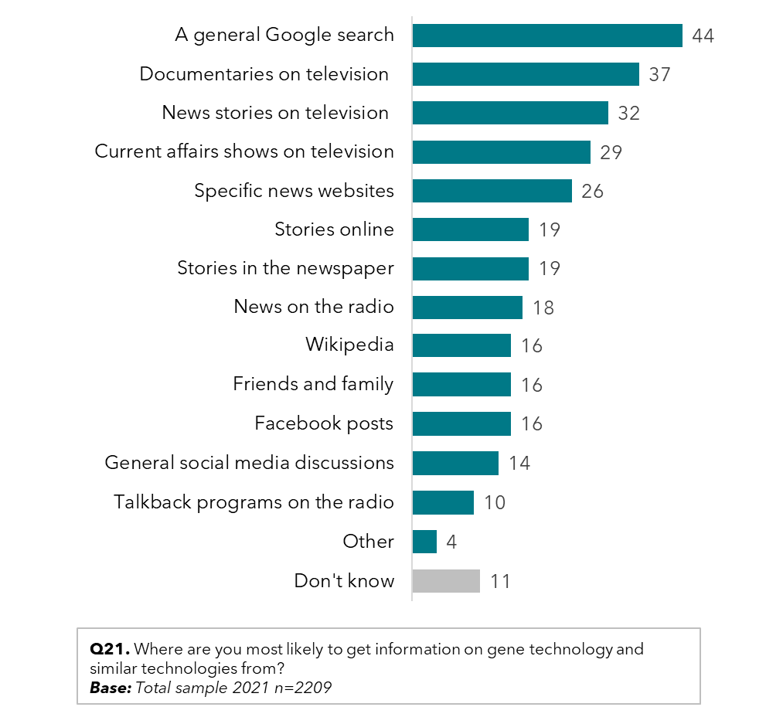

80% of the population surveyed reported trusting TV documentaries for gene technology information (20% of whom found them very trustworthy, and another 80% found them somewhat trustworthy). Varying news-related sources were at least somewhat trusted by over 65% of people surveyed, including news websites, news stories on television, and news on the radio, yet when it came to very trustworthy sources for information on gene technology, family and friends ranked higher than news sources (17% very trusted, compared with the next highest at 12-14%).

Despite this, family and friends were less cited sources of information on gene technology. Though current affair programs ranked lower in trust, they were reportedly used more frequently as sources of information on gene technology as well.

Figure : Trusted sources of information on gene technology (2021)

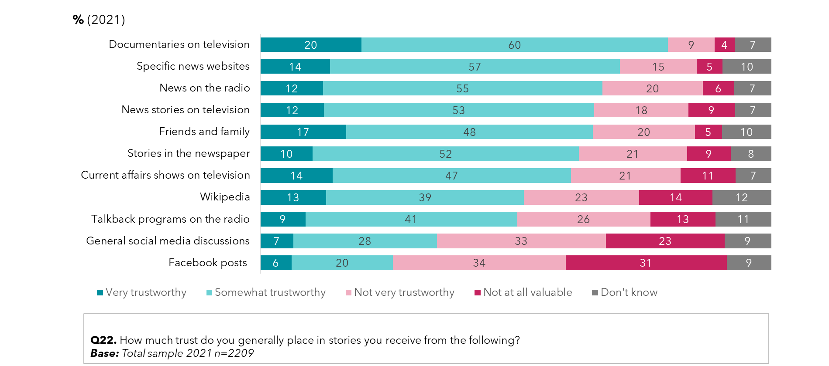

75% of people surveyed are concerned about fake news and misinformation (scoring concern 7 to10, out of 10), with 38% highly concerned (10 out of 10). A proportion feel unable to always identify fake news (27% rating their ability 0-5) and only 11% feel they are always able to identify if something is fake news / misinformation. 60% feel they are regularly exposed to fake news (scoring 7,8 9 or 10) and 20% feel they are always exposed.

Figure : Concerns regarding fake news and information

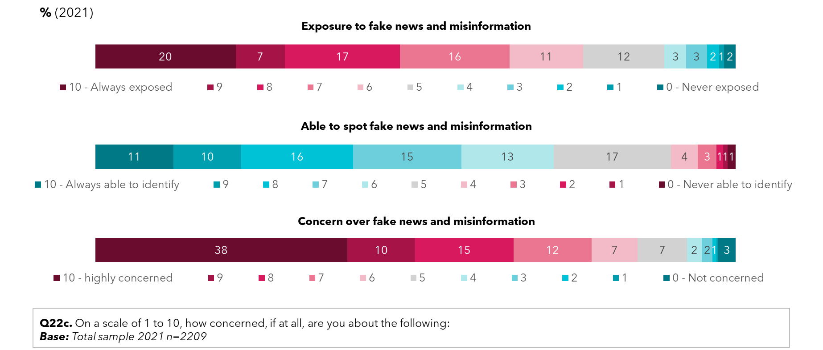

## Awareness and trust in organisations providing information about genetic modification

The Department of Agriculture, Food Standards Australia New Zealand (SANZ), the Department of Health and the CSIRO are among the top four organisations recognised by the general public as being responsible for genetic modification, recognised by over 30%. Awareness of OGTR was recognised by over a quarter of people surveyed (26%) when prompted. Awareness of the Therapeutic Goods Administration (TGA) improved significantly by 6% to 26% - which would be expected given its higher profile in COVID-19 vaccine stories. Fewer people reported not being aware if any of these organisations are responsible for genetic modification in Australia, down to 23% from 29% in 2019.

Figure : Prompted awareness of responsibility of organisations for regulation of gene technology– by year

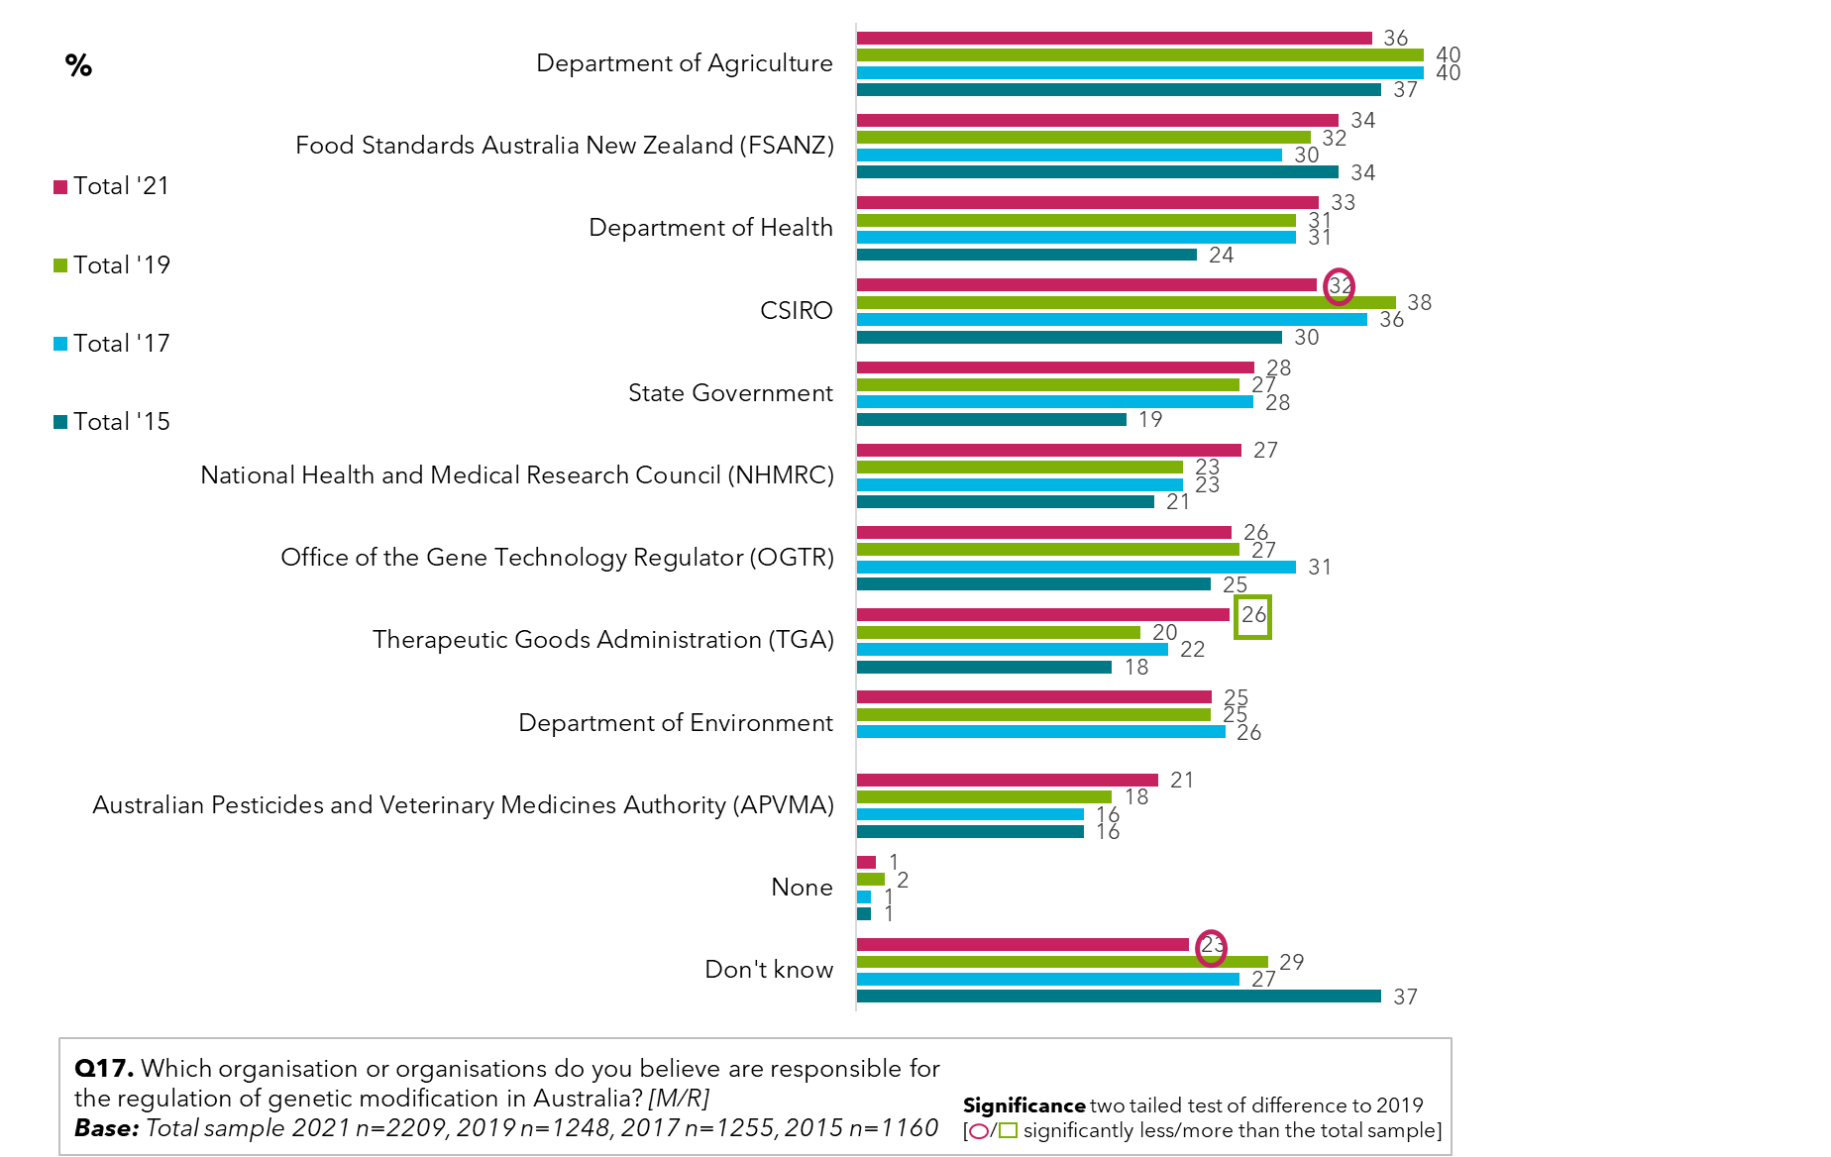

When prompted, in 2019, CSIRO was the most recognised organisation (80%), but in 2021 it has dropped to 72%, and the Department of Agriculture has overtaken it (78%). Awareness of the TGA and NHMRC have both improved significantly by 8% and 6% respectively since 2019, and prompted awareness of the OGTR is 15%.

Figure : Prompted awareness of organisations that are responsible for regulation of gene technology – by year

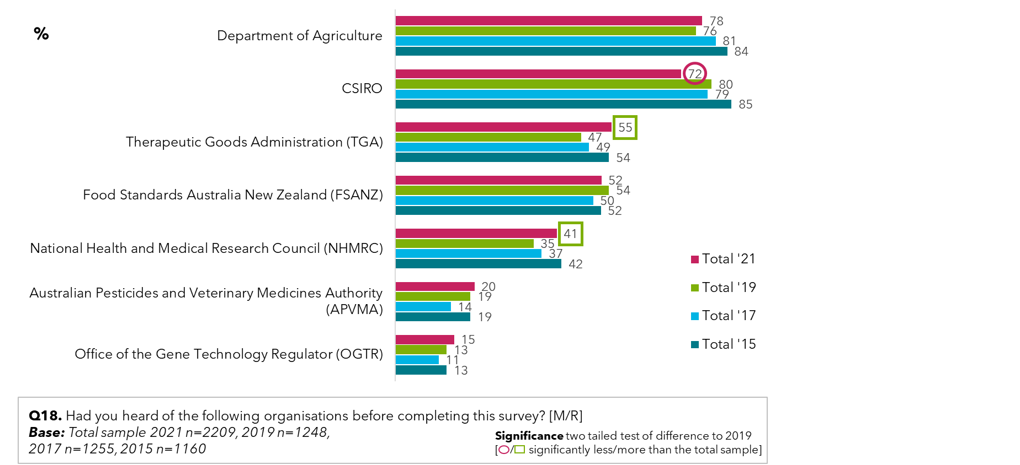

Trust in information from organisations about the risks and benefits of genetic modification or gene technology has improved significantly in 2021. Trust in the OGTR has jumped from 60% to 74%, the highest of any organisation prompted.

Although trust in organisations has risen significantly across the board, it remains lower for state-and territory governments and for the Commonwealth Government. The least trusted organisations are overseas regulators who are on average strongly mistrusted by almost a quarter of people surveyed (24%).

Figure : Levels of trust in what organisations say about gene technology (2021)

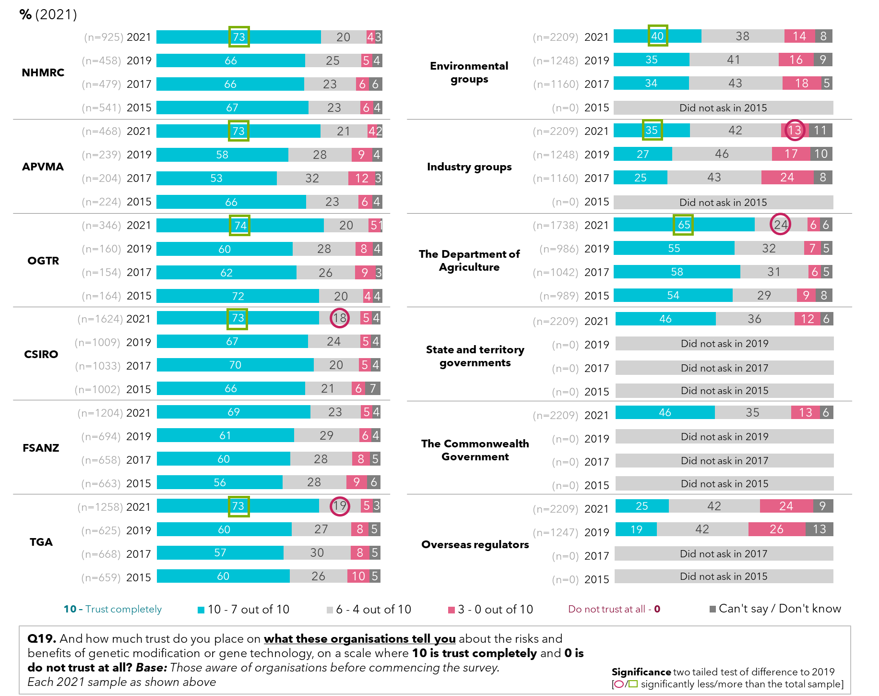

When it comes to agreeing whether the regulations the government sets in place over genetic modification and other biotechnologies are sufficiently stringent and are complied with, almost a quarter of people surveyed in 2021 were still somewhat unsure when it came to genetic modification for agriculture and food production (23% and 22% can’t say/ don’t know). Compared to 2019 though, significantly more people in 2021 did believe the rules that regulate the use of genetic modification are sufficiently rigorous (up 9 points to 40%) and complied with (up 9 points to 42%).

For genetic modification and biotechnology regulation for medical research, people were more confident that the rule and regulations set by the government are complied with (44% now strongly agree – up 8% since 2019). That the regulations are sufficiently rigorous is also up to 41% who strongly agree (up 6% on 2019). When deciding if there should be regulatory approval before commercial use of genetic modification is allowed, the majority of people strongly agreed (55%).

Figure : genetic modification rules and regulations – by year

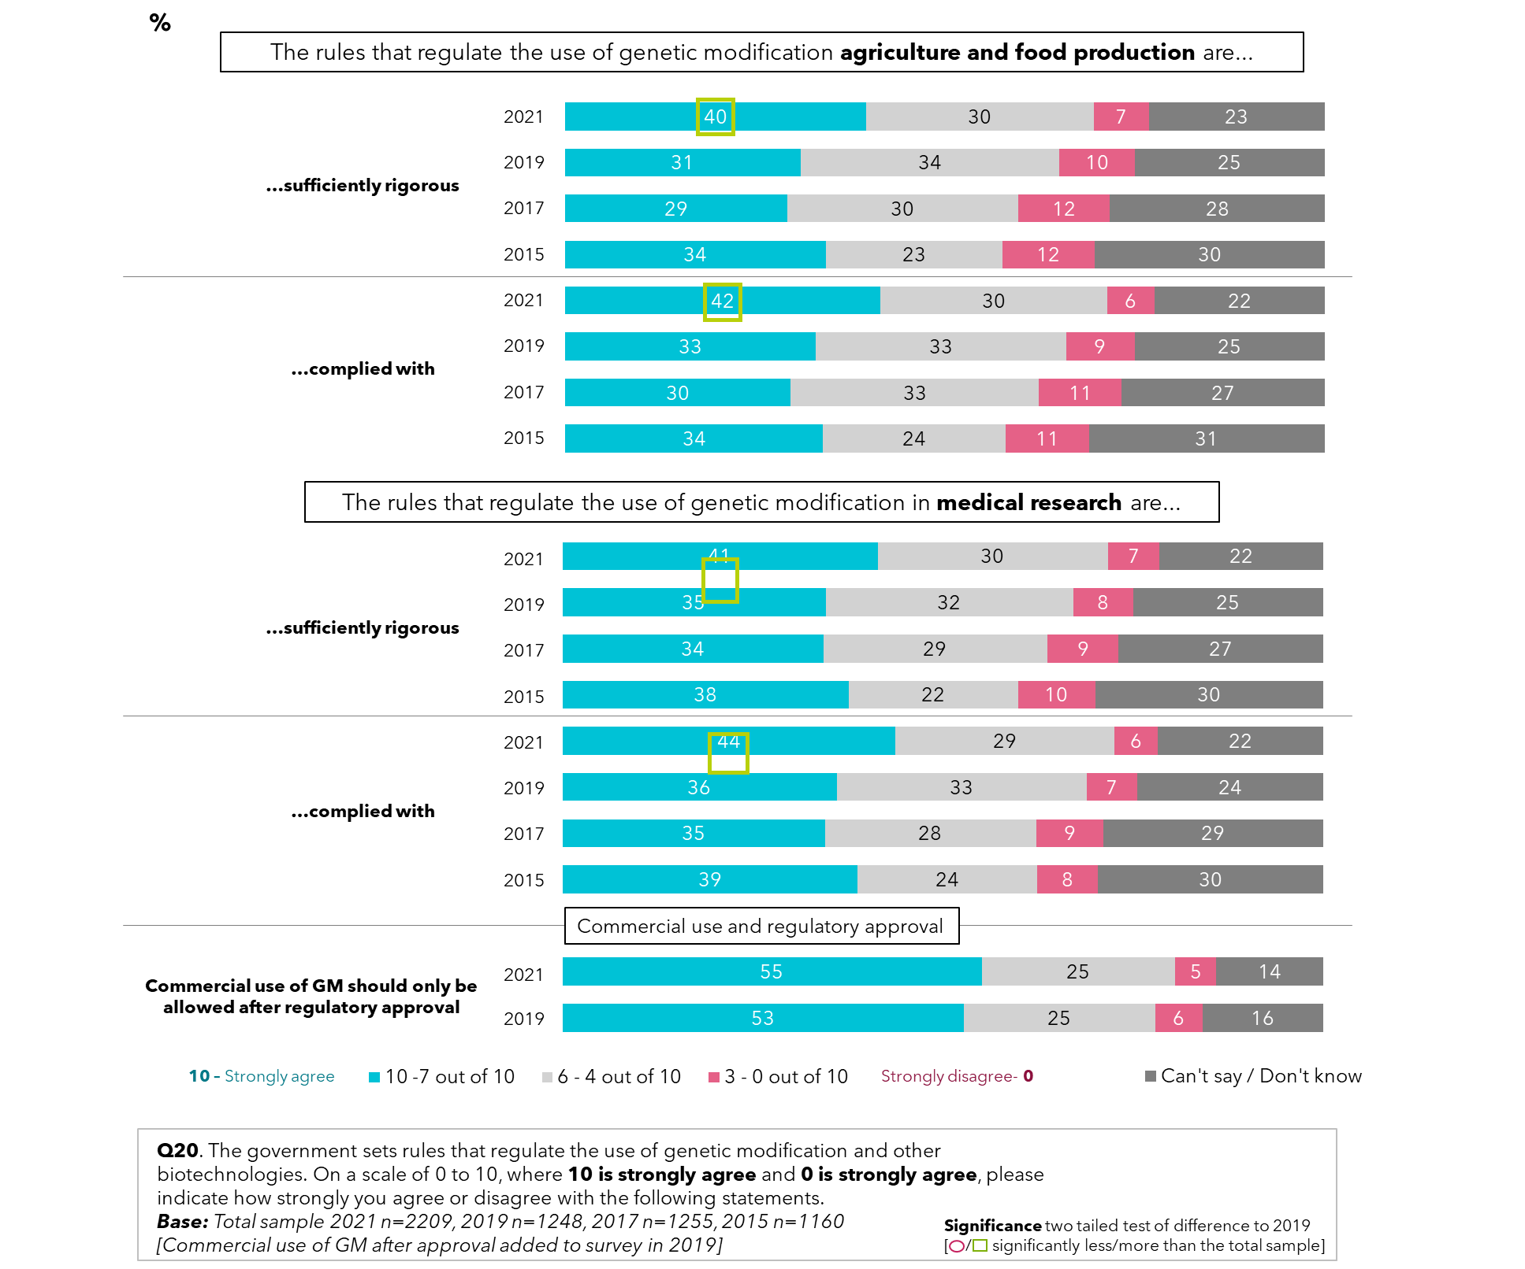

# Conclusions

* While there have not been massive shifts since 2019 despite the impact of the COVID-19 experience there is stronger support for genetic modification generally at 39% of high support in 2021, up from 33% in 2019. The level of resistance remains the same as in 2019. However, there has also been considerable growth in support for genetic modification in foods and crops, supported strongly by 44% (up from 35% in 2019). When considering specific uses of genetic modification, genetic modification for medical purposes remains the most acceptable use, with strong support at 61% of people surveyed.
* Again, while there have not been major changes in attitudes to genetically modified foods over the past two years, compared to the scale of change in previous studies, since 2019 there has been a significant shift towards finding modification of plant genes acceptable for the purpose of producing food. 38% of people surveyed now strongly feel this is acceptable, up from 30% in 2015 and 2019, and only 19% are strongly against the idea, down from 28% in 2015.
* Interestingly, when exploring views by age group, younger people again express greater confidence in genetic modification to produce food than do the older people surveyed. Over 4 in 10 people aged 50 or younger feel it is very appropriate to modify the genes of plants to produce food, with a confidence rating of 7-10 out of 10. If the positive changes in attitude continue with the younger people aged 18–30 then society will move notably towards embracing gene technology more.
* There were no significant changes in awareness of gene technologies and biotechnology, and there continued to be high levels of wrongly stating what crops might be genetic modification in Australia (corn, wheat and tomatoes for example). This correlates with a general drop in coverage of genetic modification issues in the media, and the relatively high *don’t know* and *not sure* responses.
* The data continues to indicate that knowledge and awareness of genetic modification issues is generally shallow.
* GMOs appear to be a low-level issue for most people, and they gather information on it as part of a general media diet, predominantly passively through watching TV with TV documentaries the most trusted and actual source of information on genetic modification.
* Support or rejection of genetically modified crops is still highly conditional. Now 70% of adult Australians are supportive of or are open to genetically modified technology to produce food, although 1 in 2 people require reassurance from the regulator before being satisfied that it is safe (52%).

# Appendix 1 – Sample size

The following provides a more detailed picture of the sample profile obtained. Please note that the figures are unweighted.

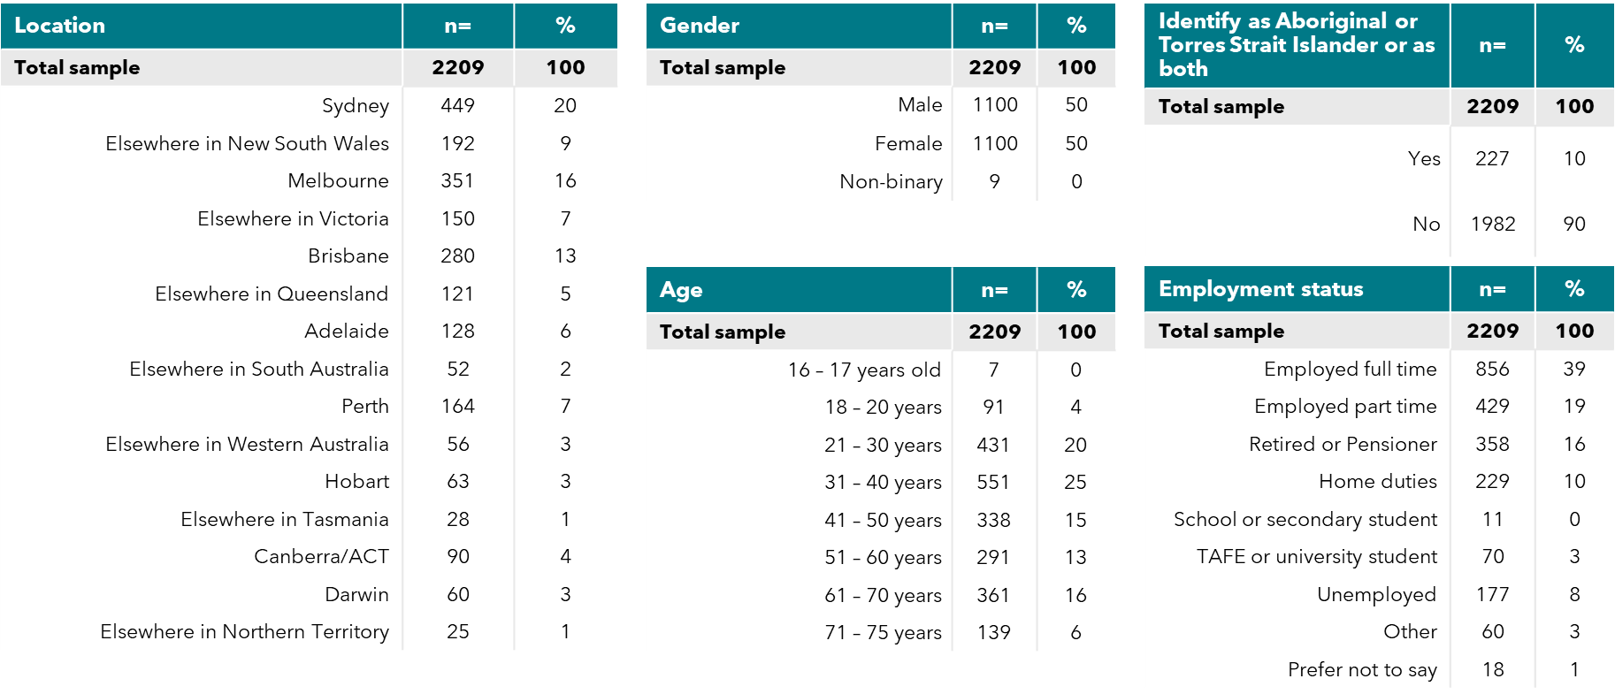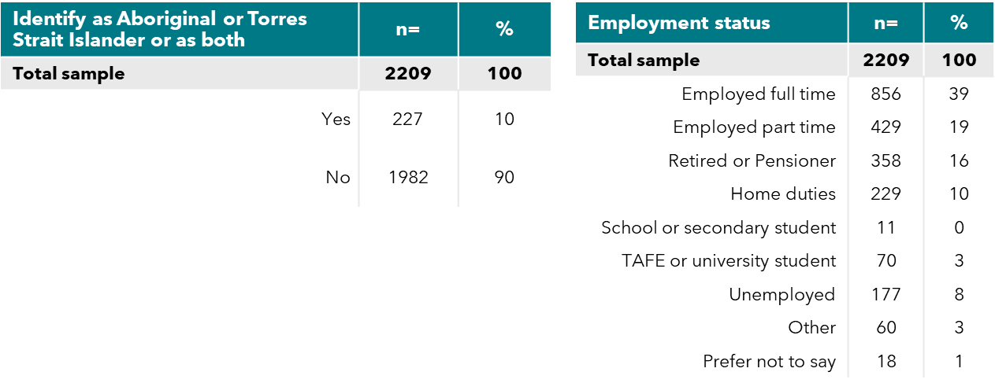

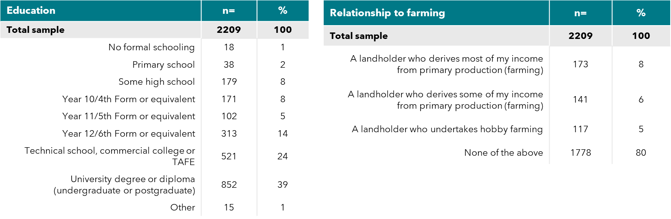

1. Chi-Square Automatic Interaction Detector