# Safflower in Australia

Safflower has been commercially cultivated as a minor crop in Australia since the 1950s.

It is grown for the edible oil and industrial oil markets. After oil is extracted from the seed, the remaining meal can be used as a stockfeed.

Alternatively, the whole safflower seeds are used for birdseed.

# GM safflower

The first commercial GM safflower was released in Australia in 2018.

The two GM safflower lines approved in Australia have been genetically modified to increase the level of a particular oil, oleic acid, in their seeds.

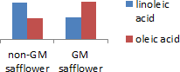

GM safflower oil was originally developed for use in the industrial oil market. High purity oleic acid is used for industry applications as a replacement for petroleum-based precursors in the manufacture of plastics, lubricants or cosmetics.

Food Standards Australia New Zealand (FSANZ) is responsible for food safety, and approved the use or sale of food derived from the GM safflower lines on 13 November 2018 ([A1156 – Food derived from Super High Oleic Safflower Lines 26 and 40](https://www.foodstandards.gov.au/code/applications/Pages/A1156%E2%80%93FoodderivedfromSuperHighOleicSafflowerLines26and40.aspx)). GM safflower oil is now available for human consumption.

High oleic acid has been achieved by changing the expression of two genes already present in safflower. This change results in more oleic acid and less linoleic acid in the GM safflower seeds. GM safflower can only be grown under a licence issued by the Gene Technology Regulator (the Regulator). Criminal charges can apply for non-authorised dealings with GM crops of any kind.

# Risk analysis of GM safflower

Prior to the release of the GM safflower in 2018, the Office of the Gene Technology Regulator (OGTR) prepared a comprehensive Risk Assessment and Risk Management Plan (RARMP).

The RARMP considered the risk of harm to the health of people or animals or to the environment from commercially releasing this GM safflower.

This included a thorough review of relevant national and international scientific literature, as well as critical evaluation of data supplied by the applicant. Advice was also taken from experts, agencies and authorities and the public.

The RARMP concluded that GM safflower poses no more risk to the health and safety of people and the environment than non-GM safflower. The Regulator subsequently approved the licence.

The licence allows the cultivation of GM safflower anywhere in Australia, subject to any moratoria imposed by States and Territories for marketing purposes.

Two GM safflower lines have been authorised since 2018 under licence [DIR 158](https://www.ogtr.gov.au/gmo-dealings/dealings-involving-intentional-release/dir-158). You can read the RARMP, the licence and other supporting information through the GMO Record on the OGTR website.

# Oversight of GM safflower

The OGTR monitors scientific and other literature for any new information relevant to approved GM crops. The OGTR also maintains oversight of commercially grown GM safflower to ensure it remains safe.

If something changes, and a GM crop can no longer be considered safe, the Regulator has the power to cancel existing licences to grow the crop.

*Left photograph provided with permission of GRDC

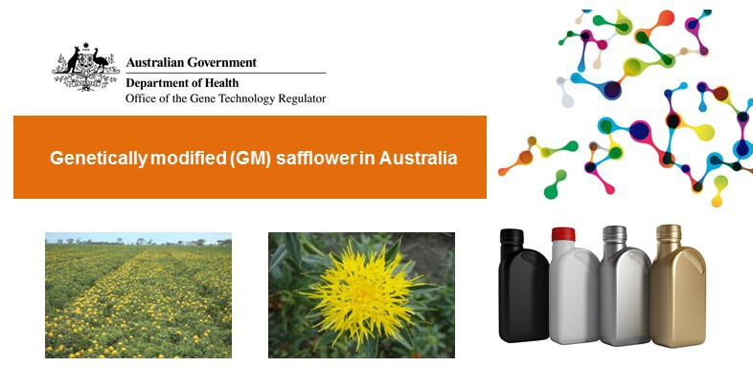



Related factsheets

Genetically modified (GM) crops in Australia

Stockfeed and genetically modified (GM) crops

Further reading

Genetically modified organisms in Australia

How are genetically modified organisms (GMOs) regulated in Australia

Version 1.1

April 2021

