Recently, the Office has received a large number of inquiries from the public in relation to claims that genetically modified (GM) vaccines have been aerially sprayed into the environment via ‘chemtrails’ as an intentional release. The term ‘intentional release’ in the *Gene Technology Act 2000* is used to describe work with genetically modified organisms (GMOs) where GMOs will not be confined to laboratories, greenhouses, insectaries and other specialised facilities. For example, a clinical trial with a GM vaccine is undertaken in a hospital setting which is not certified by the Gene Technology Regulator (the Regulator). This has led to speculation on some websites that the vaccine/s approved by the Regulator would be distributed by aerial spraying and are intentionally released into the environment. These speculations are false. The Regulator has never approved, or been asked to approve, aerial distribution of any GMOs. To address these concerns, we have published information on what we mean by the term ‘intentional release’ <https://www.ogtr.gov.au/news/announcement/what-do-we-mean-intentional-release>.

OGTR News Update – October 2022

Clinical Trials

Intentional Release

Staff from the OGTR have co-authored a manuscript ‘[**Horizontal gene transfer from genetically modified plants - Regulatory considerations**](https://www.frontiersin.org/articles/10.3389/fbioe.2022.971402/full)**’** that has been published in Frontiers in Bioengineering and Biotechnology and is part of a research topic ‘[**Genetically Engineered Products: Preparing for the Future**](https://www.frontiersin.org/research-topics/22361/genetically-engineered-products-preparing-for-the-future#articles)**’.**

The publication explores the likelihood and potential harm arising from horizontal gene transfer (HGT) of introduced or modified DNA in GM plants to other organisms. Updated evidence of the likelihood, factors, and barriers for HGT to take place from GM plants to other organisms is presented. The legislation and frameworks the Australian Gene Technology Regulator adhere to with respect to the consideration of risks posed by HGT are also presented.

Horizontal Gene Transfer

**Dr Matthew O’Mullane Appointed:**

We are pleased to announce Dr O’Mullane as our Executive Director of Science and Evaluation. Matt comes with extensive experience in risk assessment and regulation, having worked in several agencies including Office of Chemical Safety, OGTR, APVMA and more recently FSANZ.



**Notices**

***New application form for clinical trial licences***

The Regulator has issued a new licence application form specifically for human clinical trials of GMOs. It is available on the [OGTR website](https://www.ogtr.gov.au/resources/publications/application-licence-conduct-human-clinical-trial-gmo) in PDF and Microsoft Word formats. An updated version of the clinical trial guidance document - [Guidance for conducting human clinical trials involving GMOs](https://www.ogtr.gov.au/resources/publications/guidance-conducting-human-clinical-trials-involving-gmos) - is available on the OGTR website.

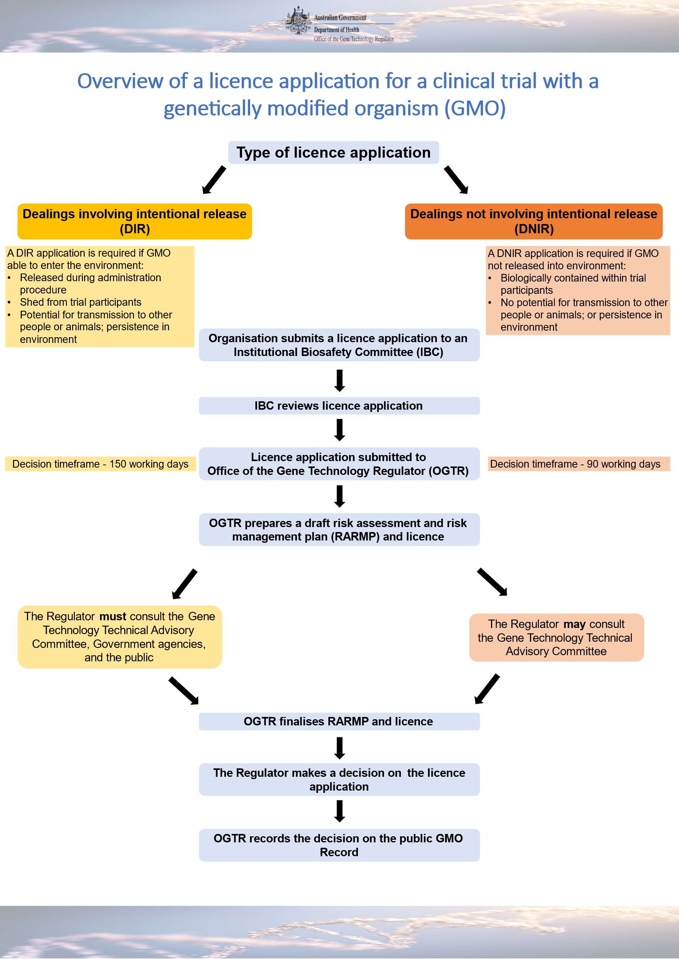

The Regulator must make a decision within 90 working days for DNIR licences, and within 150 working days for DIR licences (or 170 working days if a significant risk is identified). The longer DIR assessment timeframe allows for the required consultation with the Gene Technology Technical Advisory Committee, other government agencies and the public.

***Overview of the licensing process***

Licence applications must be in writing, using one of the forms provided on the [OGTR website](https://www.ogtr.gov.au/apply-gmo-approval). To ensure that the information included is complete, applications must be reviewed and endorsed by an Institutional Biosafety Committee before submission to the Regulator.

The OGTR uses the information provided to prepare a Risk Assessment and Risk Management Plan (RARMP) that identifies risks to the health and safety of people and the environment and manages those risks. For clinical trials, our focus is on risks to people other than trial participants – e.g., clinical trial staff handling the GMO; carers, household contacts and members of the community who may be exposed to the GMO via trial participants; and to animals, such as pets, livestock and native wildlife. The Regulator’s decision whether or not to issue a licence is based on the RARMP.

The new form is for both applications for dealings involving intentional release (DIR) *and* dealings not involving intentional release (DNIR), noting that different evaluation processes and timeframes still apply to the different licence types. It will be phased in over a three-month transition period. Until **31 December 2022**, clinical trial licence applications will be accepted on any of:

* the new licence application form;
* the current [DNIR licence application form](https://www.ogtr.gov.au/apply-gmo-approval/apply-dnir-licence); or
* the current [DIR licence application form for non-plant GMOs](https://www.ogtr.gov.au/resources/publications/application-dir-licence-involving-non-plant-gmo).

From **1 January 2023**, all human clinical trial licence applications must be on the new form.





Frequently asked questions about clinical trial licences

**Q**

***What arrangements need to be in place before we can submit a licence application?***

**A**

To allow the assessment to be undertaken, applicants should be able to identify the types of facilities to be used – e.g., hospitals, clinical trial units or GP clinics. Applicants should also be able to explain how the GMO will be prepared, administered, transported, stored, distributed, and how waste disposal will be managed. All sites engaged must be able to comply with relevant licence conditions.

**Q**

***Can the OGTR advise on DNIR/DIR classification of our clinical trial?***

**A**

If it is unclear whether a planned clinical trial requires a DNIR or DIR licence, we encourage applicants to consult us before preparing the application. Please provide information regarding the nature of the GMO and how it will be administered, as well as data demonstrating the capacity of viable GMO to be shed, excreted, or transmitted to other humans or animals. Please contact the OGTR if your clinical trial includes AAV-based viral vectors as some are considered eligible for a DNIR licence.

**Q**

***We want to run another clinical trial with the same GMO – do we need a new licence?***

**A**

Licences are specific to the GMOs and activities described in the application. If the new work does not comply with all licence conditions, it may be possible to vary the licence, or a new licence may be needed. This will depend on how the proposed changes impact on the risks originally assessed. The OGTR’s Policy on scope for variation of GMO licences can be viewed [online.](https://www.ogtr.gov.au/resources/publications/policy-scope-variation-gmo-licences)

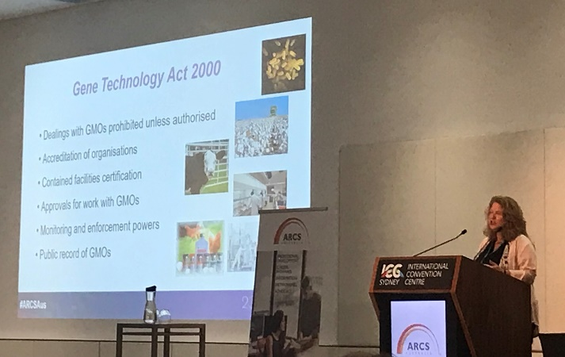

Caption Above: Dr Heidi Mitchell speaking at the ARCS Conference.

**Useful Links**

[Apply for a licence to conduct a clinical trial with a GMO](https://www.ogtr.gov.au/apply-licence-conduct-human-clinical-trial-gmo)

[Guidance for conducting human clinical trials involving GMOs](https://www.ogtr.gov.au/resources/publications/guidance-sponsors-clinical-trials-humans-involving-gmos)

Contact information for inquiries about clinical trials: [ogtr.cdes@health.gov.au](mailto:ogtr.cdes@health.gov.au) or 1800 181 030

**2022 ARCS Australia conference:**

OGTR staff attended the recent ARCS Australia Annual Conference. Dr Heidi Mitchell and Ms Geraldine Lester from the Contained Dealings Evaluation Section gave three presentations titled *Regulation of cell and gene therapy*, *What’s new in regulation of clinical trials with GMOs in Australia?* and *OGTR regulation of human clinical trials involving GMOs: What you need to know*. The team also spoke with many attendees at the OGTR booth over the three-day meeting.