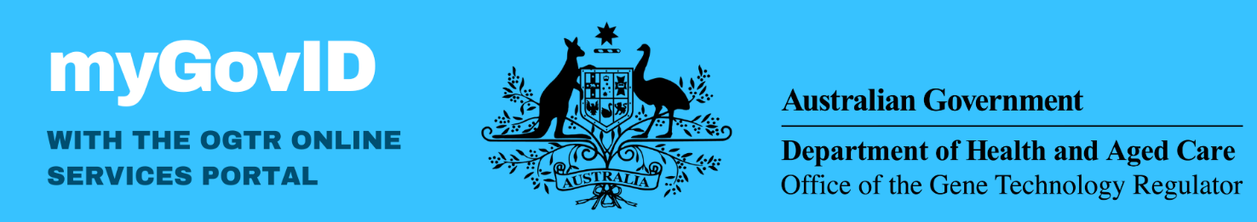

What is myGovID and why does the OGTR require myGovID to access the portal?

myGovID is an authentication system that allows you to prove who you are online. Possessing a myGovID makes it easier to verify your identity and securely sign in to participating government online services, such as the **OGTR Online Services Portal**. It provides greater security for our users accessing their application data and helps the OGTR to ensure authorised users are making requests. myGovID is used across many different government agencies and services. More information can be found [here.](https://www.mygovid.gov.au/where-to-use)

Privacy & Security

myGovID requires your consent to share personal details with the Department of Health and Aged Care. The OGTR only collects information required to perform our regulatory functions. Your myGovID email will be used solely to associate your professional contact details with your myGovID account. Information such as your date of birth will not be used, received, or stored by the OGTR. The myGovID app uses encryption as well as the security features in your device, such as fingerprint, face, or password. This is to protect your identity and help stop other people accessing your information.

What will you need to set up your myGovID?

|  |  |
| --- | --- |
| **A smart device** | **A personal email address** |
| The myGovID app is compatible with most smart devices and is only available from the Apple App Store or Google Play. | As it’s your personal Digital Identity, your identity documents will be linked to the email you choose. It **should not** be a shared or work email address. |

Choosing your identity strength

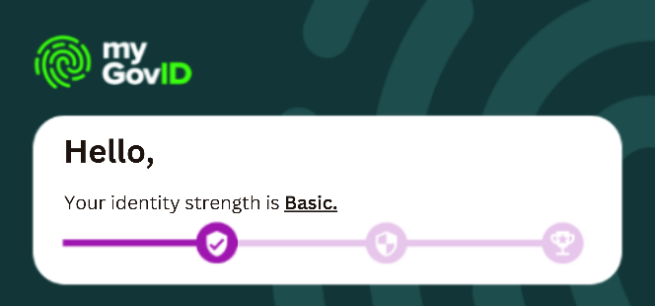To establish a myGovID you must specify the identity strength level. The OGTR Online Services Portal requires **‘Basic’** identity strength, however myGovID accounts with ‘Standard’ identity strength or higher allow access to most other participating government online services. To use a ‘Basic” identity strength, please take note of the panel at the top of your myGovID app. Once it appears like the image to the right, you have successfully reached ‘Basic’ identity strength. While it may look like you need to supply further information, this is only required to reach a stronger identity strength.