# OGTR Online Services Portal Registration Guide

# Registering for myGovID

Before registering for the OGTR Online Services Portal via myGovID, users need to have created a myGovID account.

Your myGovID is your digital identity and unique to you. Possessing a myGovID makes it easier to verify your identity and securely sign in to participating government online services.

To establish a myGovID you must specify the identity strength level. The **OGTR Online Services Portal** requires **Basic** identity strength, however ‘Standard’identity strength myGovID accounts allow access to most other participating government online services.

For requirements to set up an account with basic identity strength, please see the setup instructions on the [myGovID website](https://www.mygovid.gov.au/set-up) or refer to our [myGovID Fact Sheet.](https://www.ogtr.gov.au/resources/publications/mygovid-ogtr-online-services-portal)

# OGTR Online Services Portal Registration Process

To begin registering for the OGTR Online Services Portal call the OGTR on 1800 181 030 or email on [ogtr.applications@health.gov.au](mailto:ogtr.applications@health.gov.au) to receive an official invitation.

This invitation will contain a link that **expires after 72 hours.**

If you are unable to accept the invitation before it expires, please call the OGTR on   
1800 181 030 or email on [ogtr.applications@health.gov.au](mailto:ogtr.applications@health.gov.au).

1. 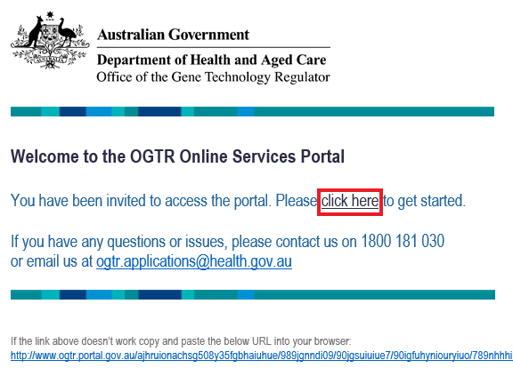Click **[click here]** or copy and paste the link into your browser.

1. 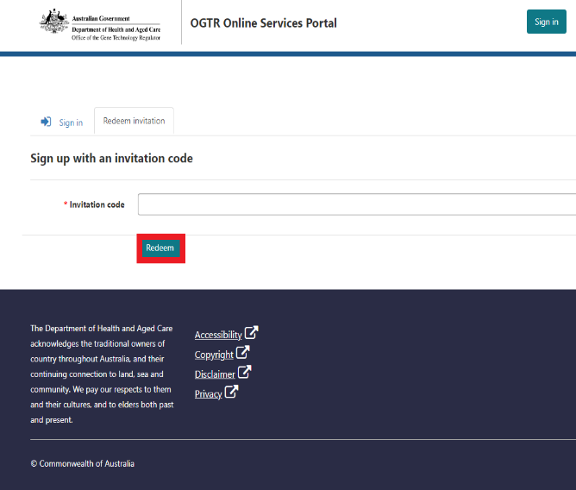A unique code from the email will pre-populate into the invitation code field to redeem your invitation in the portal. Do not share your invitation code with anyone and treat it securely.

Click **[Redeem]**

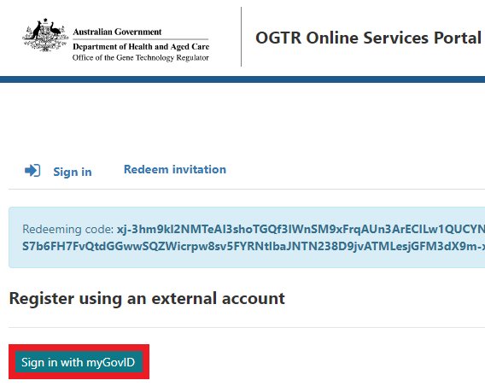

1. Click **[Sign in with myGovID]**
2. 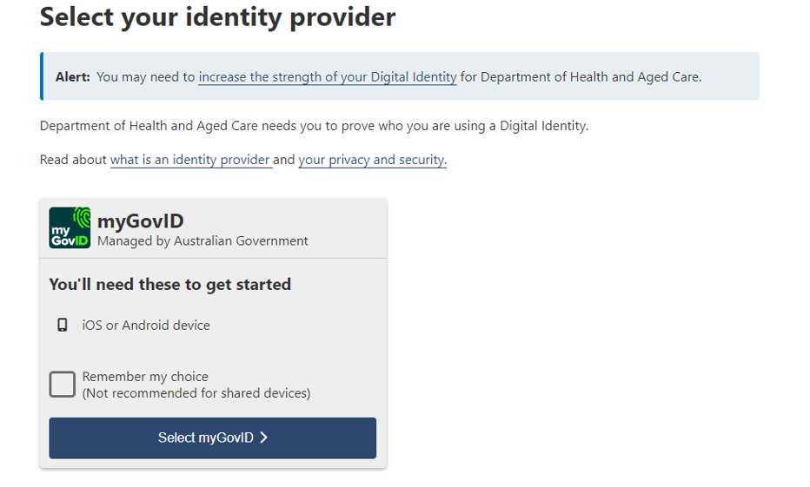Click **[Select myGovID]**
3. 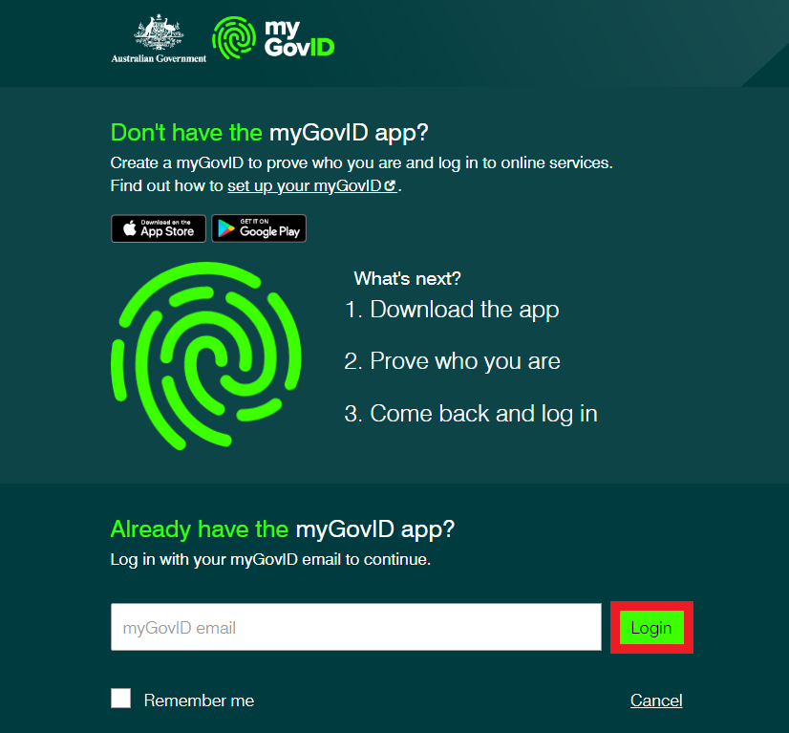Enter the email address associated with your myGovID account in the email field, then click **[Login].** Remember this is your personal email address and not a work or generic email address.
4. 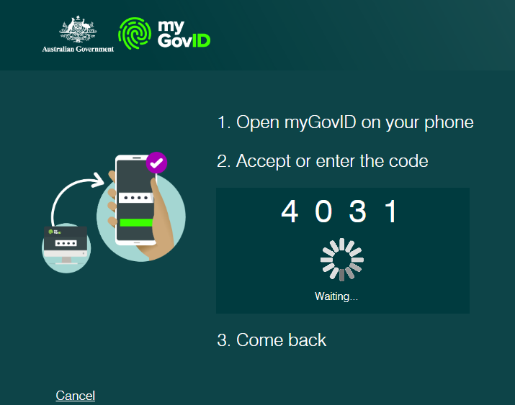Enter or accept the 4-digit code in your myGovID app.
5. To continue, you’ll need to give your consent to share your myGovID details with the Department of Health and Aged Care. If you already interact with other Department of Health and Aged Care portals you may have already consented to share your information. The OGTR only collects information required to discharge our regulatory functions. This means that information such as your date of birth will not be visible to the OGTR. Your myGovID email collected at this step will only be used to associate your contact details with your myGovID account.

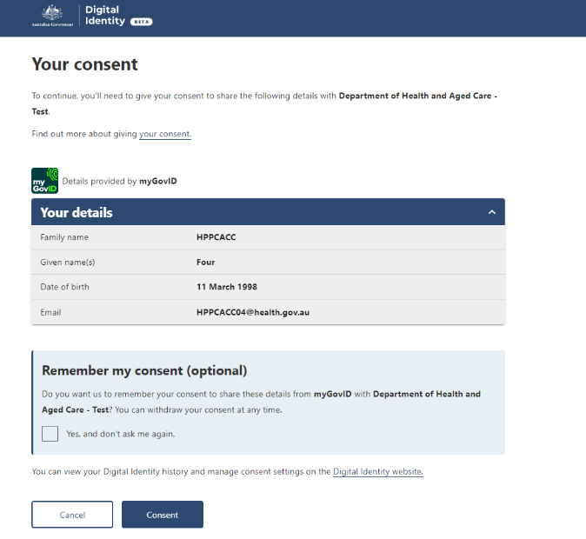**Note:** *The OGTR website includes further information about* [*privacy*](https://www.ogtr.gov.au/privacy) *and how we handle the information we collect.*

1. Accept the Terms and Conditions

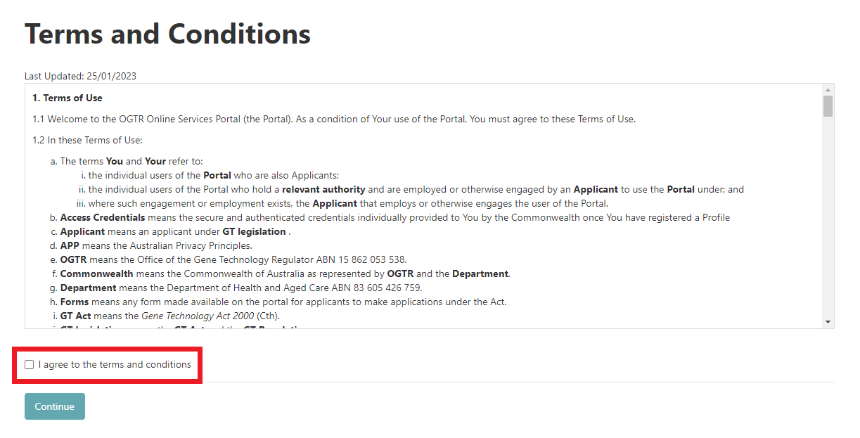**Note:** *You will need to agree to the Terms and Conditions each time you sign-in to the Portal.*

1. Establish your User Profile

The first time you log into the portal, your user profile will need to be established. Your profile page will be displayed, showing your current contact details held by the OGTR.

**Note:** *Even if the details shown are incorrect you need to “Acknowledge” them to access the portal. To update the details please follow the instructions on the page to notify the OGTR.*

1. Welcome to the OGTR Online Services Portal. For further assistance from this point, please refer to the [**OGTR Online Services Portal User Guide.**](https://www.ogtr.gov.au/resources/publications/ogtr-online-services-portal-user-guide)