OGTR Online Services Portal User Guide

## Introduction

The OGTR Online Services Portal (the ‘Portal’) is part of a continuous improvement project at the OGTR, to streamline and improve interaction with the Gene Technology Scheme in Australia. A range of services and information will become available within the Portal as it is developed.

This guide assists you from the point of logging into the portal. It follows from the [**OGTR Online Services Registration Guide.**](https://www.ogtr.gov.au/resources/publications/ogtr-online-services-portal-registration-guide) Individual guides are available for each of the services in the portal.

Contents

Introduction 1

Accessing the Portal 2

Navigation of the Portal 3

Accessing your User Profile page 4

Accessing Portal Services 4

Preparing a new Submission 5

Accessing draft Submissions 6

Searching the Draft Submissions dashboard 7

Accessing completed Submissions 8

## Accessing the Portal

1. Login to the OGTR Online Services Portal using the [**OGTR Online Services Portal Registration Guide**](https://www.ogtr.gov.au/resources/publications/ogtr-online-services-portal-registration-guide)for assistance, starting from step three of the login process. Some steps may be skipped if you have selected to “Remember” options.
2. Accept the Terms and Conditions
   1. Read and accept the Terms and Conditions by ticking “I agree to the terms and conditions” and selecting [Continue].

**Note:** *You will need to agree to the Terms and Conditions each time you sign-in to the Portal.*

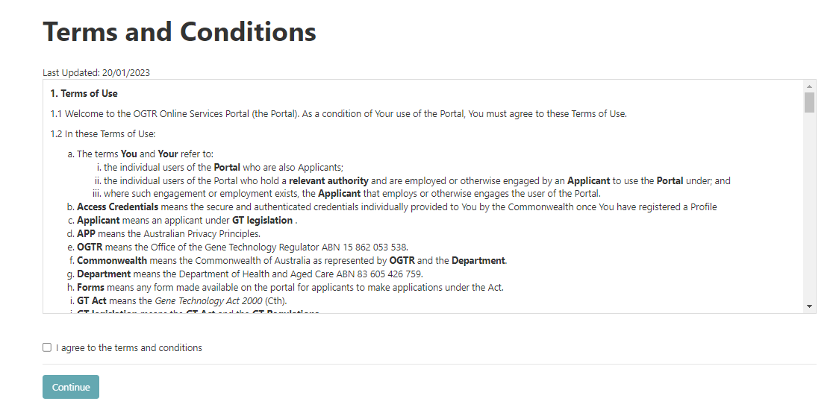

## Navigation of the Portal

Once you have signed into the portal, you will be on the “Home” page. It will look much the same as the landing page for the portal (before you signed in), however you will see your name at the top right of the screen.

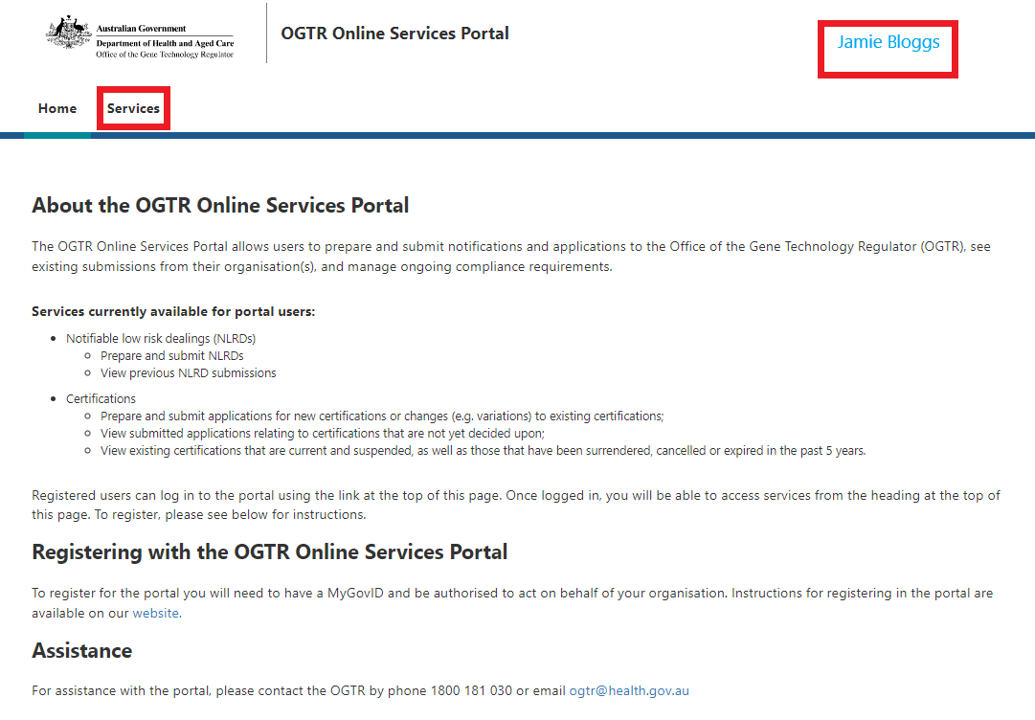This is shown as “**Jamie Bloggs**” in the below example.

### Accessing your User Profile page

You can access your “User Profile” page from your username in the top right corner of every page, this is **“Jamie Bloggs”** in the example.

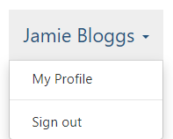

1. From the dropdown, select “My Profile”
2. You will see your details visible on the screen.

**Note:** *If any of the details require updating, please contact the OGTR using the clickable email link on the “My Profile” page, or by calling the number shown.* 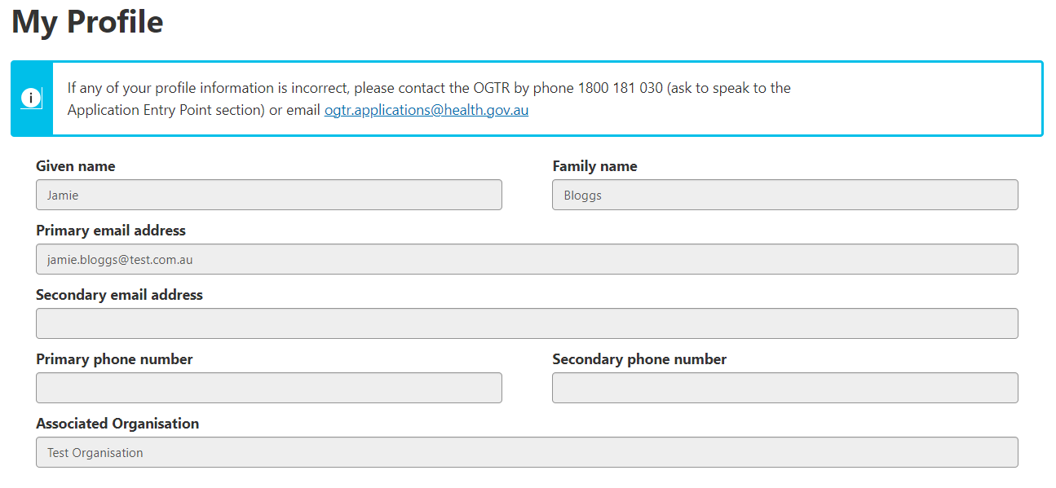

### Accessing Portal Services

1. To access the different services available in the Portal, select [Services] from the tab menu.  
   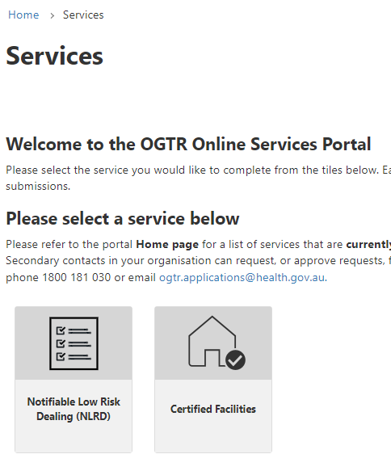
2. From the “Services” page you can access different services available in the portal. For example, to access NLRD related service, select the Notifiable Low Risk Dealing (NLRD) tile.
3. Services will have a dashboard available, that may have multiple tabs. In the NLRD example:
   * **“Draft submissions”** tab - shows forms that have not yet been submitted.
   * **“NLRDs”** tab – shows individual NLRDs and limited information about them including status, OGTR Identifier and expiry date.
4. Services may also have buttons available, in the NLRD example:
   * The **“New submission”** button accesses the NLRD reporting form.

See below for additional details on accessing the features of a service.

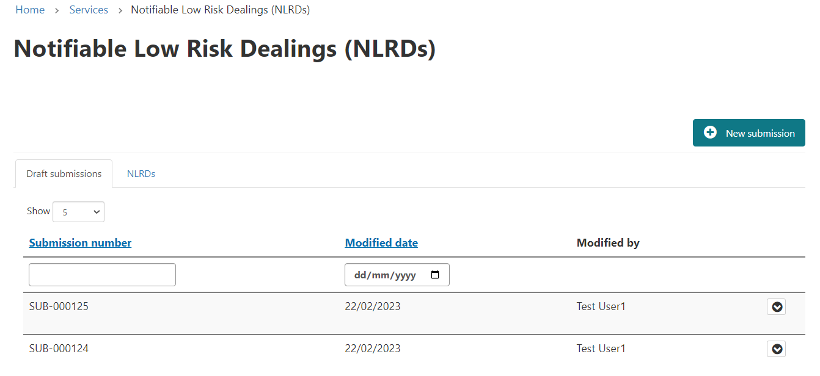

**New submission**

**“Draft submissions” dashboard**

**“NLRDs” dashboard**

## Preparing a new Submission or Application

From a dashboard select the submission or application button, this will open a new submission or application form.

Image showing close-up of "New Submission" button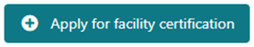

Please refer to the [Using the OGTR Online Services Portal](https://www.ogtr.gov.au/apply-gmo-approval/using-ogtr-online-services-portal) webpage forreferences to assist completing each service form.

## Accessing draft Submissions

Draft submissions can be accessed via the “Draft Submissions” dashboard on a service. This dashboard contains information about form submissions that have not been completed, including:

* Submission number
* Last modified date
* Name of the user who last modified the submission

**Note:** *Columns may vary between services.*



By default, submissions are sorted by the “Submission number” and can also be sorted by the “Modified date” column, by clicking on the heading.

**Note:** *When you click the heading to sort, an arrow will appear showing you the direction of sorting (i.e. smallest to largest/oldest to newest). The arrow appears on the far right of each column. E.g. the image below shows the “Modified date” column being sorted from “oldest to newest”.*

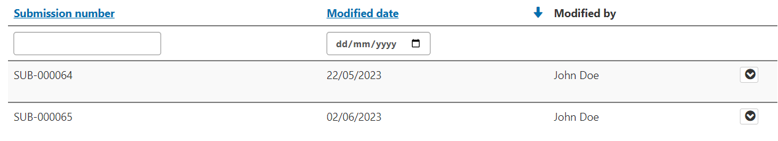

To reopen an incomplete draft submission, you can click the down arrow on the right-hand side of the row. Click [View/Edit] to reopen the submission form at the page it was last saved. Click [Delete] if the submission is no longer required. You will need to confirm deletion on a second prompt screen. 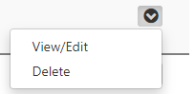

### Searching the Draft submissions dashboards

You can search dashboards by either “Free text field”, “Date picker”, or “Dropdown”.

The number at the bottom of the screen shows you how many records your search has found

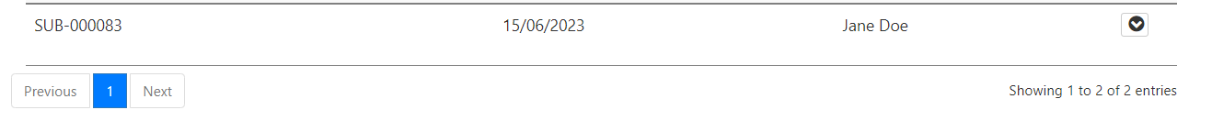

#### Searching by “Free text field”

1. In the below example, type *any part* of the submission number into the blank field at the top of this column:

* Typing in “**SUB-000089**”, “**000089**”, or “**8**” will all give you the same result of “**SUB-000089**.
* You do not need to use wildcards in this search i.e. **00008\***
* Typing in “**8**” will give you all results with a “**8**” in the submission number (shown in image below) 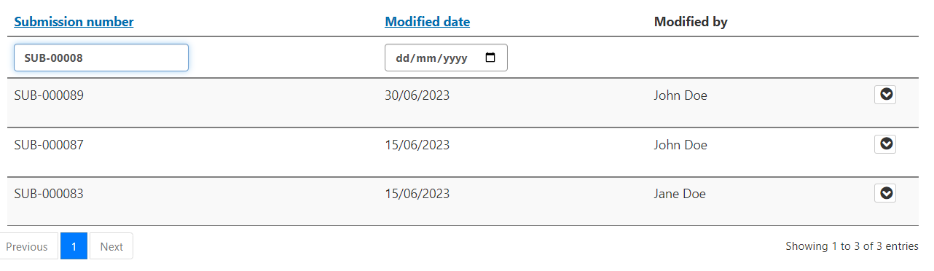

#### Searching by “Date picker”

1. Select a date by clicking on the “calendar” icon in the date field and selecting a date from the date picker. **Note:** *You cannot type into the date field; you must use the date picker.*

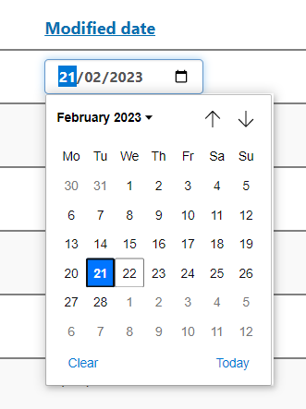

1. The records will filter once the calendar is closed.

**Note:** *You can combine multiple searches, i.e. search for both submission number and date at the same time (shown in image below).* 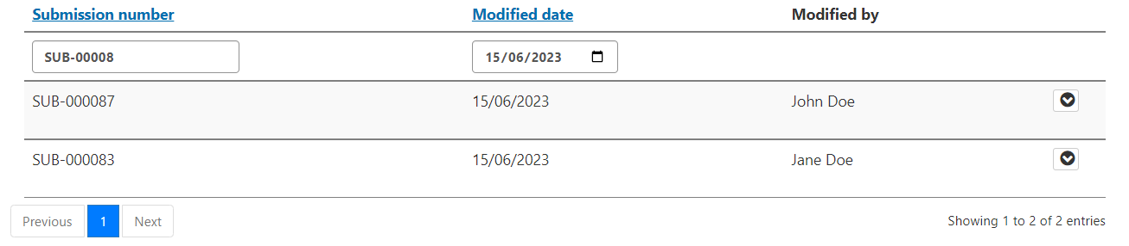

#### Searching by “Dropdown”

1. As shown in the screenshot below, the downward arrow will be visible when a dropdown exists.
2. Click the arrow and select the option you wish to filter the column by. **Note:** *Only one option can be selected for each column at a time.*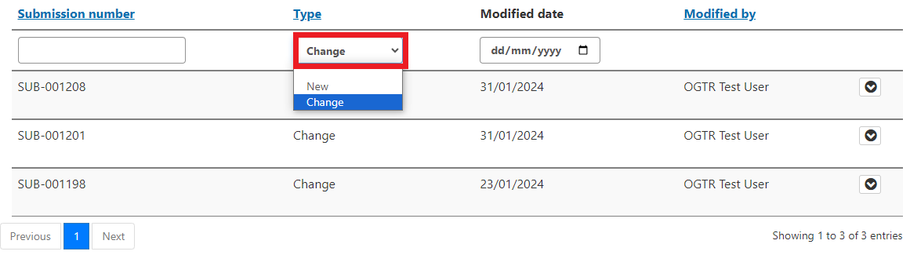

## Accessing completed Submissions

Submission records are only used while a submission is being drafted. After submission the record will no longer appear on the “Draft submissions” dashboard in a service. Instead, an application or notification will be visible on another dashboards. For example, the “NLRD” dashboard in the Notifiable Low Risk Dealing service contains information about **individual NLRD records** from completed submissions, including:

* OGTR ID (allocated once the form has been submitted)
* IBC Identifier
* Project Title
* IBC Name
* Status (e.g. Notified, Pending, Withdrawn, or Expired)
* Expiry Date (based on IBC assessment date)

***Note:*** *a “Pending” status refers to an NLRD that may have some additional checking to be completed by the OGTR. This can occur if, for example, the “Organisation proposing to undertake the dealing” has been manually entered, or is an organisation not yet known to the OGTR. Once manual checking has been finalised (during this time, the OGTR will reach out with any questions they may have) you should see the “Status” update to “Notified”.*

#### Searching a dashboard

You can search records on dashboards similarly to the Draft Submissions dashboard. Boxes at the top of columns indicate searchable fields, e.g. in the NLRD dashboard records may be searched by any of the columns.

**Note:** *You can combine searches, i.e., search in multiple columns at the same time.*

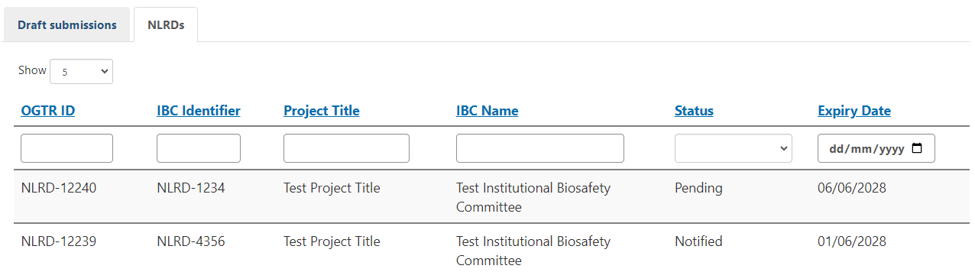

##### Searching by any of the text fields

To search by any of the “free text” fields, type *any part* of the ID/Identifier/Project title/IBC Name into the blank field at the top of the column:

* Typing in “**345**”, “**NLRD**”, or “**3**” will all give you the result of IBC Identifier **“NLRD-Identifier-00345”** (along with other results that contain those characters)
* You do not need to use wildcards in this search (e.g. IBC-ID-*)
* The number at the bottom right of the table shows you how many records your search has found

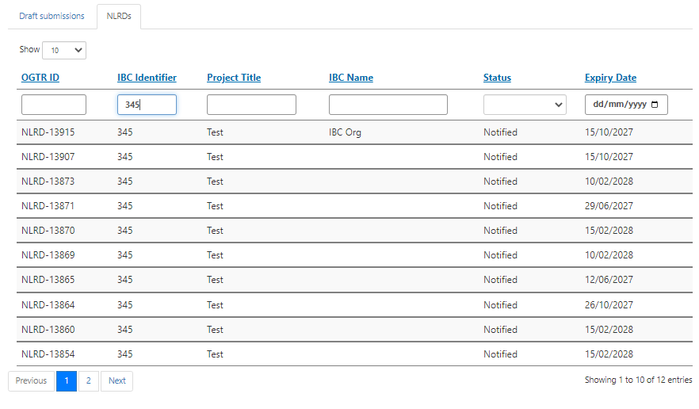

##### Searching by “Dropdown”

In the above screenshot, you can search by ‘Status’, using the dropdown to select from:

* Notified
* Pending
* Withdrawn (this is an administratively applied status used only in specific circumstances)
* Expired

**Note:** *You can only search by one status at a time.*

##### Searching by “Date picker”

1. Select a date by clicking on the “calendar” icon in the date field and selecting a date from the date picker. **Note:** *You cannot type into the date field; you must select from the date picker.*

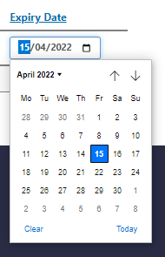

1. The records will filter once the calendar is closed. 