**OGTR Portal and SmartForm updates**

Over the past few years, we at the OGTR have been modernising our application forms using the SmartForms platform provided by the Department of Industry, Science and Resources (DISR). DISR has [advised](https://www.industry.gov.au/government-government/smartforms) that it is unable to continue providing the service for SmartForms from 30 June 2024.

The Certified Facilities service is now live following the successful launch of the OGTR Online Services Portal (the Portal) in the middle of last year with the NLRD service. The Certified Facilities service allows a user to:

* Prepare and submit applications for new certifications or changes (e.g. variations) to existing certifications;
* View submitted applications relating to certifications that are not yet decided upon;
* View facilities that are currently certified or suspended, and those that were surrendered, cancelled, or have expired in the past 5 years.

The assigned Primary or Secondary contacts in organisations can request, or approve requests, for services to be added to individual user profiles, or new user access to the portal. Refer to this [guidance note](https://www.ogtr.gov.au/resources/publications/guidance-note-ogtr-contact-roles-and-authorisation) for further information regarding OGTR Contact Roles and Authorisation. To request portal access, please fill out the ‘Portal Access’ portion of the [Contact Changes form.](https://www.ogtr.gov.au/ongoing-regulatory-compliance/reporting-changes-key-organisation-contacts)

**ABSANZ Conference**

Heidi Mitchell (Contained Dealings Evaluation Section) and Andrew Berry (Monitoring and Compliance Section) travelled to Queenstown, New Zealand to represent OGTR at the 11th annual Association of Biosafety for Australia and New Zealand (ABSANZ) biosafety and biocontainment conference from 1‑3 November 2023.

The goal of the conference was to bring together Australian and New Zealand industry representatives, research facility managers, researchers, and regulatory agencies, as well as a large number of international speakers, to discuss all aspects of biosafety, including risk analysis and regulation. The theme of the 11th ABSANZ conference was Biosafety and Biosecurity in Turbulent Times.

# REMINDER: 10th National IBC Forum

**The Forum will be held at the National Gallery of Australia, Canberra, on the 16th, 17th & 18th of September 2024. Attendance is at no charge and includes lunch and refreshments on all days. An evening reception will be held from 5:30 to 7:30 pm on Monday 16 September, where canapés will be served with a bar available for attendees to purchase beverages.**

**DIR 199**

DIR- 199 was issued to Queensland University of Technology for Commercial release of banana genetically modified for resistance to Fusarium wilt tropical race 4 (TR4). The GM banana is modified to provide resistance to the pathogen which causes Panama disease, a serious disease affecting Australia's banana industry. Food Standards Australia New Zealand (FSANZ) has approved this GM banana for sale as a food in Australia and New Zealand. For more information see the [OGTR](https://www.ogtr.gov.au/gmo-dealings/dealings-involving-intentional-release/dir-199) and [FSANZ](https://www.foodstandards.gov.au/food-standards-code/applications/A1274-Food-derived-from-disease-resistant-banana-line-QCAV-4) websites.

**PC2 Certification Guidelines**

We are currently conducting a review of the Guidelines for Certification of Physical Containment Level 2 (PC2) facilities (the Guidelines). The Guidelines were last updated in 2013. We have observed a trend in requests for the certification of multipurpose facilities where a modular approach may be more appropriate.

**What is changing?**

The proposed approach can be broadly separated into Guidelines for facilities where dealings with GM micro-organisms either will or will not be conducted. The Guidelines will be modular, so will contain a general section which is applicable to all PC2 facilities and then annexes that include additional requirements and conditions for different facility types. The Guidelines will replace the current Guidelines for Certification of a PC2 Laboratory, Animal, Plant, Aquatic and Invertebrate Facilities. We will retain the Constant Temperature Room and Large Grazing Animal Facility Guidelines in their current form. The approach is illustrated below and includes four Guidelines.

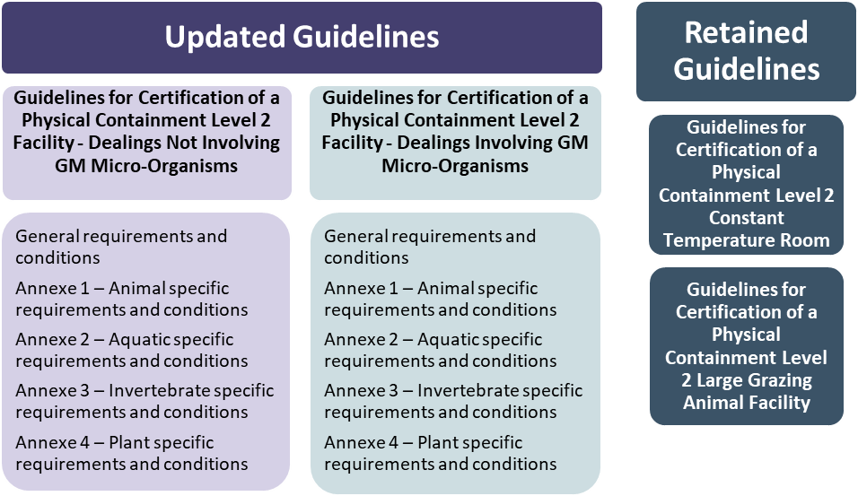

***Guideline for Certification of a PC2 Facility - Dealings Not Involving GM Micro-Organisms***

A facility certified under these Guidelines would only allow dealings with GM animals, GM aquatic organisms, GM plants and GM invertebrates. Examples include animal breeding facilities, most current plant facilities, and GM mosquito breeding facilities. These Guidelines would not allow the facility to be used for dealings involving any GM micro-organisms. Requirements and Conditions will be less stringent in these Guidelines to provide a balanced and risk proportionate approach to containment of these organisms.

***Guidelines for Certification of a PC2 Facility - Dealings Involving GM Micro-Organisms***

These Guidelines will replace the PC2 Laboratory Guidelines, and include annexes that are applicable for dealings with organisms infected with GM micro-organisms. All general requirements and conditions of these Guidelines would apply whether or not some or all dealings involve GM micro-organisms, including use of personal protective equipment and work practices. Organisations can decide how to manage their facilities upon the issue of these two new Guidelines. This approach may require some re-arrangement of activities in the short term for certification holders, but we believe this will be a much better approach in the future. A webinar providing some further details is available [here](https://youtu.be/mQdu-NdoqM4).

**DNIR Updates**

Recently, the Regulator has issued two DNIR licences to allow acquisition, culture and testing of historically generated cell lines. The lines were transduced with early viral vector technology, with no historical documentation to demonstrate that they are free of replication competent viruses (RCVs). After testing, cell lines that do not contain RCVs will be used for research as exempt dealings or a NLRD.

**Cell lines that require a licence**:

A cell line will not meet the criteria listed in Schedule 3 Part 2, 2.1 (l) (ii) and (iii) or (m) (iii) (iv) of the [Gene Technology Regulations 2001](https://www.legislation.gov.au/Details/F2020C00957) (i.e. a PC2 NLRD) when the gag, pol and env viral genes are present on the same loci in the packaging cell line, and the expression vector did not incorporate deletions in the 3’- or the 5’-LTR, as the system has the potential to generate RCVs. Therefore, in this situation, a licence is required to conduct work, including testing to detect the presence of RCVs with this cell line. If testing of the cell line does not detect the presence of the RCVs, then the work can be conducted as an exempt dealing or a NLRD.

**Classification of GMOs**

To assist IBCs with classification of GMOs, we are providing a series of recent Questions and Answers. We are happy to respond directly to any questions that you have and if we believe there is broad interest we will include answers in the next issue of the newsletter.

The GMO classification of the iPSCs depends on the method used to generate them. If iPSCs are generated using gene technology, then they would be considered GMOs. For example, if iPSCs are generated using Cytotune-iPS Sendai Reprogramming Kit or using nucleofection, they will be classified as a GMO as the traits that occurred by gene technology are still present in the iPSCs. Please note that the *Gene Technology Act 2000* does not specify genotypic or phenotypic traits, all traits must be taken into account.

The Regulator has clarified that when considering whether a genetic modification confers an immunomodulatory effect, the intention is to only include proteins, nucleic acid sequences or other molecules that either up-regulate or down-regulate the normal host immune response following exposure to an antigen. The intention is to exclude expression of antigens that induce a normal host immune response. However, if the GMO includes proteins that could up-regulate or down-regulate the normal host immune response (e.g., cytokines or co-stimulatory molecules) in addition to the antigen, it may be considered to have an immunomodulatory effect.

Are induced pluripotent stem cells (iPSCs) classified as GMOs under the *Gene Technology Act 2000*?

What is meant by the term ‘immunomodulatory effect in humans’ in the Gene Technology Regulations 2001?