2024

# Community attitudes towards gene technology

June 2024

|  |  |  |
| --- | --- | --- |
| Instinct and Reason logo | Prepared For: | Office of the Gene Technology Regulator  Sarita Dhounchak, Diana Hall |
| Consultants: | Instinct and Reason  David Donnelly, Dr Craig Cormick, Danica Jobson |
| Date:  Reference: | June 2024  3377 |
| WWW.INSTINCTANDREASON.COM | Suite 302, 410 Elizabeth Street, Surry Hills, NSW 2010 sec = PUBLIC | | |

Contents

Community attitudes towards gene technology 1

Figures 4

Tables 5

Key findings 8

Trends since 1999 11

Implications 15

Background, objectives, and methodology 18

Objectives 18

Methodology 19

Stage 1 – Inception and planning 19

Stage 2 – Survey design 19

Stage 3 – Survey fieldwork 20

Stage 4 – Survey analysis and reporting 21

Stage 5 – Final reporting 21

Main Report 22

Main findings 23

Awareness and understanding of biotechnologies 23

Perceptions of whether genetic modification will improve our way of life 26

Support for genetic modification 26

Confidence in the genetic modification of crops and food 33

Perceptions of types of genetically modified crops grown across Australia 44

Attitudes to genetically modified crops and genetic modification technology in food production 45

What does the community want to know about genetic modification and where is the information coming from? 51

Awareness and trust in organisations providing information about genetic modification 55

Conclusions 60

Appendix 1 63

Figures

Figure 1: Attitudinal changes towards biotechnology and genetic modification over time 12

Figure 2: Changes in awareness and trust in the OGTR 13

Figure 3: General support for genetic modification or gene technology from 2015-2024 13

Figure 4: Support for genetic modification from 2015-2024 14

Figure 5: Trust by awareness of OGTR 15

Figure 6: Awareness of genetic modification terminology and understanding – by year 23

Figure 7: Awareness of the levels of genetic modification in Australia – by year 24

Figure 8: Awareness of the levels of genetic modification of fruit and vegetables in Australia – by year 24

Figure 9: Awareness of the levels of genetic modification in Australia – by age (2024) 25

Figure 10: Awareness of the levels of genetic modification of fruit and vegetables in Australia – by age (2024) 25

Figure 11: Perceptions on whether or not genetic modification technologies will improve our way of life – by year 26

Figure 12: Support for the use of genetic modification in general 26

Figure 13: Levels of support for genetic modification and gene technology for specific uses – by year 27

Figure 14: Levels of support for genetic modification and gene technology for specific uses – by income derived from land 28

Figure 15: Levels of support for genetic modification and gene technology for livestock uses – by year 28

Figure 16: Levels of support for genetic modification and gene technology for livestock uses – by income derived from land 29

Figure 17: Perceptions towards scientific technology – random samples A + B, by year 30

Figure 18: Support for biotechnology development: sciences and technologies (1) – by year 31

Figure 19: Support for biotechnology development: sciences and technologies (2) – by year 32

Figure 20: Support for basis of genetic modification food and crop decisions – by year 32

Figure 21: Confidence in food and the support of the use of gene technology in food and crops – by year 33

Figure 22: Support for the use of genetic modification in food and crops – (2024) 33

Figure 23: Willingness to eat genetic modification food – by year 35

Figure 24: Willingness to eat genetic modification food – by age (2024) 37

Figure 25: Willingness to eat genetic modification food – by gender (2024) 38

Figure 26: Willingness to eat genetic modification food – by state and territory (2024) 38

Figure 27: Levels of support for genetic modification and gene technology for specific uses – by First Nations people 39

Figure 28: Levels of support for genetic modification and gene technology for specific uses – by language spoken at home 39

Figure 29: Levels of support for genetic modification and gene technology for specific uses – by income derived from land 40

Figure 30: Attitudes towards modifying plant genes to produce food (2024) 40

Figure 31: Attitudes towards modifying plant genes to produce food – by age 41

Figure 32: Attitudes towards modifying plants genes to produce food – by gender 41

Figure 33: Concern over genetic modification of foods and crops - by year 42

Figure 34: Concern over genetic modification of foods and crops - by gender and age (2024) 42

Figure 35: Attitudes towards genetic modification in food production – by year 43

Figure 36: Awareness of genetic modification crops being grown in their state/territory 44

Figure 37: Awareness of genetic modification crops in state/territory – by state (2024) 44

Figure 38: Prompted awareness of specific genetic modification crops – by state (2024) 45

Figure 39: Support for genetic modification crops if given reassurance – by capital city and non-capital city 45

Figure 40: Support for genetic modification crops if given reassurance – by capital city and non-capital city 46

Figure 41: Support for genetic modification crops if given reassurance – by year 46

Figure 42: Public opinion on using genetic modification technology to produce food – by year 47

Figure 43: Public opinion on using genetic modification technology to produce food – by income derived from land 47

Figure 44: Reasons for favouring the use of genetic modification technology to produce food – 2024 sample supportive of genetic modification food production 48

Figure 45: Reasons for opposing the use of genetic modification technology to produce food – 2024 sample opposed to genetic modification food production 49

Figure 46: Value placed on various genetic modification outcomes and goals (2024) 50

Figure 47: Value placed on various genetic modification outcomes and goals – by year 50

Figure 48: Attitudes to genetic modification for industrial or therapeutic uses – by year 51

Figure 49: Regulator reassurance to increase support for genetic modification food production – by 2024 sample supportive but seeking regulator assurance to reassure genetic modification technologies are safe (2024) 52

Figure 50: Scientific reassurance to increase support for genetic modification food production – by 2024 sample unsupportive however seeking scientific reassurance that genetic modification technologies are safe (2024) 53

Figure 51: Where the public get information about gene technology (2024) 53

Figure 52: Trusted sources of information on gene technology (2024) 54

Figure 53: Concerns regarding fake news and information 54

Figure 54: Prompted awareness of responsibility of organisations for regulation of gene technology– by year 56

Figure 55: Prompted awareness of organisations that are responsible for regulation of gene technology – by year 57

Figure 56: Levels of trust in what organisations say about gene technology (2021) 58

Figure 57: Genetic modification rules and regulations – by year 59

### Tables

Table 1: Sample by state or territory 63

Table 2: Sample by Gender 63

Table 3: Sample by Age 63

Table 4: Sample by Aboriginal or Torres Strait Islander 64

Table 5: Sample by Industry currently working in 64

Table 6: Sample by Education 64

Table 7: Sample by state/territory 64

Table 8: Sample by year and state/ territory 65

Table 9: Sample by year and gender 65

Table 10: Sample by year and age 65

Glossary

|  |  |
| --- | --- |
| **Term** | **Definition** |
| APVMA | Australian Pesticides and Veterinary Medicines Authority |
| Biotechnology | A broad term to cover the application of the science of living things. It can include genetic modification but does not necessarily involve the use of genes. |
| Cloning | A form of assisted reproduction which allows an exact genetic copy of an animal to be created, which is essentially an identical twin. |
| CSIRO | Commonwealth Scientific and Industrial Research Organisation |
| Department of Agriculture | Department of Agriculture, Fisheries and Forestry |
| Department of Health | Department of Health and Aged Care |
| DNA | Deoxyribonucleic acid – the double helix of genetic instructions for all organisms. |
| Herbicide | Substances used to control unwanted plants |
| FSANZ | Food Standards Australia New Zealand |
| Gene editing | A laboratory technique to make small precise changes to genes. It does not involve the transfer of genes from one living thing to another. |
| Genome editing | Another word for gene editing |
| GM | Genetically modified |
| GM product | A thing (other than a GMO) derived or produced from a GMO |
| GMO | Genetically modified organism |
| OGTR | Office of the Gene Technology Regulator |
| Organism | Any living matter |
| NHMRC | The National Health and Medical Research Council |
| Pesticide | Also known as insecticides, substances used to control unwanted pest insects |
| Regulations | Gene Technology Regulations 2001 |
| Regulator | The Gene Technology Regulator |
| Synthetic biotechnology | A new form of biotechnology where the principles of engineering are used to build new biotechnology structures that might not otherwise have existed, such as creating new organisms to use in medicine or to clean up oil spills. |
| TGA | Therapeutic Goods Administration |
| Therapeutic uses | Used for medical benefits |

Executive Summary

# Key findings

The Office of the Gene Technology Regulator needs to further its understanding of community attitudes in Australia to GMOs, gene technology and its regulation. The key objective for this research is to provide an analysis of current attitudes and also analyse the longitudinal data to examine if and/or how community attitudes have changed over time. Key findings for the community attitude’s survey undertaken in 2024 are:

**Stability of attitudes**

In 2024, support for GM technologies largely reflects results shown in 2019, while indicating a slight downward trend since 2015. After the global COVID-19 pandemic and spikes in support in 2021, attitudes appear to have returned to what we might consider a new ‘baseline’. Support for genetic modification remains stable, with 38% of the Australian community in support of its use in general, and 20% against it. A large portion of the community continue to sit on the fence (37%), or don’t know how they feel (6%).

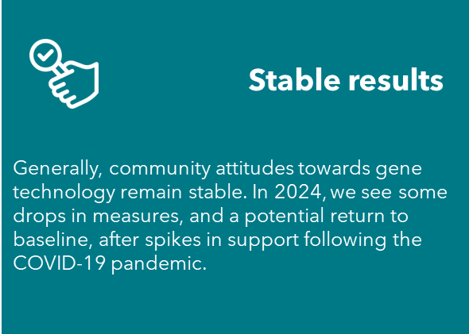 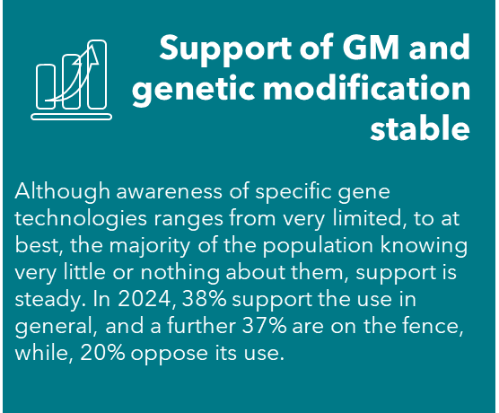

Over the long-term, community awareness and understanding of gene technologies have worsened. At best, 27%* of Australians surveyed feel they know enough about cloning of animals to explain it, and a further 57%* have heard of it but couldn’t explain it. This is compared to a high in 2015 of 39% feeling they knew enough to explain it to a friend, and a further 49% having heard of it but not being able to explain it. The gap is also widening for people who haven’t heard of cloning of animals at all, increasing from 8% of the community, to 14%, over the 9 years perceived understanding has been measured.

When prompted on what uses of genetic modification there are in Australia, the community on a whole remain hazy; many consumers are not sure whether they are consuming foods and products that involved genetic modification in production.

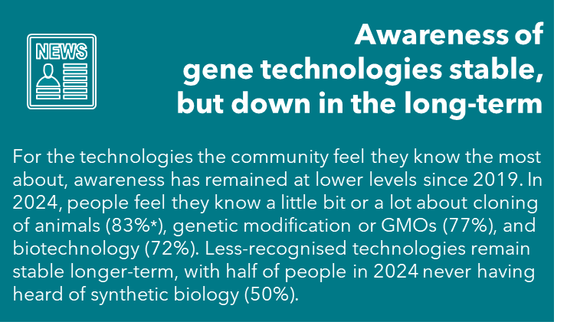 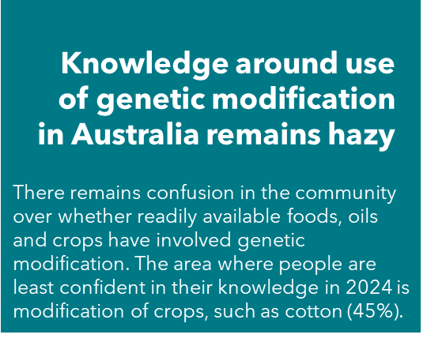  
*These data have been rounded to the nearest whole percentage. Please see Stage 4 – Survey analysis and reporting ‘Rounding of figures’ on page 21 for further information.

**Support for different uses differs**

When it comes to specific uses, 2024 revealed some decreases in support in the community from 2021, for medical uses (down 5 percentage points to 56%), and for use in food and crops (down 8 percentage points). This is while a growing portion of the community in 2024 are less certain about the health and safety risks of not vaccinating children, up from 12% in 2015 to 21%.

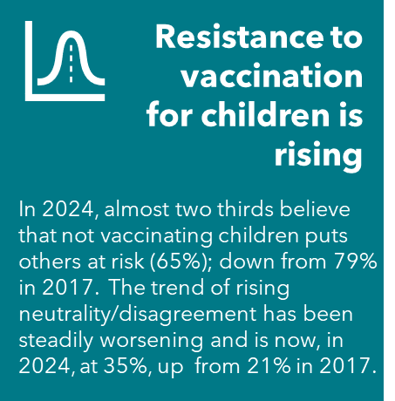 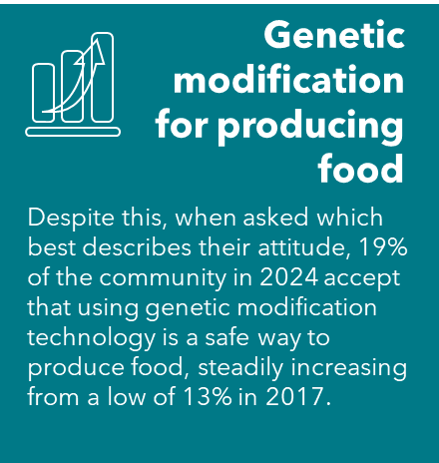 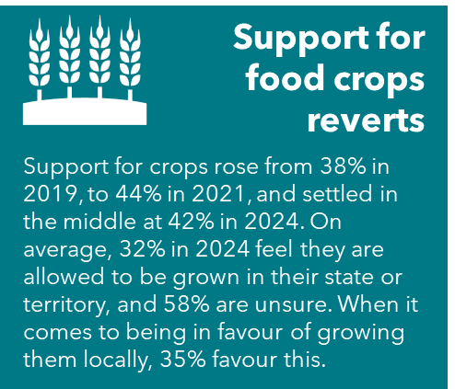 [This image says 'Support for medical use still strong: 
Health and medical applications of GM still rate highly. While there was a slight drop in 2024 for genetically modified therapeutics or medicines (45%; -6%) and for medical uses of genetic modification (56%; -5%) from 2021, these still rate highly as does support for using GM for medical uses such as producing insulin or vaccines. This rated highest for different uses of GM at 56%.'](#_Support_for_genetic)

**Trust is at risk**

Trust placed on the information that organisations provide about the risks and benefits of genetic modification or gene technology has declined from peaks in 2021. For the Department of Agriculture, the decline in trust was a statistically significant drop. For OGTR, trust has decreased, but not significantly so (69%, down 5 percentage points from 2021). Trust in the information OGTR provides remains at a higher level than in 2019 (60%). State, territory and Commonwealth governments have similar levels of trust held by the community, and both showed decreases that were not statistically significant. However, there was a statistically significant increase in distrust in governments. In turn, there are concerns from the community that the regulations in place aren’t sufficiently rigorous (12%) or being complied with (10%).

This image says 'Trust in regulation at risk: Trust in getting true and complete information on the risks and benefits of genetic modification and gene technology has fallen. The fall for the OGTR is not statistically significant (69% now trust OGTR; down 5%) but trust has fallen for other regulators: TGA (60%; -13%), and the Department of Agriculture (59%; -6%). Although CSIRO and NHMRC play no role in the regulation of gene technology, trust was also down with CSIRO (65%; -8%), and NHMRC (63%; -10%).'

[This image says 'Trust in regulation at risk: Trust in getting true and complete information on the risks and benefits of genetic modification and gene technology has fallen. The fall for the OGTR is not statistically significant in 2024 (69% now trust OGTR; down 5%) but trust has fallen for other regulators: TGA (60%; -13%), and the Department of Agriculture (59%; 
-6%). Although CSIRO and NHMRC play no role in the regulation of gene technology, trust was also down with CSIRO (65%; -8%), and NHMRC (63%; -10%).'](#_Awareness_and_trust) 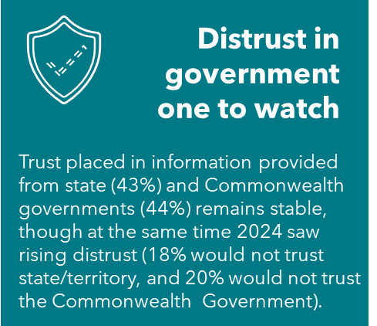 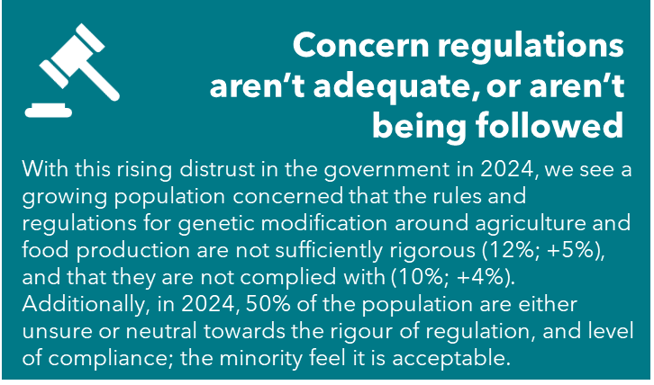

**Paired with the rise in misinformation and use of alternative news sources**

69% of people surveyed felt they are regularly or always exposed to fake news and misinformation, and not everyone is confident that they can identify when something is inaccurate (8% are aware they cannot). Recognition of regulators and as trusted sources of accurate information is crucial with rising fake news and misinformation, in a time when 42% of the community would get their news about gene technology from a general Google search, and 34% from social media discussion.

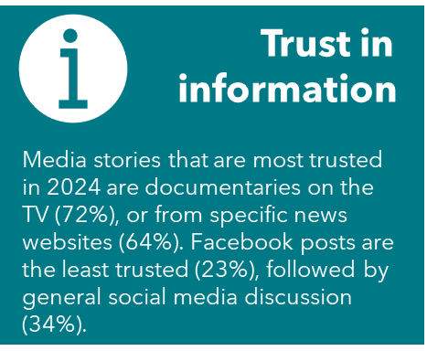 [This image says 'Sources for GM: For information on gene technology and similar technologies, people are most likely to do a general Google search to see what comes up (42%).
'](#_What_does_the) 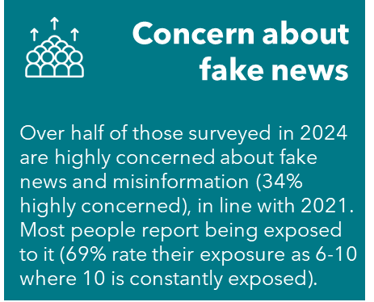 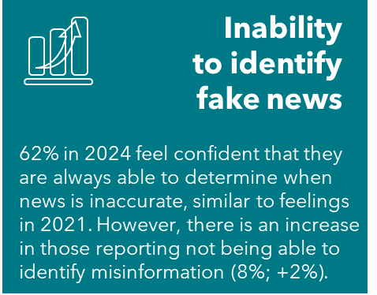

**Awareness of OGTR is increasing**

Despite growing misinformation, the community is increasingly able to recognise who the regulator is. Prompted awareness of the OGTR among the community is sitting at 17%. A greater portion, 31% of the population, could correctly identify OGTR as responsible for the regulation of genetic modification in Australia, making its way into the top four, and a significant increase from 2021 (up 5 percentage points).

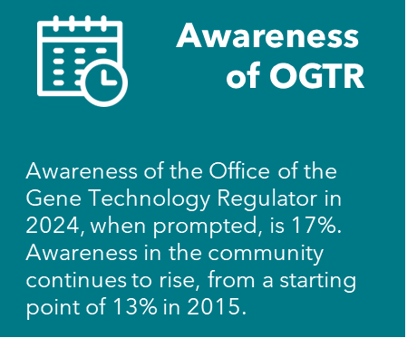 [This image says 'Responsibility for genetic modification regulation: OGTR is seen as responsible for the regulation of gene technology in Australia by 31%, when prompted. This is significantly higher than the 26% in 2021.
However, the community continue to feel the Department of Agriculture is the regulator responsible for genetic modification (37%).'](#_Awareness_and_trust)

Underpinning support of genetic modification is the understanding that it has positive benefits, and that they outweigh any perceived harms. Knowing that it can improve crop yield, quality, predictability and efficiencies led to greater support. In 2021, 54% of the community recognised the benefits of genetic modification and felt it would improve their way of life, and this has reduced to 40% in 2024. For those that don’t know enough about it, there is a risk of lower support, as for 22% of the population to be supportive (of forms of GM such as for the production of food) they need to first know it is safe.

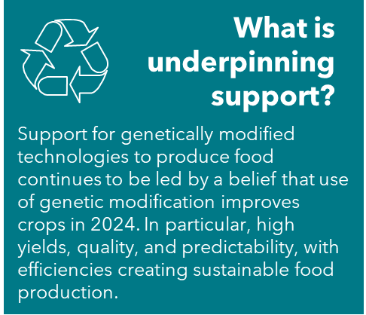 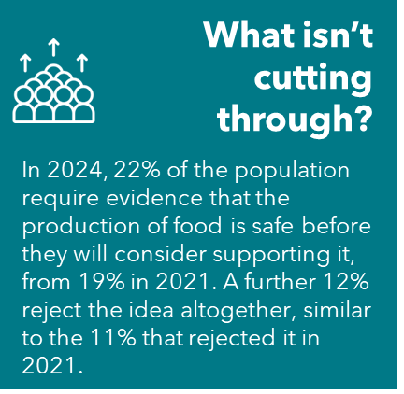 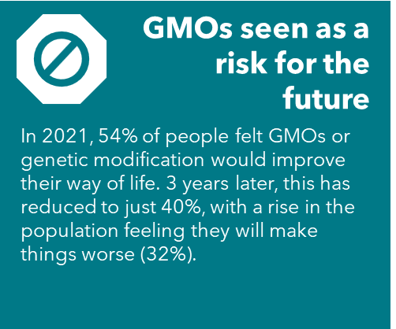

**Interesting differences**

Mirroring patterns seen through the years of attitudinal differences in the community, in 2024 gender differences are apparent. Men are more comfortable in uses of gene technologies, and consumption of ingredients and foods produced by genetic modification, compared to women.

In 2024, a robust sample were farmers, identified by income being derived by primary production from their land. Among these landholders, they were categorised into most of their income from farming, some of their income from farming, and hobby farming. These three groups of landholders showed significant differences to the general population, where there was a closer relationship between those involved in livestock and food production and greater support for uses of gene technology and genetic modification.

For farmers whose income mostly comes from primary production, support for genetic modification and gene technology was greater than for people who do not generate any income from primary production (64% compared to 32%). Similarly, farmers showed greater support for uses in food and crops (63% to 31%), and believe it is a safe way to produce food (43% compared to 16%).

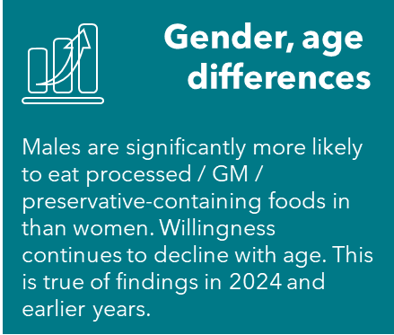 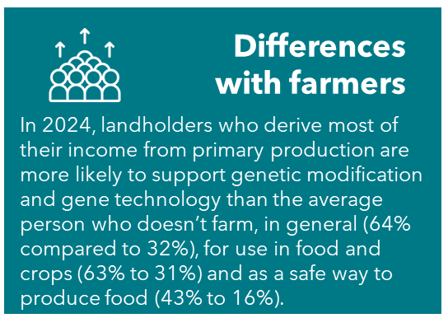

**Impact of COVID-19**

The data suggest there are no significant lasting influences from the COVID-19 pandemic on community attitudes, understanding or awareness of OGTR, or genetic modification more widely. For the majority, it played no part, and for others, the pandemic cemented their attitudes or increased concerns, which since appear to have largely returned to levels seen in 2019.

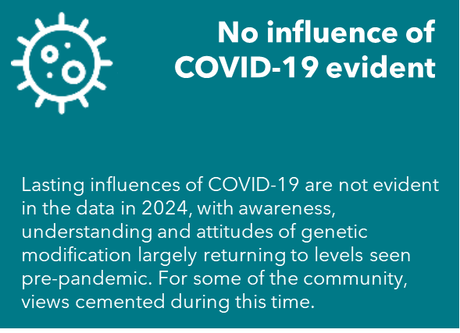

# Trends since 1999

Support for various uses of biotechnology and genetic modification has varied considerably over the 25 years since 1999 when measurements began. In the absence of knowledge, public support is responsive to external stimuli and global factors, most likely when attention is focused on the issue by media and special interest groups – either positively or negatively. With worsening knowledge over time in the Australian community of what genetic modification is, and even if it is being used, attitudes will be based less on knowledge and more on other factors. So, when forming personal views about whether to support a new field of science like biotechnology and genetic modification, people interpret information through the filter of their values, feelings, and past experiences. Hence, survey responses are assertions of a mixture of facts, opinions, beliefs, or prejudices.

Ideally, OGTR want community members to base their support for genetic modification on verifiable facts by searching for the evidence. However, facts about genetic modification need to be contextualised and conclusions provided about the benefits being delivered to give these facts meaning. The context for genetic modification remains missing for a community with low levels of knowledge, increasing distrust of science and governments, and a growing belief that science benefits the rich. The rise of fake news and misinformation leads the community to be highly susceptible to inaccurate information around genetic modification. There is a continued lack of trust in governments, and the emergence of AI has fuelled general distrust of information sources.

As such, support for many forms of genetic modification applications has been quite variable since 1999. In recent years, acceptance that genetic modification technology can safely be used in the production of food has risen from a low of 13% in 2017, to a high of 19% in 2024.

Perhaps the best example of the wide variation in support is with using genetic modification in food and drinks (which has been measured since 1999) which has finished slightly below the level of support when measurements began in 1999. After strong support in the early 2000s (73% in 2007), support declined markedly through to 2015 when only 49% supported its use. This was followed by a steady but small rise in support until 2021, to 60%. Currently, support for use of gene technology in food sits at just over half the community, or 53%.

In 2024, support for the use of biotechnology and genetic modification for making plants more pest resistant (66%) remains far greater than support for its use in food (53%), a trend that emerged at the turn of the century.

Figure 1: Attitudinal changes towards biotechnology and genetic modification over time

This chart depicts attitudinal changes from 2019 to 2021, across a range of technologies including 'use human genes in medicines/vaccines', 'make plants more pest resistant', 'using stem cells to conduct medical research and treat diseases', 'using gene technology in food and drinks' and 'using human genes in animals for growing organs'.


Trust in OGTR (and its precursor) has remained at high levels since measurement began in 1999, with 69% of the Australian community trusting in information provided by the organisation about the risks and benefits of genetic modification and gene technology.

The possible influence of the COVID-19 pandemic showed spikes in trust, at 74% in 2021, which have since levelled out in 2024.

Figure 2: Changes in awareness and trust in the OGTR

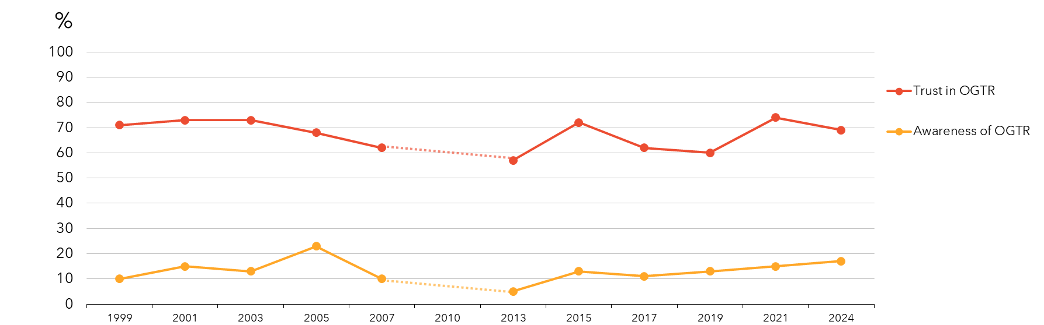

When it comes to general support for the use of GM or genetic modification, the Australian community have been consistent in their views; 38% in 2024 are supportive or completely supportive of it. A similar proportion don’t feel strongly either way (37%). Fewer are against its use, generally (20%).

Figure 3: General support for genetic modification or gene technology from 2015-2024

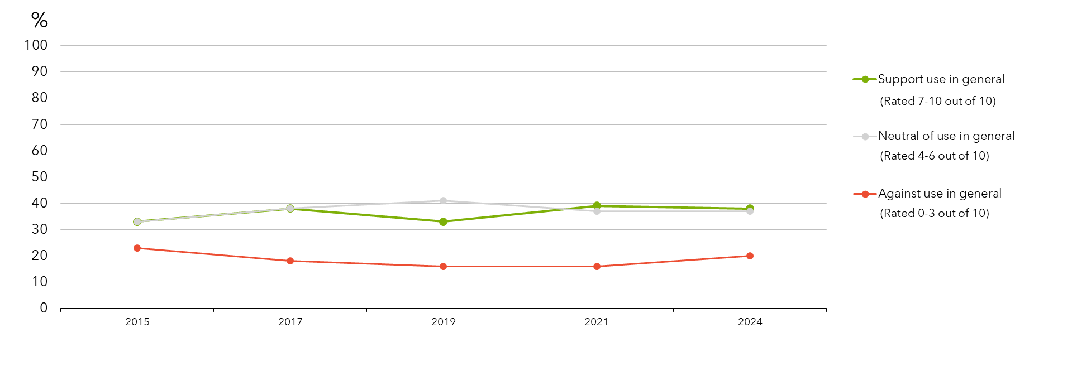

Support is different for different applications but follow similar patterns. The community continue to show greatest support for its use in generating therapeutics or medicines, decreasing from a peak of 51% in 2021, to 45% in 2024. This is followed by its use in crops (42% support), food (40%), gene editing (37%) and finally in the cloning of animals (30%). In 2024, we see similar levels of support to 2019.

Figure 4: Support for genetic modification from 2015-2024

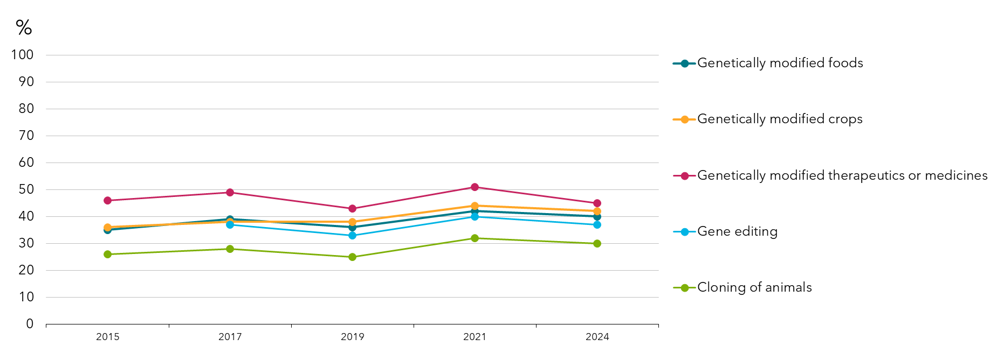

Some of the key findings in relevant studies over the past few years, that help explain the context of public attitudes, trust and concerns, include:

*The Edleman Trust Barometer for 2024*, which provides a good overview of factors influencing changes in public opinion, found that people worry about the quality of information they are receiving from Government, business and the media and want access to information on new technologies that is balanced and addresses their concerns in a real way.[1] The study, *Innovation in Peril*, focused on trust in innovation against a backdrop of ongoing economic and geopolitical instability. Demonstrating how the tone of a survey can affect the findings, when first asked questions that highlighted their concerns, they then found that 57% of people surveyed rejected GMO foods, and 10% embraced them, while 35% rejected gene-based medicines and 20% embraced them.

They also found that key worries amongst Australians, which are relevant to overall feelings of trust, include 70% worry about inflation, 78% worry about hackers, 66% worry about nuclear war, 63% worry about climate change and 56% worry about an information war.

By comparison, a study conducted for Food Standards Australia New Zealand in 2022, found that 30% of the public were supportive of GM foods generally, 44.5% were in the middle, and 25.5% were not supportive. These results, as the study points out, are closer to the 2019 study conducted for OGTR than the most recent study in 2021. The FSANZ study also pointed out that there are many factors, such as trust, and the use to which the technology is put than can influence people’s attitudes.[2]

A 2023 study looking at drivers of attitudes towards new technologies (artificial intelligence, nanotechnology and human gene editing) identified worldviews that influenced attitudes as: faith in science, spirituality, conspiracy beliefs and aversions to tampering with nature).[3]

Several studies found that there was limited public awareness and low knowledge of gene edited foods, which makes surveying people about technologies like CRISPR, difficult.[4]

A 2023 paper looking at trust and New Genomic Technologies (NGTs) argues for continued strong regulation, and found that to ensure trust, GMO regulations “must demonstrate the authorities’ ability to manage the scientific, socio-economic, environmental, and ethical complexities and uncertainties associated with NGTs”.[5]

Figure 5: Trust by awareness of OGTR

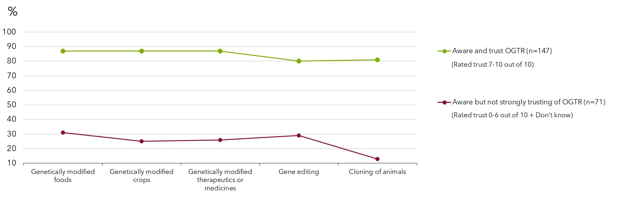

# Implications

The community have varying views on genetic modification and the way it is used. In broad terms, the Australian community can be seen as having four distinct mindsets, or world views, when it comes to genetic modification, regardless of the application.

About one in five (19%) hold a very supportive position when it comes to genetic modification. What is critical to understand is that they know enough to explain genetic modification to a friend and believe that the technology will improve our way of life. Furthermore, as this group focuses on the issues and the benefits, their support rises, and concerns diminish. This indicates that having the ability to understand the technology enough to explain genetic modification appears a pre-requisite for solid support.

The next group, who conservatively support genetic modification and its applications represent almost half of the Australians surveyed (47%). The foundation stone of their support is a solid belief that science is a force for good and will deliver a better life for everyone in the future. It is not knowledge of genetic modification that supports their view but rather a more general belief in science and its contribution to their lives. As such, there remains some questions in their mind about genetic modification that are not fully resolved, and they feel and report some concern about genetic modification. In the absence of enough knowledge, they are reliant on the regulator to ensure that genetic modification is used safely and appropriately. However, knowledge of the benefits that genetic modification delivers appears to shore up their support. The broad communication or information strategy required to reach this group is promotion of the role of the regulator and reinforcement of genetic modification benefits.

While one in five (22%) started the survey quite opposed to genetic modification, as they progressed and became aware of the benefits of genetic modification, their level of support rose, and concerns diminished. This indicates that those in this group with more moderate opposition can be persuaded with knowledge of the role of regulators and information about the benefits of the technologies. As time passes and technologies are proven to help in the medical sphere, in food security and in the environment, it is possible that some will gradually come to support more genetic modification applications. The broad strategy for this group is more genetic modification education, showing the benefits that exist, particularly using case studies of people they can identify with.

There is a group strongly and comprehensively opposed to genetic modification (12%). They have a distrust for science in general and believe that science will not provide them with a better life in the future. Their distrust of genetic modification stems from a strongly held belief that people (and science) should not meddle with nature. They are unwilling to eat any ‘genetic modification-tainted’ foods as a result of concern about the technology and what it may have done to their food. The distrust of science includes their views on vaccination where they do not agree that being unvaccinated poses a risk to others – and all these views, they say, have firmed as a result of the COVID-19 pandemic experience.

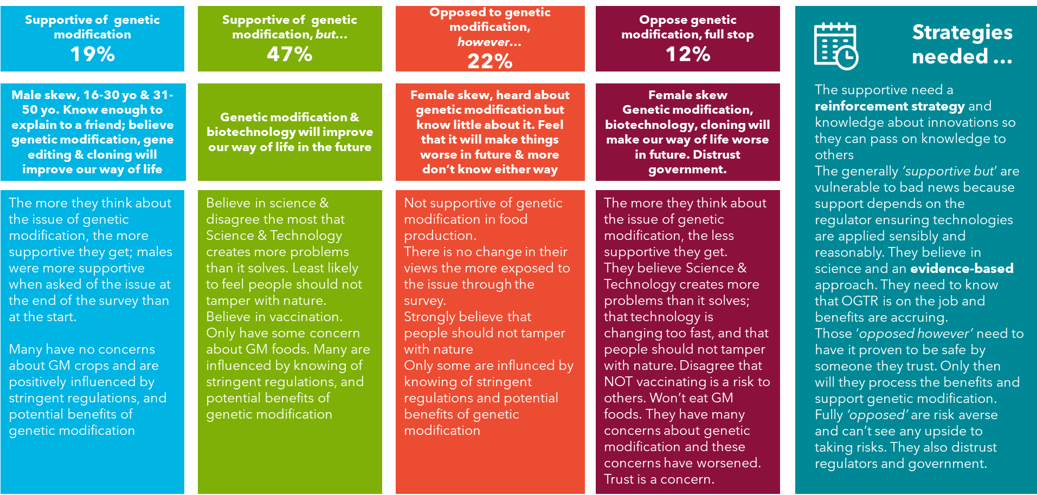

Project Background

# Background, objectives, and methodology

The Gene Technology Regulator (the Regulator) administers *the Gene Technology Act 2000* to protect the health and safety of people and environment by identifying risks posed by or as a result of gene technology and manages risks by regulating dealings with genetically modified organisms (GMOs).

Gene technology is a form of biotechnology. Biotechnology includes the use of biology in agriculture, environment, and pharmaceutical development. It also refers to the production of GMOs and the manufacture of products from them. Recent activity in biotechnology involves directly modifying genetic material of living things, referred to as genetic modification, recombinant DNA technology, or genetic engineering. Other types of biotechnology include using enzymes and bacteria in applications such as waste management, industrial and food production, and remediation of contaminated land. The largest sub-sector of biotechnology companies in Australia work on therapeutics, such as pharmaceutical development and medical procedures. Other sub-sectors are agricultural applications, and diagnostics.

Community support is crucial to the development of the Australian biotechnology sector. If Australians are not in favour of an application, research and development in this area will be constrained and a host of potential benefits in fields ranging from medicine to textiles could be missed, resulting in a lost opportunity for individuals, industry and the nation as a whole. Public attitudes help shape both industry uptake of emerging technologies and the underlying regulatory framework for them.

Over recent years, there have been a number of surveys of community attitudes towards biotechnology that have helped gauge the state of Australian public awareness, identify knowledge gaps and track changes in awareness and attitudes over time. The findings have been used to develop strategies to engage with the community on these issues including increasing public awareness of developments in emerging technologies. This study continues to track those community attitudes and behaviours.

## Objectives

The research objectives for this study were:

* To explore current awareness, attitudes and understanding towards general science and technology, genetic modification, specific biotechnology issues and specific applications and controllers of the technology
* To explore differences in awareness, perceptions and attitudes according to key demographic variables such as age, gender, location and education, and in terms of mindsets to determine segments in the community
* To understand if the COVID-19 pandemic has a long-lasting influence on attitudes towards genetic modification

## Methodology

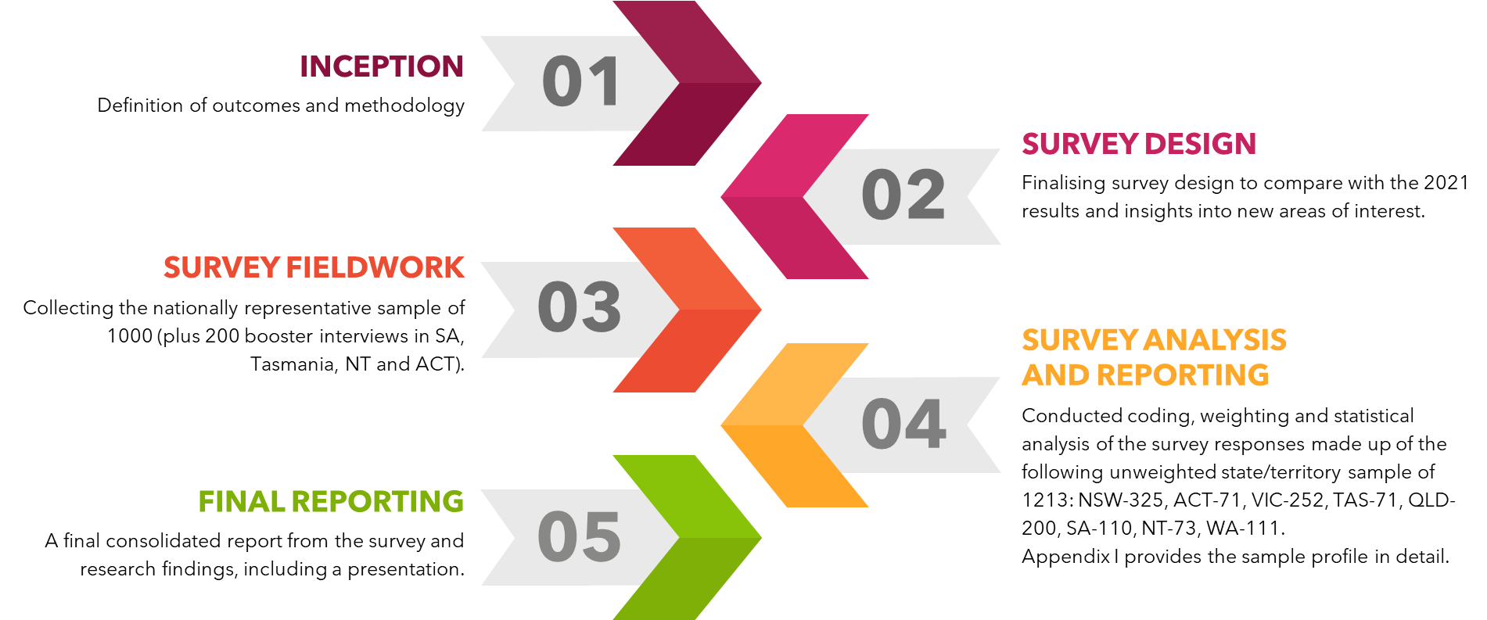

### Stage 1 – Inception and planning

An initial online meeting was held with the Office of the Gene Technology Regulator (OGTR) to define the outcomes sought and assess the best options to deliver the project in the timeframe specified. The existing body of knowledge was considered, including past and current community attitudes and areas of concern, past and current strategies and initiatives, and the effectiveness of these.

External factors affecting perceptions of gene technology, innovations and its regulation and also the social, technological, political, economic and legislative contexts affecting these were discussed.

The survey methodology was agreed upon, replicating the survey methodologies of previous years and eliminating the impact of externalities. A sample size returning to the 2019 and earlier methodology was decided upon, after a larger sample in 2021.

### Stage 2 – Survey design

Cognitive testing of the draft survey was undertaken in 2019 to ensure respondents understood what they were being asked, and only minor changes were made, with no additional piloting necessary in subsequent years.

Survey questions ensured accurate and reliable tracking from previous years. Changes made in 2021 to the survey were maintained in 2024, such as:

* The inclusion of questions around the impact of the COVID-19 pandemic on attitudes
* Separation of industrial and therapeutic uses of GM technology
* Attitudes towards genetic modification in livestock expanded to include heat tolerance and disease resistance
* Questions around nanotechnology were removed

Care was taken in the survey design to manage the tendency of respondents to favour a ‘risk’ response which could easily distort findings and make concerns appear higher than they actually are. The survey covered the following areas:

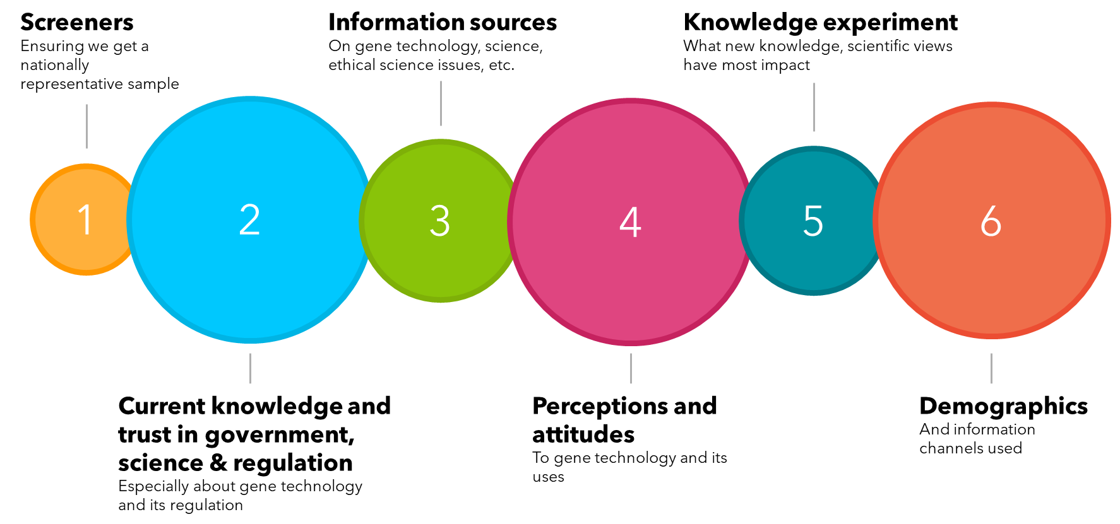

The final survey was approved by OGTR.

The following definitions were provided to survey respondents:

This table shows definitions provided to survey respondents for terms used. They include: Genetic modification or GM is using laboratory techniques to basically, “cut and paste” a gene from one living thing to another, or modifying or removing a gene within an organism. Something that has been modified by GM can be called a genetically modified organism (GMO). 
Gene editing also known as genome editing, is a laboratory technique to make small, targeted changes to the genes of an organism. It does not involve the transfer of a gene from one living thing to another. One of the most common techniques used to edit genes is CRISPR (clustered regularly interspaced short palindromic repeats).
Biotechnology is a broader term that covers the application of the science of living things, and is used widely in agriculture, beer and wine production, food processing and medical treatments. Biotechnology sometimes uses genetic modification, but also includes processes that do not involve the use of genes. 
Cloning of animals another form of assisted reproduction in animal husbandry which allows livestock breeders to create an exact genetic copy of superior breeding animals to produce essentially an identical twin for the purpose of healthier offspring. Cloning does not manipulate the animal’s genetic make-up nor change an animal’s DNA. 
Synthetic biology is a new form of biotechnology, where the principles of engineering are used to build new biological structures that might not otherwise have existed, such as creating new organisms to use in medicines or to clean up oil spills.

### Stage 3 – Survey fieldwork

The 18-minute survey was completed between April and May 2024 using an online survey to ensure a nationally representative sample of 1213 Australians (the core sample of 1000 was boosted to ensure analysable samples from the smaller jurisdictions of Tasmania, NT, South Australia, and the ACT). Quotas were set for states and territories, rural and metropolitan, and gender. Recruitment for the online survey was taken from a reputable research-only panel.

The male to female ratio was 50:50 with 560 males and 560 females and represented a similar age profile to that of the 2021 study. The combination of a representative national sample with quotas and weighting, delivered a sample that could be directly compared to the previous research and accurately identify changes in the views and attitudes of the Australian community.

While the people sampled in this survey were not the same individuals sampled in previous surveys, they were drawn from similar demographic areas, so the responses obtained, while not indicating individual changes of attitudes, captured the movement of attitudes across the broader population.

### Stage 4 – Survey analysis and reporting

Data cleaning and coding was conducted on the survey responses. The results were weighted to the Australian population based on the most recent ABS data by state/territory, age and gender. In 2024, this was the 2021 ABS census data. The unweighted state/territory sample was NSW-325, ACT-71, VIC-252, TAS-71, QLD-200, SA-110, NT-73, WA-111.

Appendix 1 provides the sample profile in detail. The analysis included frequency counts and cross tabulations, significance testing, mean calculations and cluster analysis. The survey results were presented to the OGTR.

**Weighting of the data** – The actual sample profile provides the unweighted responses. The results presented in the rest of the report are weighted to the Australian population based on 2021 ABS data by state/territory, age and gender.

**Statistical significance** – 5% at 95 percent level of confidence – All tests for statistical significance have been undertaken at the 95 percent level of confidence, and unless otherwise noted, any notation of a ‘difference’ between subgroups means that the differences discussed are significant compared to the sample average at the 95 percent level of confidence. The report only notes those differences that are statistically significant, and these differences are marked in the graphs and tables by a pink circle/oval or a green square/rectangle where they are different to the aggregate sample, compared with other segments. The legends on the charts denote whether the responses being compared are by year (2021, or 2021, 2019, 2017 and 2015), age, gender and geographical location. For significance testing by gender, the sample base of “other non-binary” genders is too small, and significant differences were compared between males and females.

**Treatment of means** – Where responses are scale variables, for example 1 to 5 where 1 is disagree strongly and 5 is agree strongly, the mean is also calculated with the removal of don’t know and reported and also compared for statistical significance at the 95% level of confidence.

**Rounding of figures** – may result in anomalies of +/- 1% - All results have been rounded to the nearest whole percentage figure and anomalies of about +/- 1% may occur in charts i.e. in the chart above, total percentages for each bar add to 99%, or 100% or 101% due to rounding error.

Net figures are also rounded, which may also result in anomalies. Net results are also rounded after summing the separate proportions rather than simply summing two rounded figures (e.g. ‘% total agree’). For this reason, anomalies of about 1% sometimes occur between net results and rounded results shown in charts. For example, a proportion of 33.3% ‘agree’ rounds to 33%, and a proportion of 12.4% ‘strongly agree’ rounds to 12%. However, when combined to derive the total agree (i.e. agree plus strongly agree), 33.3% plus 12.4% equals 45.7%, which would be rounded to 46%. In this case, the results would be shown in a chart as 33% agree and 12% strongly agree, but the proportion reported as ‘total agree’ would be 46%.

### Stage 5 – Final reporting

The following provides a final and consolidated report from the survey results.

# Main Report

# Main findings

## Awareness and understanding of biotechnologies

Since 2015, the proportion of the population knowing enough about genetic modification technologies to explain them to a friend has decreased. Animal cloning remains the most well-known technology terminology. Even so, the portion of people who know enough about it that they could explain it to a friend has dropped to 27% in 2024, from a high of 39% in 2015. This is a trend reflected across other technologies, with increases in people who have not heard about genetic modification or GMOs (20%), or biotechnology (24%). The Australian community feel they know least about synthetic biology, with half of the population continuing to report that they have not heard of the technology before.

Figure 6: Awareness of genetic modification terminology and understanding – by year

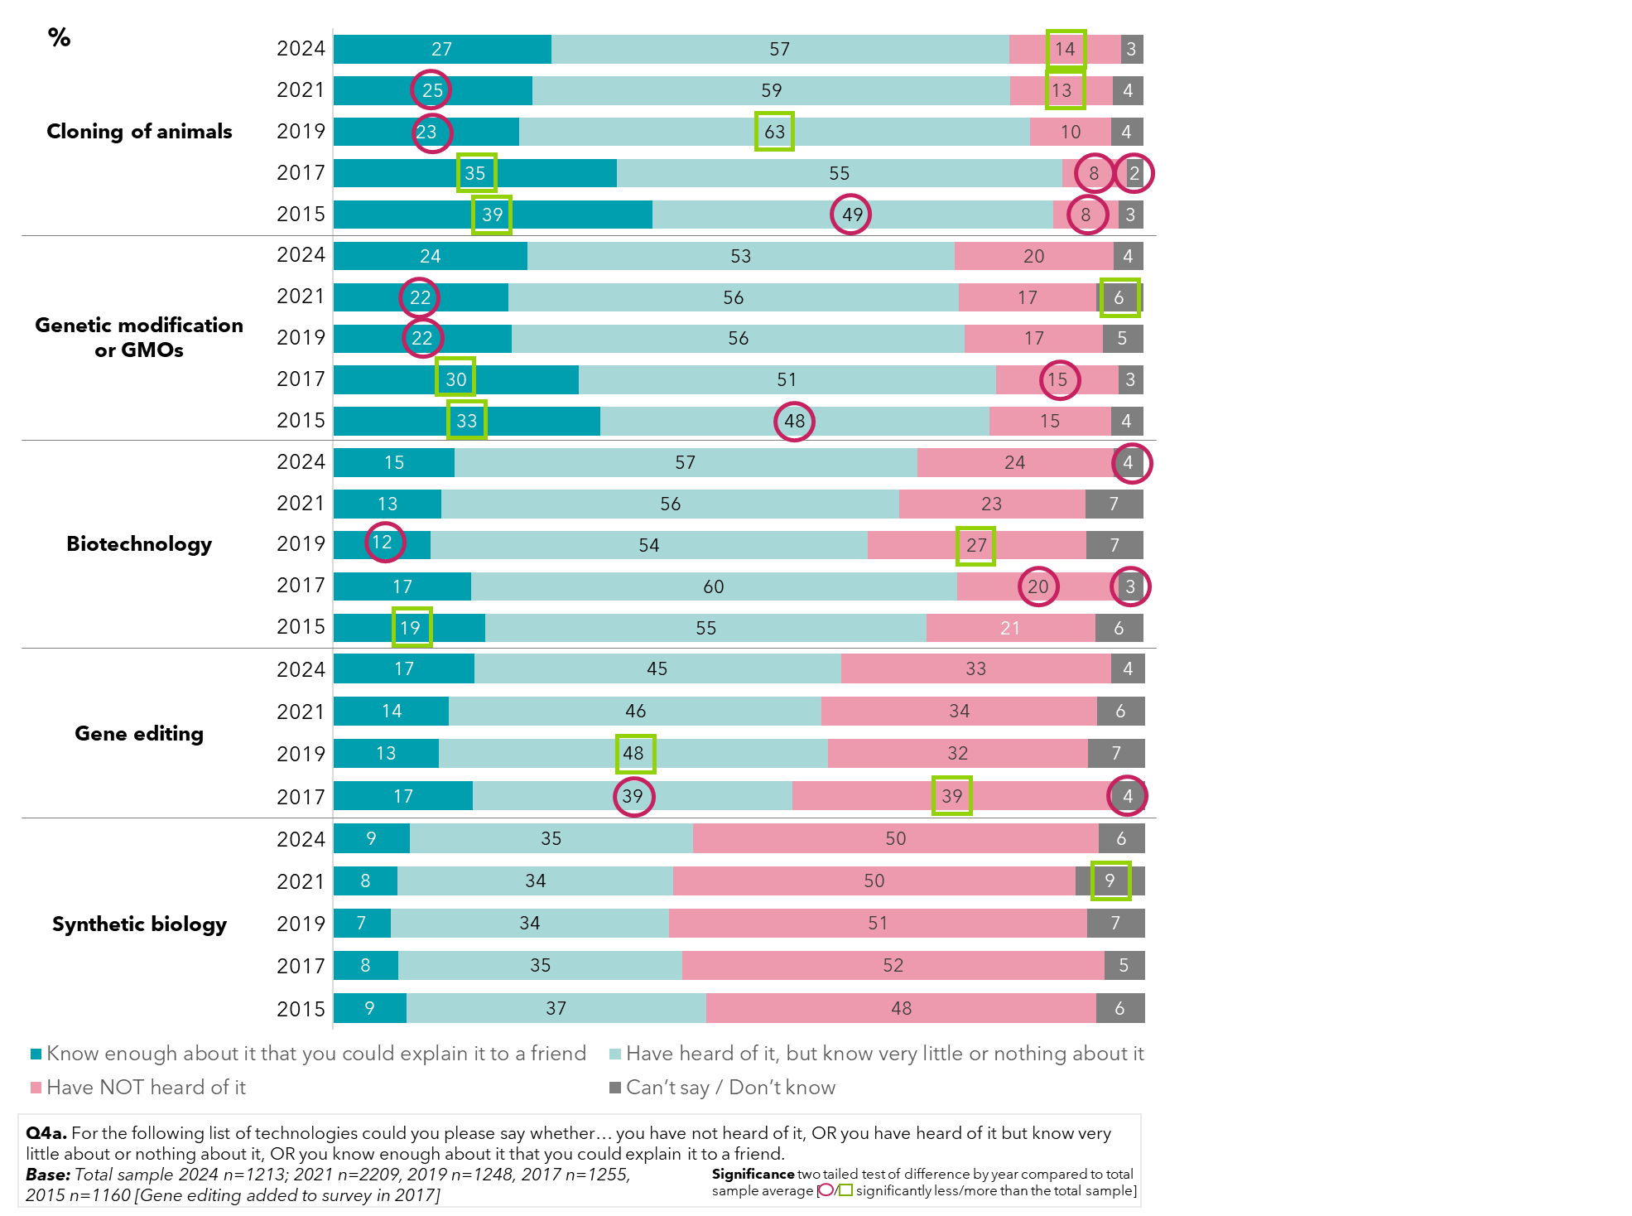

Awareness of the use of genetic modification in Australia remains mixed; often, community members are unsure if foods and crops are genetically modified. The greatest recognition of its use is in processed foods (39%) and vegetable oils (35%). For cotton grown in Australia, a significantly greater number of people than in recent years believed most grown is not genetically modified in 2024 (22%).

Figure 7: Awareness of the levels of genetic modification in Australia – by year

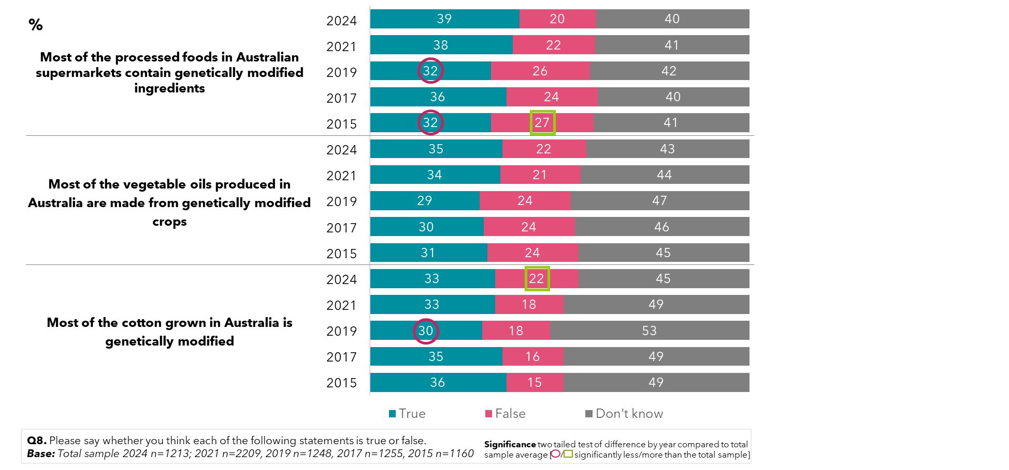

When it comes to fresh fruit and vegetables, 37% of the population in 2024 were correct in understanding that most food grown in Australia is not genetically modified. Although this figure has not shifted dramatically since 2015, there are indications in 2021 and 2024 of a growing misunderstanding of this, with a higher portion incorrectly believing most fresh fruit and vegetables grown in Australia is genetically modified.

Figure 8: Awareness of the levels of genetic modification of fruit and vegetables in Australia – by year

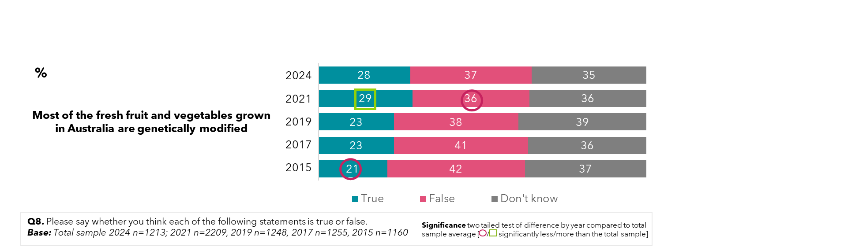

When looking at awareness by age, differences emerge in the community. Younger members of the community, aged between 16 and 30, are significantly more likely to believe genetic modification was involved for ingredients contained in most processed foods (49%) and in vegetable oils produced in Australia (46%). People aged 51 to 75 are more unsure if these are applications of genetic modification.

For cotton crops, however, people aged 51-75 had the greatest belief that they were genetically modified (36%).

Figure 9: Awareness of the levels of genetic modification in Australia – by age (2024)

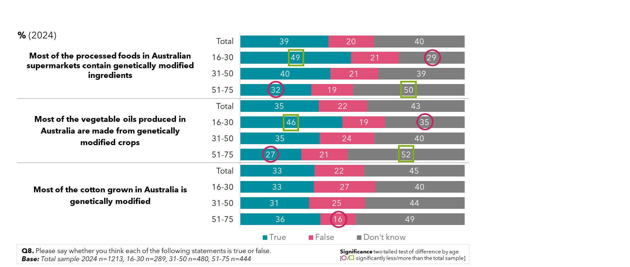

The younger the respondent, the more likely they were to believe that most fruits and vegetables grown in Australia were genetically modified. However, there was little difference in those who felt this was false.

Figure 10: Awareness of the levels of genetic modification of fruit and vegetables in Australia – by age (2024)

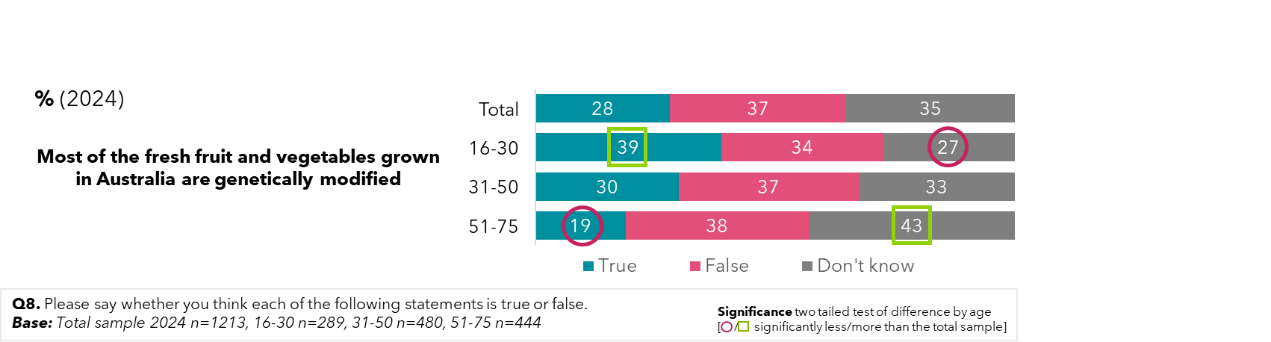

## Perceptions of whether genetic modification will improve our way of life

Following a bump in optimism for the impact of many technologies to their way of life in the future, the Australian community in 2024 have a less optimistic view led by negativity towards the cloning of animals (35%), and towards genetic modification or GMOs (32%). There remains a stable portion of the population unsure of the impacts of these technologies.

Figure 11: Perceptions on whether or not genetic modification technologies will improve our way of life – by year

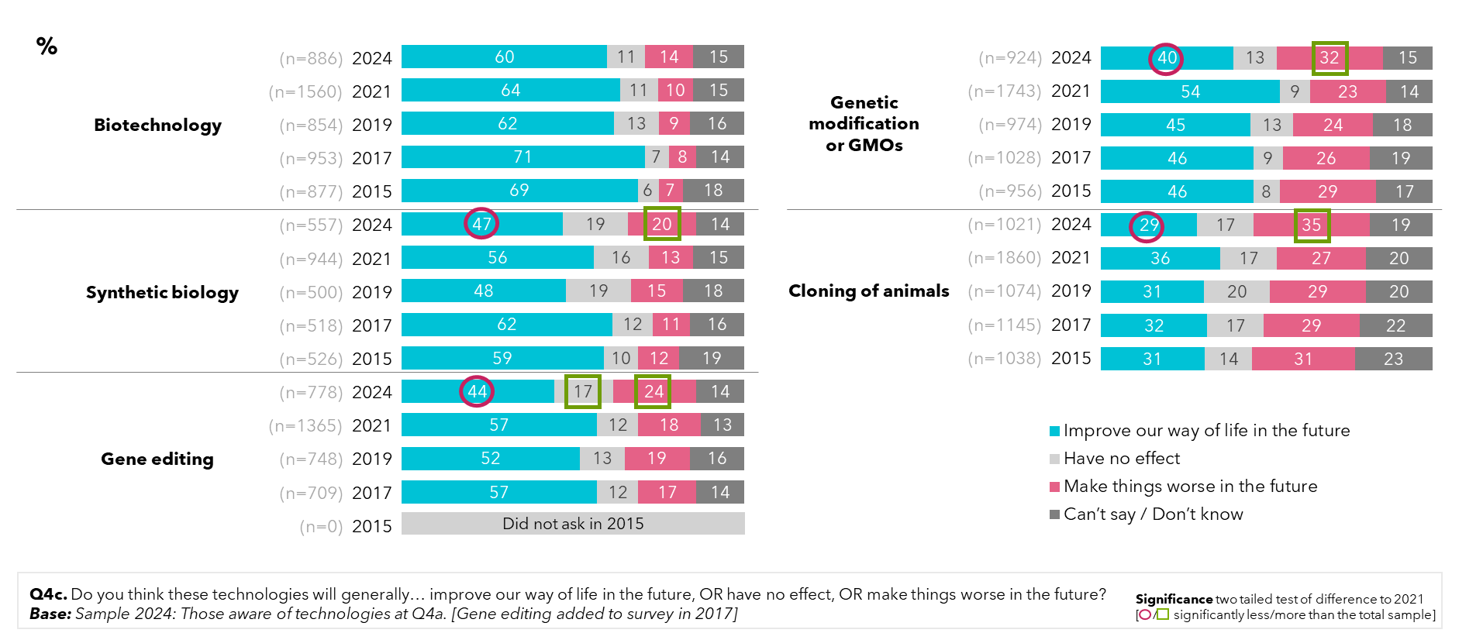

## Support for genetic modification

Support for the use of genetic modification in general has remained stable since 2015, with the largest cohort in support of GM in 2024 (42%), and a quarter of the population feeling neither supportive nor unsupportive (25%).

Figure 12: Support for the use of genetic modification in general

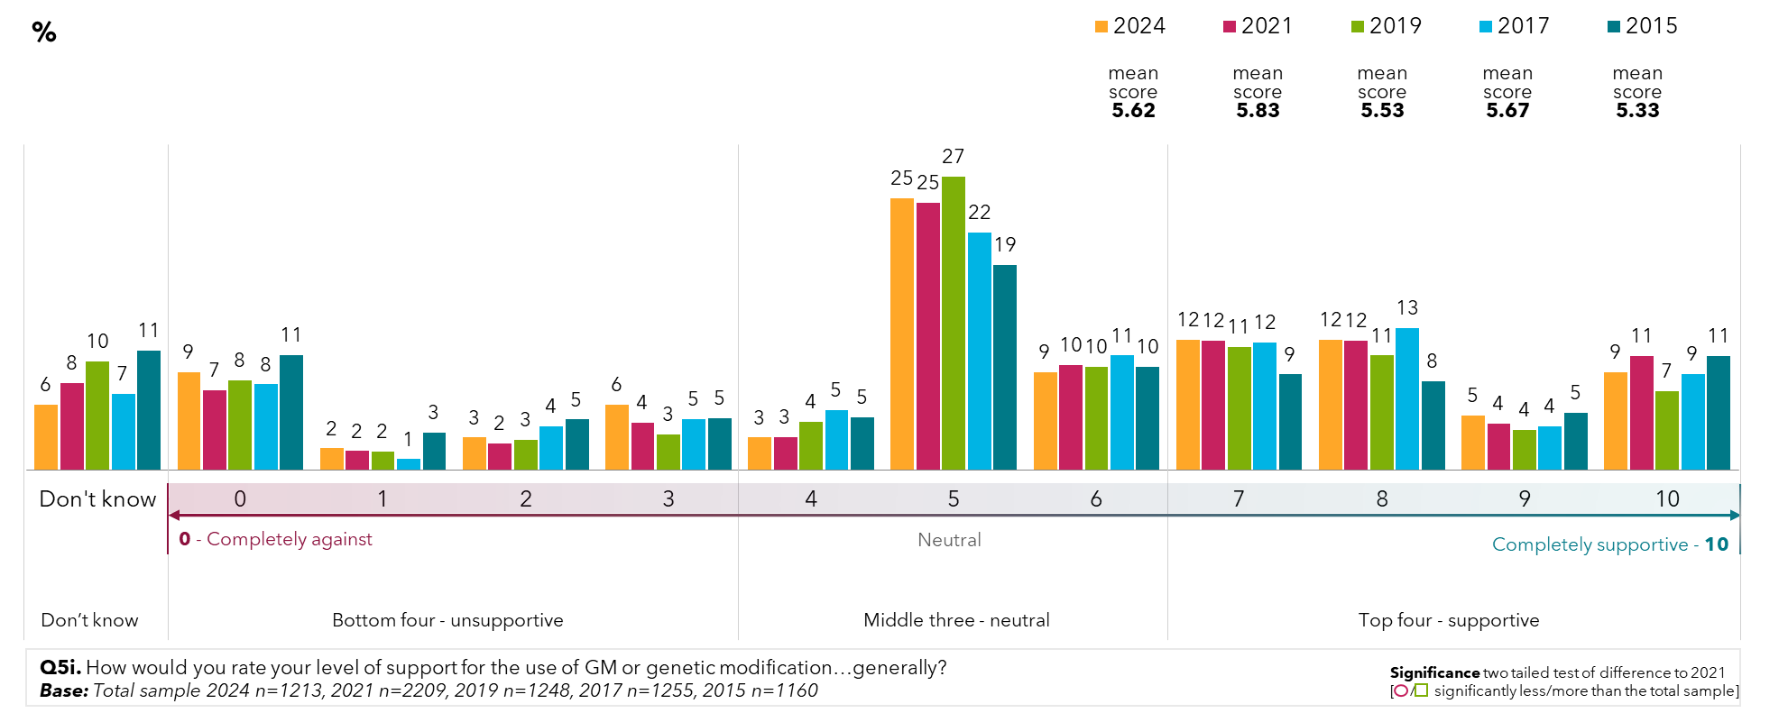

When prompted with specific potential uses of genetic modification, support amongst the population differs to support in general; for medical uses such as producing insulin or vaccines, support is greatest at 56%. Industrial uses such as making biofuels or plastic replacements from plants are also seen favourably by more than half the population (53%). For food and crops, support is waning in 2024 (36%), and is lower in the community for general uses (38%), or other uses (53%).

Support was again higher among those surveyed in 2021 than in 2024.

Figure 13: Levels of support for genetic modification and gene technology for specific uses – by year

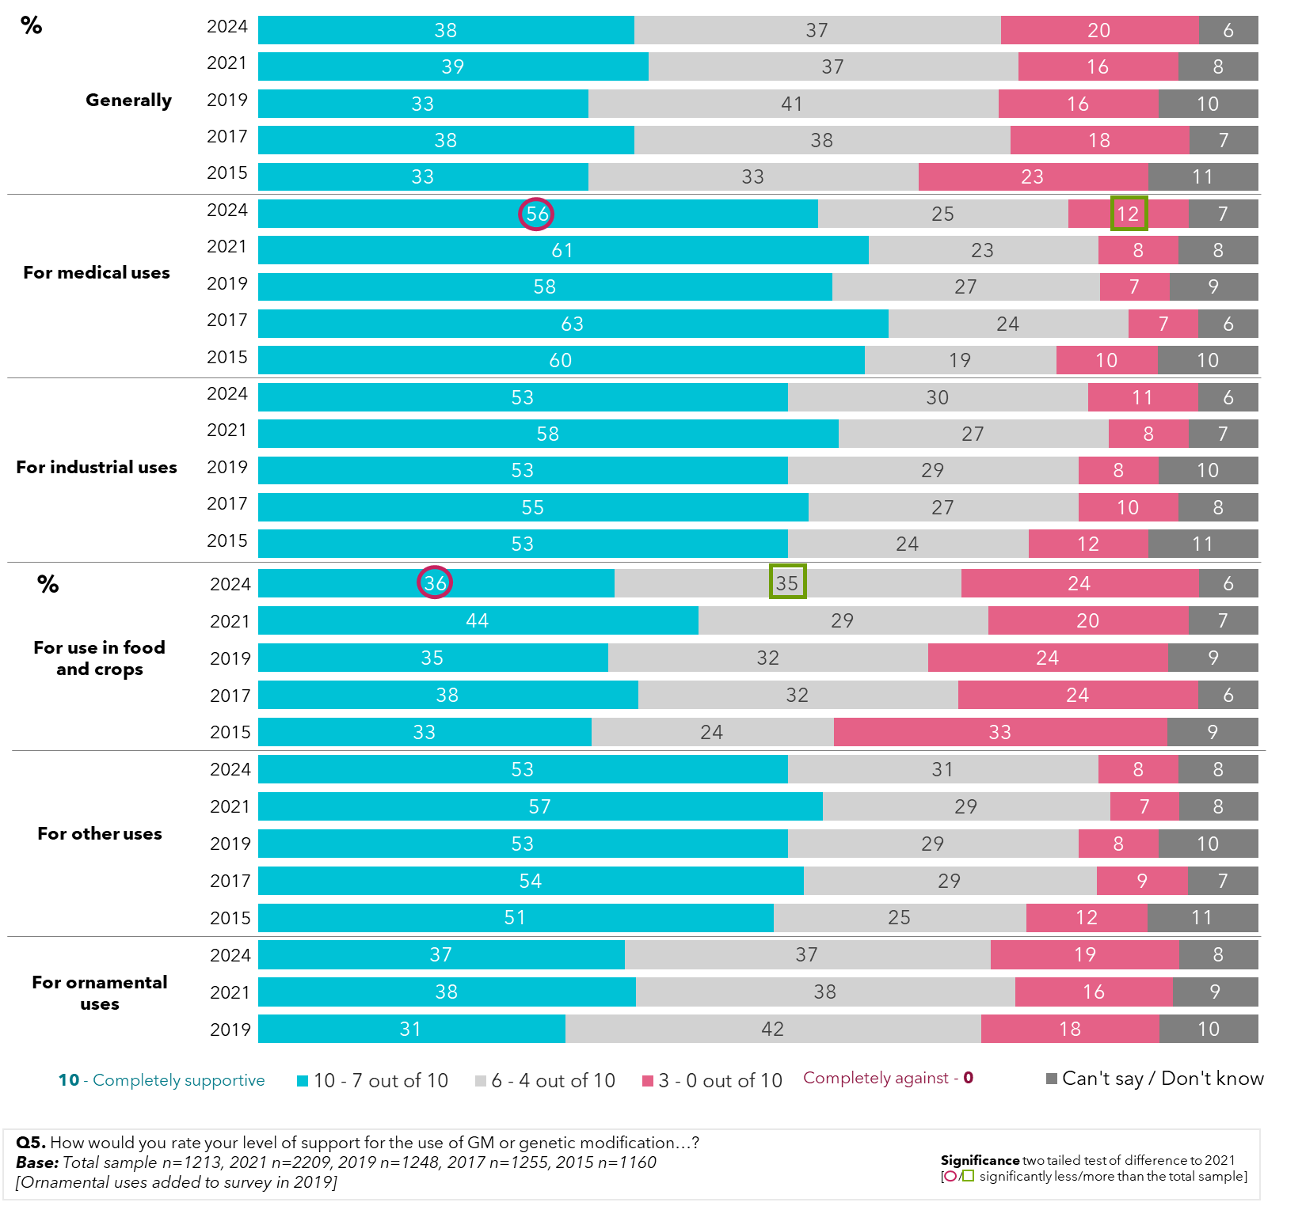

Landholders deriving income from primary production reported greater support for genetic modification in general, and for use in farming, compared to those who do not derive any income from farming. For people whose livelihoods rely heavily on farming, 64% support its use in general, and 63% for use in food and crops (compared to 32% and 31% for non-farmers). Those who hobby farm or derive a part income from the land also showed greater support for these uses.

Figure 14: Levels of support for genetic modification and gene technology for specific uses – by income derived from land

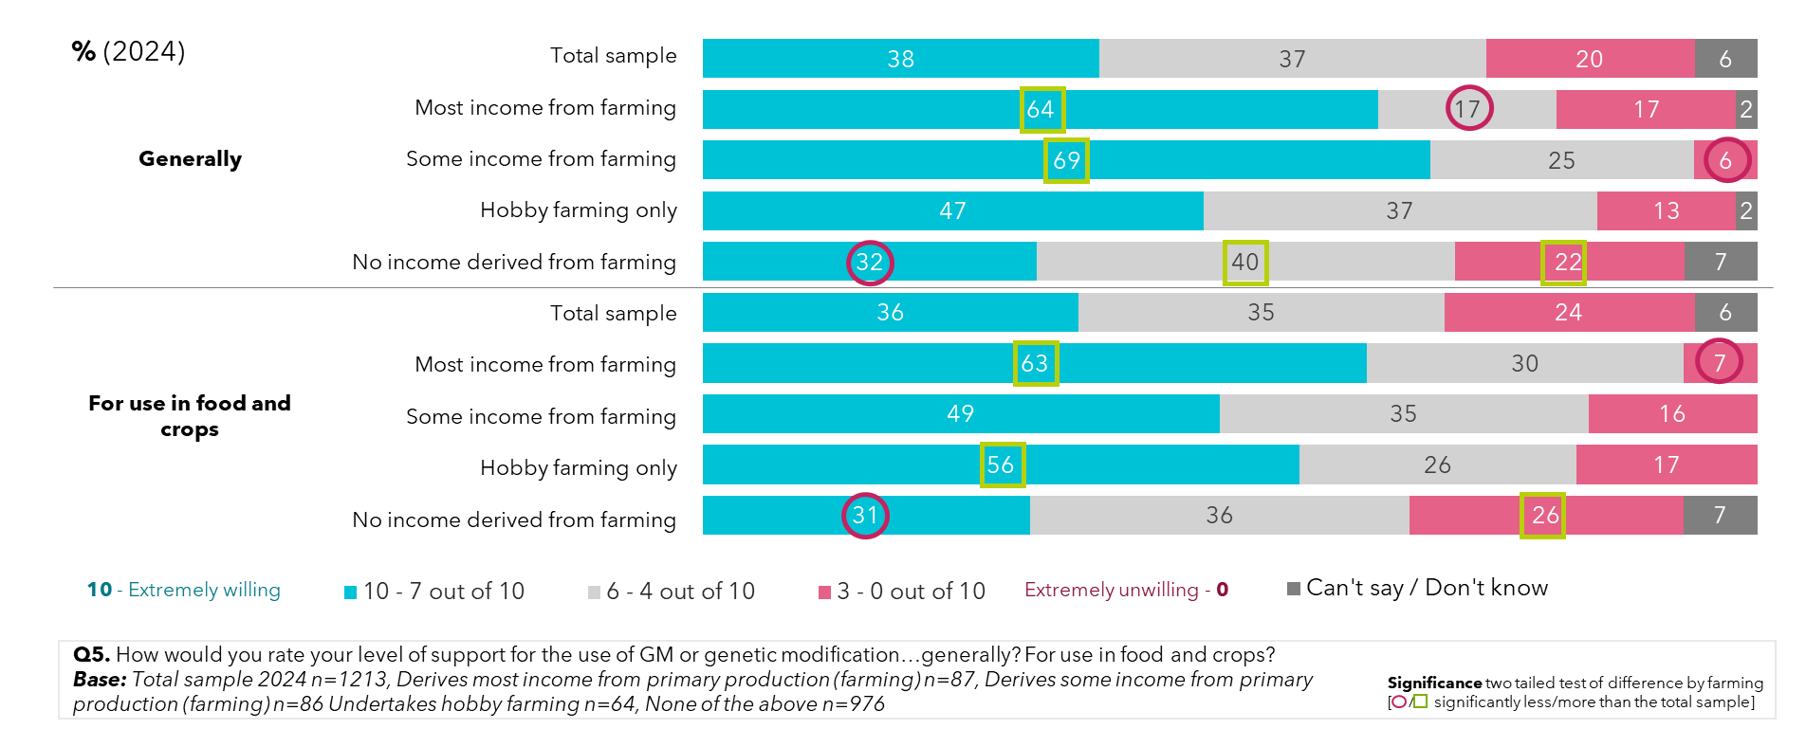

Support for genetic modification and gene technology is lower in 2024 than three years ago, across all 3 livestock uses, including vaccines for heat tolerance, disease resistance and modifying feed to reduce greenhouse gases/methane. These results are closer to those found in 2019.

Figure 15: Levels of support for genetic modification and gene technology for livestock uses – by year

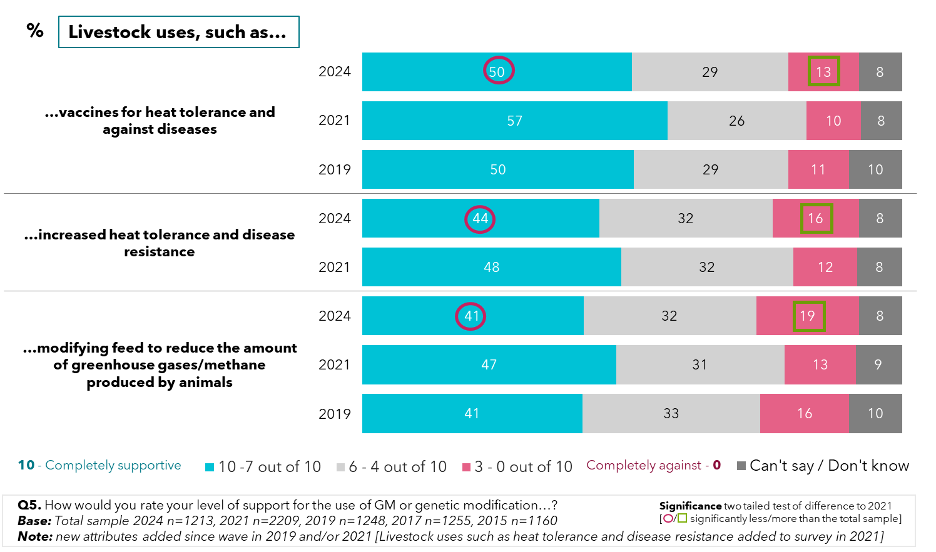

Landholders who derive most of their income from primary production are most supportive of the various livestock uses for genetic modification. The greatest support is in vaccinations for heat tolerance and against diseases (68%), compared to 50% support on average. People who don’t derive income from farming show lower support when it comes to increasing heat tolerance and disease resistance (42%) and modifying feed for reducing methane produced by animals (38%).

Figure 16: Levels of support for genetic modification and gene technology for livestock uses – by income derived from land

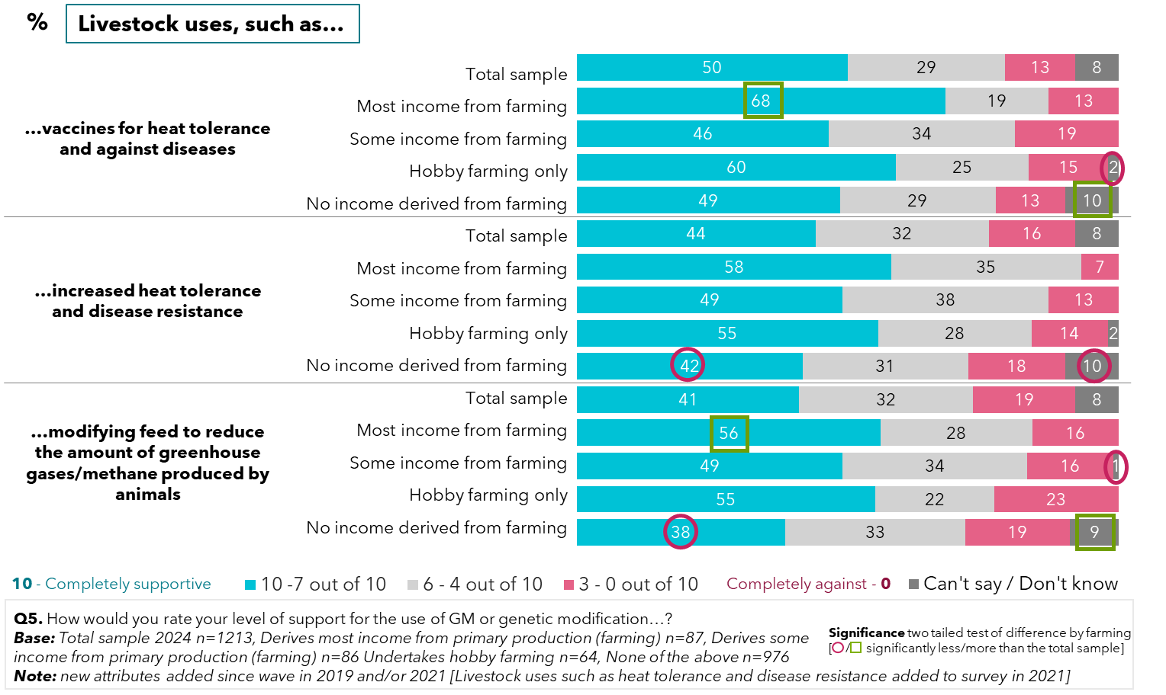

Concerns around tampering with nature (54%) and the speed of technological change (52%) are at their highest levels in 2024, since in the most recent round of surveying began in 2015 and have crossed beyond the 50% mark for the first time. This is true for both those asked at the start of the survey, and those at the end of the survey after having been prompted further on the topic.

There is also a strengthening feeling of divide and inequality among some of the population in 2024, with those answering at the end of the survey more likely to feel scientific advancements disproportionately benefit the rich (54%) and create more problems than they solve (34%). Such attitudes have been steadily climbing since 2015.

The standout issue in this question of the survey was around childhood vaccinations. Almost two thirds believe that not vaccinating children puts others at risk (65%); down from 79% in 2017. Worryingly, the trend of rising neutrality and disagreement with this statement has been consistently worsening and is now, in 2024 at 21% neutral, 10% disagreeing or 4% unable to state an opinion. A total of 35%, which is up from 21% in 2017. This is one of the few trends that has not seen a reset post COVID-19.

This drop in support of not vaccinating children is in line with other studies that have found vaccine hesitancy has increased in Australia, with vaccine services being disrupted by misinformation during the COVID-19 pandemic. A 2014 study in *the Medical Journal of Australia* found that there was an increase in misperceptions around vaccines, with an increase in people stating that vaccine ingredients may cause harm from 14.6% in 2017 to 19.4% in 2023.v Likewise the Department of Health and Ageing’s Australian Immunisation Register, has found that there have been general declines in childhood vaccination rates since peaking in 2020.

Of interest though, the percentage of people who were strongly disagreeing that not vaccinating children put others at risk was lower for those asked the question at the end of the survey, over those who were asked it at the start of the survey (13% compared to 7%). It may be that considering the different applications of GM, both those they might support and those they might not, leads to a slightly less negative view of vaccination, as having people consider both sides of an argument often does – but this would need more work to better understand.

Figure 17: Perceptions towards scientific technology – random samples A + B, by year

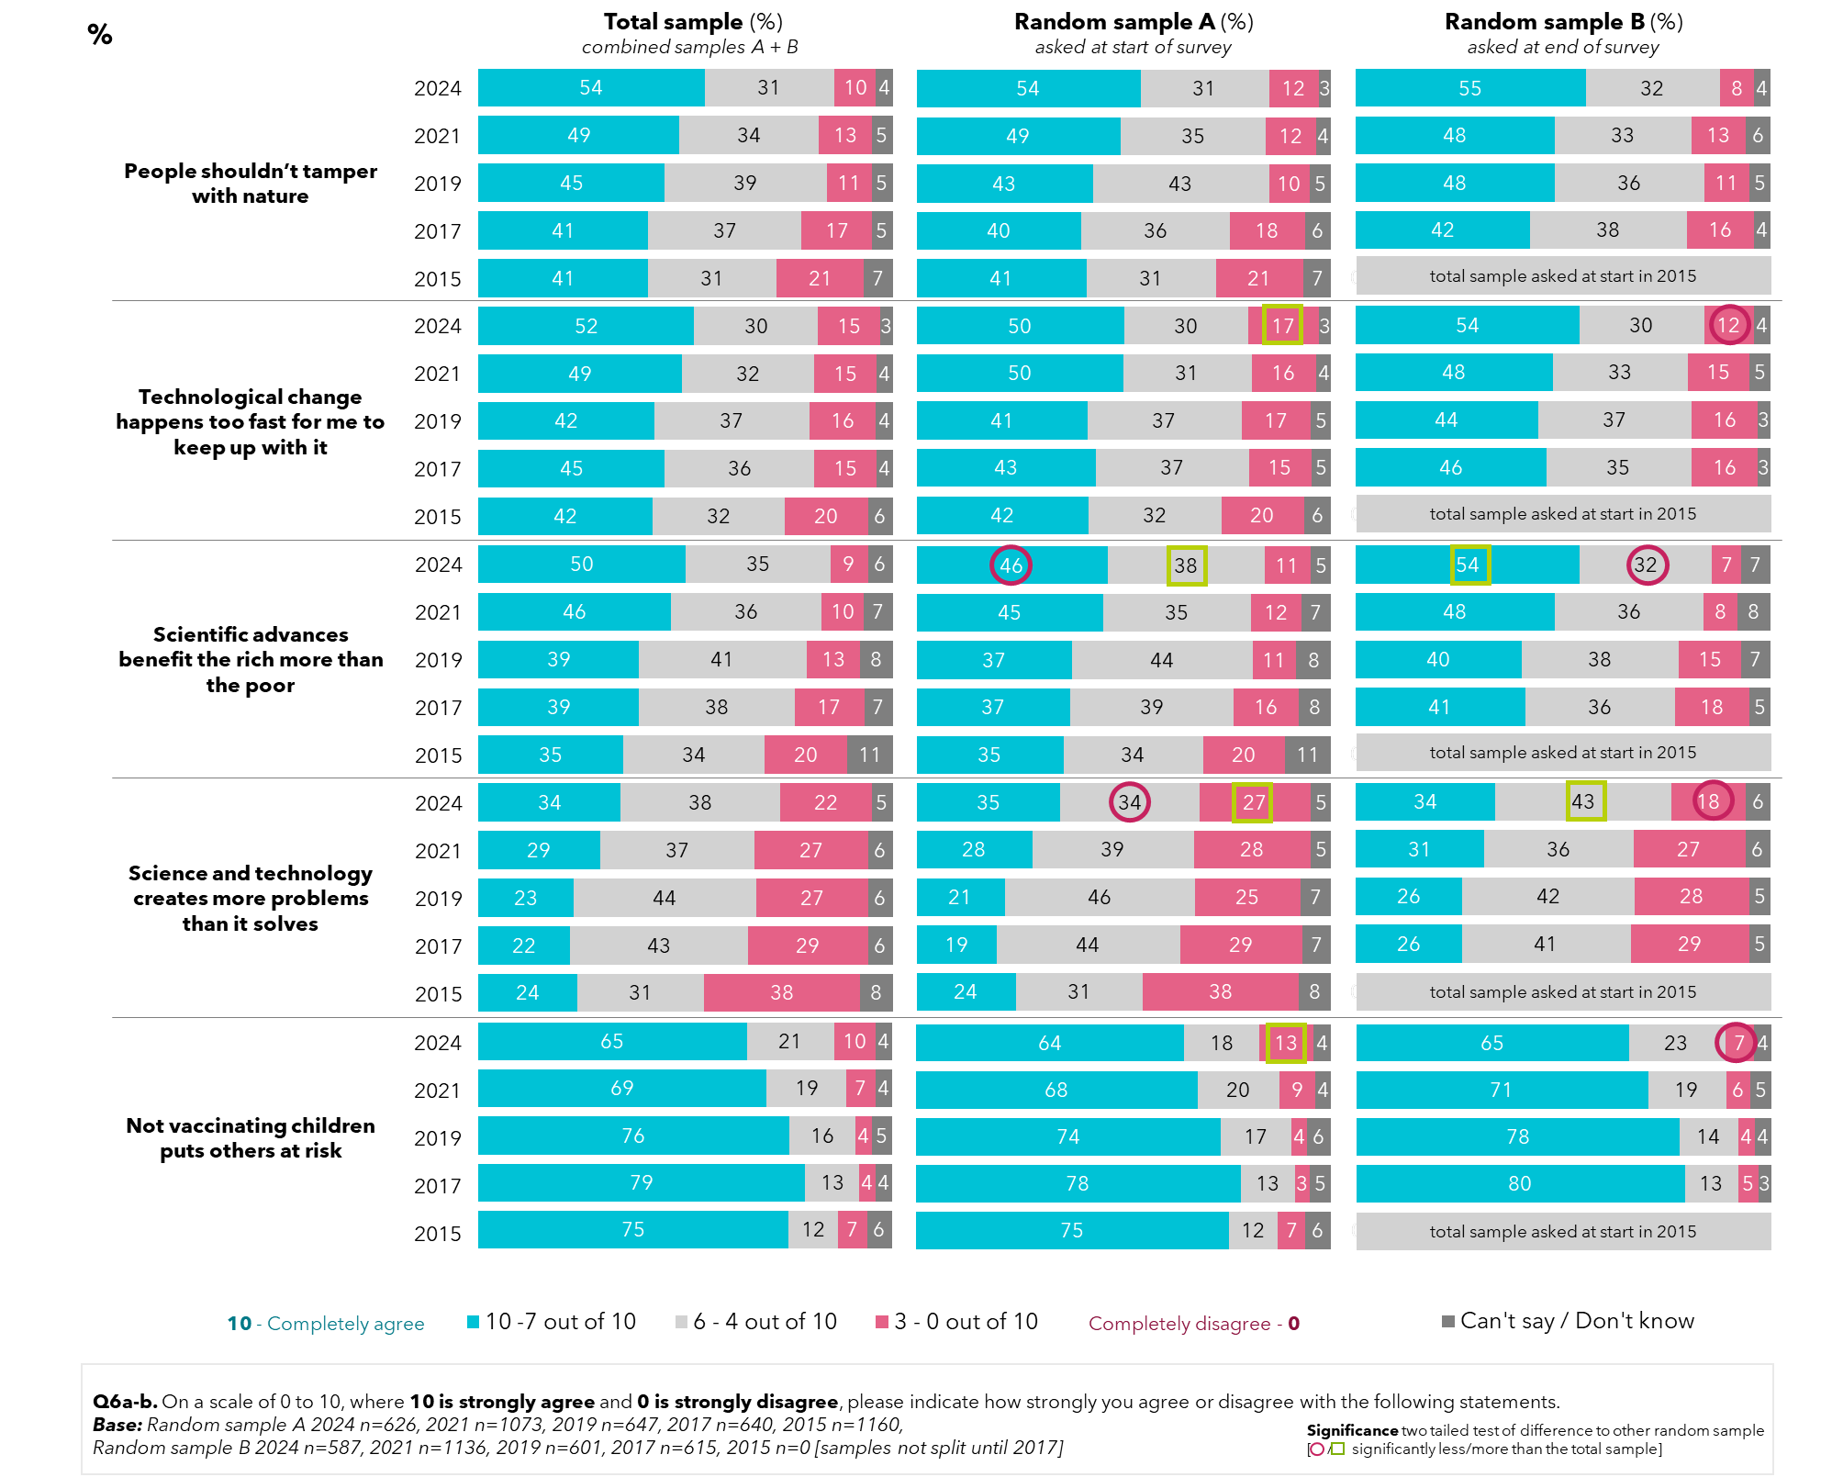

2021 saw a significant rise from 2015 in support for science and technology for biotechnological development, shown by all three mean scores outlined in green in the graph below. For genetically modified therapeutics or medicines, support rose from 43% in 2019, to 51% in 2021 when vaccinations were top-of-mind during the COVID-19 pandemic and declined again to 45% in 2024. In 2024, the influence appears to have diminished, with support reverting to levels more closely seen in 2019, pre-pandemic. Support for genetically modified crops and foods followed similar patterns.

Figure 18: Support for biotechnology development: sciences and technologies (1) – by year

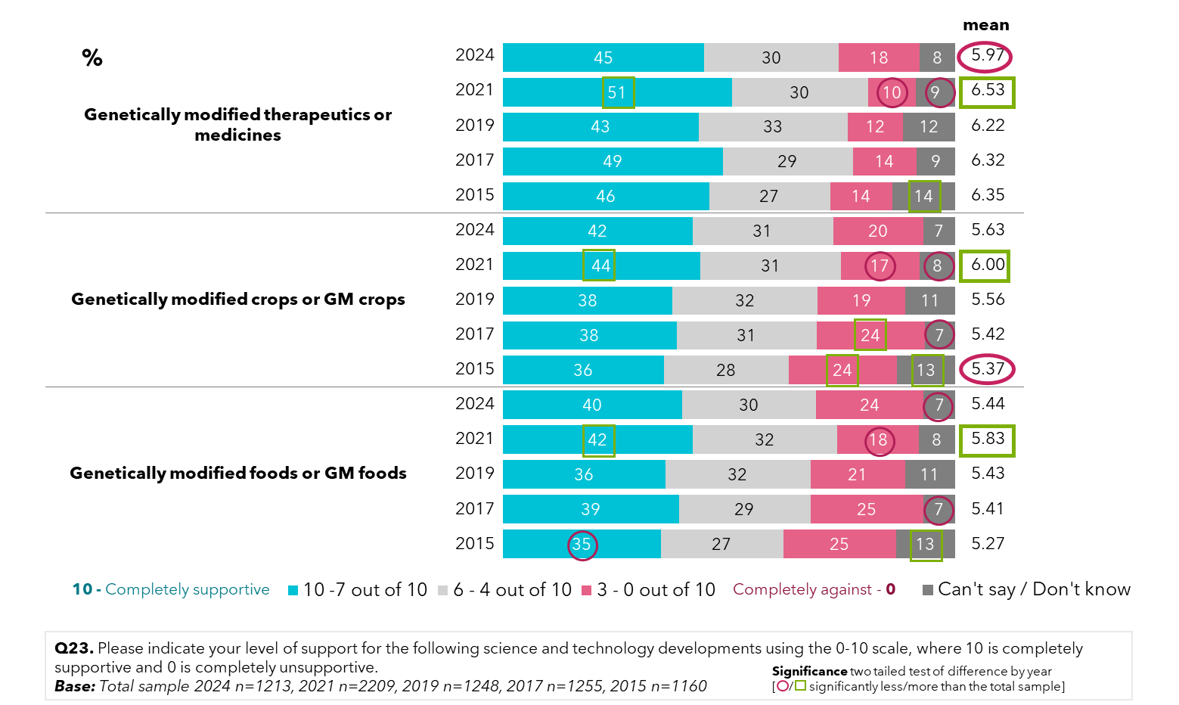

While support for synthetic biology remains at around 38%, there has been an increase in those who do not support it (11% in 2021 to 16% in 2024). Like uses of genetic modification, 2021 had statistically higher mean scores indicating higher overall support than the long-term average.

Of note, despite very low understanding and awareness, synthetic biology is still seen as a more favourable development than gene editing, at 37% support, and cloning of animals, with 30% support.

Figure 19: Support for biotechnology development: sciences and technologies (2) – by year

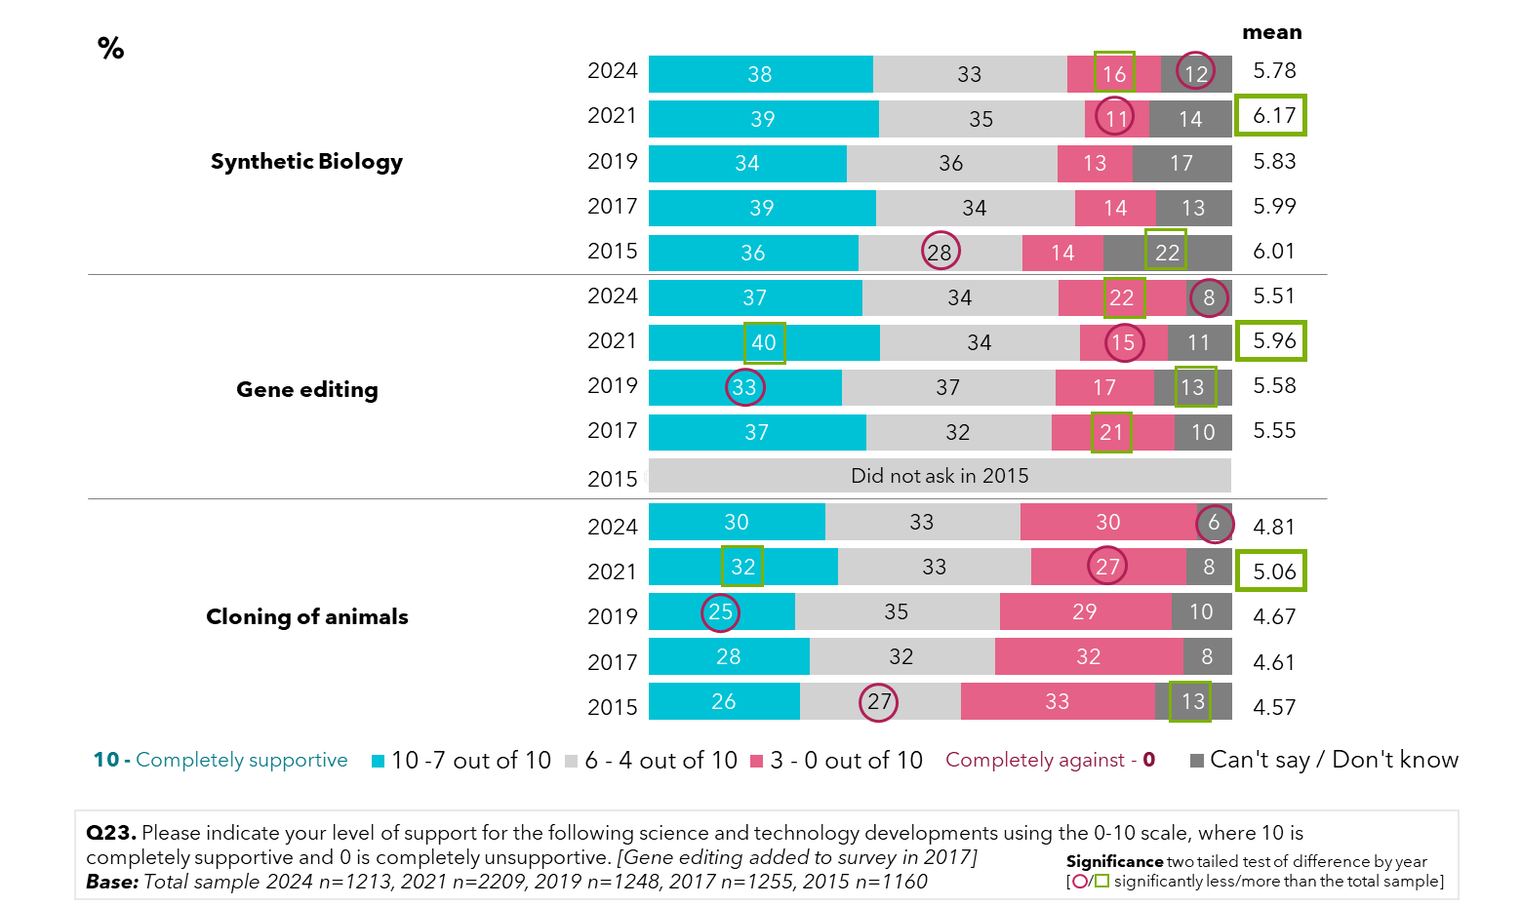

Though there is low understanding of genetic modification, the reasons behind the use of genetic modification in the community still strongly influence acceptance of its use. For determining if genetic modification should be used in foods and crops, the community feel science, safety and morals should play the biggest part, and less thought about the economic impact should be given in these decisions. In 2021 and 2024 post-pandemic, there is a stronger emphasis on science and safety over morals.

Figure 20: Support for basis of genetic modification food and crop decisions – by year

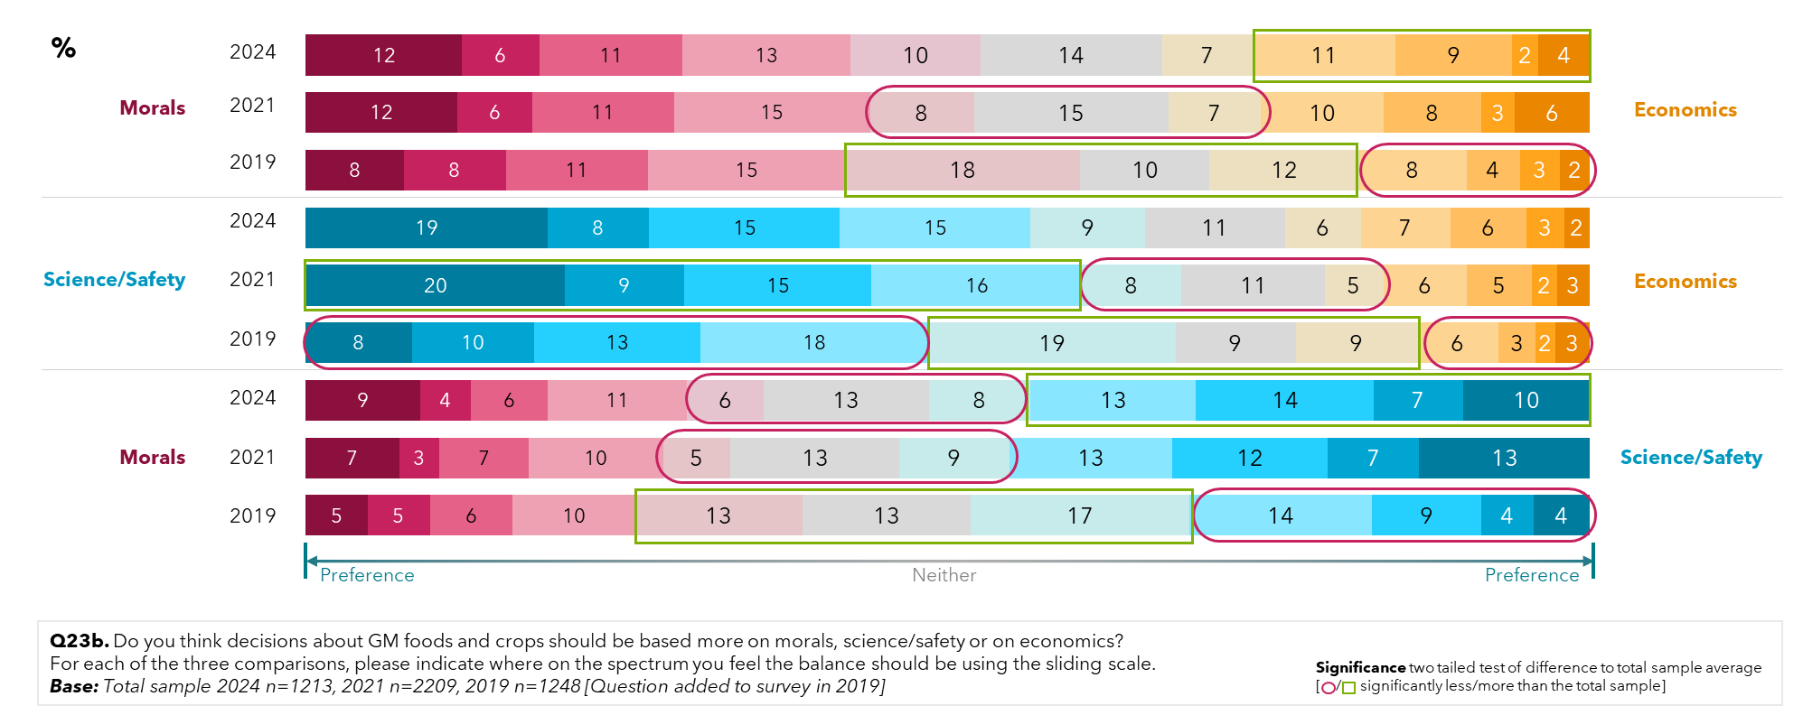

## Confidence in the genetic modification of crops and food

Since 2017, the level of support for the use of genetic modification in food and crops has remained steady. Again, 2021 brought greater support of this use, with mean support dropping back in 2024 (from the mean of 5.84 back to 5.40). This was driven by a drop in the proportion in the top four rating scores out of 11, for being supportive of GM foods and crops (from 44% in 2021 to 36% in 2024).

Figure 21: Confidence in food and the support of the use of gene technology in food and crops – by year

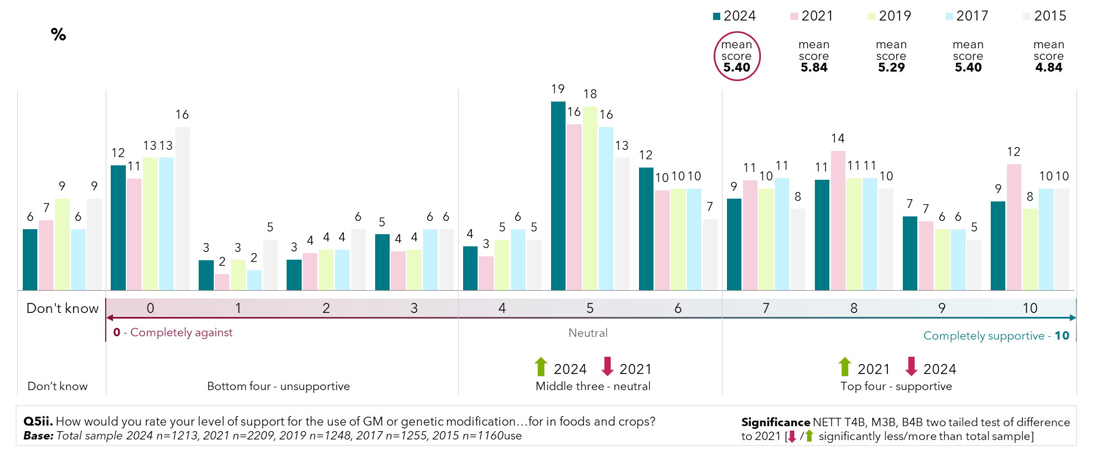

By gender, men are more likely to score either an 8 or a 9 out of 10 for their level of support for the use of GM in food and crops, compared to women, and have a significantly higher mean score at 5.55 out of 10 than women at 5.24 out of 10. Women surveyed are more likely than males report they do not know how they feel about it (7%).

Figure 22: Support for the use of genetic modification in food and crops – (2024)

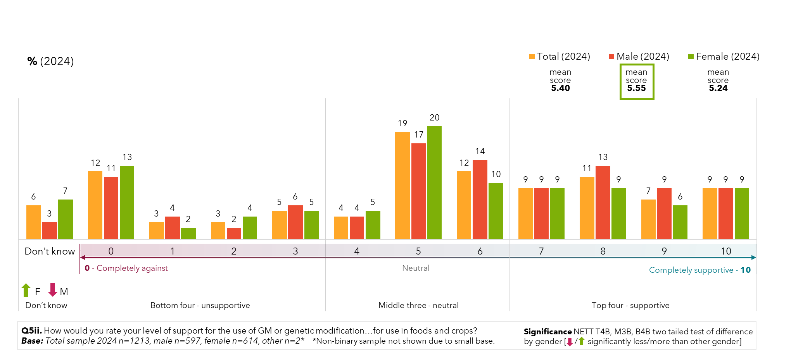

For types of food surveyed, the Australian community are more willing to eat organic food (54%) over any type of processed food. Even so, willingness to consume organic food has trended down from 62% in 2015. Results on acceptance of food types are similar to 2021, with no significant differences observed. Respondents were least willing to eat food grown with the use of pesticides (28%) and food products from genetically modified animals (29%).

There was a close clustering of willingness to eat processed cakes or biscuits with a small amount of GM (35%), meat and animal products fed with GM stock feed (34%), processed foods (34%), processed bread or soy milk from GM crops (33%), GM fruits and vegetables (32%) and food containing preservatives (32%). There has also been a general downward trend of those who would not be willing to eat different processed foods.

In 2024, we see approximately a third of the community willing to consume different types of foods involving genetic modification, but a larger proportion of the community are on the fence, not feeling strongly either way. A proportion of the community would not knowingly eat foods grown with pesticides (32%), products from GM animals (31%), or genetically modified fruit and vegetables (29%).

When it comes to genetically modifying the fruits and vegetables directly, more people are willing to eat them (32%) than are not (29%). For food containing preservatives, around 3 in 10 Australians are willing to consume them, while more of them (4 in 10) sit on the fence. For food grown with the use of pesticides, which had the lowest reported support, with only 28% support in 2024, over a third (36%) sit on the fence and another third are unsupportive (32%).

Figure 23: Willingness to eat genetic modification food – by year

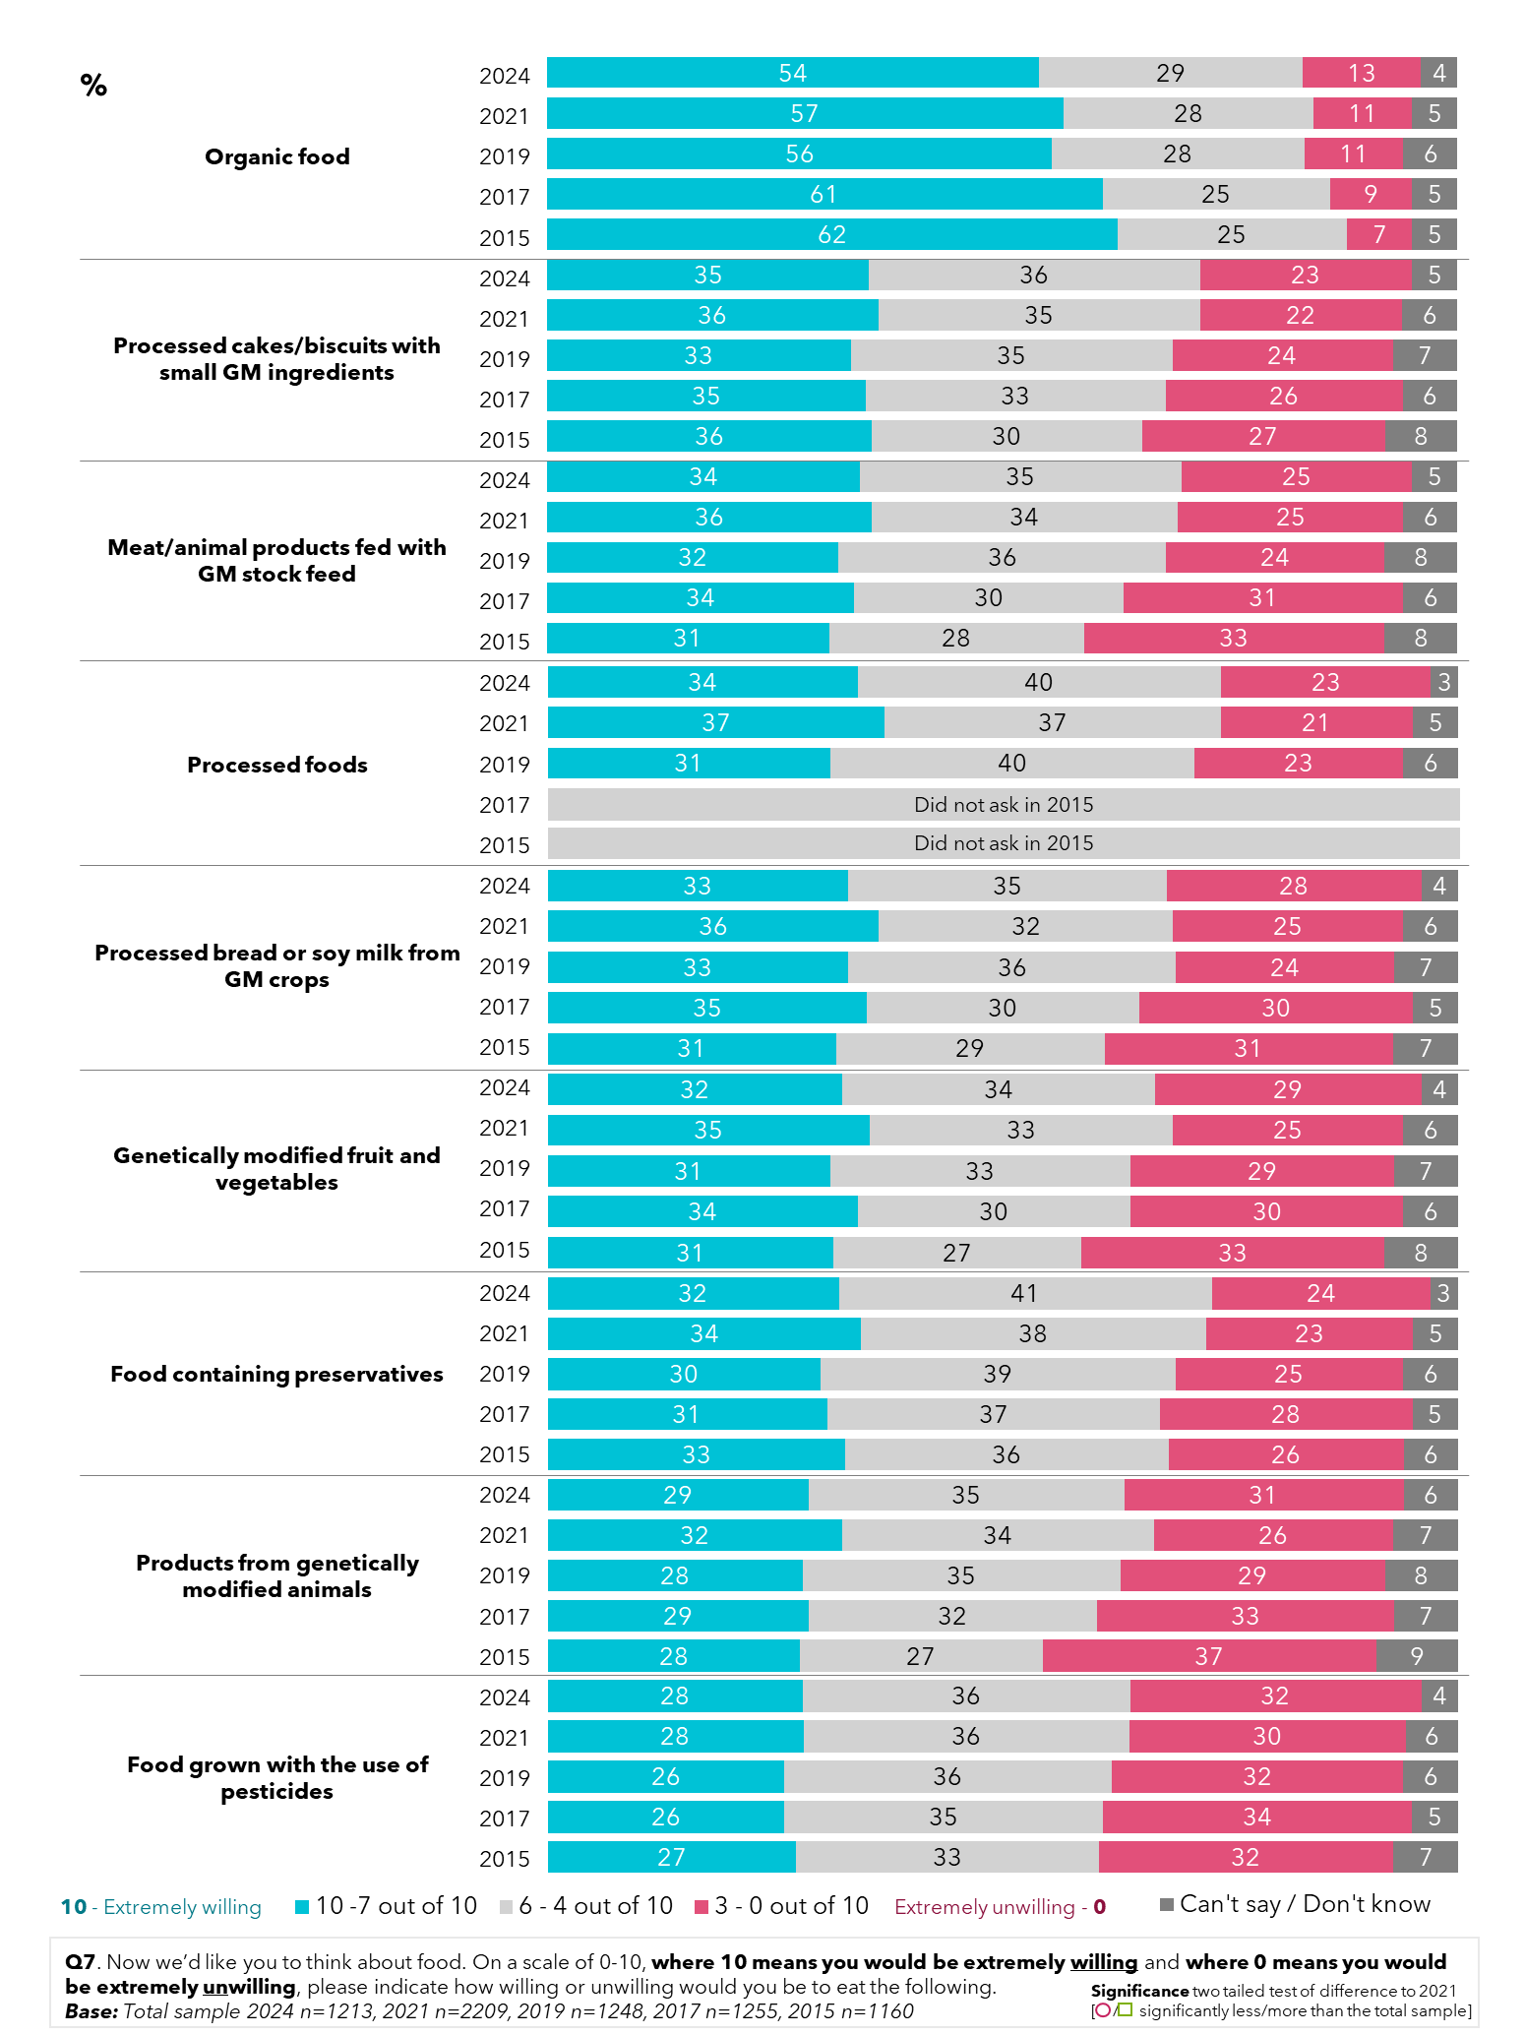

By age, survey respondents aged 31-50 were most supportive of organic food (with 6 in 10 being willing to eat it), while older respondents were more polarised in their views, with closer to half (47%) being willing to eat it, but 17% being unwilling. Older participants (aged 51-75) are also less likely to be willing to eat processed cakes/biscuits with GM ingredients, as well as meat/animal products fed GM stock feed, with 3 in 10 of them being unwilling to do so. We see a similar trend across GM food types, with older survey respondents (aged 51-75) generally being less supportive of the various GM food types.

Those aged 16-30, meanwhile, are more supportive of processed foods, with 4 in 10 being willing to eat them, while there is a change in the general trends in relation to eating GM fruits and vegetables, with 4 in 10 of the 31–50-year-olds willing to eat them, being higher than the youngest group. Willingness to eat various GM food is also lowest for the older respondents and higher for younger respondents. Younger respondents (aged 16-30) are most willing to eat products from genetically modified animals and food grown with the use of pesticides (just over a third of them are willing to do so.)

Figure 24: Willingness to eat genetic modification food – by age (2024)

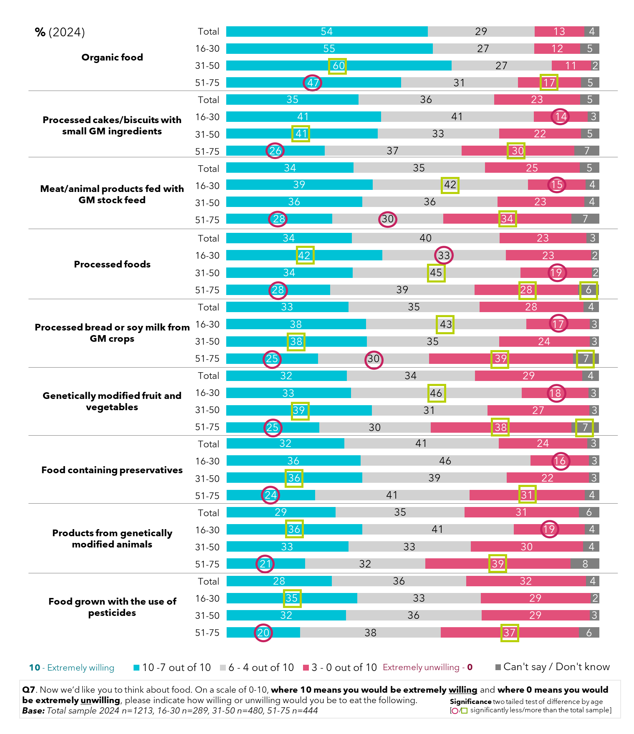

By gender, men surveyed in 2024 continue to be significantly more willing to consume modified foods than women, across GM foods, processed foods, and foods containing preservatives.

Figure 25: Willingness to eat genetic modification food – by gender (2024)

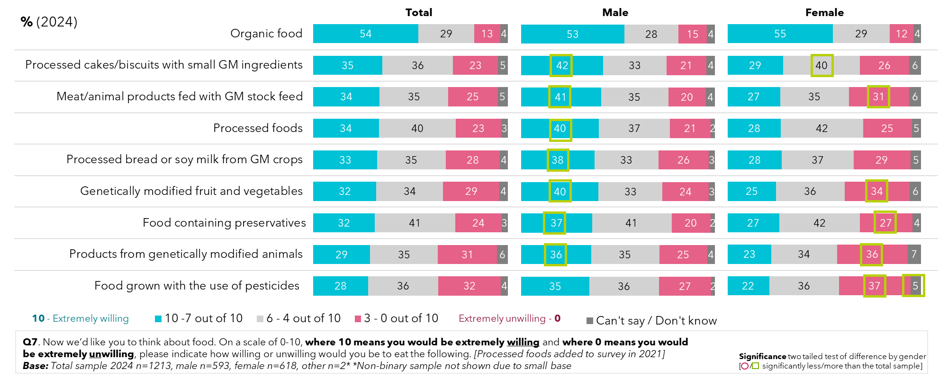

Willingness to consume food containing GM ingredients varies by state and territory. While NSW and Victoria have relatively similar levels of willingness to consume different foods, with the exception of organic food, there are noticeable preferences elsewhere, in particular Tasmania, the ACT, and the Northern Territory. In these regions, there is greater acceptance (but varying between state/territory) of many products made with or including GM ingredients (though it should be noted being smaller jurisdictions they had smaller survey sizes).

Figure 26: Willingness to eat genetic modification food – by state and territory (2024)

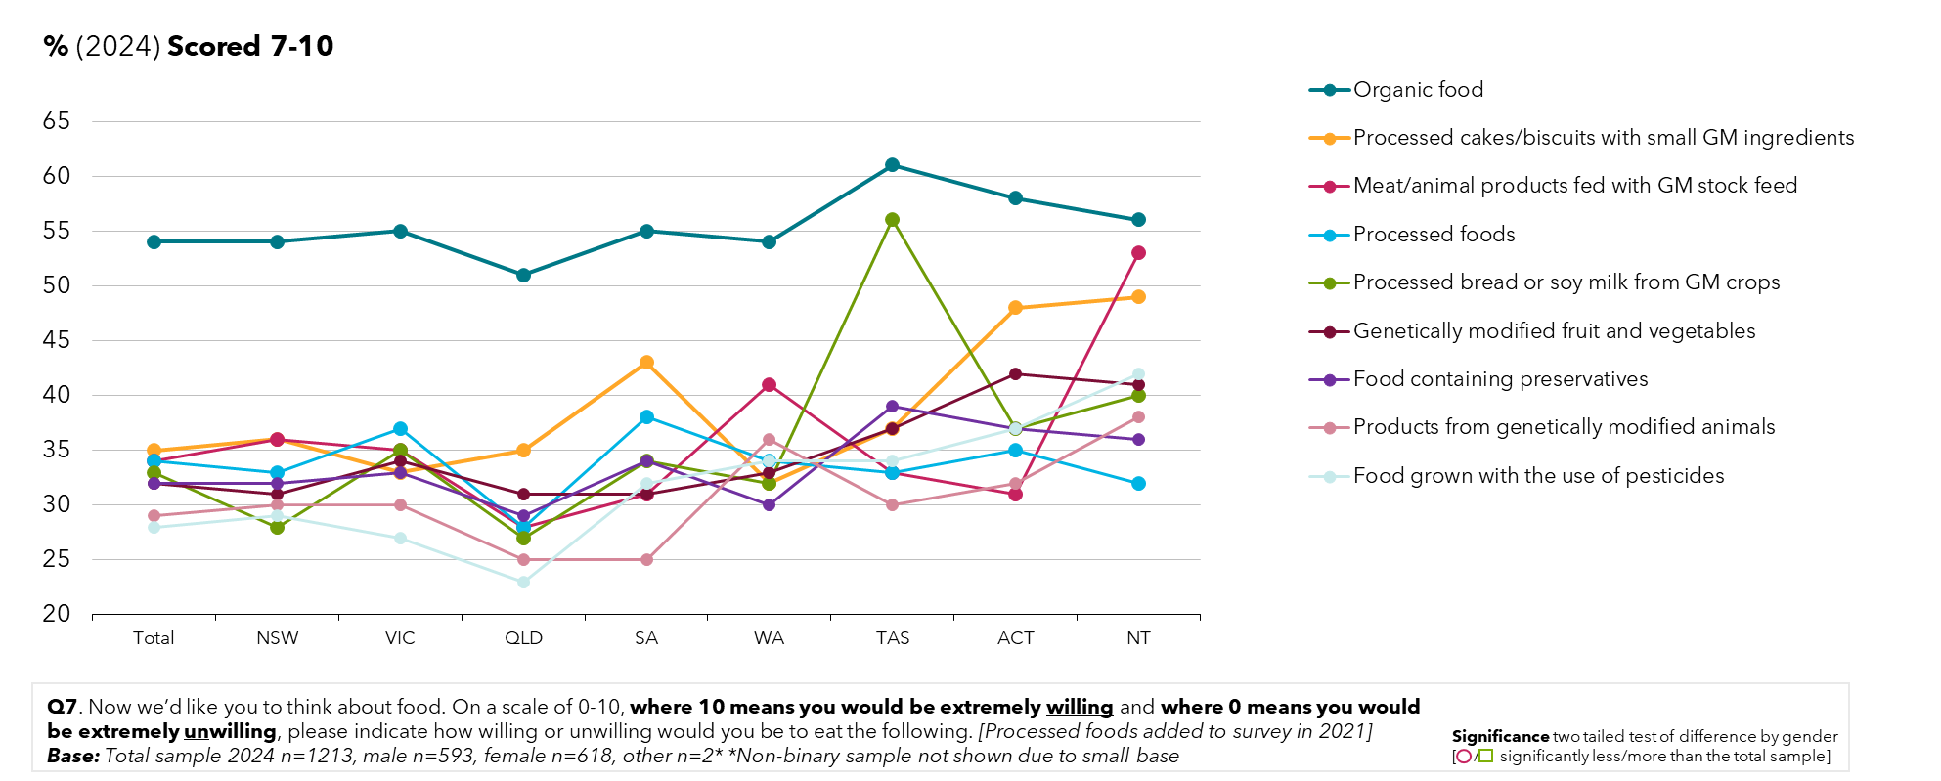

Participants identifying as First Nations (slightly less than 10% of survey respondents), were significantly more willing to consume all types of food production and processing surveyed, apart from organic foods which were rated slightly less than the community average.

Figure 27: Levels of support for genetic modification and gene technology for specific uses – by First Nations people

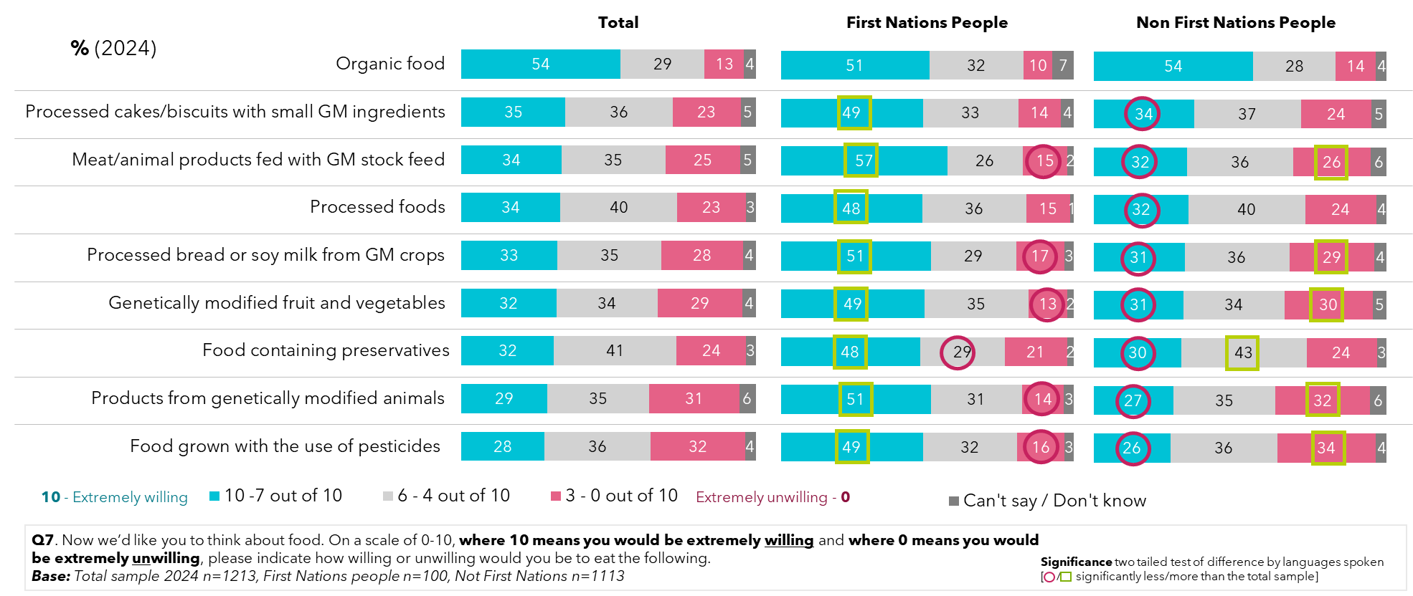

Conversely, when we look to people who speak a language other than English at home (about 14% of respondents), there was not a great deal of difference seen compared to the average. The exceptions were for organic foods, which on average saw greater acceptance (66%), and products from genetically modified animals (38%).

Figure 28: Levels of support for genetic modification and gene technology for specific uses – by language spoken at home

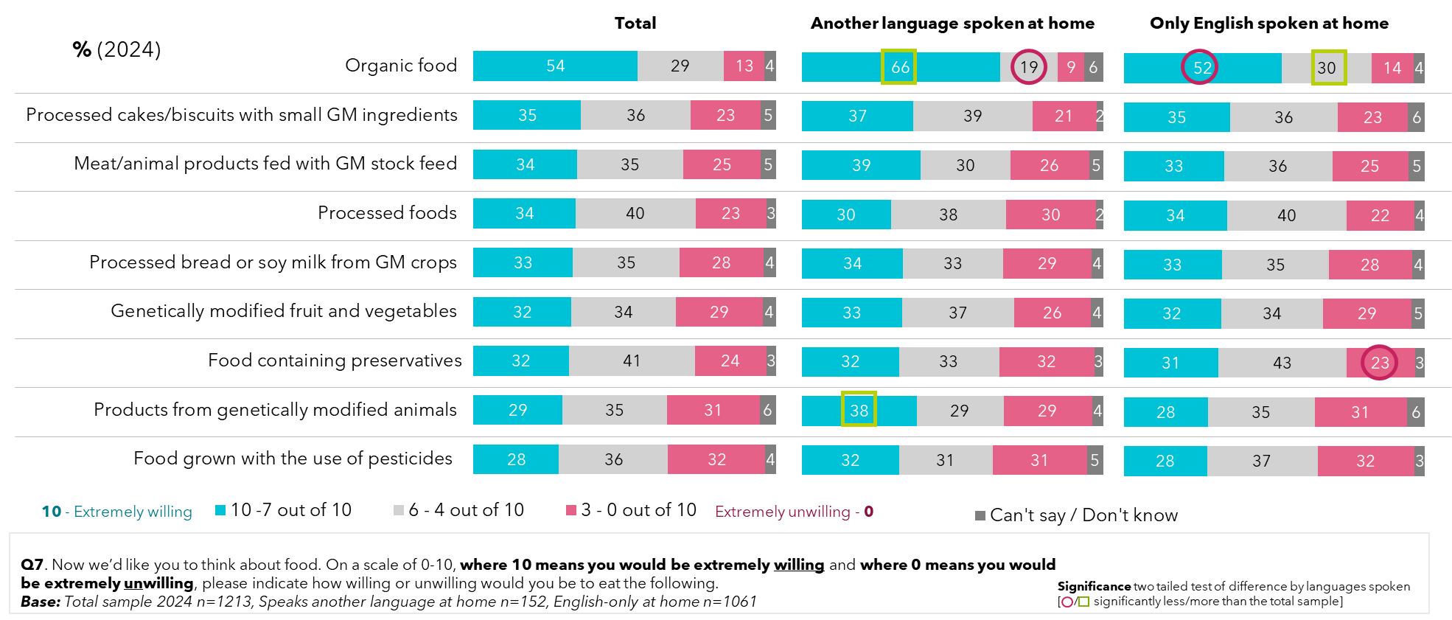

Landholders who derive most of their income from primary production reported far greater willingness to consume all types of food production and processing surveyed, than average, revealing a stark difference to people who do not derive any income from farming.

Figure 29: Levels of support for genetic modification and gene technology for specific uses – by income derived from land

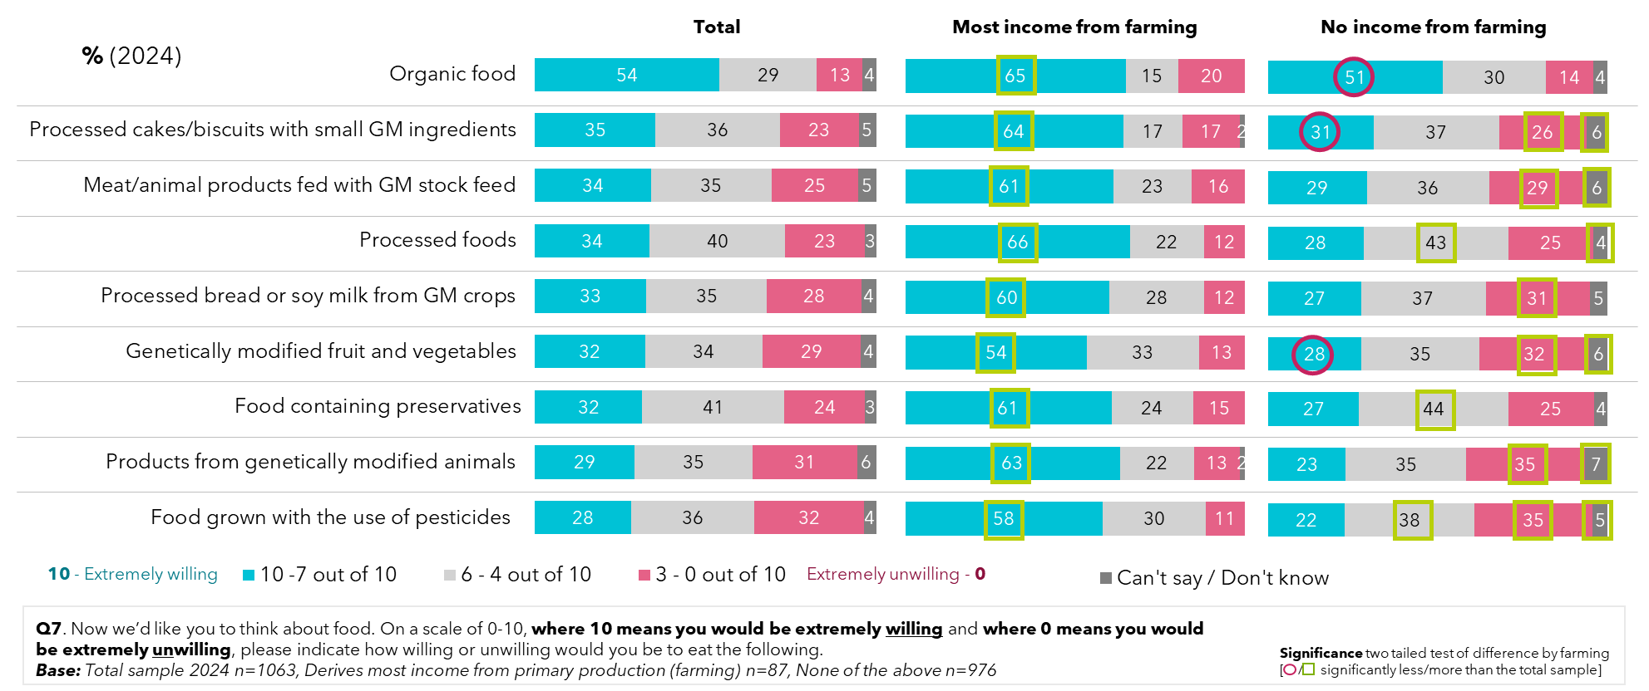

Compared to 2021, the total sample for 2024 is less accepting of modifying genes of plants to produce food, with a higher proportion indicating it is unacceptable (at 26%), leading to a lower overall mean score (5.23 compared to 5.65 in 2021), but again is returning to levels of 2019 and prior.

Figure 30: Attitudes towards modifying plant genes to produce food (2024)

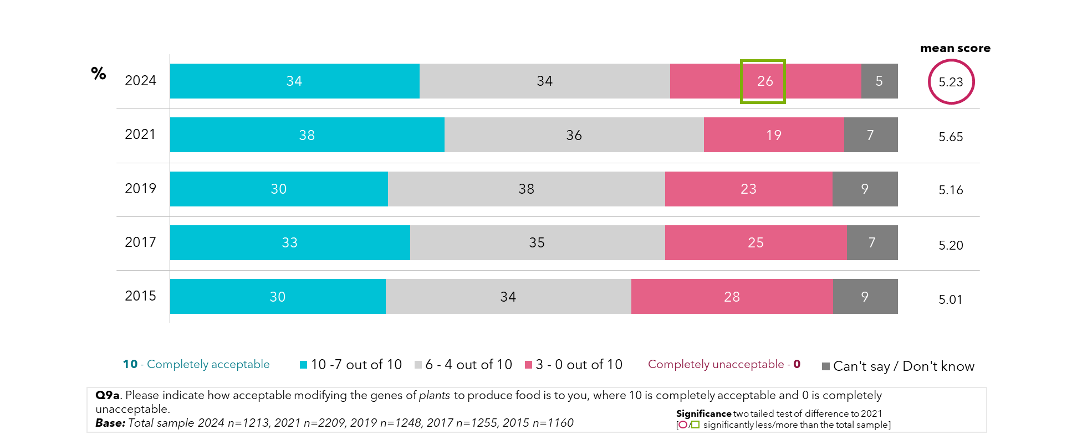

Those aged 16-30 years old are more likely to be accepting of modifying plant genes to produce food (with 4 in 10 finding this acceptable), while in contrast, older survey respondents, aged 51-75 years, are less likely to be accepting of it.

Figure 31: Attitudes towards modifying plant genes to produce food – by age

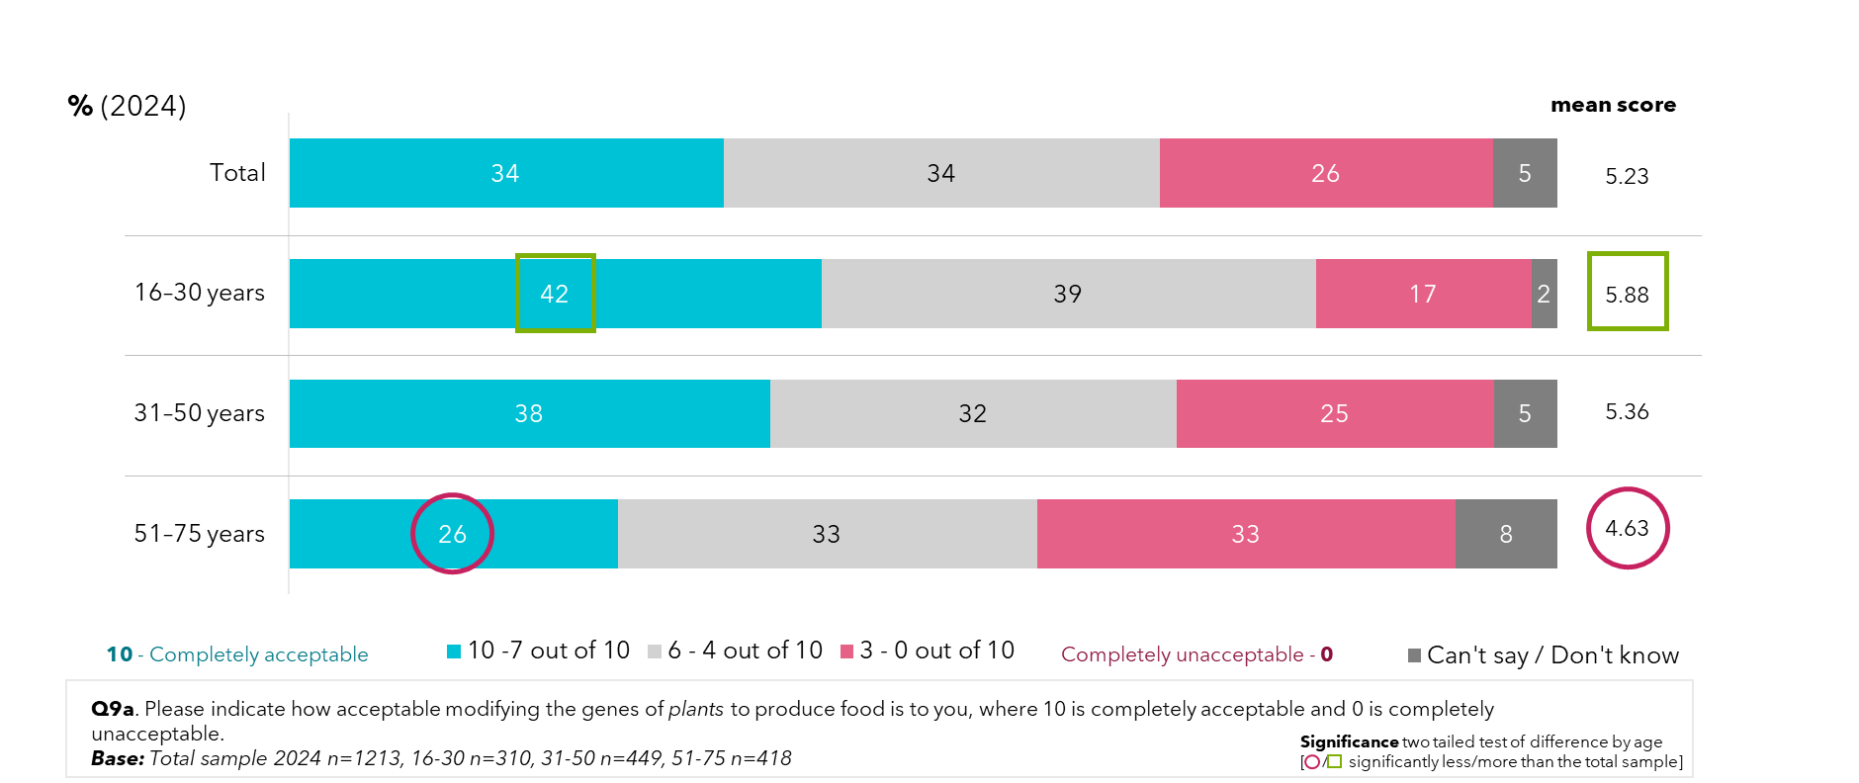

Like the greater support shown among men for use of genetic modification for food and crops, they also have stronger support for modifying the genes of plants to produce food; 4 in 10 men find it acceptable, compared to fewer than 3 in 10 women.

Figure 32: Attitudes towards modifying plants genes to produce food – by gender

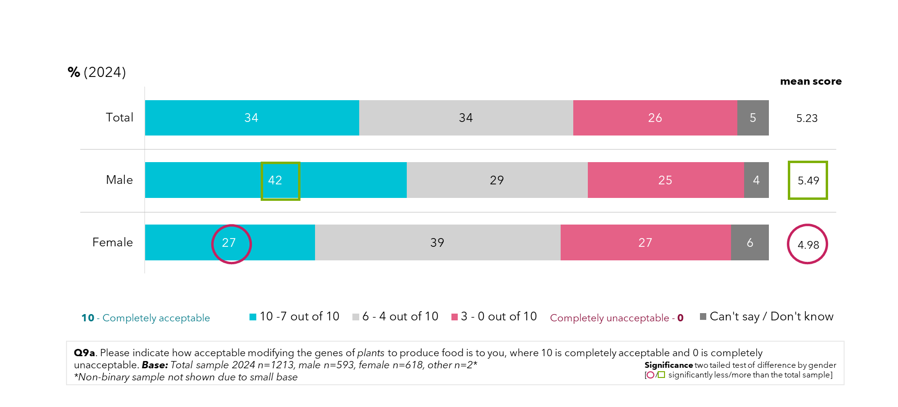

Compared to 2021, fewer people in 2024 have just some concern about GM foods and crops, shifting to either not being concerned at all, or having many concerns. A few years on from the height of the COVID-19 pandemic, 41% looking back feel it impacted their attitudes, an increase from the 35% who felt this way in 2021, suggesting views after the pandemic are not only resettling to pre-pandemic levels, but are being cemented.

Figure 33: Concern over genetic modification of foods and crops - by year

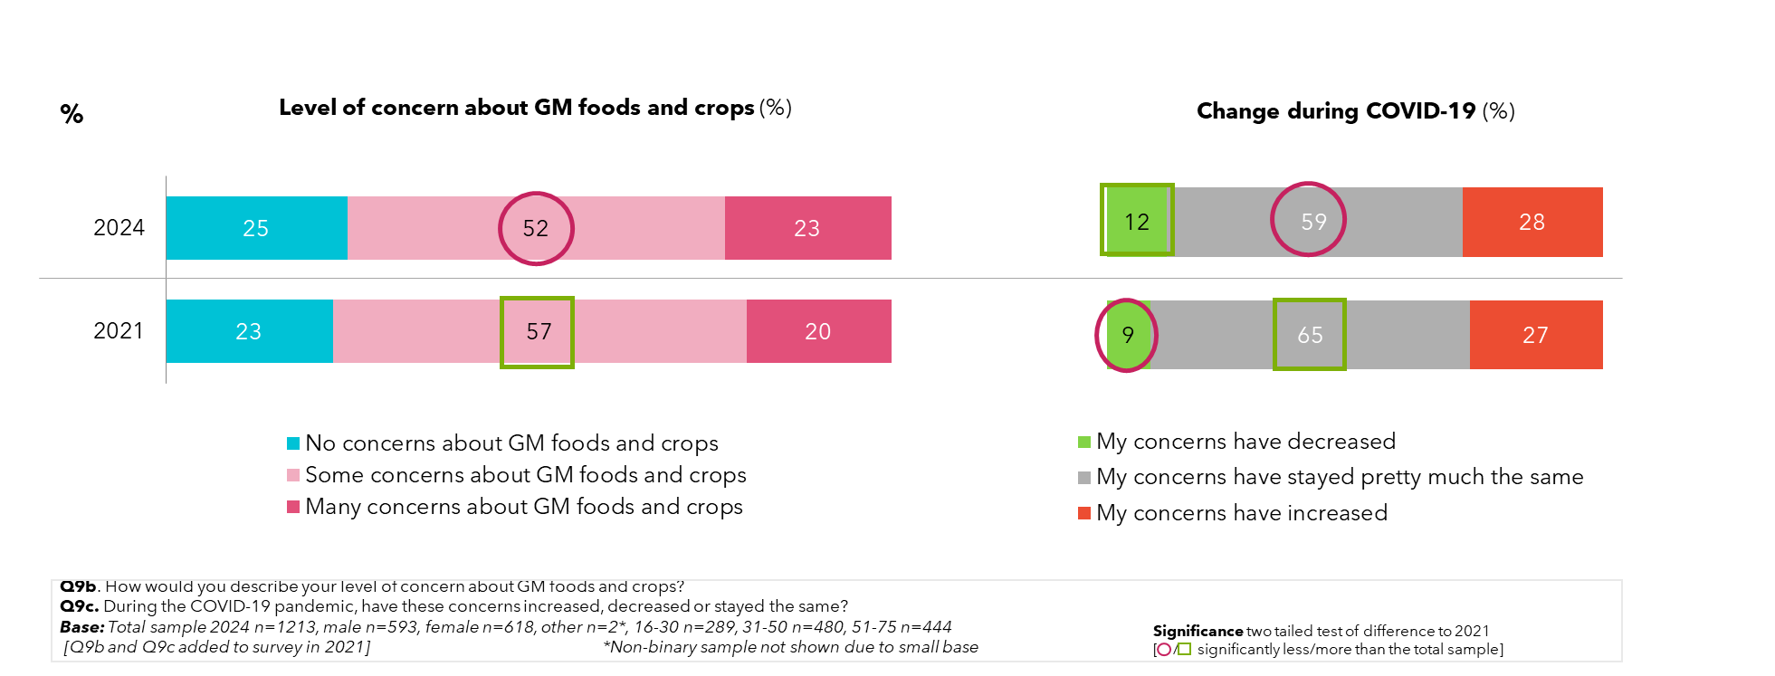

As per 2021, men are more likely to have no concerns about GM food and crops than women, while younger survey participants are more likely to be even less concerned. Men are more likely to report that their concerns decreased during the pandemic, while older participants (aged 51-75) are more likely to report that their concerns have stayed pretty much the same during the pandemic.

Figure 34: Concern over genetic modification of foods and crops - by gender and age (2024)

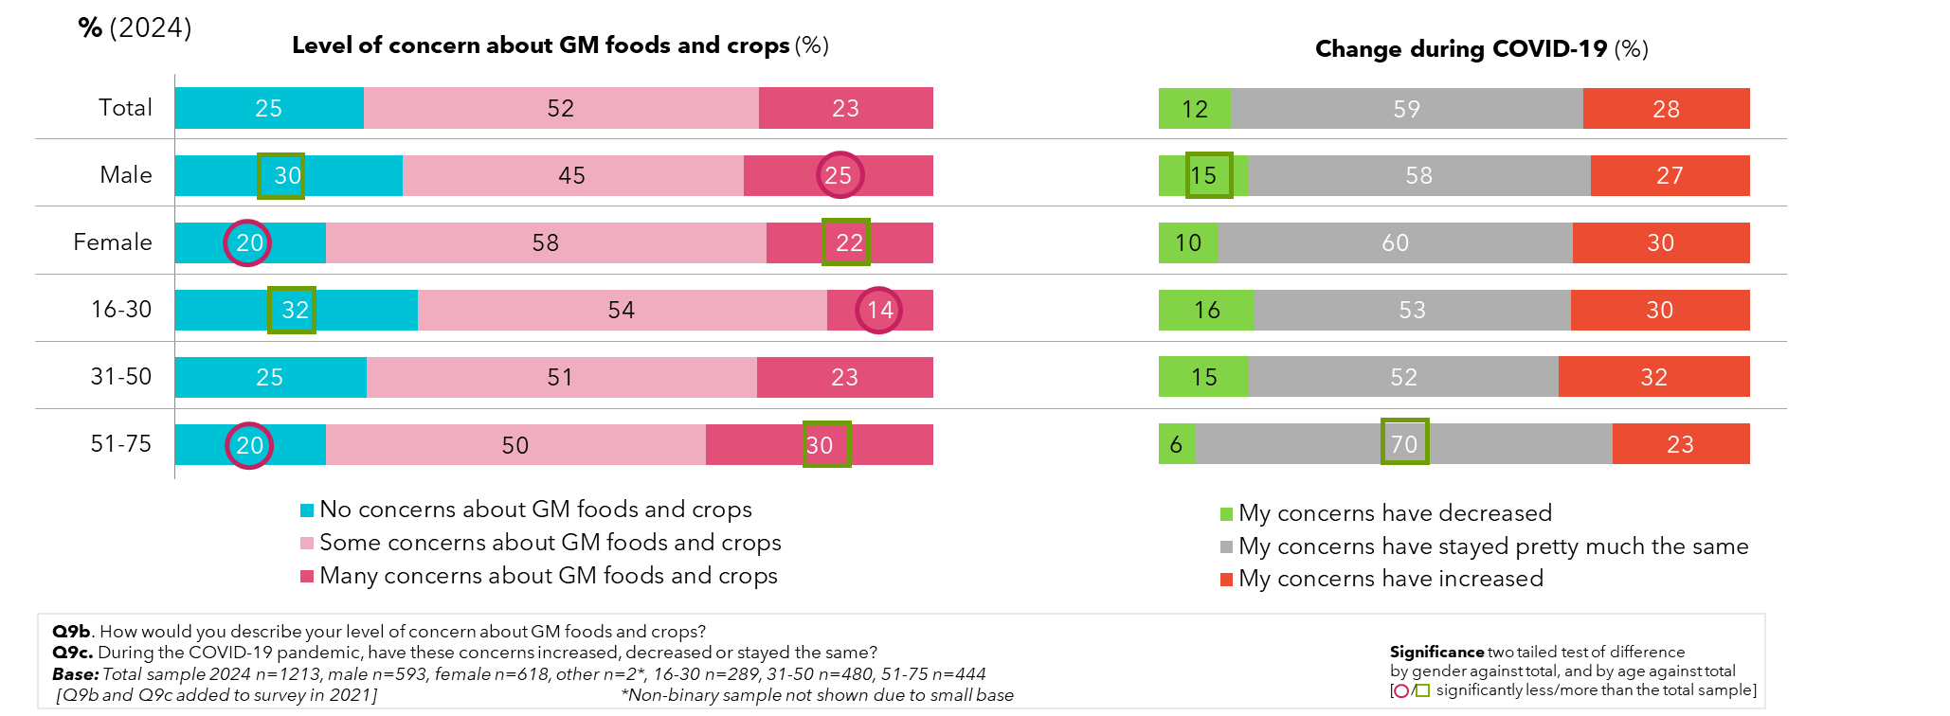

On average in 2024, introducing new genes to a plant from a plant of the same species has reasonable levels of support, at 42%, however there are more who find this unacceptable compared to 2021 (17%).

‘Switching on’ or ‘off’ genes is strongly supported by a third (33%) of people surveyed in 2024, this result is closer to levels seen in previous years than in 2021, while the proportion who find this unacceptable has increased from 17% to 22% since 2021. Meanwhile, just over a quarter support introducing the genes of a bacterium or animal in 2024, these results are similar to the ones from 2021.

Figure 35: Attitudes towards genetic modification in food production – by year

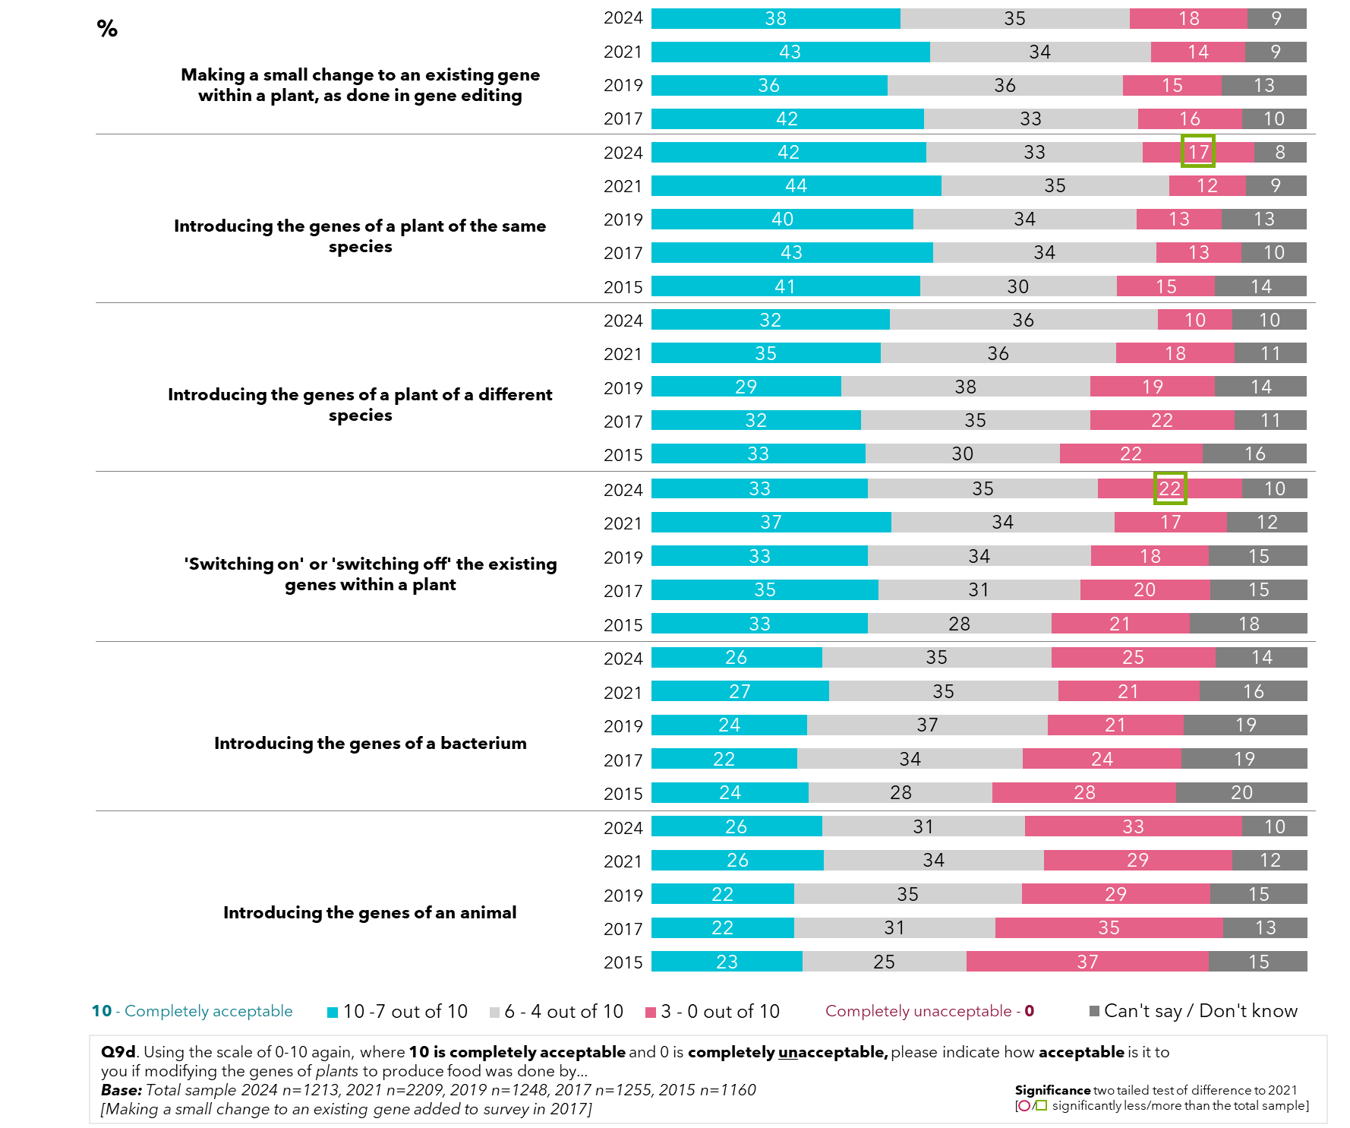

## Perceptions of types of genetically modified crops grown across Australia

Approximately a third of respondents stated that they believed GM crops are allowed to be grown in the state/territory they reside in. Among those that believe it is allowed, canola and tomatoes were mentioned by around 4 out of 10, with tomatoes interestingly having significantly risen since 2021. The proportion of the community who report feeling aware that there are GM crops, but unsure which, has decreased to 13% in 2024 from 21% in 2021.

Figure 36: Awareness of genetic modification crops being grown in their state/territory

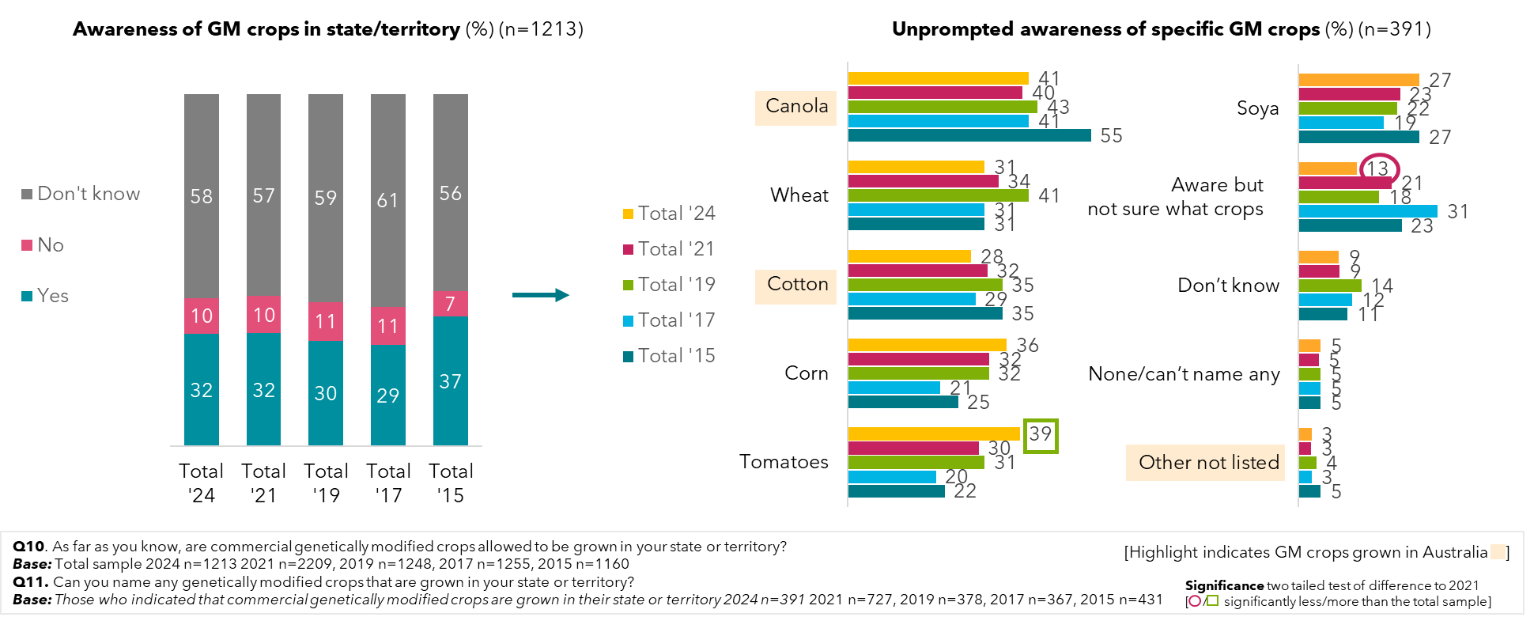

Across the states and territories, the proportion of people who feel GM crops are allowed to be grown follow a similar pattern of low awareness of whether GMcrops are banned or not in their jurisdictions. Most people report being unsure if the regulations allow GM crops in their state, followed by a fifth to a third believing they are allowed to be grown there, and finally, a minority thinking they are banned. There are actually only two jurisdictions having full state/territory-wide bans: Tasmania and the ACT, and both still scoring very low on the accuracy of this (7% and 6%). Awareness of GM crops is higher in WA, with close to half (47%) being aware.

Figure 37: Awareness of genetic modification crops in state/territory – by state (2024)

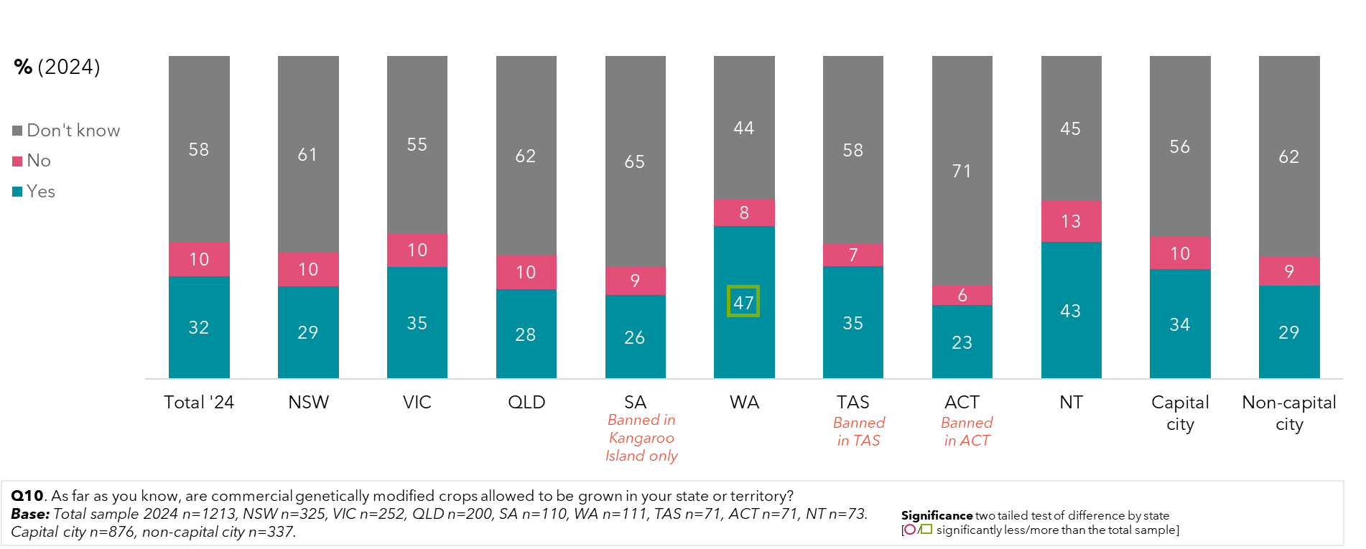

There were no significant differences in general understanding of genetically modified crops grown by state or territory, though corn in South Australia and the ACT and cotton in Tasmania (all jurisdictions with full or partial bans) stand out in comparison.

Figure 38: Prompted awareness of specific genetic modification crops – by state (2024)

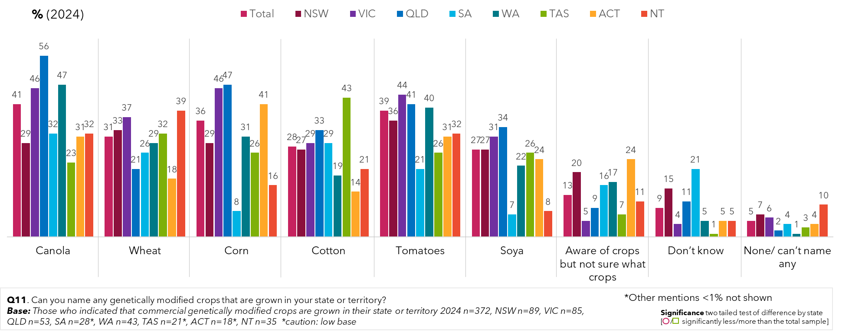

## Attitudes to genetically modified crops and genetic modification technology in food production

While there has been a general drop back to 2019 levels in support for growing GM crops in States and Territories, those states where more support this than do not, include the Northern Territory, Tasmania, the ACT and Western Australia. In South Australia and Victoria, it is close to equal and in NSW more oppose this than support it. In Capital cities, there is more support for growing GM crops in their state or territory, but in non-capital cities, more do not support it.

Of those supportive of GM crops in their state, there is strong support for genetic modification if given reassurance of stringent regulations and evidence of the benefits of modifying crops. The factor that would influence this support the most was learning of potential positive benefits for human health of GM crops.

Figure 39: Support for genetic modification crops if given reassurance – by capital city and non-capital city

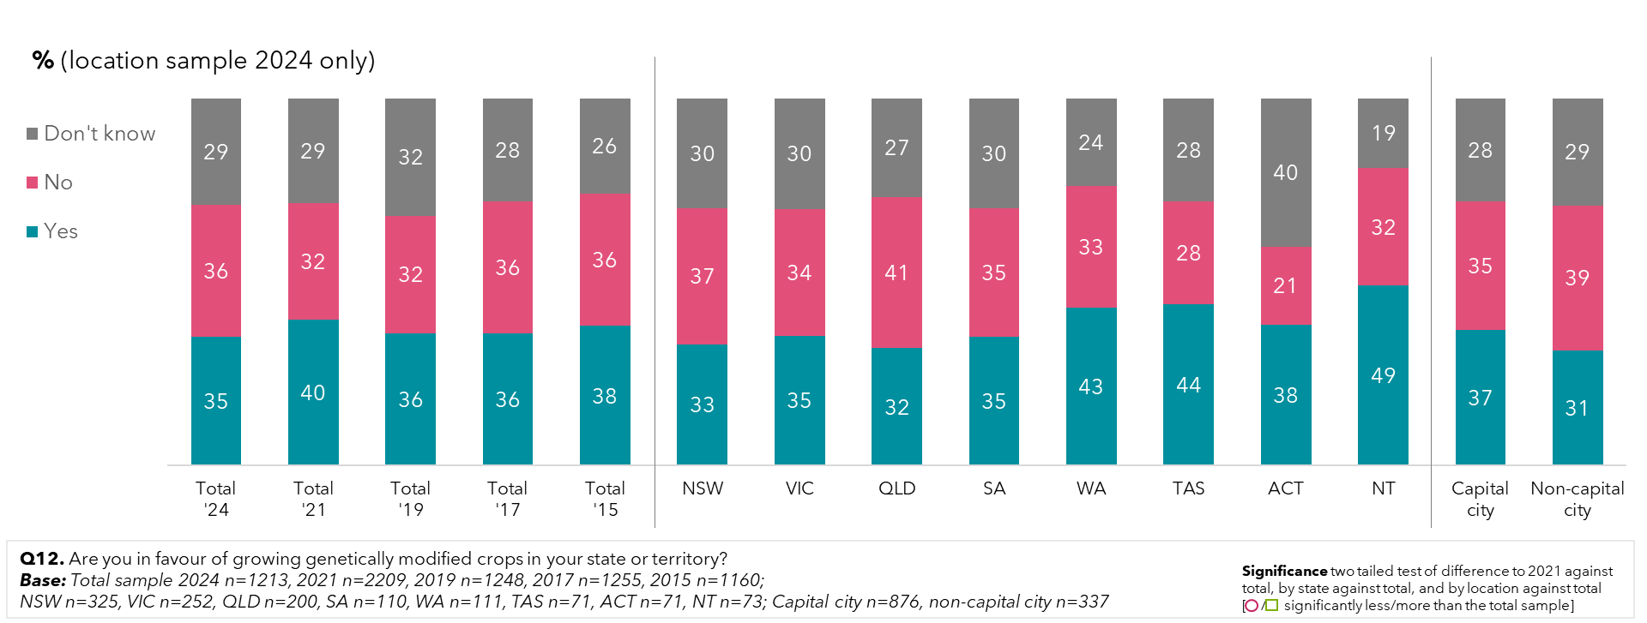

In 2024, there was stronger support for stringent regulations for GM crops in capital cities than non-capital cities. Residents outside of capital cities reported being more unsure about the benefits they needed to see to be in favour of GM crops being grown in their state.

Figure 40: Support for genetic modification crops if given reassurance – by capital city and non-capital city

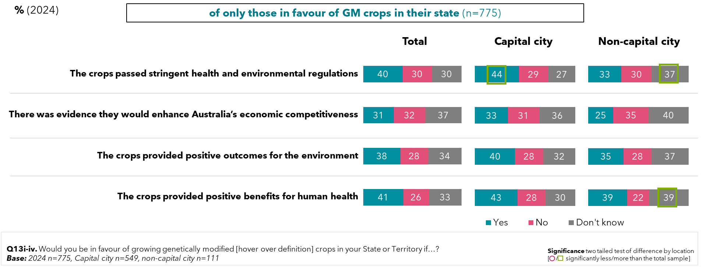

Of those in favour, the greatest reassurance would come from knowing the crops provided positive health benefits for humans (41%) and that they passed stringent health and environmental regulations (40%). Positive outcomes for the environment were less important in 2024 than 2021, but not significantly so.

Figure 41: Support for genetic modification crops if given reassurance – by year

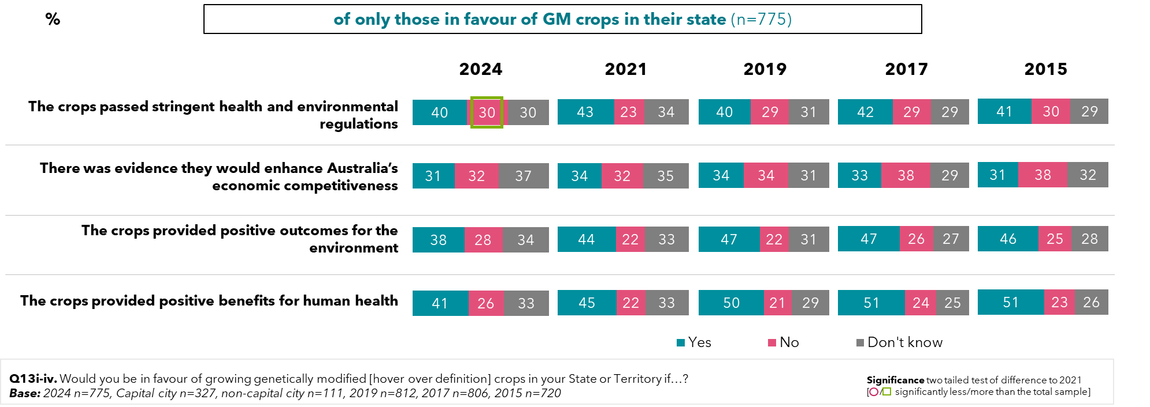

66% of adult Australians are supportive of, or open to genetically modified technology to produce food in 2024, although, like in 2021, approximately half of the population require reassurance before being satisfied that it is safe (47%). Those requiring scientific proof that it is safe before being supportive remains constant (22%), and those totally opposed remain in the minority (12%).

Figure 42: Public opinion on using genetic modification technology to produce food – by year

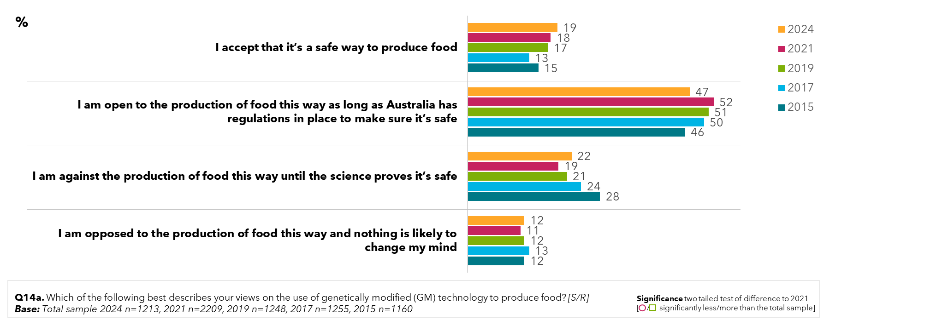

People in the community who do not derive any income from farming are significantly more likely to oppose the production of food with the use of GM technology (15%). For landholders who generate most of their income from farming, they are more likely to accept that it is a safe way to produce food (43%). For landholders who generate just some of their income from farming, 25% accept that it is safe, and 66% are open to it if Australia has regulations in place to ensure that it is safe.

Figure 43: Public opinion on using genetic modification technology to produce food – by income derived from land

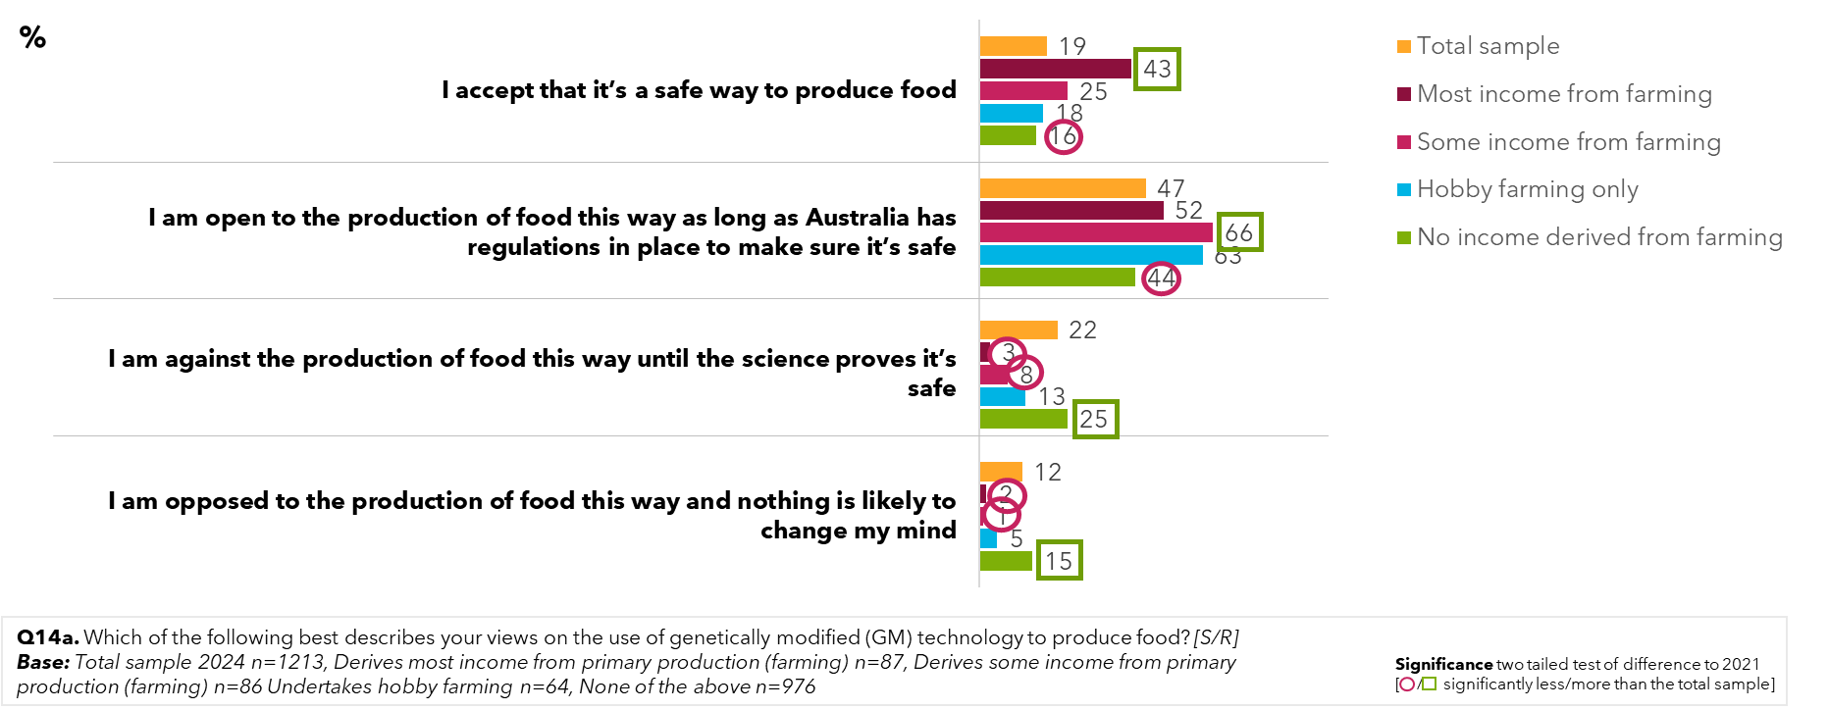

Support for genetically modified technologies to produce food is led by a belief that the use of genetic modification can improve the quantity of crops and quality (17%). This is followed by support in general (14%), believing it has a positive impact on the environment (10%), and benefits to farming and sustainability (9%).

For the general public, support for GM foods and crops is often conditional on the knowledge that with its use brings better crops, drought resistance, sustainable and safe. Specific responses which represent the range of attitudes shared include:

* *“Cavendish bananas are the perfect example of why it's ok.”*
* *“Higher Yields: GM crops can be engineered to resist pests, diseases, and harsh weather conditions, leading to higher yields and reducing crop failure. This is especially important in a world with a growing population and a changing climate.”*
* *“Particular plants can only be grown in particular climates so if a gene allow(s) that plant to be grown in a different climate I do not feel as if there is a problem.”*
* *“Increased efficiencies.”*
* *“Don’t know much about it.”*
* *“Genetically modified vegetables or fruits can use less pesticide”.*

Figure 44: Reasons for favouring the use of genetic modification technology to produce food – 2024 sample supportive of genetic modification food production

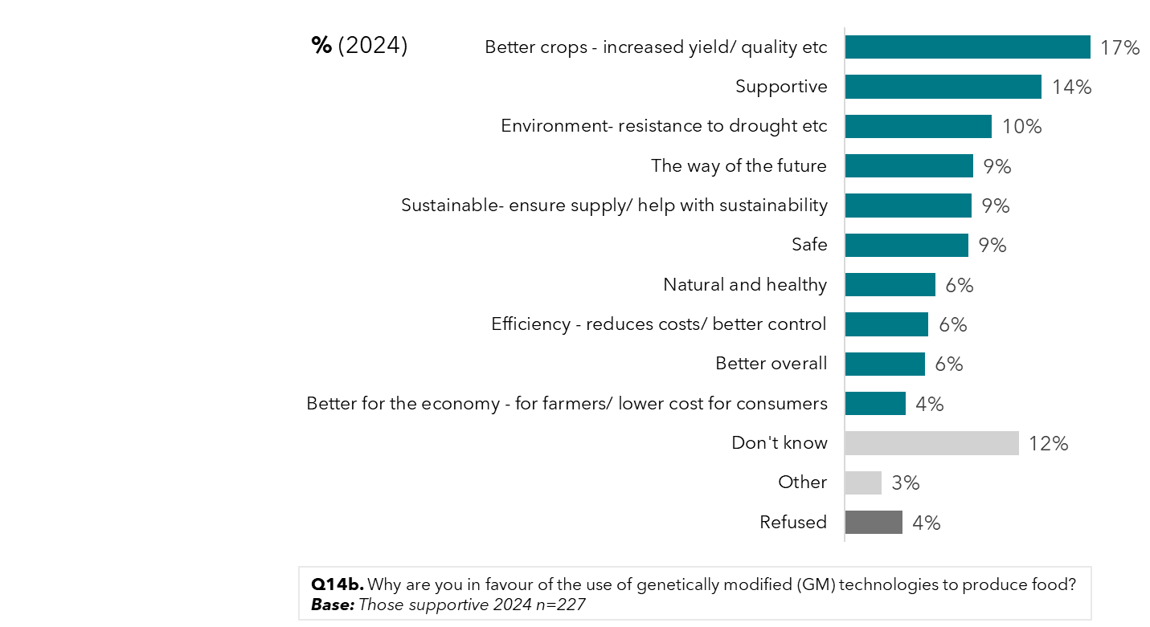

The survey also identified the key conditions by which a person would oppose the technology, with the single highest stated reason being the belief that humans should not mess with nature (46%). Other key stated concerns included worries about long-term consequences to human health animals and the environment (19%) and being harmful (16%)

In providing stated reasons for their opposition to GM foods, a lot of misinformation or mistaken beliefs were quoted by respondents. Some responses which represent the range of attitudes shared include:

* *“I think there is too much risk in the long term, side effects we don't know about yet that could be really dangerous or uncontrollable”*
* *“I was skeptical but after the covid debacle I don't trust anything scientist or government says... if they say it is safe I know it is far from safe and money is changing hands.”*
* *“Back in the 50s we didn’t have children with ADHD or any kinds of deformation like today, vegetables were grown naturally no poisons added to the ground to make things grow faster. Cows, sheep, pigs and chickens were fed natural foods, not like today [where they are] given hormones.”*
* *“Because it's against nature and we were created this way for a reason doesn't matter how tiny the details it shouldn't be messed with”*
* *“Genetically modified foods make more problems; more people are now lactose or gluten intolerant”*
* *“Do not like the idea of tampering with nature for human consumption.”*
* *“Not too educated on the topic”*
* *“Corporate greed”*

Figure 45: Reasons for opposing the use of genetic modification technology to produce food – 2024 sample opposed to genetic modification food production

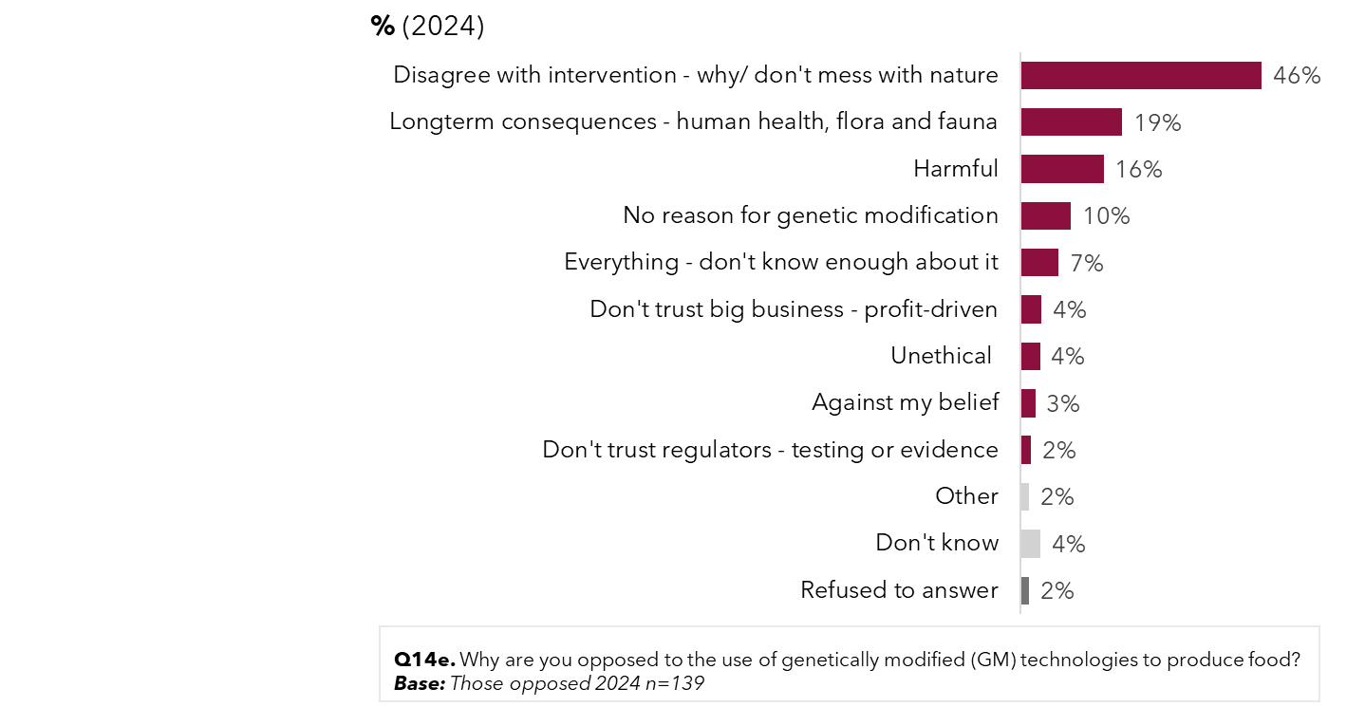

In looking what values were placed on GM, Australians currently put the greatest value on cheaper food through genetic modification (37%) – aligning with cost-of-living concerns. Health benefits of food are also rated as being valuable (35%), followed by plant drought resistance (34%) and pest resistance (33%).

Figure 46: Value placed on various genetic modification outcomes and goals (2024)

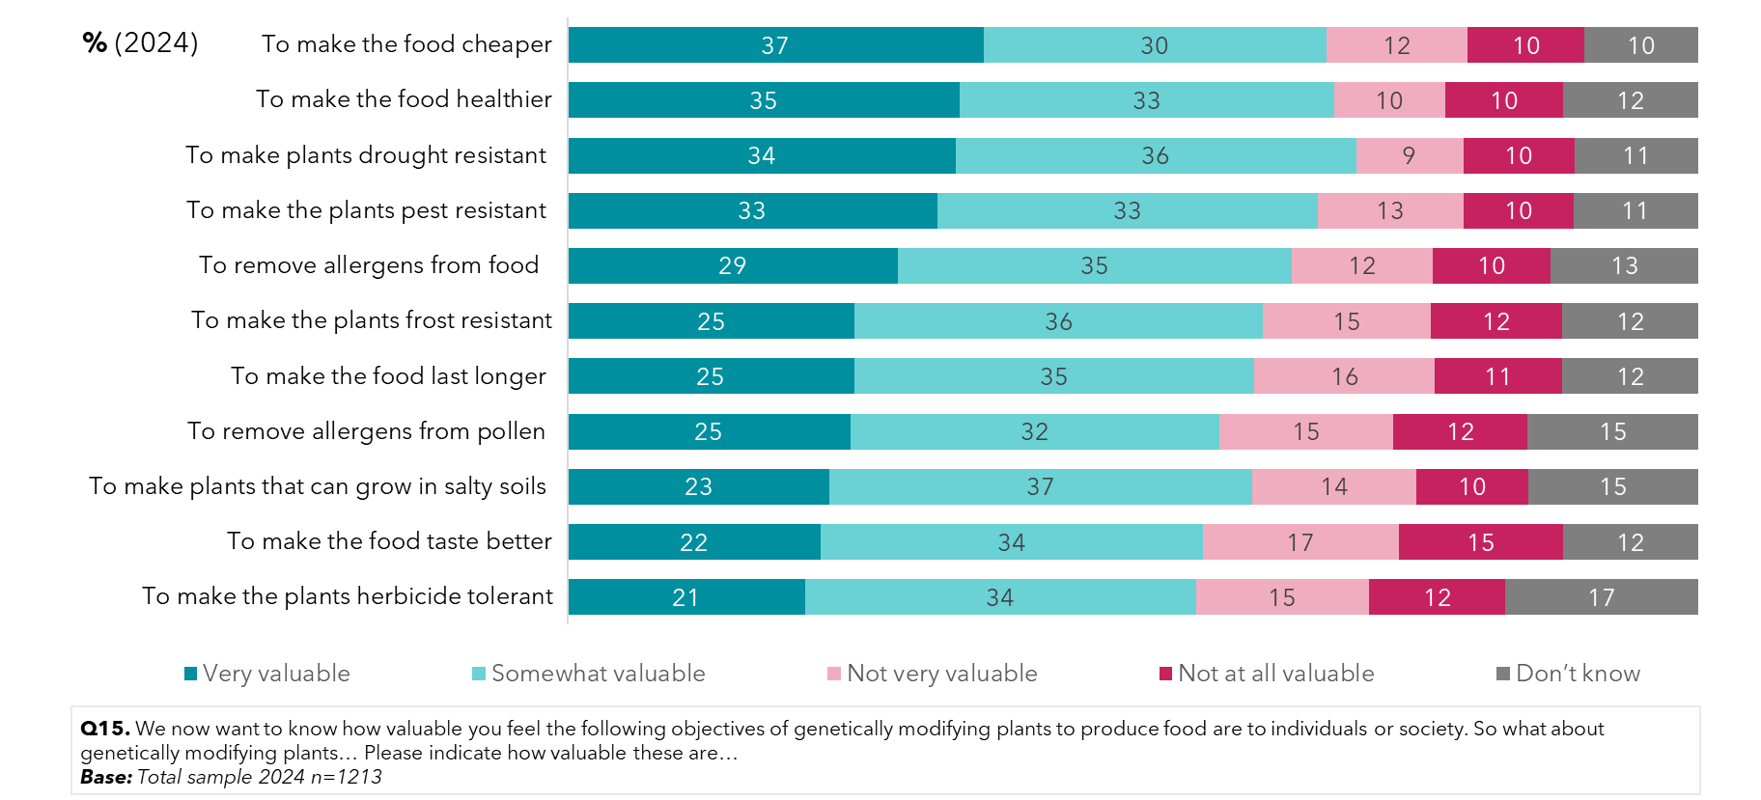

Overall, in 2024, the goals of making food healthier, making plants pest resistant and making plants drought resistance are less likely to be viewed as ‘very valuable’ compared to 2021, while making the food cheaper has seen an increase.

Figure 47: Value placed on various genetic modification outcomes and goals – by year

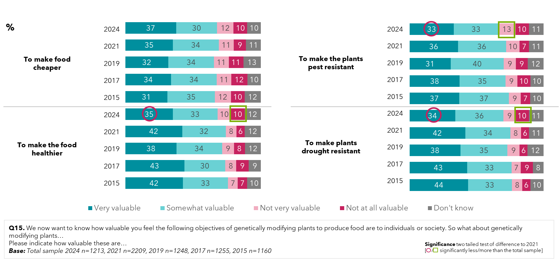

Compared to uses of GM in foods, in 2024, people were less likely to be open to using GM for therapeutic uses, and more likely to be against the production of GM for therapeutic uses until the science proves it’s safe. However, acceptance of GM for industrial uses is unchanged from 2021, and earlier.

Figure 48: Attitudes to genetic modification for industrial or therapeutic uses – by year

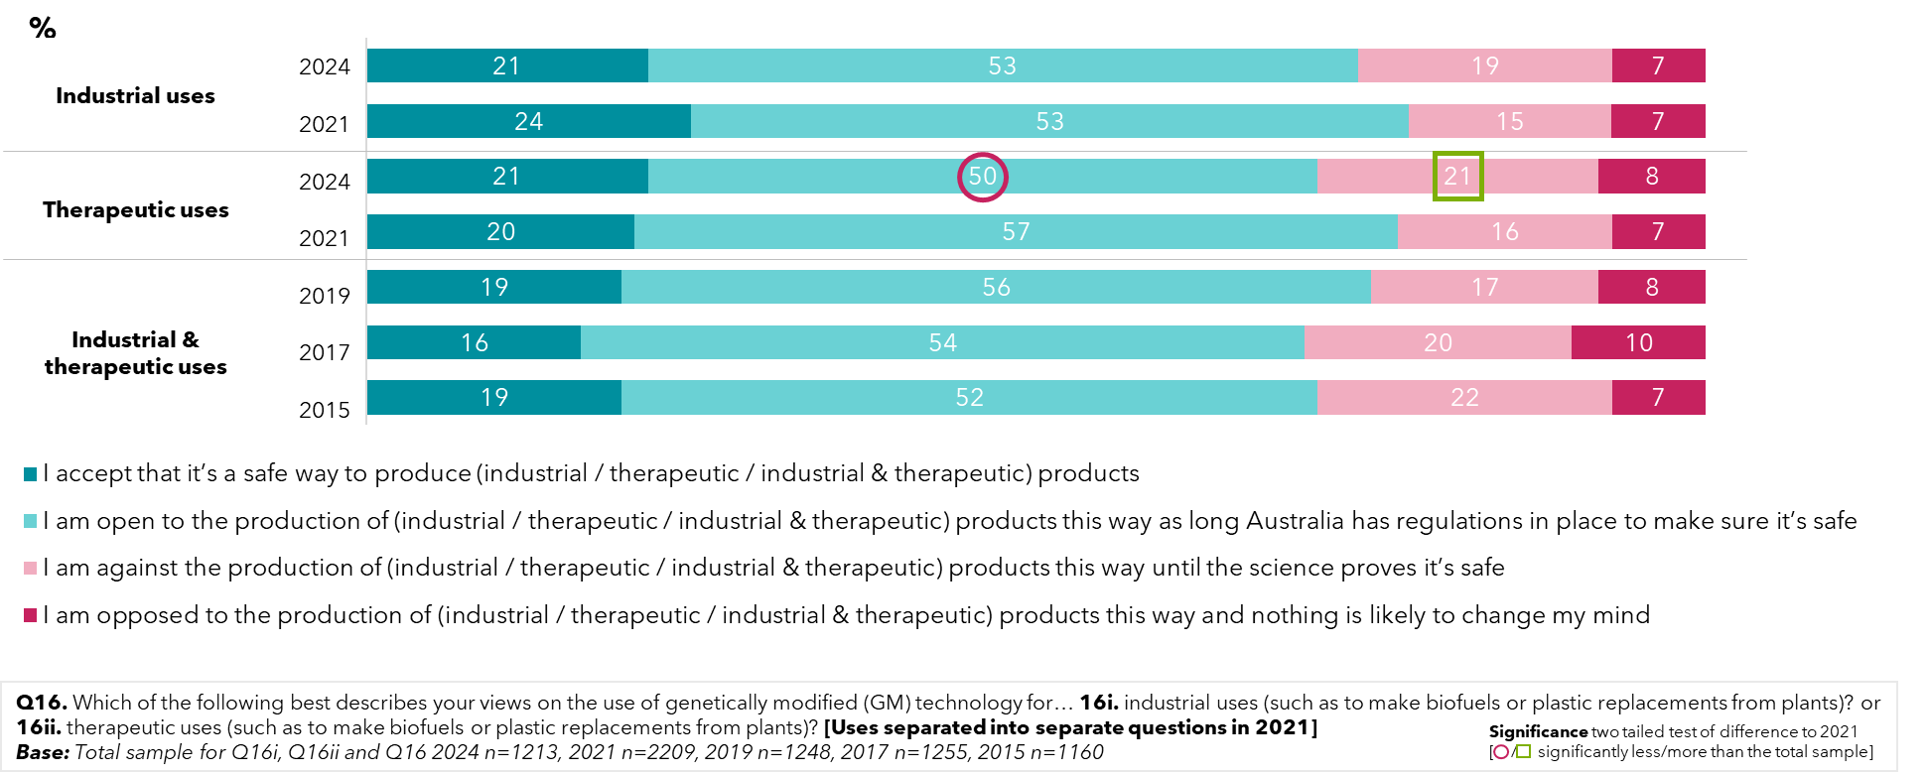

## What does the community want to know about genetic modification and where is the information coming from?

Of those supportive of genetic modification but seeking reassurance from the regulator that the technology is safe to produce food, information on potential negative health consequences were the primary concern (32%). Clearer information in general would be beneficial in securing support, to communicate the benefits of genetic modification and gene technologies.

Some responses which represent the range of attitudes shared include:

* *“Are Franken foods safe for humans and animals?”*
* *“All good as long as it is safe for public consumption”*
* *“As long as the food is safe and secure then there is nothing else for me to know in how it is produced using regulators.”*
* *“I would like to know if GM food is safe with any person with many food allergies”*
* *“It should be listed on the foods packaging or signage”*
* *“That long range safety is assured, that no bad effects are going to happen like the plant (e.g.) becoming a weed in effect and becoming a problem, taking over from native or existing crop plants”*

Figure 49: Regulator reassurance to increase support for genetic modification food production – by 2024 sample supportive but seeking regulator assurance to reassure genetic modification technologies are safe (2024)

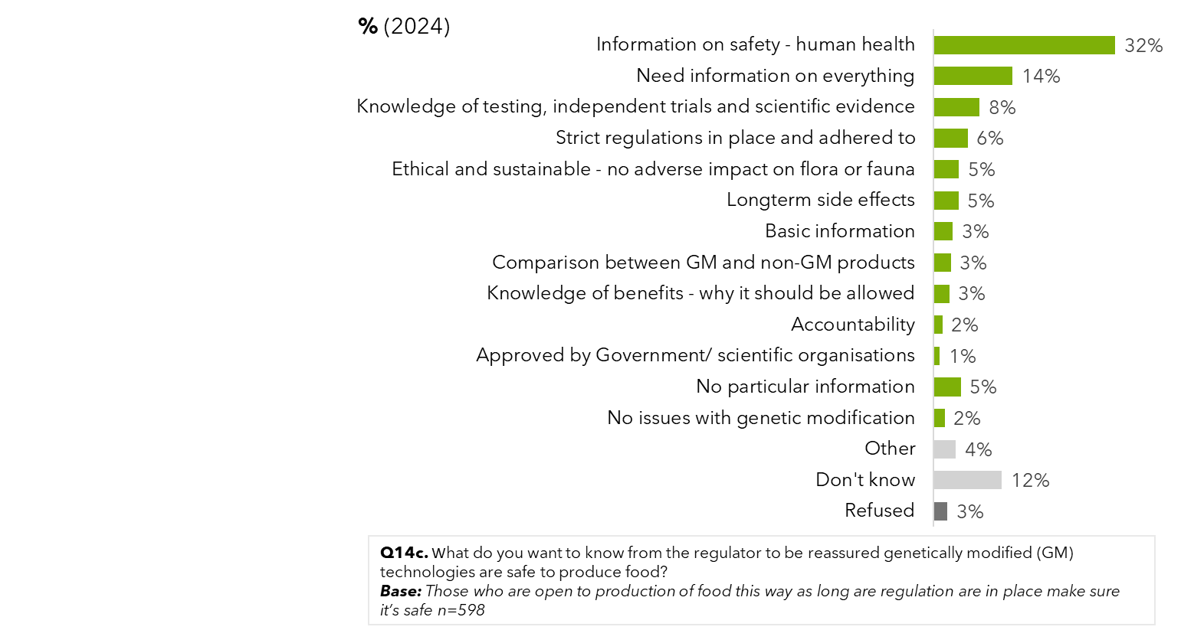

Of people who are opposed to the production of food with GM technologies, information could influence the attitudes for 32%, if they knew it was safe. There is an expectation that long-term side effects will occur, and trials haven’t been happening for long enough to reveal them. There is also a concern among a few about transparency of testing (4%).

Some responses which represent the range of attitudes shared include:

* *“Science finds outcomes to the benefit of whoever is paying them for research and as such can't be trusted. To think that science is incorruptible and beyond reproach is both stupid and naive*
* *“I think science has been corrupted like most of our institutions if there is profit to be made throw out the science”*
* *“The scientists that say there is nothing to see here have an agenda and are paid by the Govt to repeat there 2030 green new deal the ratio of scientists for and against are about 50/50”*
* *“I would like to know the true facts, not a narrative that government pushes”*
* *“Not really sure. It feels like playing God when talking about genetically modified food”*
* *“I just don't (k)now enough about this to really accept”*
* *“I like everything to be as natural as possible and unprocessed”*

Figure 50: Scientific reassurance to increase support for genetic modification food production – by 2024 sample unsupportive however seeking scientific reassurance that genetic modification technologies are safe (2024)

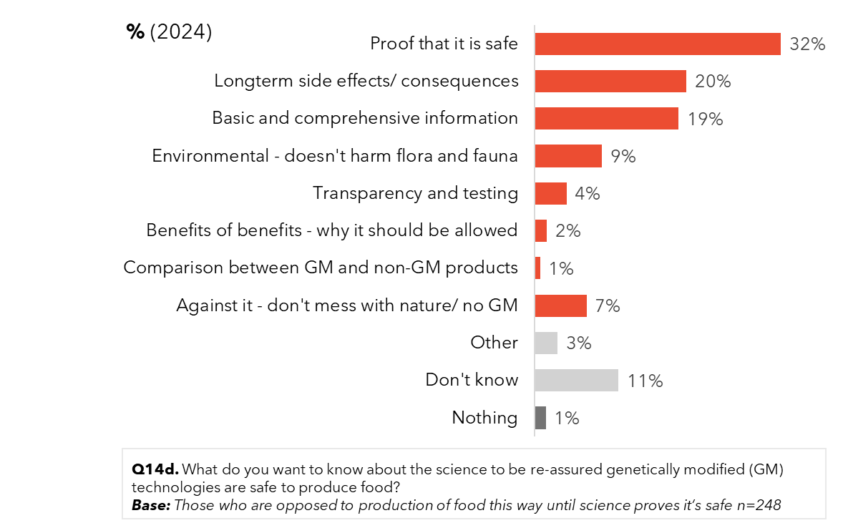

When asked where people get their information from, nearly half of the public list a general Google search as their source. Other information sources reportedly used are documentaries on television, followed by news stories on television. Since 2021, there has been an increase in general social media discussions (from 14% to 18%) and a decrease in Facebook posts (from 16% to 12%).

Figure 51: Where the public get information about gene technology (2024)

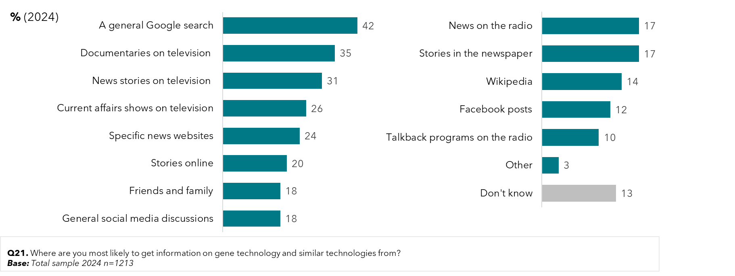

Eighty percent of the population surveyed reported trusting TV documentaries for gene technology information. Varying news-related sources were at least somewhat trusted by over 65% of people surveyed, yet when it came to very trustworthy sources, family and friends ranked higher (17% very trusted, compared with 9%-13% for mainstream media). Despite this, family and friends were a less cited sources of information on gene technology. Also, of note distrust in Facebook and social media discussions were very high (67% distrust for Facebook and 58% for general social media discussions).

Figure 52: Trusted sources of information on gene technology (2024)

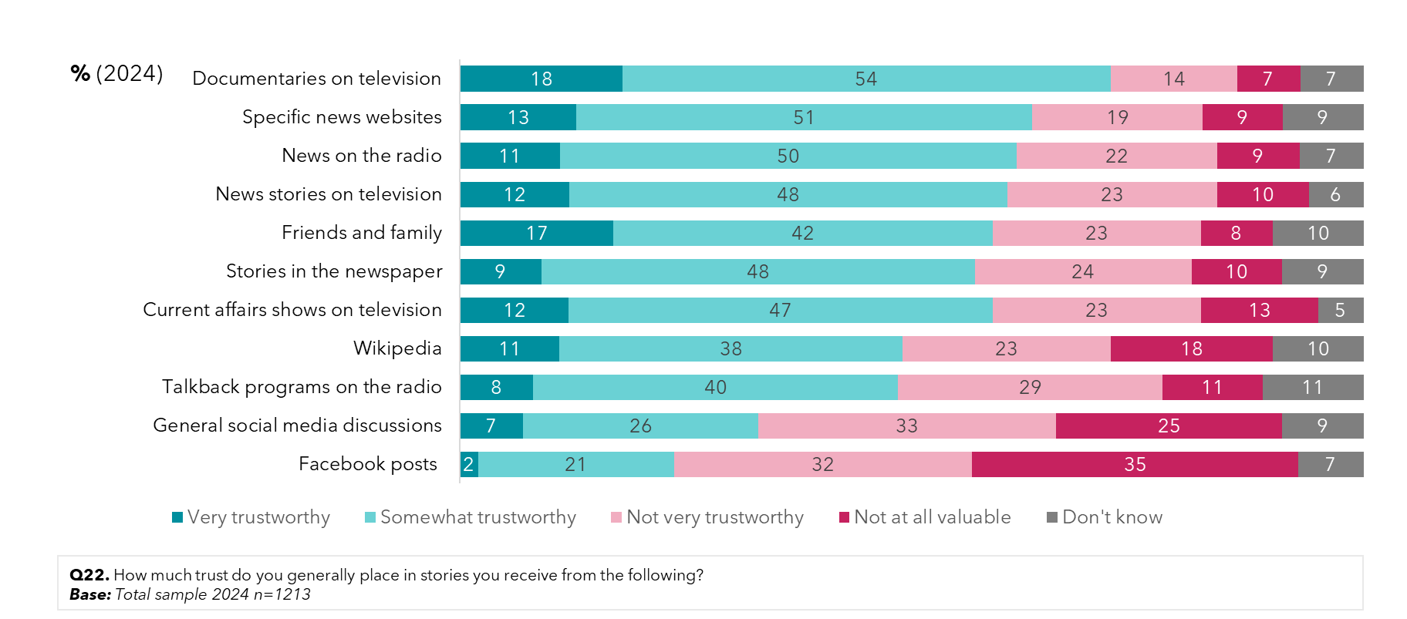

Concern over fake news and misinformation is high, with a third of those surveyed highly concerned (34%) and three quarters of respondents scoring a 6 or above out of 10 for being concerned. More than half of those surveyed (69%) feel that they are often exposed (rating at least 6/10 or above) to fake news and misinformation. Around half (62%) feel confident in their ability to spot it (rating at least 6/10 or above on ability to spot fake news), however a greater portion of the community in 2024 feel they may not be able to (8%).

Figure 53: Concerns regarding fake news and information

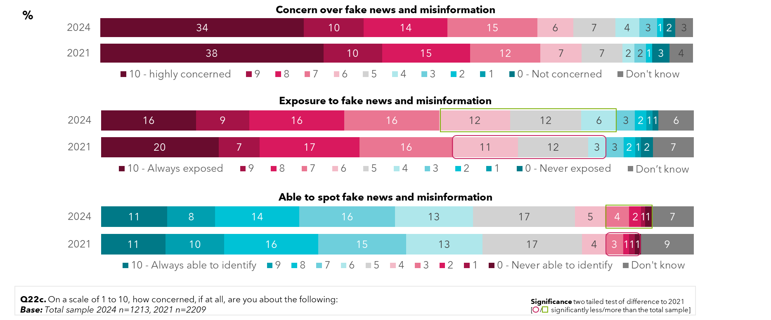

## Awareness and trust in organisations providing information about genetic modification

When prompted, the top four organisations recognized as being responsible for GM in Australia are the Department of Agriculture (the Department of Agriculture, Fisheries and Forestry), the Department of Health (the Department of Health and Aged Care), FSANZ (Food Standards Australia New Zealand) and the CSIRO (the Commonwealth Scientific and Industrial Research Organisation). These four are recognised by over 30% of the population – although there is much less awareness of what the organisations do.

In 2024, the OGTR joined the top ranked organisations, with a prompted awareness ranking of 31%. Compared to 3 years ago, awareness of the OGTR as an organisation responsible for the regulation of gene technology has increased five percentage points from 2021.

Awareness of the Department of Health’s role in the regulation of gene technology has improved over time, to 37% in 2024, a significant increase from 2021. Meanwhile, stated awareness of the CSIRO’s responsibility remains like 2021, at 31% and lower than previous years – despite it not being a regulator of gene technology, and implying there is a bit of guessing in response to organisations that sound right.

Awareness of the Therapeutic Goods Administration’s (TGA) responsibility in gene technology has also risen steadily over time, from 18% back in 2015 to now 30% a decade later, and awareness of the APVMA (Australian Pesticides and Veterinary Medicines Authority) is also higher than ever, at 26%.

However, in 2021, still a quarter of respondents do not know who is responsible for the regulation of genetic modification in Australia when prompted with regulatory and non-regulatory organisations.

Figure 54: Prompted awareness of responsibility of organisations for regulation of gene technology– by year

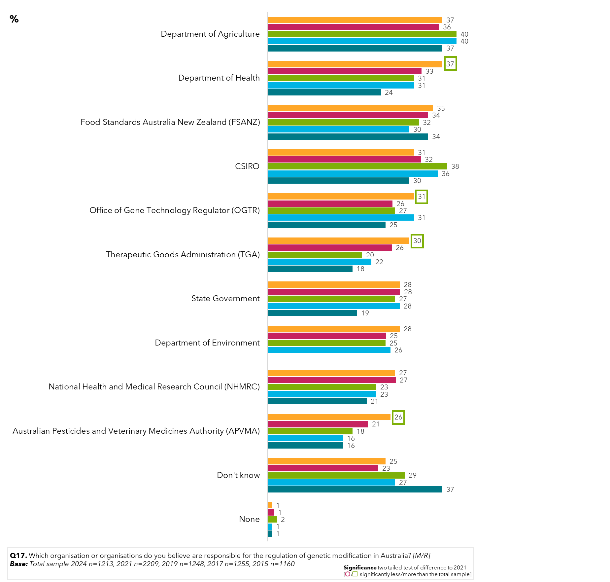

The Department of Agriculture and the CSIRO remain by far the top 2 organisations that people have heard of before completing the survey, with over three quarters of respondents having heard of them. Awareness of the OGTR is lower than for all other organisations, however it is increasing in awareness, up from the 11% in 2017 to 17% in 2024.

Figure 55: Prompted awareness of organisations that are responsible for regulation of gene technology – by year

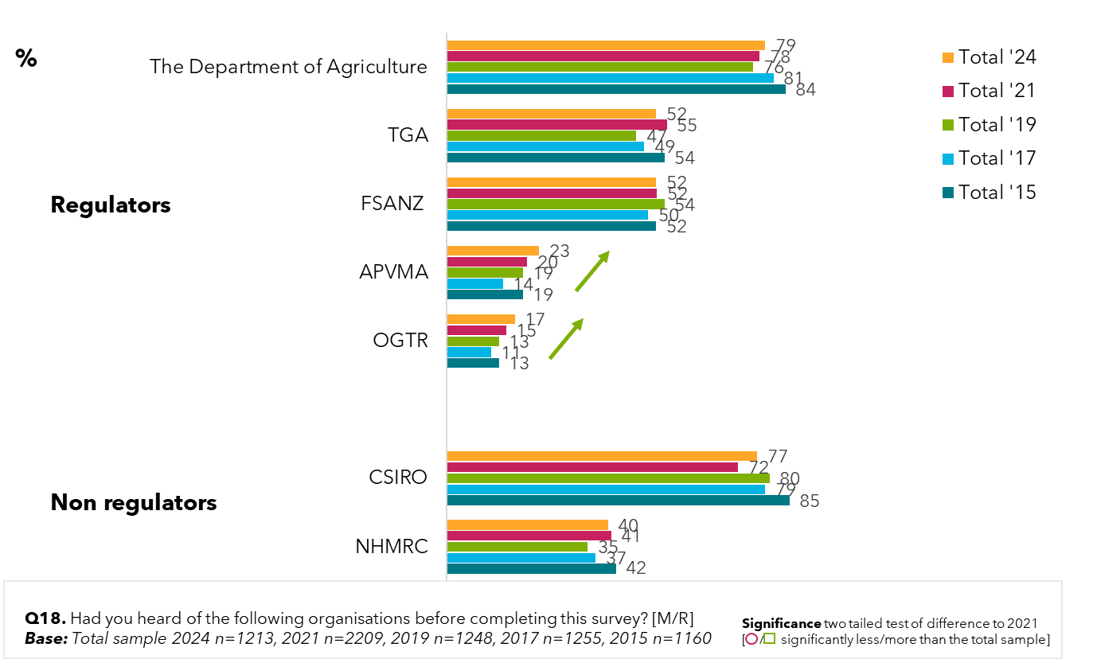

Trust in information from organisations remains on par for the OGTR, with close to 7 in 10 trusting it completely in 2024 (69% - the highest trust of all organisations cited). However, trust in the National Health and Medical Research Council (NHMRC) and the Department of Agriculture have declined in 2024 compared to 3 years ago, and distrust of industry groups has risen the most, reaching to 21% in 2024.

Similarly, trust in the CSIRO and the TGA have also dropped significantly in 2024 compared to 3 years ago, and distrust of state and territory governments and the Commonwealth government has grown in the past 3 years, with around 1 in 5 respondents not trusting them.

Figure 56: Levels of trust in what organisations say about gene technology (2021)

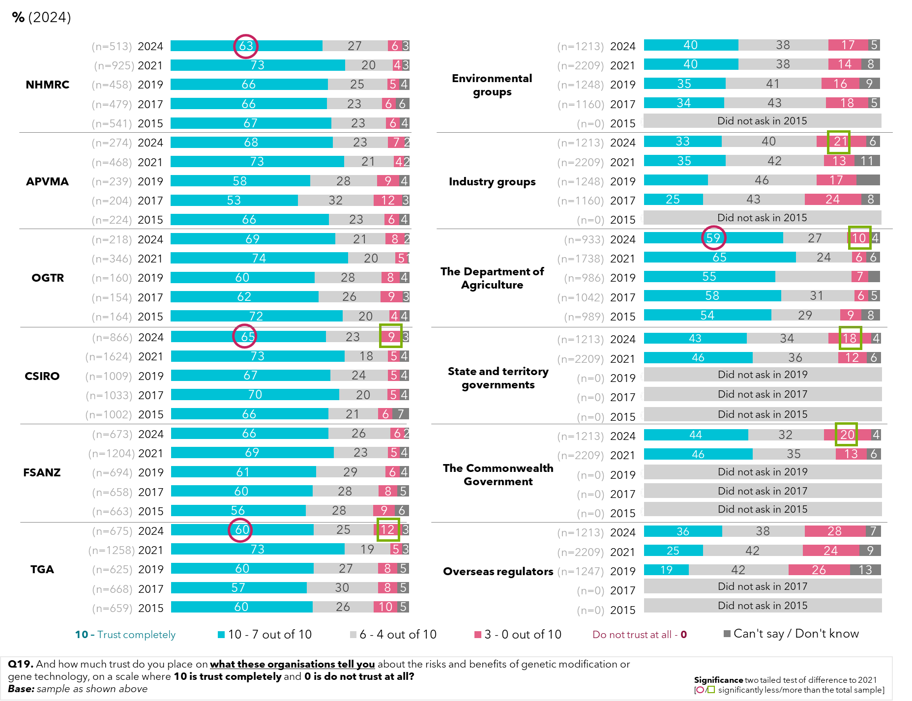

There was a small but significant increase in disagreement (0-3) that the GM rules and regulation surrounding agriculture and food production are sufficiently rigorous and complied with in 2024 compared to 3 years ago, though both were still a significant minority (7% rising to 12% and 6% rising 10% respectively).

Similarly for medical research, there was a growth in those who disagree that the rules and regulations are sufficiently rigorous (6% in 2021 to 10% in 2024) and are complied with (7% in 2021 to 13% in 2024) – although again still relatively low. Interestingly, there was also a growth in disagreement that commercial use of GM should only be allowed after regulatory approval (from 5% in 2021 to 11% in 2024).

Figure 57: Genetic modification rules and regulations – by year

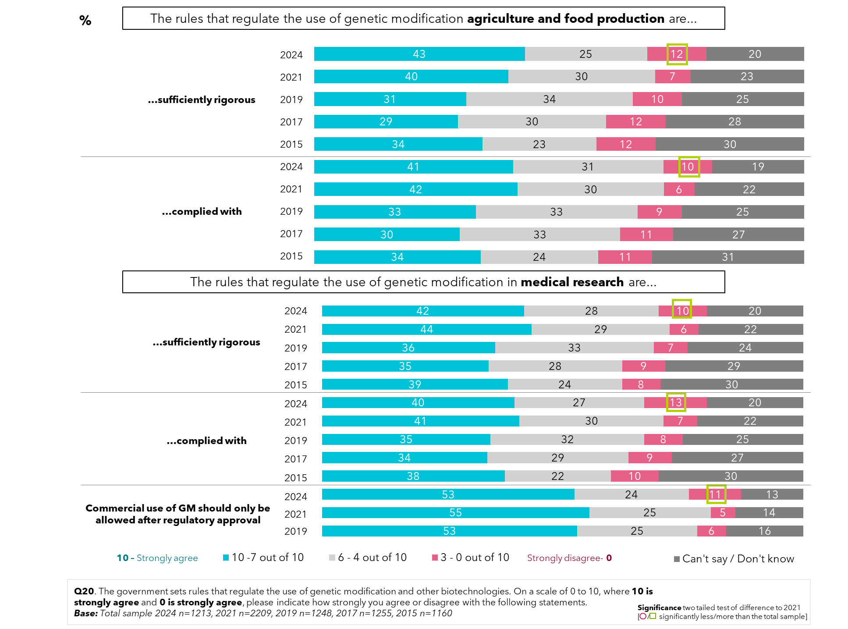

# Conclusions

The general trend across the survey has been a slight diminishing in support for GM technologies, returning to what we might consider a baseline of 2019 and earlier.

The data indicates that most people have settled into their ‘comfort zone’ of support for different applications of GM, and movements are most likely driven by external factors such as trust, types of information viewed, and other global trends. Such trends that are impacting people’s levels of trust in science and new technologies in general, include battles over truth and trust, and the emergence of AI.

A few years on from the height of the COVID-19 pandemic, 41% looking back feel it impacted their attitudes, compared to 35% who felt that way in 2021, suggesting views from the pandemic are being cemented.

In line with cost-of-living concerns, cost is also becoming a significant factor in the motives for supporting genetic modification, much more than in previous years. Also, while asking if GMOs will improve a person’s way of life, responses dropped from 54% in 2021 to 40% in 2024 – which is indicative of general pessimism about the impact of new technologies and the drop in living standards.

However, it should be added that while for most applications of gene technologies there is more support than rejection, many people still have only conditional support, which is dependent on better understanding of the technology, its impacts and its regulation. While such understanding is low, which could be seen as making people vulnerable to changing their support, this is likely being offset by high trust in the OGTR, at a time when trust in institutions is falling.

In relation to health applications of GM they still rate very highly, albeit with some drops since the highs of 2021, suggesting attitudes to health applications are also normalizing. For instance, 56% support the use of GM for medical purposes (down from 61% in 2021), and 45% support GM for therapeutics (down from 56% in 2021), but these were still the highest ratings of all the different types of science and technology developments surveyed. Likewise, levels of high support for using GM for medical uses such as producing insulin or vaccines was the highest rating for different uses of GM at 56%.

High support for GM making foods healthier rated second highest, slightly behind making foods cheaper (35% compared to 37% rating this as very valuable). In 2019, making GM foods healthier rated equally with making plants drought resistant (38%) as the highest rating application. In 2021 both applications increased to 42% high support,

There have also been significant falls in people believing that not vaccinating children puts others at risk, which has dropped from 79% in 2017 to 65% in 2024.

Again, the surveyed public have clearly stated what types of information they most require to either bolster their conditional support for GM, or to offset their conditional opposition to it. Key information needs to address safety and human health, testing and regulations, for those seeking regulator reassurance, and evidence of safety, proof of no long-term impacts and lack of harm to the environment for those seeking scientific reassurance.

When exploring views by gender and age, men are again more supportive of most gene technologies, and women more resistant. Also, younger people again express greater confidence in genetic modification to produce food than do the older people surveyed. There has been no analysis as to whether these attitudes carry through as people get older, or if their attitudes change as they age.

In line with low reported knowledge about gene technologies, there is low awareness about what crops and foods might be GM, and if GM crops were grown in a person’s state. Much information here appears to be coming from dated overseas news reports and anti-GM misinformation memes (e.g. GM tomatoes).

Related to misinformation, over half of respondents were concerned about fake news and misinformation (34% highly concerned), and while most reported being exposed to it (69% rate their exposure as 6-10), most (62%) felt confident they could determine when news was inaccurate. However, there was also an increase in those reporting not being able to identify misinformation (8%; +2).

Landholders who derive income from primary production are more likely than those who do not to support genetic modification and gene technology, such as for farmers in general (64% to 32%), for use in food and crops (63% to 31%) and as a safe way to produce food (43% to 16%). Seeing the benefits for livestock firsthand may also impact attitudes, with 68% of landholders relying on farming for most of their income supporting vaccines for heat tolerance and disease resistance, compared to 50% of the community on average in 2024.

First Nations people (almost 10% of total survey respondents) also had a higher level of support for consuming GM foods than the public. This was led by 57% willing to consume meat and other products from animals that have been fed with genetically modified stock feed, compared to 34% of the general public.

The findings that men are more supportive of genetic modification and gene technology than women, are reflected among farmers and First Nations people surveyed, too.

There are some findings that may appear contradictory at first glance – such as more people in a majority of States and Territories supporting the growing of GM crops in their jurisdictions than opposing them, while at the same time there was a drop from 54% to 40% for those who feel that GMOs will improve their way of life. Or a majority now stating that we should not tamper with nature (54%), and the speed of technological change happening too fast (52%). This is indicative of more specific questions receiving more specific answers, while attitudes towards less specific questions suggest greater influence from wider factors such as a general pessimism towards the future.

While trust in the OGTR is high (69%), there is growing feeling that that the rules and regulations for genetic modification around agriculture and food production are not sufficiently rigorous (12%; +5%) - which is likely a mirror of the rise in general distrust - and that they are not complied with (10%; +4%). Additionally, in 2024, 50% of the population are either unsure or neutral towards the rigour of health regulation, and level of compliance; while only a minority feel it is acceptable (10%).

The mainstream media are still the most used and most trusted sources of information (which include specific news websites) with trust for TV documentaries at 72%. And decreased awareness of GM is likely linked to decrease coverage in the mainstream media in recent years.

While a general Google search was cited as the single most preferred form of obtaining information there was quite a disparity in the trust of information that might be obtained online, varying from news websites (64% trust), Wikipedia (49% trust) and social media discussions (33% trust).

When it comes to sources of information for gene technologies and similar technologies, they do not differ for those aware and trusting of OGTR, and those aware but distrusting of OGTR.

Appendix

# Appendix 1

The following provides a more detailed picture of the sample profile obtained. Please note that the figures are unweighted.

Table 1: Sample by state or territory

|  |  |  |
| --- | --- | --- |
|  | **n=** | **%** |
| **Total sample** | **1213** | **100** |
| Sydney | 228 | 19 |
| Elsewhere in New South Wales | 97 | 8 |
| Melbourne | 177 | 15 |
| Elsewhere in Victoria | 75 | 6 |
| Brisbane | 140 | 12 |
| Elsewhere in Queensland | 60 | 5 |
| Adelaide | 77 | 6 |
| Elsewhere in South Australia | 33 | 3 |
| Perth | 78 | 6 |
| Elsewhere in Western Australia | 33 | 3 |
| Hobart | 49 | 4 |
| Elsewhere in Tasmania | 22 | 2 |
| Canberra/ACT | 71 | 6 |
| Darwin | 56 | 5 |
| Elsewhere in Northern Territory | 17 | 1 |

Table 2: Sample by Gender

|  |  |  |
| --- | --- | --- |
|  | **n=** | **%** |
| **Total sample** | **1213** | **100** |
| Male | 593 | 49 |
| Female | 618 | 51 |
| Non-binary | 2 | 0 |

Table 3: Sample by Age

|  |  |  |
| --- | --- | --- |
|  | **n=** | **%** |
| **Total sample** | **1213** | **100** |
| 16 – 17 years old | **17** | **1** |
| 18 – 20 years | 76 | 6 |
| 21 – 30 years | 196 | 16 |
| 31 – 40 years | 267 | 22 |
| 41 – 50 years | 213 | 18 |
| 51 – 60 years | 164 | 14 |
| 61 – 70 years | 197 | 16 |
| 71 – 75 years | 83 | 7 |

Table 4: Sample by Aboriginal or Torres Strait Islander

|  |  |  |
| --- | --- | --- |
|  | **n=** | **%** |
| **Total sample** | **1213** | **100** |
| Yes, Aboriginal and/or Torres Strait Islander | 100 | 8 |
| No | 1113 | 92 |

Table 5: Sample by Industry currently working in

|  |  |  |
| --- | --- | --- |
|  | **n=** | **%** |
| **Total sample** | **1213** | **100** |
| Employed full time | 479 | 39 |
| Employed part time | 240 | 20 |
| Retired or Pensioner | 185 | 15 |
| Home duties | 96 | 8 |
| School or secondary student | 18 | 1 |
| TAFE or university student | 55 | 5 |
| Unemployed | 100 | 8 |
| Other | 23 | 2 |
| Prefer not to say | 17 | 1 |

Table 6: Sample by Education

|  |  |  |
| --- | --- | --- |
|  | **n=** | **%** |
| **Total sample** | **1213** | **100** |
| No formal schooling | 9 | 1 |
| Primary school | 21 | 2 |
| Some high school | 82 | 7 |
| Year 10/4th Form or equivalent | 87 | 7 |
| Year 11/5th Form or equivalent | 40 | 3 |
| Year 12/6th Form or equivalent | 216 | 18 |
| Technical school, commercial college or TAFE | 317 | 26 |
| University degree or diploma (undergraduate or postgraduate) | 434 | 36 |
| Other | 7 | 1 |

Table 7: Sample by state/territory

|  |  |  |
| --- | --- | --- |
|  | **n=** | **%** |
| **Total sample** | **1213** | **100** |
| A landholder who derives most of my income from primary production (farming) | 87 | 7 |
| A landholder who derives some of my income from primary production (farming) | 86 | 7 |
| A landholder who undertakes hobby farming | 64 | 5 |
| None of the above | 976 | 80 |

Table 8: Sample by year and state/ territory

|  |  |  |  |  |
| --- | --- | --- | --- | --- |
|  | **2015** | **2019** | **2021** | **2024** |
| **Total sample** | **%** | **%** | **%** | **%** |
| NSW | 28 | 26 | 26 | 27 |
| VIC | 22 | 21 | 21 | 21 |
| QLD | 17 | 16 | 17 | 16 |
| SA | 6 | 11 | 9 | 9 |
| WA | 9 | 10 | 9 | 9 |
| TAS | 6 | 6 | 6 | 6 |
| ACT | 6 | 6 | 6 | 6 |

Table 9: Sample by year and gender

|  |  |  |  |  |
| --- | --- | --- | --- | --- |
|  | **2015** | **2019** | **2021** | **2024** |
| **Total sample** | **%** | **%** | **%** | **%** |
| Male | 49 | 48 | 48 | 49 |
| Female | 51 | 52 | 52 | 51 |
| Non-binary | 0 | 0 | 0 | 0 |

Table 10: Sample by year and age

|  |  |  |  |  |
| --- | --- | --- | --- | --- |
|  | **2015** | **2019** | **2021** | **2024** |
| **Total sample** | **%** | **%** | **%** | **%** |
| 16-30 years | 21 | 24 | 23 | 24 |
| 31-50 years | 40 | 39 | 39 | 40 |
| 51-75 years | 39 | 37 | 38 | 37 |

Sydney, Australia

Suite 302, 410 Elizabeth Street

Surry Hills NSW 2010

e: enquiries@instinctandreason.com

p: +61 (0)2 9283 2233

Darwin, Australia

Level 16, Charles Darwin Centre

19 Smith Street Mall   
Darwin NT 0800

e: enquiries@instinctandreason.com

p: +61 (0)8 8963 5633

Canberra, Australia

103/11 Trevillian Quay

Kingston Act 2604

e: enquiries@instinctandreason.com

p: +61 2 6231 0350

London, UK

No. 7 Ridgmount Street, suite 1,

London, WC1 E7AE,

United Kingdom

e: international@instinctandreason.com

p: +44 (0)2 03 355 4454

Sydney, Australia

Suite 302, 410 Elizabeth Street

Surry Hills NSW 2010

e: enquiries@instinctandreason.com

p: +61 (0)2 9283 2233

Darwin, Australia

Level 16, Charles Darwin Centre

19 Smith Street Mall   
Darwin NT 0800

e: enquiries@instinctandreason.com

p: +61 (0)8 8963 5633

Canberra, Australia

103/11 Trevillian Quay

Kingston Act 2604

e: enquiries@instinctandreason.com

p: +61 2 6231 0350

London, UK

No. 7 Ridgmount Street, suite 1,

London, WC1 E7AE,

United Kingdom

e: international@instinctandreason.com

p: +44 (0)2 03 355 4454

1. ## References

   (2024) Innovation in Peril, Edelman Trust Barometer, Edelman.
2. FSANXZ (2022) Consumer Survey Report Consumers’ perceptions of and attitudes towards genetically modified foods, Food Standards Australia New Zealand.
3. Većkalov, Bojana & van Stekelenburg, Aart & van Harreveld, Frenk & Rutjens, Bastiaan. (2023). Who Is Skeptical About Scientific Innovation? Examining Worldview Predictors of Artificial Intelligence, Nanotechnology, and Human Gene Editing Attitudes. Science Communication. 45. 10.1177/10755470231184203.
4. Strobbe, S. Wesana, J., Van Der Straeten, D., De Steur, H. (2023) "Public acceptance and stakeholder views of gene edited foods: a global overview." Trends in Biotechnology.

   v Kaufman J, Hoq M, Rhodes AL, Measey MA, Danchin MH. Misperceptions about routine childhood vaccination among parents in Australia, before and after the COVID-19 pandemic: a cross-sectional survey study. Med J Aust. 2024 Jun 3;220(10):530:532.
5.