

Risk Assessment and Risk Management Plan (Consultation version) for

**DIR****-206**

Clinical trial for the treatment of   
mycobacterial infections using bacteriophages

Applicant: Western Sydney Local Health District

25 October 2024

**This RARMP is open for consultation until 9 December 2024.**

Written comments on the risks to human health and safety and the environment posed by this proposed clinical trial of the GM bacteriophage treatment are invited. You may make your submission

via mail to: The Office of the Gene Technology Regulator, MDP 54 GPO Box 9848, Canberra ACT 2601

or

via email to: [ogtr@health.gov.au](mailto:ogtr@health.gov.au).

Please note that issues regarding patient safety and the quality of the GM bacteriophage treatment **do not** fall within the scope of these evaluations as they are the responsibilities of other agencies and authorities.

PAGE INTENTIONALLY LEFT BLANK

# Summary of the Risk Assessment and Risk Management Plan

**(Consultation Version) for**

**Licence Application DIR-206**

## Introduction

The Gene Technology Regulator (the Regulator) has received a licence application to conduct a clinical trial using a genetically modified organism (GMO). It qualifies as a Dealing involving the Intentional Release (DIR) of GMOs into the Australian environment under the *Gene Technology Act 2000*.

The applicant, Western Sydney Local Health District (WSLHD), proposes to conduct a clinical trial to evaluate the safety and efficacy of genetically modified (GM) bacteriophages, alone or in combination with non-GM bacteriophage therapy, for the treatment of Australian patients with mycobacterial infections.

The GMOs were modified from bacteriophages which have been shown to kill mycobacteria. The GMOs would be manufactured overseas and imported into Australia. They would be administered by various methods including via nebuliser, by intravenous injection, instillation, or topical application in Australia at clinical trial sites, hospitals and other sites under the hospital in the home (HITH) program.

Clinical trials in Australia are conducted in accordance with requirements of the *Therapeutic Goods Act 1989*, which is administered by the Therapeutic Goods Administration (TGA). Therefore, in addition to approval by the Regulator, WSLHD would also require authorisation from TGA before the trial commences. Clinical trials conducted in Australia must also be conducted in accordance with the [*National Statement on Ethical Conduct in Human Research*](https://www.nhmrc.gov.au/about-us/publications/national-statement-ethical-conduct-human-research-2007-updated-2018)and with the [*Guidelines for Good Clinical* *Practice*](https://www.tga.gov.au/publication/note-guidance-good-clinical-practice) of the International Council for Harmonisation of Technical Requirements for Registration of Pharmaceuticals for Human Use. WSLHD would also require approval from the Department of Agriculture, Fisheries and Forestry for import of the GMOs.

The Regulator has prepared a Risk Assessment and Risk Management Plan (RARMP) for this application, which concludes that the proposed clinical trial poses negligible risks to human health and safety and the environment. Licence conditions have been drafted for the proposed clinical trial. The Regulator invites submissions on the RARMP, including draft licence conditions, to inform the decision on whether to issue a licence.

## The application

|  |  |
| --- | --- |
| **Project Title** | Clinical trial of the treatment of mycobacterial infections using bacteriophages[1] |
| **Parent organism** | Bacteriophages (mycobacteriophages) |
| **Genetic modifications** | Deletion of genes including the repressor gene, rendering the bacteriophages lytic in order to destroy host bacteria. |
| **Principal purpose** | The proposed dealings are to administer genetically modified bacteriophages to treat Australian patients with mycobacterial infections. |
| **Previous clinical trials** | DNIR-620 issued to the Sydney Children’s Hospital Network authorised the therapeutic treatment of paediatric patients with cystic fibrosis and *Mycobacterium abscessus* disease.  DNIR-655 issued to the Alfred Hospital authorised bacteriophage therapy for severe lung disease due to *Mycobacterium abscessus* infection. |
| **Proposed limits and controls** | |
| **Proposed duration** | 5 years |
| **Proposed release size** | At least 3 participants would be enrolled in the trial in Australia |
| **Proposed locations** | This clinical trial would be conducted within Australia at clinical trial sites, hospitals and other sites through the Hospital In The Home (HITH) program. The number of sites and specific locations are yet to be determined. |
| **Proposed controls** | * Administration will be in-hospital or by qualified persons under the HITH program. * Qualified persons will change dressings. * Administration will only be to participants under Special Access Scheme categories A and B. * Administration will be limited to the treatment of those with mycobacterial infections. |

## Risk assessment

The risk assessment process considers how the genetic modification and activities conducted with the GM bacteriophages in the context of import, transport, storage, administration and disposal might lead to harm to people or the environment. Risks are characterised in relation to both the seriousness and likelihood of harm, taking into account information in the application, relevant previous approvals, current scientific knowledge and advice received from a wide range of experts, agencies and authorities consulted on the preparation of the RARMP. Both the short- and long-term risks were considered.

Credible pathways to potential harm that were considered include; the potential exposure of people to the GMO; the potential exposure of animals to the GMO; and the potential for the GMO to recombine with other similar bacteriophages. The potential for the GMO to be released into the environment and its effects were also considered.

The risk assessment concludes that risks to the health and safety of people are negligible and the risks to the environment from the proposed dealings with the GM bacteriophages are negligible. Specific risk treatment measures are included in the licence to maintain the risk context.

## Risk management

The risk management plan describes measures to protect the health and safety of people and to protect the environment by controlling or mitigating risk. The risk management plan is given effect through licence conditions. Draft licence conditions are detailed in Chapter 4 of the RARMP.

As the level of risk is considered negligible, specific risk treatment is not required. However, as this application was assessed as a limited and control licence and limited data are available for the use of this class of GMOs in clinical trials, conditions were included in the draft licence to minimise the potential for the GMO to spread in the environment. Since this is a clinical trial, the draft licence includes limits on the inclusion criteria of trial participants and the duration of the trial. In addition, there are several general conditions relating to ongoing licence holder suitability, auditing and monitoring, and reporting requirements which include an obligation to report any unintended effects.

# Table of contents

Summary of the Risk Assessment and Risk Management Plan I

Introduction I

The application II

Risk assessment II

Risk management III

Table of contents IV

Abbreviations V

Chapter 1 Risk assessment context 6

Section 1 Background 6

1.1 Interface with other regulatory schemes 7

Section 2 The proposed dealings 9

2.1 The proposed limits of the trial (duration, scale, location, people) 9

2.2 The proposed controls to restrict the spread and persistence of the GMOs in the environment 9

2.3 Details of the proposed dealings 10

Section 3 Parent organism 15

Section 4 The GMO - nature and effect of the genetic modification 22

Section 5 The receiving environment 27

5.1 Clinical trial sites 27

5.2 Relevant environmental factors 27

Section 6 Previous authorisations 27

Chapter 2 Risk assessment 29

Section 1 Introduction 29

Section 2 Risk identification 30

2.1 Risk source 30

2.2 Causal pathway 30

2.3 Potential harms 31

2.4 Postulated risk scenarios 31

Section 3 Uncertainty 40

Section 4 Risk evaluation 42

Chapter 3 Risk management plan 44

Section 1 Background 44

Section 2 Risk treatment measures for substantive risks 44

Section 3 General risk management 44

3.1 Limits and controls on the clinical trial 44

3.2 Other risk management considerations 47

Section 4 Issues to be addressed for future releases 48

Section 5 Conclusions of the consultation RARMP 48

Chapter 4 Draft licence conditions 49

References 62

# Abbreviations

|  |  |
| --- | --- |
| APVMA | Australian Pesticides and Veterinary Medicines Authority |
| CDC | Centers for Disease Control and Prevention |
| CTN | Clinical Trial Notification Scheme |
| BSC | Biological Safety Cabinet |
| DIR | Dealings Involving Intentional Release |
| DNA | Deoxyribonucleic acid |
| FSANZ | Food Standards Australia New Zealand |
| GTTAC | Gene Technology Technical Advisory Committee |
| GM | Genetically modified |
| GMO | Genetically modified organism |
| ICH-GCP | *Guidelines for Good Clinical Practice* of the International Council for Harmonisation of Technical Requirements for Registration of Pharmaceuticals for Human Use |
| HREC | Human Research Ethics Committee |
| IBC | Institutional Biosafety Committee |
| IATA | International Air Transport Association |
| mL | Millilitre |
| min | Minute |
| NHMRC | National Health and Medical Research Council |
| OGTR | Office of the Gene Technology Regulator |
| PPE | Personal Protective Equipment |
| PFU | Plaque Forming Units |
| PCR | Polymerase chain reaction |
| RAF | Risk Analysis Framework |
| RARMP | Risk Assessment and Risk Management Plan |
| SOP | Standard Operating Procedure |
| SNV | Single nucleotide variation |
| *the Act* | The *Gene Technology Act 2000* |
| the Regulations | The Gene Technology Regulations 2001 |
| the Regulator | The Gene Technology Regulator |
| TGA | Therapeutic Goods Administration |
| TSDs | The Regulator’s *Guidelines for Transport, Storage and Disposal* |
| USA | United States of America |
| WHO | World Health Organization |
| WIMR | Westmead Institute for Medical Research |

1. Risk context
   1. Background
2. An application has been made under the Gene Technology Act 2000 (the Act) for Dealings involving the Intentional Release (DIR) of genetically modified organisms (GMOs) into the Australian environment.
3. The Act and the Gene Technology Regulations 2001 (the Regulations), together with corresponding State and Territory legislation, comprise Australia’s national regulatory system for gene technology. Its objective is to protect the health and safety of people, and to protect the environment, by identifying risks posed by or as a result of gene technology, and by managing those risks through regulating certain dealings with GMOs.
4. Section 50 of the Act requires that the Gene Technology Regulator (the Regulator) must prepare a Risk Assessment and Risk Management Plan (RARMP) in response to an application for release of GMOs into the Australian environment. Sections 50, 50A and 51 of the Act and sections 9 and 10 of the Regulations outline the matters which the Regulator must take into account and who must be consulted when preparing the RARMP.
5. The *Risk Analysis Framework* (RAF) (OGTR, 2013) explains the Regulator's approach to the preparation of RARMPs in accordance with the Act and the Regulations. The Regulator has also developed operational policies and guidelines that are relevant to DIR licences. These documents are available from the Office of the Gene Technology Regulator ([www.ogtr.gov.auhttp://www.ogtr.gov.au/](http://www.ogtr.gov.au/)).
6. Figure 1 shows the information that is considered, within the regulatory framework above, in establishing the risk assessment context. This information is specific for each application. Risks to the health and safety of people or the environment posed by the proposed supply are assessed within this context. Chapter 1 describes the risk assessment context for this application.

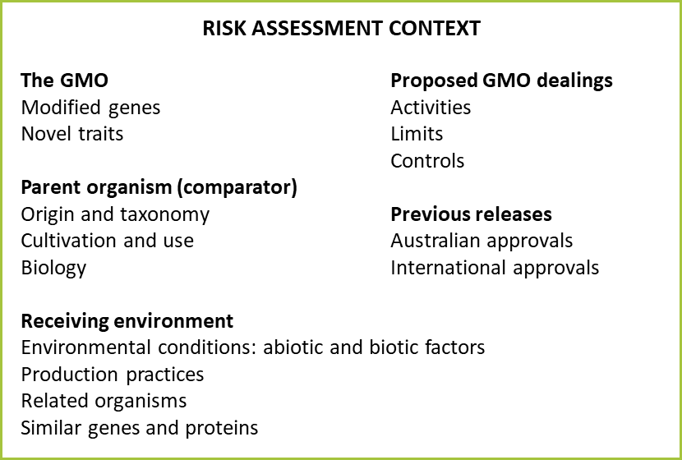

**Figure 1.** Summary of parameters used to establish the risk assessment context, within the legislative requirements, operational policies and guidelines of the OGTR and the RAF.

1. In accordance with Section 50A of the Act, this application is considered to be a limited and controlled release application, as the Regulator was satisfied that it meets the criteria prescribed by the Act. Therefore, the Regulator was not required to consult with prescribed experts, agencies and authorities before preparation of the RARMP.
2. Section 52 of the Act requires the Regulator to seek comment on the consultation RARMP from agencies - the Gene Technology Technical Advisory Committee (GTTAC), State and Territory Governments, Australian Government authorities or agencies prescribed in the Regulations, Australian local councils and the Minister for the Environment - and from the public.
   * 1. Interface with other regulatory schemes
3. Gene technology legislation operates in conjunction with other regulatory schemes in Australia. The GMOs and any proposed dealings conducted under a licence issued by the Regulator may also be subject to regulation by other Australian government agencies that regulate GMOs or GM products, including Food Standards Australia New Zealand (FSANZ), the Australian Pesticides and Veterinary Medicines Authority (APVMA), the Therapeutic Goods Administration (TGA), the Australian Industrial Chemicals Introduction Scheme (AICIS) and the Department of Agriculture, Fisheries and Forestry (DAFF).
4. Medicines and other therapeutic goods for use in Australia are required to be assessed for quality, safety and efficacy under the *Therapeutic Goods Act 1989* and must be included in the Australian Register of Therapeutic Goods. The TGA is responsible for administering the provisions of this legislation. Clinical trials of therapeutic products that are experimental and under development, prior to a full evaluation and assessment, are also regulated by the TGA through the Clinical Trial Approval (CTA) scheme or the Clinical Trial Notification (CTN) scheme.
5. For clinical trials, the TGA has regulatory responsibility for the supply of unapproved therapeutic products. In terms of risk to individuals participating in a clinical trial, the TGA (as the primary regulatory agency), the trial sponsor, the investigators and the Human Research Ethics Committee (HREC) at each trial site all have roles in ensuring participants’ safety under the *Therapeutic Goods Act 1989*. However, where the trial involves a GMO, authorisation is also required under gene technology legislation. To avoid duplication of regulatory oversight, and as risks to trial participants are addressed through the above mechanisms, the Regulator’s focus is on assessing risks posed to people other than those participating in the clinical trial, and to the environment. This includes risks to people preparing and administering the GMO and risks associated with import, transport and disposal of the GMO.
6. The International Council for Harmonisation of Technical Requirements for Registration of Pharmaceuticals for Human Use – Guidelines for Good Clinical Practice (ICH-GCP) is an international ethical and scientific quality standard for designing, conducting, recording and reporting trials that involve the participation of human subjects (ICH 1996). The guideline was developed with consideration of the current good clinical practices of the European Union (EU), Japan, and the United States of America (USA), as well as those of Australia, Canada, the Nordic countries and the World Health Organization (WHO). The TGA has adopted the ICH-GCP in principle as Note for Guidance on Good Clinical Practice (designated CPMP/ICH/135/95) (Therapeutic Goods Administration 2000), which provides overarching guidance for conducting clinical trials in Australia which fall under TGA regulation.
7. The National Health and Medical Research Council (NHMRC) has issued the *National Statement on Ethical Conduct in Human Research* (National Health and Medical Research Council et al., 2018). This document sets the Australian standard against which all research involving humans is reviewed. The *Therapeutic Goods Act 1989* requires that the use of a therapeutic good in a clinical trial must be in accordance with the ethical standards set out in this document.
8. Approval by a Human Research Ethics Committee (HREC) is also a fundamental requirement of a clinical trial. HRECs conduct both ethical and scientific assessment of the proposal and in addition often consider issues of research governance. Other elements of governance of clinical trials that are considered by HRECs include appropriate informed consent, specific inclusion and exclusion criteria, data monitoring and vaccine accounting and reconciliation.
9. DAFF administers Australian biosecurity conditions for the importation of biological products under the *Biosecurity Act 2015*. Biological products include animal or microbial derived products such as foods, therapeutics, laboratory materials and vaccines (including GM vaccines).
10. Analysis of biological samples collected from trial participants administered with the GMO would occur at clinical trial sites, or at pathology laboratories. These facilities are regulated by State and Territory governments and adhere to professional standards for safety ([NSQHS](https://www.safetyandquality.gov.au/our-work/assessment-to-the-nsqhs-standards/nsqhs-standards-second-edition/)), disease control ([Australian Guidelines for the Prevention and Control of Infection in Healthcare (2019)](https://www.nhmrc.gov.au/about-us/publications/australian-guidelines-prevention-and-control-infection-healthcare-2019) and handling of pathology samples (The National Pathology Accreditation Advisory Council ([NPAAC](https://www1.health.gov.au/internet/main/publishing.nsf/Content/health-npaac-index.htm))).
11. [NPAAC](https://www1.health.gov.au/internet/main/publishing.nsf/Content/health-npaac-index.htm) advises Commonwealth, State and Territory health ministers on matters relating to the accreditation of pathology laboratories. NPAAC plays a key role in ensuring the quality of Australian pathology services and is responsible for the development and maintenance of standards and guidelines for pathology practices. The standards include safety precautions to protect the safety of workers from exposure to infectious microorganisms in pathology laboratories. While compliance with NPAAC standards and guidelines is not mandatory, there is a strong motivation for pathology services to comply, as Medicare benefits are only payable for pathology services if conducted in an appropriate Accredited Pathology Laboratory (APL) category, by an Approved Pathology Practitioner (APP) employed by an Approved Pathology Authority (APA). Accreditation of pathology services is overseen by Services Australia (formerly Department of Human Services), and currently, the only endorsed assessing body for pathology accreditation is the National Association of Testing Authorities ([NATA](https://www.nata.com.au/)).
12. The state and territory governments regulate hospitals and other medical facilities in Australia. All public and private hospitals and day procedure services need to be accredited to the National Safety and Quality Health Service ([NSQHS](https://www.safetyandquality.gov.au/standards/nsqhs-standards)) Standards developed by the Australian Commission on Safety and Quality in Healthcare (the Commission) and endorsed by the state and territory Health Ministers. The Commission coordinates accreditation processes via the Australian Health Service Safety and Quality Accreditation (AHSSQA) scheme. The NSQHS Standards provide a quality assurance mechanism that tests whether relevant systems are in place to ensure that the minimum standards of safety and quality are met. The safety aspects addressed by the NSQHS Standards include the safe use of sharps, disinfection, sterilisation and appropriate handling of potentially infectious substances. Additionally, the Commission has developed the National Model Clinical Guidance Framework, which is based on, and builds on NSQHS Standards to ensure that clinical governance systems are implemented effectively and to support better care for patients and consumers.
13. Hospitals and pathology laboratories, including their workers, managers and executives, all have a role in making the workplace safe and managing the risks associated with handling potentially infectious substances including the proposed GMO. There are minimum infection prevention practices that apply to all health care in any setting where health care is provided. These prevention practices were initially developed by the Centres for Disease Control and Prevention (CDC) and are known as the standard precautions for working with potentially infectious material. The standard precautions are described in the [Australian Guidelines for the Prevention and Control of Infection in Healthcare (2019)](https://www.nhmrc.gov.au/about-us/publications/australian-guidelines-prevention-and-control-infection-healthcare-2019).
14. After a period of hospitalisation, the applicant has stated that the patients’ treatment may be continued at home. Each State and Territory has its own Guidelines for the treatment of patients once they return home and there is a need for follow up treatment outside of the hospital environment. In New South Wales for example, the *Adult and paediatric guidelines Hospital in the Home* include procedures to be followed in relation to drug administration and patient care in the home, in schools, workplaces, or other locations outside of hospitals or clinical sites. The medical staff are instructed to follow the *Infection and Prevention control practice handbook* when caring for a patient at home. As for most Guidelines, this would include procedures to follow in relation to hand hygiene, personal protective equipment (PPE) worn, disposal of sharps and other waste and for the transport of medicines and sharps.
    1. The proposed dealings
15. WSLHD is seeking authorisation to carry out a clinical trial to assess the safety and efficacy of a genetically modified (GM) bacteriophage treatment of mycobacterial infections (specifically caused by *Mycobacterium abscessus*).
16. The dealings involved in the proposed clinical trial are:
17. import the GMO;
18. conduct the following with the GMO:
    1. grow or culture the GMO;
    2. prepare the GMO for administration to trial participants;
    3. administer the GMO to clinical trial participants via endobronchial lavage, nebuliser, intravenous injection, instillation, or topical application;
    4. collect samples from trial participants;
    5. analyse the samples;
19. transport the GMO;
20. dispose of the GMO;

and may possess, supply, use or store the GMO for the purposes of, or in the course of, any of these dealings.

* + 1. The proposed limits of the trial (duration, scale, location, people)

1. The clinical trial is proposed to take place over a five-year period from the date of issue of the licence. At least 3 participants in Australia would receive 1 or more doses of the GMOs.
2. The clinical trial would take place at clinical trial sites and hospitals in Australia, including Westmead Hospital, Sydney. Administration may also be conducted in the homes of participants, suitable rooms at schools and workplaces under the HITH program.
3. Only trained and authorised staff would conduct dealings with the GMO. Administration of the GMO to trial participants would be conducted by qualified persons in both WSLHD and HITH throughout Australia.
   * 1. The proposed controls to restrict the spread and persistence of the GMOs in the environment
4. The applicant has proposed a number of controls to minimise exposure to the GMO, and to restrict the spread and persistence of the GMOs in the environment. These include:

* Administration will only be to participants under Special Access Scheme categories A and B.
* Administration will be limited to the treatment of those with mycobacterial infections.
* Transport and storage of the GMO to a clinical trial site or site where it will be administered will be in accordance with the Regulator’s *Guidelines for the Transport, Storage and Disposal of GMOs* (TSDs).
* Unused GMO and all waste likely to contain the GMO will be disposed of through the clinical waste stream.
* Administration will be in-hospital or by qualified persons under the HITH program.
  + 1. Details of the proposed dealings
       1. Manufacturing and import of the GMO

1. The GMO will be manufactured and lyophilised at the University of Pittsburgh, USA.
2. The GMO would be imported to the Westmead Institute for Medical Research (WIMR) under NLRD-11938. Import and transport from the Australian border to WIMR will be conducted in accordance with International Air Transport Association (IATA) shipping classification 3245 or 3373.
   * + 1. Grow or culture the GMO
3. The GMO will be cultured in a PC2 laboratory at WIMR under NLRD-11938 to determine the bacteriophage titre.
   * + 1. Transport and storage of the GMO
4. For all other transport within Australia, the bacteriophages will be transported in accordance with the Regulator’s *Guidelines for the Transport, Storage and Disposal of GMOs* (June 2011). The GMOs will be contained within a primary sealed container which will be packed in a secondary airtight sealed unbreakable container. The secondary container will be labelled with the telephone number of the person to contact should the package be damaged or lost, and also to indicate that it contains GM microorganisms.
5. The GMO will be directly imported and stored at WIMR. The GMO will be subsequently transported and stored for use in HITH.
6. Doses will be made up by a pharmacist once a week and dispensed to either the ward nurses in-hospital or the HITH nurses.
7. The doses will be made up in the pharmacy in a class II biological safety cabinet (BSC). Each vial constitutes 10 doses of treatment, and these will be stored in the pharmacy or the ward. All vials and diluted doses will have a biohazard label attached and will be stored in a fridge with appropriate labelling. On the ward, doses may be stored in a fridge within the secured drug-storage room.
8. At Westmead Hospital, the treating physicians, junior medical staff of the treating team, ward nursing staff, ward cleaning services staff, HITH nursing staff, pharmacy staff, infectious diseases physicians and microbiology laboratory staff will have access to the GM bacteriophages. The majority of dealings will be conducted by ward nursing staff and HITH nursing staff. Ward cleaning services staff will have access to the bacteriophages as part of the disposal of the bacteriophages in the clinical waste stream.
   * + 1. The clinical trial
9. The proposed clinical trial is an open-label, single-arm trial investigating a standardised treatment and monitoring protocol (STAMP) for bacteriophage therapy. The study will evaluate the safety and efficacy of bacteriophage therapies administered by various methods including by endobronchial lavage, nebuliser, intravenous injection, instillation, or topical application for the treatment of mycobacterial infections.
10. After 1–6 weeks of in-hospital admission, the participants may be treated by the HITH team, where registered nurses will visit the participant at home, school, or in the workplace to administer the bacteriophage treatment for a further 6–12 months depending on clinical outcomes.
    * + 1. Selection of trial participants
11. Relevant inclusion criteria proposed by the applicant include that participants must:

* Have confirmed mycobacterial infection.
* Be eligible for under the TGA’s Special Access Scheme for the use of unapproved products which are not included in the *Australian Register of Therapeutic Goods*. Participants must be eligible under Category A, where an eligible participant is seriously ill, or Category B where there is clinical justification for the use of unapproved products.

1. Relevant exclusion criteria proposed by the applicant include:

* Participant is unable or unlikely to adhere to schedule of monitoring and follow-up.
  + - 1. Preparation and administration of the GMO

1. Local pharmacy guidelines will be followed at each clinical site and relevant documentation including batch-specific safety data sheets will be recorded.
2. The GMO will be reconstituted in a BSC within a PC2 facility at WIMR, using the proposed protocol:
   * 1. PPE used will include gown, gloves, face mask and eye protection.
     2. Depending on administration method, 1 mL of PBS or Ringers solution will be added to each vial of GMO, mixed and a further 9 mL of PBS added.
     3. GMO will be drawn into the dosing syringe with appropriate needle or other devices.
     4. The syringe will be placed in a sealed biohazard bag, wiped with active chlorine solution or appropriate disinfectant before being removed from the BSC.
     5. The sealed biohazard bag will be placed into a second biohazard bag with an absorbent pad, and labelled with an appropriate biohazard label. This secondary bag will be placed in a hard plastic container clearly labelled with a biohazard label for transport to the participant.
     6. A biological spill kit will be available and include an appropriate denaturing solution as per the Sydney Children’s Hospital Network *Transport, Waste & Spill Management of Medicinal Products containing GMOs*.
     7. Any residual or unused GMO will be decontaminated prior to removal from the BSC.
     8. All waste inside the BSC will be placed into biohazard bags for disposal through the clinical waste stream.
     9. The BSC will be cleaned with chlorine solution, water and/or isopropyl alcohol or other appropriate disinfectant.
3. Following preparation, no specific PPE would be required for transport of the GMO to the next storage or administration site.
4. Once at the administration site, all persons present must wear appropriate PPE prior to opening the secondary biohazard bag.
5. Modes of administration are limited to (Figure 2):
6. Intravenous infusion or via a wound-drain
7. Intravenous injection or direct instillation
8. Topical application
9. Nebuliser (only in homes or in hospital, not at schools or in workplaces)
10. Endobronchial lavage (only in hospital)

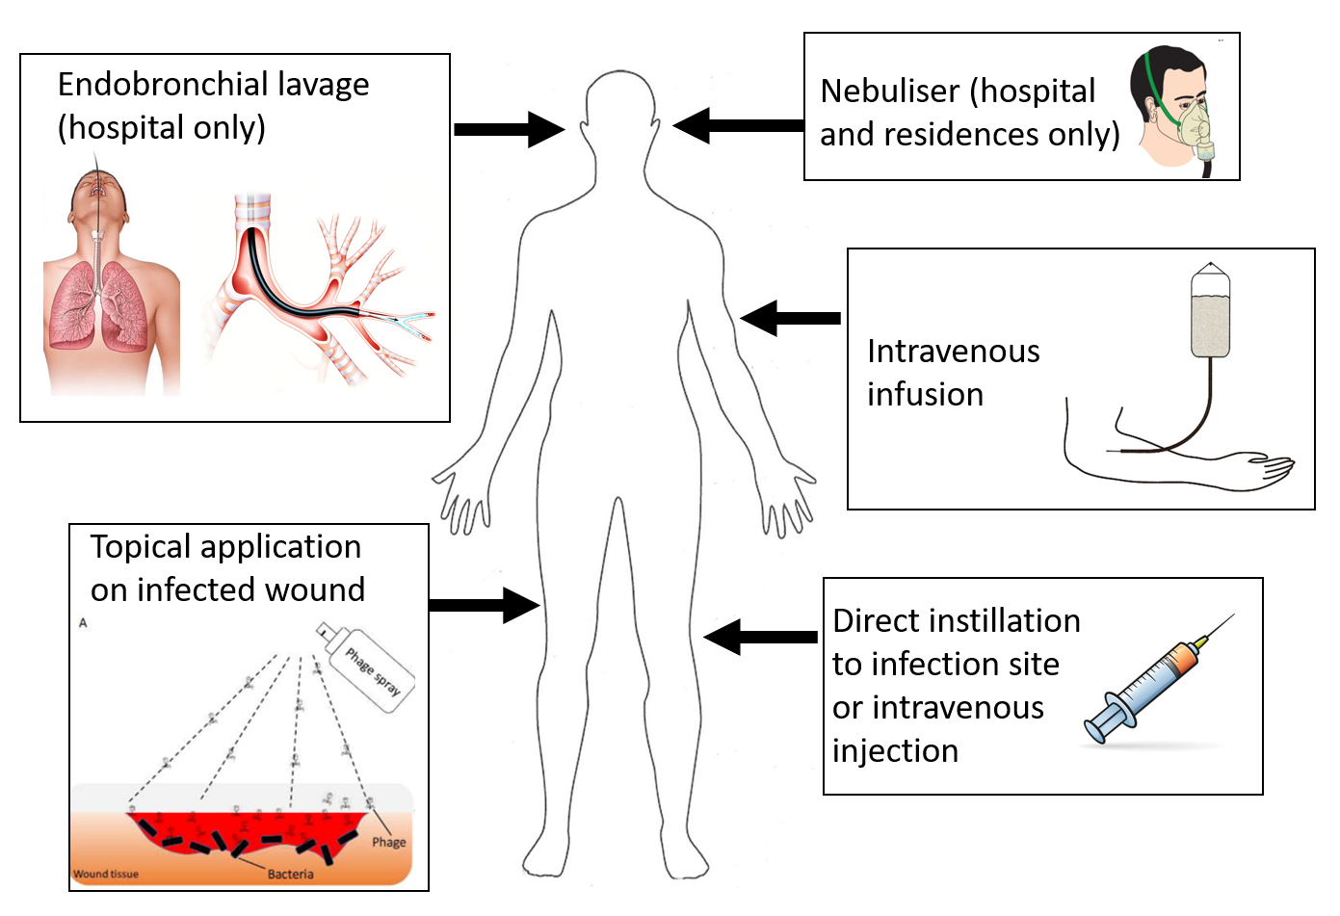

**Figure 2.** The administration methods proposed

1. The initial administration of the GMO would be in hospital, and ongoing administration of the GMO may be required outside of clinical sites, in homes, schools, or workplaces.
2. Administration by endobronchial lavage would only be conducted in hospital and performed once or a few times for each participant. Other modes of administration will be performed at least every 3 days, potentially twice per day. Small batches of vials will be stored in the hospital pharmacy so that appropriate dilutions of the bacteriophages can be made up for therapeutic use.
3. Hospitals and clinical sites have their own policies in place for these different methods of administration and post-administration care, both on-site and as part of their respective HITH programs. Staff members would be instructed to follow existing procedures. The HITH and in-hospital administration would follow the same protocols.
4. During administration, absorbent disposable pads (i.e. blueys) would be used under the area of administration in case of any leakage. During HITH administration or post-administration care when the GMO may be present, any waste that has come into contact with GMOs, such as soaked blueys and syringes will be disposed of in a sealed plastic bag for return to the clinical site to enter the clinical waste stream.
   * + - 1. Endobronchial lavage
5. Endobronchial lavage involves the insertion of a tube into the lungs to administer the GMO. This will only be conducted in hospitals.
   * + - 1. Intravenous infusion or administration via a wound-drain
6. Intravenous infusion does not require the use of sharps. Needles that are used in intravenous infusion are used to place a canula prior to the administration of the GMO and do not have any opportunity to come into contact with the GMO. The GMO is placed in an IV bag and infused slowly into the bloodstream. Volumes involved would be less than 1 L. The GMO may also be introduced to external or internal infected sites via the drainage portal used to manage fluids being exuded from the infected site.
   * + - 1. Intravenous injection or direct instillation
7. Intravenous injection for systematic administration, or direct instillation of the GMO directly into the targeted infected tissue involves different volumes of GMO. These methods involve the use of needles that will be in contact with the GMO.
   * + - 1. Topical application
8. The administration would include placing absorbent disposable pads (i.e. blueys) under area to be treated. A typical topical application to a wound would involve applying several millilitres of GM bacteriophage solution directly onto the infected site, and an equal volume onto gauze which is wrapped onto the wound, protected by plastic wrap and secured with medical tape.
   * + - 1. Nebuliser administration
9. The administering person would wear PPE including gloves, gown, eye protection and face mask. Carers would be required to leave room or wear full PPE. Bacteriophages would be nebulised in sequential batches depending on the volume being administered.
   * + 1. Sample collection and analysis
10. Biological samples would be collected to assess the presence of bacteriophages (plaque assay and qPCR) and bacteria (qPCR). Samples would be taken prior to administration of the bacteriophages, 30 minutes and 2 hours post-dose and on Days 2, 4, 8, 11, 15, 29.
11. Bacterial samples would be obtained from the site of infection, blood, urine, faeces, sputum, swabs or other clinical specimens.
12. Samples would be taken at home by HITH staff and treated in the same manner as clinical samples.
    * + 1. Decontamination and disposal of the GMO
13. Clinical waste generated in-hospital, such as syringes, gauze, bandages, PPE and protective materials that may contain or have been in contact with GMOs, as well as residual GMOs, would be disposed of in the clinical waste stream.
14. Clinical waste generated during HITH administration and care will be returned to the clinical site/s for disposal via the clinical waste stream by the HITH staff at the end of any HITH visits.
15. Participant waste at home (e.g. faeces, urine, shower water) will enter the sewage system.
    * + 1. Training
16. Personnel dealing with the bacteriophages in HITH are trained and experienced in working with infectious agents. The applicant has indicated that HITH nurses would be trained against the licence conditions.
17. The applicant has stated that the training for HITH administration and care would cover the use of sharps, waste management, and PPE. HITH staff would be given education regarding the GMO, biohazard training and spill kit training.
    * + 1. Accountability and Monitoring
18. The GM bacteriophages will only be stored securely in clinical sites and not at the sites of HITH administration.
19. Qualified third-party nurses may be employed to administer the GM bacteriophages at non-clinical sites. They will be trained in bacteriophage administration and receive 6-monthly refreshers.
    * + 1. Contingency plans
20. A biohazard spill kit containing a decontamination reagent appropriate for use on the GMO will be available during HITH visits.
21. In the event of a spill in the hospital or during HITH, the PPE used for administration of the GMO (including long-sleeved non-permeable gown, gloves, mask and eye protection) will be worn. The spill area will be mopped with absorbent paper towels, placing all waste and used PPE in zip-lock bags for return to a clinical site after the HITH visit. PPE will be removed and put into the waste bag for transport back to the clinical site for disposal in the clinical waste stream.
22. In the event of a staff member’s skin being exposed to the GMO, they would be instructed to wash down contaminated skin with a hand-disinfectant and water.
23. Spill events will be reported to the HITH manager and documented in the records of the clinical site and the participant.
    1. Parent organism
       1. The host: mycobacteria
24. Mycobacteria are bacteria of the genus *Mycobacterium,* whichincludes pathogens known to cause serious diseases in mammals, including human tuberculosis (*M. tuberculosis*) and leprosy (*M. leprae*).
25. Non-tuberculosis mycobacteria (NTM) exclude the members of *Mycobacterium* that cause tuberculosis or leprosy. NTM that colonise human epithelia are rarely pathogenic species or strains, and are typical members of the microbiota of healthy people (Table 1).
26. *Mycobacterium* is a genus of bacteria (family *Mycobacteriales)* reported to share approximately 94.5% similarity within the 16S rRNA gene (Meehan et al., 2021) and previous explorations of the phylogeny typically used a cutoff of 97% similarity in the same gene to resolve species within the genus (Pontiroli et al., 2013). Around 2018, proposals were made to split the genus into 5 different genera, based on the relative similarity of core actinobacterial proteins (Gupta et al., 2018). However, concerns were raised over the impact of this restructure in medical and clinical contexts, where complications in the diagnosis and treatment of mycobacterial infections due to inconsistent or non-standardised terminology were predicted (Tortoli et al., 2019). As this document regards the risk assessment and risk management plan for a clinical trial, mentions of *Mycobacterium* and strains thereof within this document refer to the taxonomic definitions established prior to 2018.

**Table 1**. **Examples of mycobacteria and the locations they are commonly isolated from. From** **Robinson and Huppler (2017)****.**

|  |  |
| --- | --- |
| **Species of *Mycobacterium*** | **Commonly detected in/on** |
| *M. smegmatis, M. lentiflavum* | urogenital tract |
| *M. lentiflavum* | gastrointestinal tract |
| *M. confluentis, M. branderi, M. bohemicum, M. interjectum,  M. intermedium, M. conspicuum* | mouth or respiratory tract |
| *M. smegmatis, M. bohemicum, M. intermedium* | skin |
| *M. vaccae,* the *M. avium* complex *(M. avium* and *M. intracellulare),  M. abscessus* complex *(M. abscessus* subspecies *abscessus, massiliense,* and *bolletii)* | soil and aquatic environments |

1. Mycobacteria can be found in diverse aquatic, marine and terrestrial environments, but most of the over 190 mycobacterial species do not cause disease unless they enter the body of a person with pulmonary and/or immune dysfunction. In water and soil, *Mycobacterium abscessus* (an NTM)and closely related strains within the complex can be free-living or associated with biofilms (e.g. in potable water plumbing of hospitals) or amoeba (Vaerewijck et al., 2005). Non-tuberculosis mycobacteria that are known human pathogens are listed in Table 2.

**Table 2. Non-tuberculosis mycobacteria that are known human pathogens*.* From** **To et al. (2020)**

|  |  |
| --- | --- |
| * *M. abscessus* group   + *M. abscessus*   + *M. bolletii*   + *M. massiliense* * *M. fortuitum* group   + *M. fortuitum*   + *M. peregrinum*   + *M. porcinum* * *M. avium* complex   + *M. avium*   + *M. chimaera*   + *M. intracellulare* | * *M. smegmatis* * *M. vaccae* * *M. mucogenicum;* * *M. haemophilum* * *M. gordonae* * *M. kansasii* * *M. simiae* * *M. marinum* * *M. malmoense* * *M. xenopi* * *M. ulcerans* |

1. NTM can cause chronic pulmonary disease, disseminated disease in immunocompromised people, skin and soft tissue infections, and superficial lymphadenitis. 80-90% of recorded NTM infections are part of pulmonary diseases (To et al., 2020).NTM infections are usually attributed to environmental exposure to common materials such as soil or drinking water in households and healthcare facilities (Thomson et al., 2013; Tzou et al., 2020). NTM infections are not typically transmitted between people, although *M. abscessus* has been observed to be transmitted between patients with cystic fibrosis (Zhang et al., 2024).
2. NTM pulmonary infection is often associated with underlying lung conditions such as cystic fibrosis. In such instances, patients often experience rapidly declining lung function resulting in poor treatment outcomes and fatality. This situation is further aggravated by the emergence of multi-antibiotic resistant strains of *M. abscessus*. Current research is focusing on alternative treatments for this condition and in particular the use of mycobacteriophages.
   * 1. Bacteriophages
3. Bacteriophages are viruses that specifically infect and replicate within bacteria, and can be found in all environments that bacteria have colonised, including soil, waste water, and animal and human tissues (Clokie et al., 2011; Hatfull, 2018).
4. Bacteriophages have been used in therapeutic treatment of specific bacterial infections, particularly in countries where antibiotics are unavailable or unaffordable*.*In addition, they are widely used as biocontrol agents in food due to their specificity and lack of impact on taste (Ali et al., 2022).
   * + 1. Physical structure
5. Figure 3 shows a tadpole-shaped bacteriophage with a head (protein capsid containing the genome). The head is connected to the elongated sheath by a neck or collar region. The sheath forms a hollow tube through which the bacteriophage nucleic acid is injected into the host cell. At the bottom of the sheath, a base plate and tail fibres facilitate the attachment to the host cell.

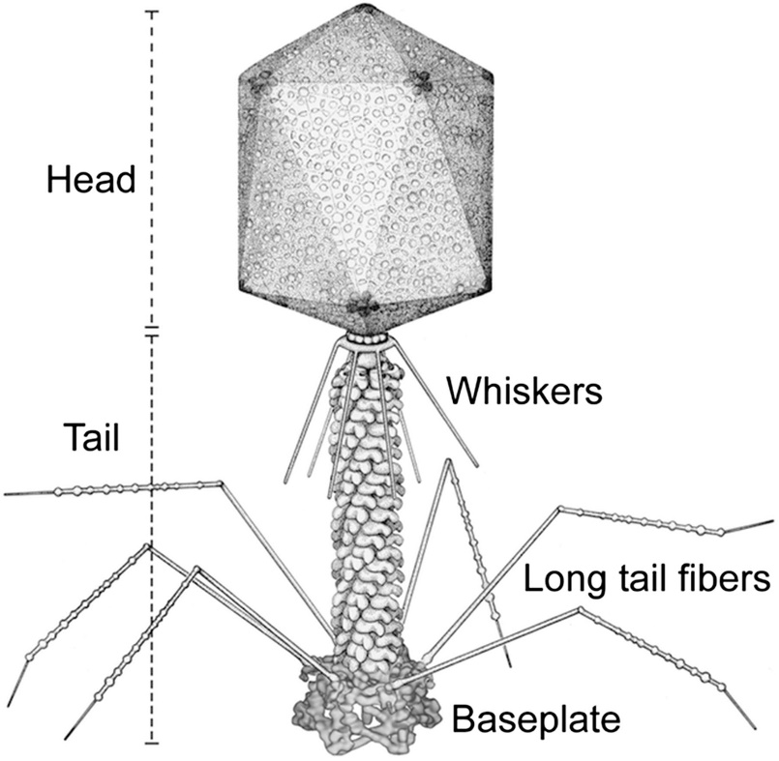

**Figure 3.** Bacteriophage structure. From Yap et al. (2016).

1. Bacteriophages exist naturally as predators of the bacteria present in the environment but also on and within the human body. Bacteriophages usually outnumber the eukaryotic viruses detected in the human virome, as shown in metagenomic analysis of lung, vaginal, skin, oral and intestinal microbiota (Breitbart et al., 2003; Colomer-Lluch et al., 2011a; Minot et al., 2011; Oh et al., 2014; Virgin, 2014).
2. Environmental factors can affect the persistence of bacteriophage outside of a host, such as pH, temperature, UV, ions and salinity. However, the susceptibility of different types of bacteriophage to environmental deactivation differs greatly between bacteriophage types and hosts (Jończyk et al., 2011; Karczewska et al., 2023).
3. As an example of the ability of bacteriophages to remain viable in harsh environments, a common method of preparing bacteriophages for transportation is to lyophilise the bacteriophage suspension. This involves rapid freezing followed by sublimation of the solvent in a vacuum. Lyophilised bacteriophages may be stored at room temperature for weeks, while retaining their ability to infect hosts when reconstituted.
   * + 1. Infection cycle
4. Bacteriophages need to enter host cells to reproduce. The first step of this process is the binding of tail fibres onto specific bacterial host receptors (adsorption). Subsequently, a rigid tube is propelled from the sheath puncturing a hole in the bacterial cell through which the bacteriophage injects its genetic material.
5. In the lytic cycle (virulent infection), the bacteriophage hijacks the bacterial host cell mechanism and replicates rapidly. The process involved in bacteriophage replication is illustrated below (Figure 4) and results in bacterial death.
6. The lysogenic cycle is also named temperate or non-virulent infection. After injection of its genetic material into a host cell, the bacteriophage genome integrates into the host genome with the assistance of bacteriophage integrase. The integrated bacteriophage nucleic acid is named a prophage and it enters a dormant state within the infected cells. It is passively replicated along with the bacterial genome and emerges when conditions become favourable. If the bacterial host is exposed to external stresses such as UV light, low nutrients or chemicals, the prophage may re-enter a lytic cycle.

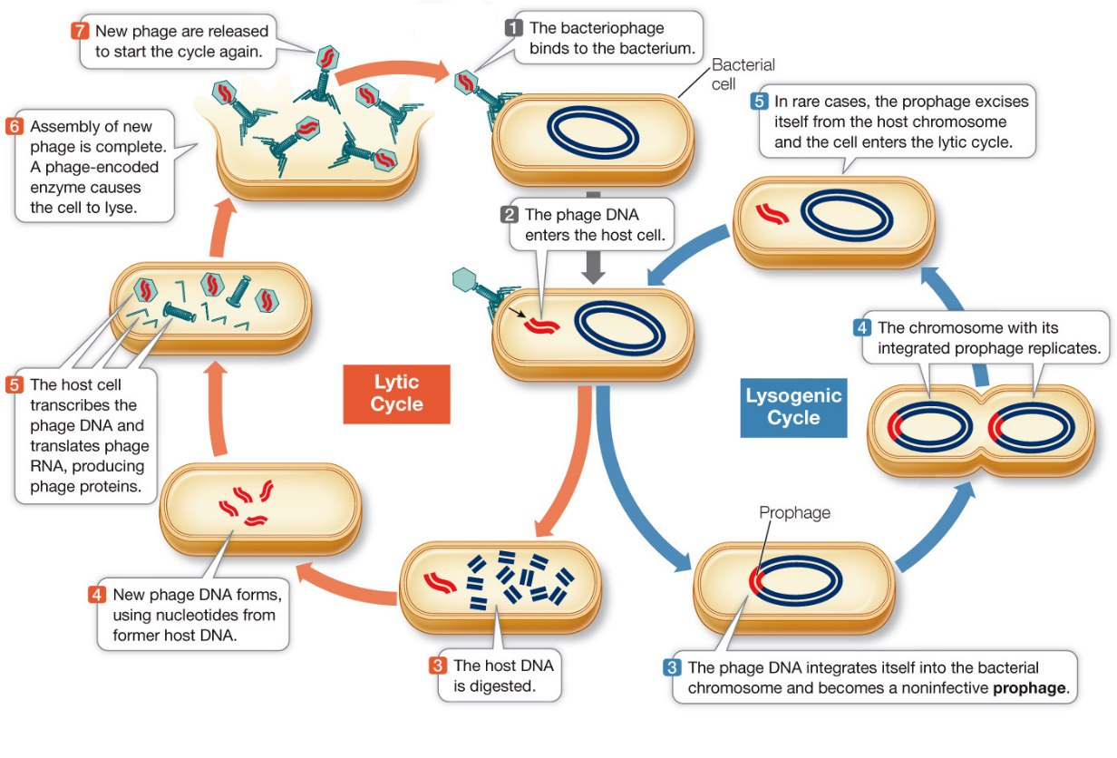

**Figure 4**. The lytic and lysogenic lifecycles of bacteriophages. From Hillis et al. (2016)

* + - 1. Genomic organisation

1. In bacteriophages, a repressor binds short specific DNA sequences and controls the expression of a gene or an operon (Figure 5). The establishment of a lytic or lysogenic cycle results from competition between repressors and anti-repressors (Cro) for the control of the operon region containing the three operators that determine the lytic/lysogenic genetic switch. A competition won by the repressor results in the repression of anti-repressor gene’s transcription, the expression of genes involved in lysogeny and the establishment of the lysogenic cycle. Deletion of the repressor gene renders the bacteriophage lytic.

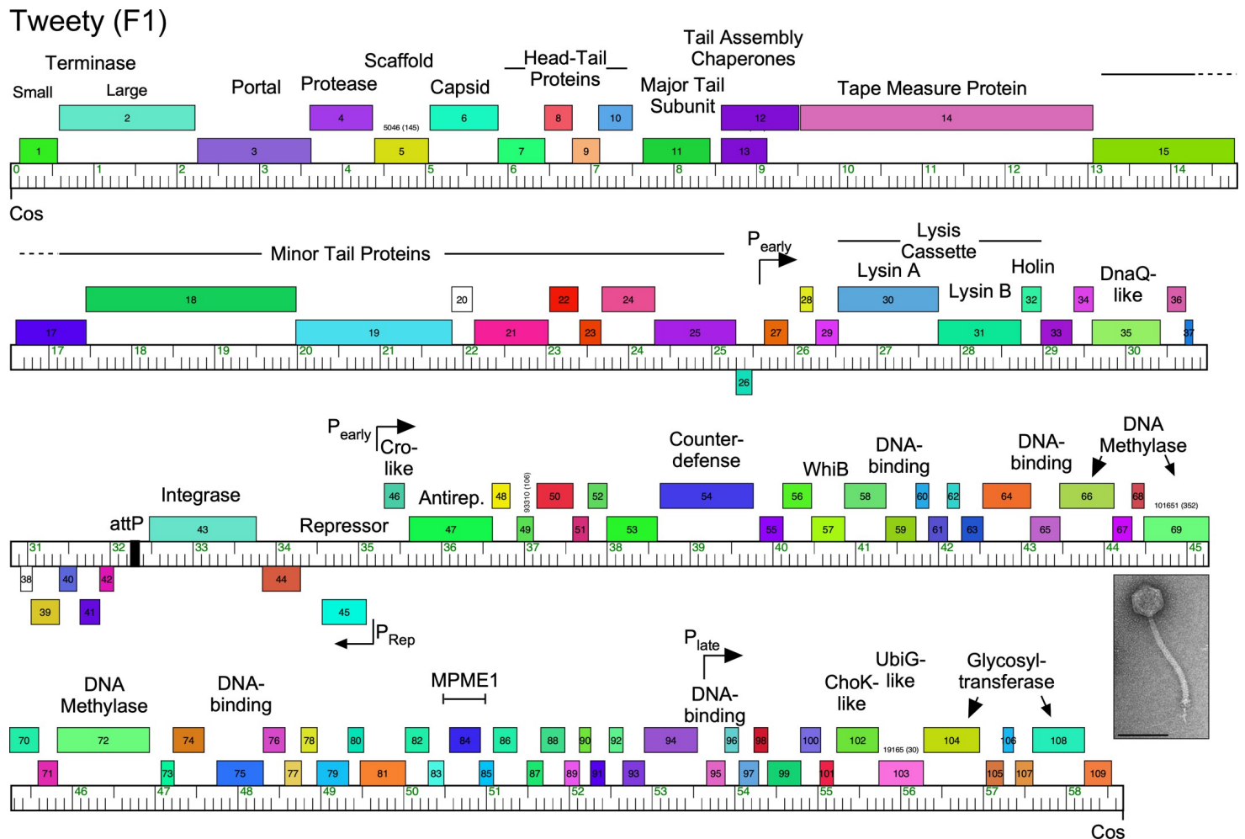

**Figure 5.** Schematic of general genomic organisation of mycobacteriophage *Tweety* with repressor outlined. From Hatfull (2022).

1. Factors that influence whether a bacteriophage infection enters into a lytic or lysogenic cycle include the bacterial cell environment. These factors may promote or repress the promoters of genes involved in the establishment of either of these cycles, including the repressor or anti repressor Cro. The lysogenic cassette has been demonstrated to contain all the components for the lytic-lysogenic decision (Broussard et al., 2013).
   * + 1. Recombination
2. Bacteriophage recombination is possible. If two bacteriophages co-infect a bacterium simultaneously, homologous recombination can take place (Figure 6). Similarly, exchange of DNA is theoretically possible between a bacterial plasmid and a bacteriophage. The frequency of recombination depends on the level of similarity at the recombination site (Campbell, 2003; Chen et al., 2019). These natural phenomena have been exploited to engineer various bacteriophages (Pires et al., 2016). However, the recombination frequencies were found to be quite low (5x 10-3 at best in a laboratory environment).

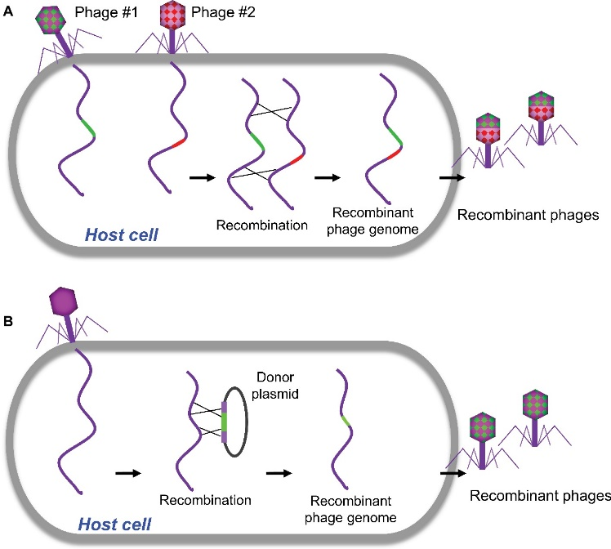

**Figure 6.** Traditional homologous recombination-based bacteriophage engineering (Chen et al., 2019)

1. As mentioned above, bacteriophages can integrate into the bacteria genome (prophage). Under stressful conditions, the prophage can excise itself from the bacterial DNA to form an episome. During this process, it is possible that the prophage leaves behind part of bacteriophage DNA within the bacterial genome or that a fragment of bacterial genome is inadvertently excised with the bacteriophage.
   * 1. Mycobacteriophages
2. Mycobacteriophages are bacteriophages that can only infect mycobacteria. In August 2022, the taxonomic system of the International Committee on Taxonomy of Viruses (ICTV) was changed to remove several major bacteriophage families, such as *Siphoviridae, Podoviridae*, and *Myoviridae*. Mycobacteriophages are currently within the class *Caudoviricetes* (Turner et al., 2023). To date, all isolated mycobacteriophages possess double-stranded DNA genomes (Hatfull, 2018).
3. Some mycobacteriophages have a broad host range and infect a wide range of mycobacteria while others have a very narrow host range (Hatfull, 2010; Hatfull, 2018). Those that have a narrow host range are highly specific and can only infect a specific mycobacterium. However, there are multiple examples of mycobacteriophages expanding their host range under selective pressure (Jacobs-Sera et al., 2012).
4. Mycobacteriophages do not directly induce severe disease in human as they specifically infect bacteria (Tetz and Tetz, 2018). Bacteriophages (which include mycobacteriophages) are the most abundant members of the gut microbiome and are a critical regulator of bacterial populations and microbiota stability and may be indirectly responsible for the establishment of human diseases associated with the alteration of the gut microbiota.
5. Mycobacteriophages can be found in soil, seawater, oceanic and terrestrial surfaces and extreme environments (very high or very low temperatures). They have been detected wherever bacteria can be found, such as in wastewater and hospital tap water (Clokie et al., 2011).
6. The environmental persistence of the mycobacteriophages in this clinical trial are not characterised, but inferences about their survivability may be made based on their hosts and the environments these usually survive or, more importantly, propagate in. The presence and persistence of NTMs in surface microlayers and water droplets, or adherence to soil particles, rocks, or synthetic materials (e.g., plumbing pipes), and their disinfectant resistance is partially attributed to the cell surface hydrophobicity of NTMs due to their lipid-rich outer membrane (Falkinham, 2021). NTMs are also oligotrophic and can survive in low nutrient environments. From this, it may be anticipated that mycobacteriophages may be resilient to environmental degradation. Conversely, some mycobacteriophages could be susceptible to environmental degradation and only effectively transmit from host to host in high host-densities, such as in colonies formed in localised environmental conditions, e.g. biofilms or infections.
7. Mycobacteria are usually associated with soil, aquatic environments, and biofilms. In soil or biofilms, the hosts may be more immobile and therefor a lytic bacteriophage effectively infecting and replicating in the population would cause a localised extinction of the host and reduce the propagation of the bacteriophage.
8. Mycobacteriophages can be destroyed by UV irradiation, and most common disinfectants such as bleach. The relevant methods of bacteriophage eradication should take into account the differences in the structure and bacteriophage type, which are often not characterised for bacteriophages used in medical administrations. Alcohols are capable of disrupting the capsid, but this varies drastically between different bacteriophages (Karczewska et al., 2023).
   * 1. Risk Group and containment
9. According to The Australian Standard 2243.3:2022 *Safety in Laboratories Part 3: Microbiological safety and containment* (Standards Australia/New Zealand, 2022), mycobacteriophages should be classified as a Risk Group 1 organism as they are unlikely to cause disease in humans or animals.
10. PC1 containment and work practices are appropriate when working with bacteriophages.
    1. The GMO - nature and effect of the genetic modification
       1. Mycobacteriophages in this clinical trial
11. There are two major hurdles to the use of mycobacteriophages in the treatment of *M. abscessus* infection: most have a limited host range and most are temperate (Guerrero-Bustamante et al., 2021).
12. Limited host range is an issue when treating specific strains of NTM. While a limited host range is beneficial in terms of limited off-target effects, it can be challenging to identify effective bacteriophages against specific NTMs. As such, screening different mycobacteriophages that are effective against a specific NTM needs to be done on a case-by-case basis and will result in different combinations of bacteriophages administered as a cocktail specific to the bacterial strains involved in an infection.
13. When used to treat a mycobacterial infection, lysis of the bacteria responsible for an infection is a critical element of the therapeutic effect, and therefore emphasis is placed on selecting mycobacteriophages that are lytic. Mycobacteriophages possess a repressor gene that is critical for the establishment of a lysogenic phase so removal of the repressor gene renders the bacteriophages lytic.
14. The method used to generate each of the GM mycobacteriophages discussed in this RARMP is called the Bacteriophage Recombineering of Electroporated DNA (BRED). This technique exploits the bacteriophage’s biological ability to recombine when two bacteriophages are simultaneously present in a bacterium. The frequency and success of this recombination depends on the sequence homology of the two co-infecting bacteriophages. In this method, gene deletion is conducted using a small 200 base pair (bp) double stranded (ds) DNA substrate, which possess 100 bp of homology upstream and downstream of the region to be deleted in the selected bacteriophage. The bacteriophage DNA to be modified and the 200 bp ds fragment are co-electroporated into *M. smegmatis* cells proficient for recombineering (Marinelli et al., 2008; van Kessel and Hatfull, 2007). The dsDNA substrate and the bacteriophages recombine in the bacterium, potentially resulting in the desired deletion of a gene. The modified bacteriophages possessing desired genotypes can subsequently be selected using various plaque assays depending on the targeted outcome. Plaque assays involve plating dilutions of a bacteriophage suspension on a “lawn” of appropriate hosts. In the case of the bacteriophages in this study, plating them on a lawn of *M. abscessus* will select for the bacteriophages capable of infecting and replicating in *M. abscessus*.
15. Modified bacteriophages possessing the desired genotypes are often the minority of the bacteriophages produced by BRED. CRISPY-BRED utilises the CRISPR-Cas system to increase the yield of recombineered bacteriophages that possess specific desired genotypes, relative to recombineered bacteriophages that do not (Lv et al., 2023; Mahler et al., 2023; Wetzel et al., 2021). This is accomplished by designing the recombineering process such that recombineered bacteriophages that do not possess the desired genotypes instead have sites that are targeted by a Cas protein for restriction, thus inactivating the bacteriophages with the undesired genotype.
16. Epigenetic modification (DNA methylation) of some GM bacteriophages involved the culture of the parent bacteriophage in a host bacterium which is transformed with a plasmid containing genes of the target bacterium. The resultant bacteriophage is able to infect the target bacterium, but this trait is lost if the bacteriophage is grown in the original host again.
    * + 1. Attributes of mycobacteriophages proposed to be covered by the licence
17. Thebacterium *M. smegmatis* is the host ofthe parent mycobacteriophages from which the GM bacteriophages in this study are derived. *M. smegmatis* occurs naturally in and on humans and is rarely associated with disease*.* Therapeutic treatment of severe infections by *M. abscessus* may require a bespoke cocktail of GM and/or non-GM bacteriophages. Bacteriophage strains are cultured and those that infect a specific strain of *M. abscessus* are selected. Some of these may contain naturally occurring mutations*.* The GM mycobacteriophages are modified to be lytic by inactivation of the repressor gene.
    * + 1. Specific bacteriophages proposed for the clinical trial
18. Modifications to the non-GM parent mycobacteriophages that are caused by gene technology as defined by the *Act* are shown in Table 3.

**Table 3: Modifications to parent organisms resulting from gene technology**

|  |  |  |  |
| --- | --- | --- | --- |
| **Parent bacteriophage** | **Bacteriophage** | **Genetic modifications** | **Modified traits** |
| BPs | **BPs∆33HTH** | deletion of repressor | Renders the bacteriophage lytic |
| CrimD | **CrimDΔ41-43** | deletion of integrase and repressor genes, gene 42. | Renders the bacteriophage lytic and cannot integrate |
| ZoeJ | **ZoeJΔ43-45** | deletion of integrase and repressor genes, gene 44. | Renders the bacteriophage lytic and cannot integrate |
| Fionnbharth | **FionnbharthΔ45-47** | deletion of integrase and repressor genes, gene 46. | Renders the bacteriophage lytic and cannot integrate. |
| Fred313 | **Fred313_cpmΔ33** | deletion of repressor and integrase genes. | Renders the bacteriophage lytic and cannot integrate. |
| phiGD34-2 | **phAK2** | deletion of repressor, integrase, genes 33, 38, 37 | Renders the bacteriophage lytic. |

* + 1. Current GM bacteriophage therapy in humans
       1. Mycobacteriophages and bacteriophage therapy

1. Given the emergence of multi-drug resistant bacteria worldwide and the decline in the development of novel antibiotics, bacteriophage therapy is currently being used for the treatment of antibiotic resistant bacterial infections. All reported cases of bacteriophage therapies showed that they were safe and well tolerated (Azimi et al., 2019; Dąbrowska, 2019; Dedrick et al., 2019; Principi et al., 2019).
2. Mycobacteriophages do not infect human cells and are highly specific to a bacterial host. This narrow spectrum of infectivity can prevent the unintended destruction of other beneficial bacteria present in the human microbiota. However, there are also limitations to the success of this therapy. The specificity of a bacteriophage to a particular bacterium often has to be demonstrated and this is not always an easy process.
3. In systemic administration, a large dose of mycobacteriophage is required to reach the desired organ or tissue. This may induce a significant immune response and the immune system is highly efficient in clearing bacteriophages. Post injection, they are very quickly neutralised by the mononuclear phagocyte system (MPS) and are diluted in the volume of blood. Some studies suggests that, within 30 minutes of the injection, the level of bacteriophage titre in the blood system is 0.3% of the hypothetical value calculated from the bacteriophage dose and its dilution in the blood volume (Dąbrowska, 2019).
   * + 1. Example of a GM bacteriophage therapy
4. GM bacteriophage cocktails were successfully used to treat a 15 year-old patient with cystic fibrosis in the UK. Following a bilateral lung transplant, this patient developed a *M. abscessus* infection, which was treated with anti-microbial therapy for around 9 months. At discharge from the hospital, this patient was diagnosed with a disseminated *M. abscessus* infection. The patient status deteriorated with additional skin infections appearing on her arms, legs and buttock. The surgery wound showed areas of breakdown (Dedrick et al., 2019).
5. Screening was carried out to identify mycobacteriophages able to infect *M. abscessus* GD01, the bacterial strain responsible for the patient’s infection, which identified:

* Wild-type mycobacteriophage, Muddy, a naturally lytic bacteriophage for this strain.
* A GM mycobacteriophage, ZoeJ, which was engineered using BRED to delete its repressor gene (Gene 45).
* GM mycobacteriophages BPs∆33HTH_HRMGD01 and BPs∆33HTH_HRMGD10. As the GM lytic bacteriophage infected *M. abscessus* GD01 poorly, host range mutants (HRM1 and HRM10) were isolated with an improved infection specificity for GD01 (Broussard et al., 2013).

1. A cocktail of these 4 bacteriophages (3 GM and 1 non-GM) contained in *M. smegmatis* were administered to the patient first topically on the wound, followed 24 hours later by IV injections twice daily for a period of 32 weeks. No adverse events were recorded, and the treatment was well tolerated and found to be safe. One month following the commencement of the treatment, the topically treated surgery wound had significantly improved when compared to the skin lesions on the patient’s body.
2. This treatment was shown to be effective, and the patient displayed clinical improvement such as sternal wound closure, improved liver function and substantial resolution of infected skin modules.
3. Bacteriophages were detected in the serum one day following the commencement of the treatment, but levels progressively declined until serum bacteriophage concentration fell below detection levels one week later. The decline in the amount of detectable bacteriophages in serum could be due to the initial replication of the administered bacteriophages in the bacterial hosts, followed by decline as the host numbers were reduced and the immune system progressively cleared the bacteriophages that were replicating. Bacteriophages were not detected in sputum. Low levels of bacteriophages were detected in faeces 4 to 6 days after the initial treatment and in wound swabs 3 to 5 days after the initial treatment.
4. Subsequent studies using similar approaches with GM bacteriophages also show successful, well-tolerated clinical outcomes (Nick et al., 2022).
   * + 1. Shedding and biodistribution studies
5. A significant challenge in the use of this relatively novel technology is that the only data collected so far has been through the treatment of individual patients through compassionate use. This is the case around the world, and this means that data regarding safety, efficacy, shedding and biodistribution studies have not been readily available or appropriate for analysis and interpretation. A limitation of personalised treatment is the difficulty of collecting meaningful data and analysis where there is no standard treatment, but rather a cocktail of bacteriophages used that vary between patients. However, there are a number of studies using bacteriophages, GM or non-GM, or a mixture of both for the treatment of a range of mycobacterial infections.
6. Bacteriophage movement between body compartments is observed at a low level, such as movement from/to the circulatory system from the gut or lungs (Figure7).

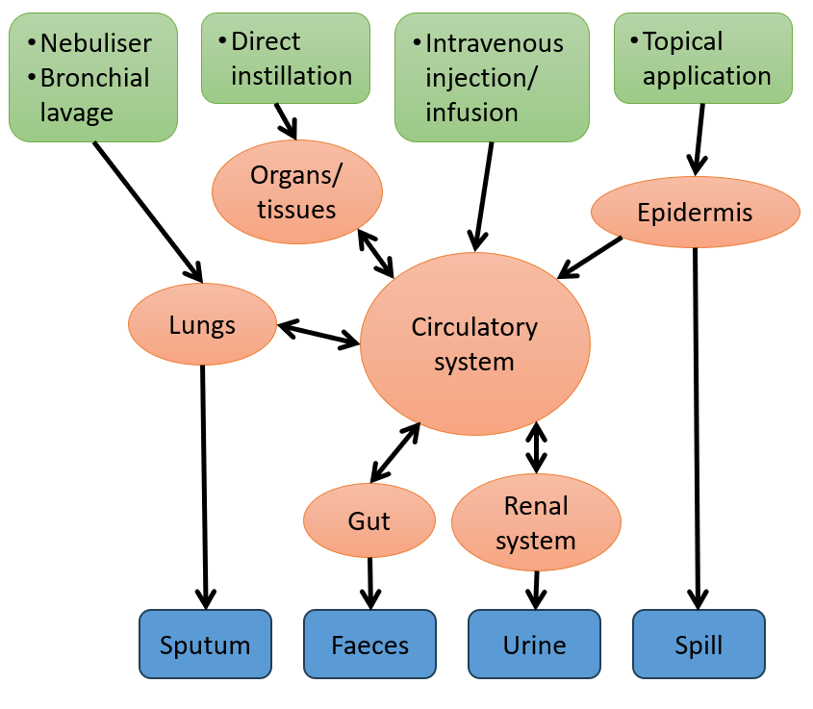

**Figure 7.** Shedding possibilities based on administration method. Arrows indicate direction of potential movement of bacteriophage particles.

1. Oral administration is the least efficient method for the systemic delivery of bacteriophage therapy. Studies show that bacteriophage absorption is limited and is highly dependent on the administered dose (Principi et al., 2019). Bacteriophages administered orally can pass through the gut and be shed, but are generally highly susceptible to extreme pH levels and are unstable in the stomach and upper intestines. As a result, they are often detected in faeces in low quantities. Host specificity, bacteriophage morphology and taxonomy have not been correlated with the relative amounts of the bacteriophage able to pass through the gut, which suggests that the general physical properties of bacteriophages are not causally related to their survival in, or shedding from, the gut (Dąbrowska, 2019). This type of administration has not been proposed in this trial.
2. The most efficient systemic administration route is via injections, either intravenous, intraperitoneal or intramuscular. These modes of delivery are more likely to deliver the bacteriophage to any target tissues or organ (such as skeletal muscle, heart, thymus, bone marrow, kidney or bladder). The lungs may also be reached through these routes, but a higher bacteriophage dose is required, given that bacteriophage penetration has lower efficiency (Dedrick et al., 2019). Bacteriophages typically accumulate in the spleen, liver and lymph nodes (Dedrick et al., 2019).
3. Penetration of bacteriophage to blood can occur through different administration methods (Dąbrowska, 2019):

* direct injection >95%
* inhalation 66%
* topical 50%
* oral 41%.

1. Accumulated data studies investigating bacteriophage clearance from circulating blood in rodent models indicated rapid bacteriophage clearance that slows with time. The median number of bacteriophages detected in the blood after 24 hours after intravenous administration was 1-2% of the number detected after 1 hour (Figure 8) (Dąbrowska, 2019).

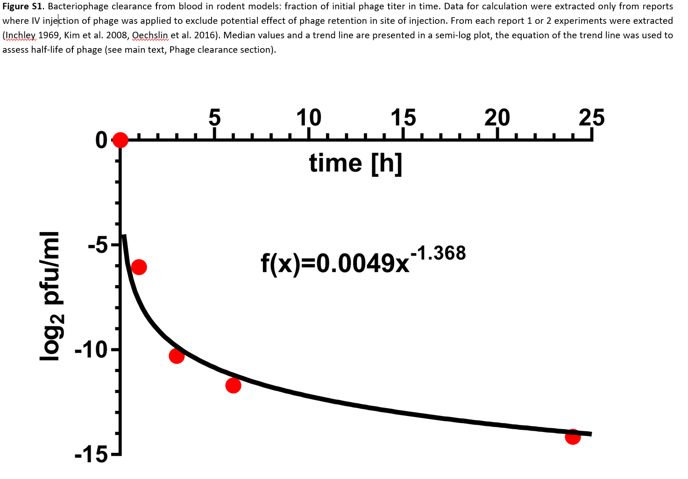

**Figure 8.** Bacteriophages detected in blood of rodent models after intravenous administration.FromDąbrowska (2019).

1. Bacteriophage shedding in the urine is possible but seems to be limited and dependent on the initial dose selected for the treatment. Low level shedding is possible in faeces and sputum (Dąbrowska, 2019), and the detection of bacteriophages in urine samples after oral administration across 3 studies was 87.3% in children versus 35% in adults (Nang et al., 2023).
2. Previous studies have observed a dose dependency between the amount of bacteriophage administered and that subsequently detected in urine, proposing that a minimum dose of 109 PFU is required to be able to detect bacteriophages in the urine of mice administered via intravenous injections (Nishikawa et al., 2008; Schultz and Neva, 1965). Reflecting this, studies in dogs showed that the relative concentration of bacteriophages in urine parallels the concentration in plasma (Keller and Zatzman, 1959). Thus, if bacteriophage clearance in plasma is expected to be rapid, the number of bacteriophage particles potentially released in urine would correspondingly be less.
   1. The receiving environment
3. The receiving environment forms part of the context for assessing risks associated with dealings with GM bacteriophages (OGTR, 2013). It informs the consideration of potential exposure pathways, including the likelihood of the GMO spreading or persisting outside the site of release.
   * 1. Administration sites
4. The intended primary receiving environment would be the clinical trial participants.
5. The secondary receiving environments would be the clinical trial site, hospitals and HITH sites where the GMO might be administered, and the waste contained for disposal at clinical sites. These exact sites are yet to be identified. All clinical sites involved in the study would be equipped to handle infectious agents and procedures would be conducted in accordance with institutional policies based on standard precautions for handling potentially infectious substances and in accordance with the *Australian Guidelines for the Prevention and Control of Infection in Healthcare* (National Health and Medical Research Council, 2019)*.*
6. Each State and Territory has its own guidelines for the treatment of patients once they return home and there is a need for follow up treatment outside of the hospital environment, including procedures to be followed in relation to drug administration and patient care outside of hospitals or clinical sites.
7. The routes by which the GMO could enter the wider environment is via spill, or via shedding from the inoculated trial participants.
   * 1. Relevant environmental factors
8. The abundance and persistence of bacteriophages in the environment is discussed in Section 3.2.
   1. Previous authorisations
9. The Regulator has previously approved DNIR licences for dealings with some of the proposed GMOs:

* DNIR-620 for the Sydney Children’s Hospital Network authorised the *Therapeutic treatment of paediatric patients with cystic fibrosis and Mycobacterium abscessus disease.*
* DNIR-655 for the Alfred Hospital authorised *Bacteriophage therapy for severe lung disease due to Mycobacterium abscessus infection.*

1. This application is being assessed as a DIR licence, as it Involves administration of the GMO to participants outside of hospital under the HITH program.
2. Risk assessment
   1. Introduction
3. The risk assessment identifies and characterises risks to the health and safety of people or to the environment from dealings with GMOs, posed by or as the result of gene technology (Figure 9). Risks are identified within the established risk assessment context (Chapter 1), taking into account current scientific and technical knowledge. A consideration of uncertainty, in particular knowledge gaps, occurs throughout the risk assessment process.

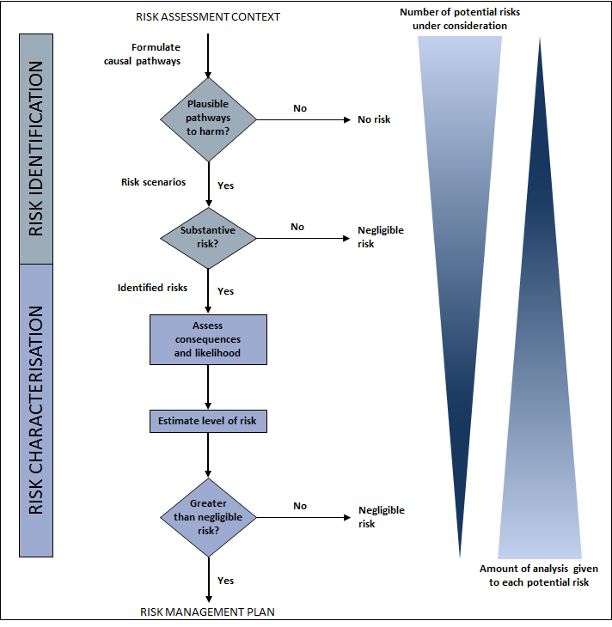

**Figure 9.** The risk assessment process

1. The Regulator uses a number of techniques to identify risks, including checklists, brainstorming, previous agency experience, reported international experience and consultation (OGTR, 2013).
2. Risk identification first considers a wide range of circumstances in which the GMO, or the introduced genetic material, could come into contact with people or the environment. This leads to postulating causal pathways that may give rise to harm for people or the environment from dealings with a GMO. These are called risk scenarios.
3. Risk scenarios are screened to identify substantive risks, which are risk scenarios that are considered to have some reasonable chance of causing harm. Risk scenarios that could not plausibly occur, or do not lead to harm in the short and long term, do not advance in the risk assessment process (Figure 9), i.e. the risk is considered no greater than negligible.
4. Risk scenarios identified as substantive risks are further characterised in terms of the potential seriousness of harm (Consequence assessment) and the likelihood of harm (Likelihood assessment). The consequence and likelihood assessments are combined to estimate the level of risk and determine whether risk treatment measures are required. The potential for interactions between risks is also considered.
   1. Risk identification
5. Postulated risk scenarios are comprised of three components (Figure 10):
6. The source of potential harm (risk source)
7. A plausible causal linkage to potential harm (causal pathway), and
8. Potential harm to people or the environment.

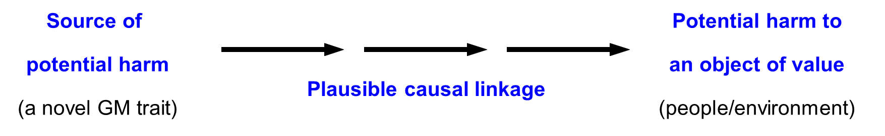

**Figure 10:** Components of a risk scenario

1. When postulating relevant risk scenarios, the risk context is taken into account, including the following factors detailed in Chapter 1:

* the proposed dealings
* the proposed limits including the extent and scale of the proposed dealings
* the proposed controls to limit the spread and persistence of the GMO and
* the characteristics of the parent organism(s).
  + 1. Risk source

1. The parent organisms of the GMO are mycobacteriophages, a diverse group of bacteriophages that infect mycobacteria. Details of the properties of these GMOs can be found in Chapter 1 section 4. The GMOs have been modified to be lytic.
2. Potential sources of harm can be intended novel GM traits associated with one or more of the removed genetic elements or unintended effects/traits arising from the use of gene technology.
3. As discussed in Section 4.1, the GMOs have been modified bydeleting at least the repressor gene to render the bacteriophages lytic and unable to enter a lysogenic or temperate lifecycle. Relative to the unmodified parent organism, this modification is considered further as a potential source of risk.
   * 1. Causal pathway
4. The following factors are taken into account when postulating plausible causal pathways to potential harm:

* the proposed dealings;
* proposed limits, including the extent and scale of the proposed dealings;
* characteristics of the parent organism;
* routes of exposure to the GMOs, the introduced gene(s) and gene product(s);
* potential effects of the introduced gene(s) and gene product(s) on the properties of the organism;
* potential exposure of other organisms to the introduced gene(s) and gene product(s) from other sources in the environment;
* potential exposure of other organisms to the GMOs in the environment;
* the release environment;
* spread and persistence of the GMOs (e.g. dispersal pathways and establishment potential);
* environmental stability of the organism (tolerance to temperature, UV irradiation and humidity);
* unauthorised activities; and
* practices before and after administration of the GMO.

1. Although these factors are taken into account, many are not included in the risk scenarios below as they do not lead to a plausible pathway to harm.
2. As discussed in Chapter 1.1, the TGA, the trial sponsor, the Investigators and HREC all have roles in ensuring the safety of trial participants under the *Therapeutic Goods Act 1989*, and human clinical trials must be conducted in accordance with the *National Statement on Ethical Conduct in Human Research* (National Health and Medical Research Council et al., 2018). Therefore, risk scenarios in the current assessment focus primarily on risks posed to people other than the intended treatment recipient, and to the environment.
3. The Act provides for substantial penalties for unauthorised dealings with GMOs or non-compliance with licence conditions, and also requires the Regulator to have regard to the suitability of an applicant to hold a licence prior to the issuing of the licence. These legislative provisions are considered sufficient to minimise risks from unauthorised activities. Therefore, unauthorised activities will not be considered further.
   * + 1. Development of host resistance
4. It is anticipated that the administration of these GM bacteriophages would occur on multiple occasions in the same trial participant over a lengthy period of time. Mycobacterial infections resistant to a GM bacteriophage could develop with time. The release of a resistant mycobacterium and its associated GM bacteriophages into the environment via shedding from the trial participant could result in the spread in the environment of mycobacteria resistant to antibiotics and bacteriophages, and remove the last treatment option for people with that specific strain of mycobacterial infection.
5. However, resistance towards multiple bacteriophage strains carries a cost to the host bacteria, which would impact the survival or propagation of the resistant bacteria in the wider environment (Bohannan and Lenski, 2000; Hall et al., 2012; Koskella et al., 2012). To cause harm, the resistant mycobacterium would have to survive in the environment, retain the antibiotic and bacteriophage resistance without selection pressure and encounter another person to infect. As, the potential of resistance developing to bacteriophage infection in mycobacterial hosts is only relevant to humans, and the target mycobacterial strains are specific to each (or a few) patients with existing infections; the potential for resistance to the bacteriophage therapy developing in target mycobacterial strains and causing harm will not be considered further.
   * 1. Potential harms
6. The following factors are taken into account when postulating relevant risk scenarios for this licence application:

* harm to the health of people or non-target organisms, including disease in humans or animals or adverse immune response to the GMO
* the potential for establishment of a novel bacteriophage that could cause harm to people or the environment.
  + 1. Postulated risk scenarios

1. Four risk scenarios were postulated and screened to identify substantive risk. These hypothetical scenarios are summarised in Table 4 and discussed in depth in Section 2.5.
2. In the context of the activities proposed by the applicant and considering both the short and long term, none of the four risk scenarios gave rise to any risks that could be greater than negligible.

**Table 4. Summary of hypothetical risk scenarios from dealings with GM bacteriophages.**

| **Risk Scenario** | | | | **Substantive risk?** | **Reasons** |
| --- | --- | --- | --- | --- | --- |
| **#** | **Risk source** | **Causal Pathway** | **Potential harm** |
| **Risks to people undertaking dealings with the GMOs** | | | | | |
|  | GM bacteriophage | Exposure of people undertaking dealings with GMO during import, transport, preparation, administration and waste disposal, e.g. sharps injury, contact during spill, ingestion or inhalation  🡻  GM bacteriophages are internalised by the body or remains on epithelia (e.g. gut, skin, mucous membranes)  🡻  GM bacteriophages kill non-target bacteria.  🡻  Imbalance in human microbiome/ proliferation of pathogenic bacteria | Disease or ill health | No | * During import, the GMO will be packaged according to IATA shipping classification UN 3245 or 3373. Transport within Australia would be according to the TSDs. These would minimise the risk of spillage and exposure. * Staff would be wearing PPE and handling small volumes of the GMO, in the order of magnitude too small to allow significant uptake of the GMO. * Exposure to staff involved in the transport of GM waste for the purpose of disposal would be minimised by the transport procedures including standard practices for the packaging of clinical waste. These standards minimise the risk of spillage during transport.   **In the event of exposure:**   * Bacteriophages specifically infect bacteria and do not cause disease in people. * The GM bacteriophages used in the trial are developed/selected for their ability to infect the specific target-strain of *M.  abscessus* present in the trial participant. Mycobacteria that are susceptible to the GM bacteriophages are highly unlikely to be present on/within a non-participant. * The small amount of GMO to which people could inadvertently be exposed to would minimise the uptake and establishment of the GMO. * The immune system of the person exposed to the GMO is likely to clear any bacteriophages entering the body very quickly. |
| **Risks to other people or the environment** | | | | | |
|  | GM bacteriophage | 1. GM bacteriophages administered to the participant.   🡻  Bacteriophage particles are released into the hospital or HITH administration room, or the administered or progeny bacteriophages in the participant are shed in bodily fluids and excreta.  🡻  Care givers, people in household or pets are exposed to the GMO  🡻  As in Risk Scenario 1 | Disease or ill health | No | * The GMO could be released into the administering room due to spills or aerosols produced by nebulisation or coughing after administration to the lungs. * Any shedding of GMO bacteriophage particles by the participant would be a very small fraction of the administered dose. * Shedding of infectious bacteriophage particles is expected to be minimal and occur for, at most, a few days, based on the data collected from bacteriophage therapy around the world and a similar treatment described in Section 4.2.   **In the event of exposure:**   * The GM therapeutic would not survive in a healthy person as discussed in Risk Scenario 1. * The route of exposure of shed GM bacteriophages to other people would be unlikely to introduce a bacteriophage to a new habitat (e.g. epithelium) containing a susceptible host on or within the exposed person. * Given the very small amount that may be released in the environment, it is highly unlikely that this would result in the proliferation of the GMO in a susceptible host bacterium found in the environment or on animals. |
| **Risks to people or the environment due to recombination** | | | | | |
|  | GM bacteriophage | 1. Exposure routes as described in Risk Scenarios 1 & 2   🡻  The GM bacteriophages infect target bacteria. Co-infecting bacteriophages recombine in host bacteria.  🡻  New mycobacteriophages are produced with a different host ranges or traits.  🡻  As in Risk Scenario 1 | Disease or ill health | No | * As the GM bacteriophage is lytic, wild-type bacteriophage would already have to be residing in the host cell’s genome (integrated as a result of lysogeny) for a GM bacteriophage subsequently coinfecting the cell to recombine with it.   **In the event of recombination:**   * The outcome is no worse than any other recombination that could occur between wild-type bacteriophages that are able to infect the specific strain. * The GM bacteriophage could only impart the trait of obligate-lytic lifecycle, reducing a recombinant bacteriophage’s ability to persist in the environment. * A wild bacteriophage could not take on novel traits from a GM bacteriophage that would change its host range, as they are both specific for the same bacterium. * It is highly unlikely that any recombination between co-infecting bacteriophages with similar host-specificity would result in the emergence of a new bacteriophage with a different host range. * There would already be bacteriophages present within the body undergoing recombination or mutation without harm. This includes the potential inactivation of a single gene such as the repressor, which would render a bacteriophage lytic. * Considerations relevant to exposure and its consequences are as discussed in Risk Scenarios 1 and 2. |
| **Risks to the environment** | | | | | |
|  | GM bacteriophage | 1. GM bacteriophages are administered to the participant   🡻  Bacteriophage particles are shed in bodily fluids and excreta  🡻  GM bacteriophages are released into the environment (e.g. waste treatment)  🡻  GM bacteriophages kill non-target bacteria.  🡻  Wider impacts on other organisms | Ecological disturbance | No | * Shedding is expected to be minimal for the reasons discussed in Risk Scenario 2. * Bacteriophages exist throughout the environment already and infect only bacteria. * GMOs shed in faeces and urine would go into wastewater treatment. This process includes decontamination processes. * Most mycobacteria present in untreated sewerage are either not susceptible to the bacteriophage or would be lysed if they are infected with the GMO. * Bacteriophages require a host to replicate and propagate. With the exception of the target bacteria shed from a participant, it is highly unlikely that the target strain of *M. abscessus* would exist in the environment, or that bacteriophages released into the environment would encounter susceptible hosts before environmental factors inactivate the bacteriophage. * Animals with mycobacterialinfections may be positively impacted, possibly removing a natural means of population control in feral animals. However, beyond the effect on an individual animal with a mycobacterial infection, ecological impacts of this would require mycobacterial infections to be established in multiple individuals within or between populations. |

* + 1. Risk Characterisation
       1. Risk scenario 1

|  |  |
| --- | --- |
| **Risk source** | GM Bacteriophage |
| **Causal pathway** | * + 1. Exposure of people undertaking dealings with GMO during import, transport, preparation, administration and waste disposal, e.g. sharps injury, contact during spill, ingestion or inhalation   🡻   * + 1. GM bacteriophages are internalised by the body or remains on epithelia (e.g. gut, skin, mucous membranes)   🡻   * + 1. GM bacteriophages kill non-target bacteria.   🡻   * + 1. Imbalance in human microbiome/ proliferation of pathogenic bacteria |
| **Potential harm** | Disease or ill health |

**Risk source**

1. The source of potential harm for this postulated risk scenario is the GM bacteriophage.

**Causal Pathway**

1. The GMO would be transported in sealed, unbreakable containers according to the TSDs. Spills would be contained inside the containers and able to be decontaminated using common cleaning products (e.g. bleach) with the use of a spill kit. Nonetheless, unintentional release of the GMOs from their containers may result in exposure through contact with skin or mucous membranes, including the gut if ingested, or the lungs if inhaled.
2. Staff could be exposed to the GM bacteriophages via a spill, aerosols or sharps injury during the course of their work.
3. During preparation of the GMO, aerosols will be contained within a BSC.
4. While unlikely, during preparation of the GMO (e.g. drawing reconstituted bacteriophages from vials) and in an administration involving needles for instillation or injection, a sharps injury could occur. This could result in the GMO being internalised within the body, into an organ or tissue, or into the blood system and distributed throughout the body.
5. In all methods of administration, the applicant stated that PPE including surgical masks and gloves would be worn. This will reduce the risk of exposure via aerosols and contact.
6. During the administration of the GMO via endobronchial lavage, the GMO is anticipated to be present in aerosolised sputum and saliva.
7. During the administration of aerosolised GMO via nebuliser, exposure to the skin, eyes and respiratory tract of the administering person may occur.
8. During topical application of the GMO, a small amount of GMO may spill from the site of administration. This would be unlikely to generate aerosols and blueys or other absorbent membranes would be used to collect any spills and disposed of appropriately.
9. Room surfaces including walls, windows, floors, furniture and bedding could be contaminated with the GMO due to a spill or aerosols produced from nebuliser administration or coughing. Clothing or personal materials such as tissues or bandages used on the site of administration could also be contaminated.
10. Exposure to people or pets entering the room could occur if they contact surfaces which have been exposed to aerosols containing the GMO. Skin contact (e.g. fingers) with contaminated surfaces could transport the bacteriophages to the mouth, and pets may lick contaminated surfaces.
11. During HITH, nurses will transport the GMO from the clinical site to the administration site and return unused GMO and waste to the clinical site, to enter the clinical waste stream. External service providers will also be used to transport waste containing the GMO for destruction.
12. Exposure to staff involved in the transport of GM waste for the purpose of disposal would be minimised by the transport procedures including standard practices for the packaging of clinical waste. These standards minimise the risk of spillage during transport.

*In the event of exposure:*

1. If the bacteriophages are internalised in the body, they would need to infect a host to persist within an exposed person. As mentioned in Chapter 1, Section 4.2.3, bacteriophages are generally cleared by the mammalian immune system within hours. The opportunity for a bacteriophage to find a host and persist within the body would be limited to a couple of hours in a healthy person. Nonetheless, bacteriophage therapy has not been associated with disease in immunodeficient, pregnant, or young people where the immune system may not clear the bacteriophages as rapidly.
2. The bacteriophages used in this trial are highly specific to their host strains of mycobacteria (as discussed in Chapter 1). Extensive selection has been required to identify the bacteriophages capable of infecting the specific strain of *Mycobacterium* infecting each participant, indicating that if the GMO is released into the environment or a person is exposed, it is highly unlikely to encounter another host that it is able to infect before it is inactivated by environmental factors. Different bacteriophages have variable persistence in the environment under different environmental factors.
3. Bacteriophages are unable to infect human cells or non-mycobacterial organisms. If people are exposed to the GMOs and *M. abscessus* is not present, the GMO could not propagate. Therefore, it is highly unlikely that in the event of exposure the GM bacteriophages would survive in a healthy person.

**Potential harm**

1. In the event the GMO were able to infect a strain of *M. abscessus* on an exposed person, the strain could be a pathogen, and so there would be no direct harm to the person through exposure to the GMO. Otherwise, microbial imbalances are generally transient or treatable.
2. If the bacteriophages administered to treat *M. abscessus* infections were able to infect non-pathogenic mycobacterial strains, imbalances could occur in natural microbial assemblages on or within the human body where competition typically prevents the non-pathogenic organisms that contribute to the homeostasis of healthy microbial assemblages from functioning in a manner such that they become pathogenic (e.g. proliferation, toxin excretion) and disease occurs.
3. For example, an estimated >30% of the global population is colonised with *Candida* and/or *Mycobacterium*. In this population, ~90% show no clinical signs of disease, do not develop disease, and these microbes are instead observed to behave as commensals. While *Candida* (fungi) and *Mycobacteria* (bacteria) belong to different domains of life, they elicit similar innate and adaptive immune responses in the human body, and disease caused by these organisms is often attributed to imbalances between them and/or the immune system of the host. However, microbial imbalances of otherwise non-pathogens such as these are generally either self-resolving or treatable.

**Conclusion**

1. Risk scenario 1 is not identified as a substantive risk because in the event of an exposure, bacteriophages cannot infect organisms other than their host strain of bacteria and are cleared by the mammalian immune system quickly. Therefore, this risk could not be considered greater than negligible and does not warrant further detailed assessment.
   * + 1. Risk Scenario 2

| **Risk source** | GM Bacteriophage |
| --- | --- |
| **Causal pathway** | 1. GM bacteriophages administered to the participant.   🡻   1. Bacteriophage particles are released into the HITH administration room, or the administered or progeny bacteriophages in the participant are shed in bodily fluids and excreta.   🡻   1. Caregivers, people in household or pets exposed to the GMO   🡻   1. As in Risk Scenario 1 |
| **Potential harm** | Disease or ill health |

**Risk source**

1. The source of potential harm for this postulated risk scenario is the GM bacteriophage.

**Causal Pathway**

1. As mentioned in risk scenario 1, various methods of administration will be used for the treatment of mycobacterial infection resulting in various shedding profile for each participant. Post-administration, replication of the bacteriophages in the target bacterium will result in shedding of the bacteriophages from the participant. Shed bacteriophage may be in expectorates from the respiratory tract, from fluids or leakage from topical applications to wounds, or in faeces or urine. As described in Section 4.2.3, only low amounts of bacteriophage move between organs and tissues, confining the majority of the bacteriophages in the area where it is administered on the body. The number of bacteriophages shed is correlated with the administered dose and the time period following administration. Bacteriophages are rapidly cleared by the immune system and there is low level of excretion by the renal system. They also have limited ability to enter the gut or lungs from the circulatory system (Dąbrowska, 2019).
2. Shedding of infectious bacteriophage particles is expected to be minimal and occur for, at most, a few days, based on the data collected from bacteriophage therapy around the world and a similar treatment described in Chapter 1, Section 4.2.3.
3. However, pets and carers could come into contact with the GMO through this pathway. As in Risk Scenario 1, exposure may occur to people or pets entering the room where surfaces may be contaminated with the GMO due to aerosols from nebuliser administration, sputum or saliva.
4. In both cases, exposure to the GMO shed by the participant or residual GMO deposited on surfaces would be a very small fraction of the administered dose.

*In the event of exposure:*

1. As described in Risk Scenario 1, the GM bacteriophages only infect their specific target strain of bacteria, cannot replicate without a host, and are cleared by the immune system quickly. It is highly unlikely that exposure of pets or carers to the GMOs results in harm.

**Potential harm**

1. As described in Risk Scenario 1, bacteriophages cannot themselves cause disease in humans or animals, and infection of other mycobacteria would not directly cause disease unless it results in imbalances of the microbial assemblage such that disease occurs. Diseases resulting from microbial imbalances are usually treatable in both humans and pets.

**Conclusion**

1. Risk scenario 2 is not identified as a substantive risk because any loss of the bacteriophages into the administration room or through shedding from the participant will be small, in addition to the reasons described in Risk Scenario 1. Therefore, this risk could not be considered greater than negligible and does not warrant further detailed assessment.
   * + 1. Risk Scenario 3

| **Risk source** | GM Bacteriophage |
| --- | --- |
| **Causal pathway** | 1. Exposure routes as described in Risk Scenarios 1 & 2   🡻   1. The GM bacteriophages infect target bacteria. Co-infecting bacteriophages recombine in host bacteria.   🡻   1. New mycobacteriophages are produced with a different host ranges or traits.   🡻   1. As in Risk Scenario 1 |
| **Potential harm** | Disease or ill health |

**Risk source**

1. The source of potential harm for this postulated risk scenario is the GM bacteriophage.

**Causal Pathway**

1. Exposure could occur via the pathways detailed in Risk Scenarios 1 & 2, including inhalation of aerosols produced by administration via nebuliser, coughing, skin contact and subsequent ingestion.

*Recombination between the administered GM bacteriophages*

1. The GM bacteriophages in the administered cocktail are all modified to be lytic, and the only modification to the parent bacteriophages made by gene technology is to deactivate the repressor gene. The loss of the repressor function itself may occur in nature, as the deactivation of a gene can occur due to small but critical mutations, and is likely to occur at a low frequency in wild bacteriophages. Some of the GM bacteriophages have additional deletions (e.g. integrase) or single-nucleotide variations (SNVs) which would occur routinely in nature. These other mutations include those which occur as the bacteriophages are passaged (cultured) to develop and isolate strain/s capable of infecting the target bacterial strain. Selection for the presence advantageous mutations under changing environmental and biotic pressures is a naturally occurring process. The selection of host-range mutants (HRMs) involves culturing the bacteriophage alongside its desired target host cells, such that a mutant able to successfully infect and replicate in the host can be identified. This process of host range expansion under selective pressures occurs constantly in the environment.
2. The inactivation of the integrase gene (and other genes of unknown function) in some of the bacteriophages is likely due to unintended loss of some genes adjacent to the repressor during the recombination process used to deactivate the repressor. Inactivation of the integrase gene prevents integration of the bacteriophage genome into that of the host cell, but is not a requirement of the lytic lifecycle, which has demonstrated dependency on the function of the repressor gene.
3. The recombination of the GM bacteriophages would not produce a bacteriophage capable of more harm, as the recombinant bacteriophage would possess the obligate-lytic trait of its parents and destroy the host cell.

*Recombination with a wild bacteriophage*

1. GM bacteriophages could infect a susceptible *M. abscessus* strain that is already infected with an environmental bacteriophage. As the GM bacteriophages are lytic, a wild-type bacteriophage would already have to be residing in the host cell’s genome (integration and lysogeny) for a GM bacteriophage subsequently coinfecting the cell to recombine with it. Lysogenic lifecycles often involve mechanisms to prevent superinfection of the host by subsequent bacteriophages, which would further reduce the likelihood or incidence of recombination.
2. Recombination between similar bacteriophages within a mycobacterial host or the mutation of a single strain resulting in changed host-range would be highly unlikely to result in the host range extending beyond members of the *Mycobacteriaceae.*
3. There would already be bacteriophages present within the body undergoing recombination or mutation without harm. This includes the potential inactivation of a single gene such as the repressor, which would render a bacteriophage lytic.
4. A wild-type bacteriophage would be unlikely to take on novel traits from a GM bacteriophage that would change its host range, or vice versa, as they are both specific for the same bacterium.
5. The most likely recombination could result in a GM bacteriophage regaining the repressor gene and being able to enter a lysogenic cycle. Therefore, it is highly unlikely that any recombination between these bacteriophages would result in the emergence of a new bacteriophage with a different host range.

**Potential harm**

1. A recombination event could only introduce the obligate-lytic lifecycle (lack of a repressor gene) to another bacteriophage. This could be either another GM bacteriophage (which already lacks the repressor) or an environmental bacteriophage, where the resulting recombinant bacteriophage would also be lytic. The outcome would be no worse than any other recombination that could occur between wild-type bacteriophages that are able to infect the specific strain.
2. The worst case scenario would be a wider host-range and lysogeny being restored, which could produce a stable population of new bacteriophages infecting a different host. Nonetheless, this lysogenic recombinant bacteriophage would only possess traits that already exist in the environment. It is highly unlikely that the GMO could develop a host range that includes non-mycobacterial bacteria.

**Conclusion**

1. Risk scenario 3 is not identified as a substantive risk because a recombinant GM bacteriophage could not gain traits that could cause more harm than a wild-type bacteriophage. Therefore, this risk could not be considered greater than negligible and does not warrant further detailed assessment.
   * + 1. Risk Scenario 4

| **Risk source** | GM Bacteriophage |
| --- | --- |
| **Causal pathway** | 1. Bacteriophage particles are shed in bodily fluids and excreta or released during a spill   🡻   1. GM bacteriophages are released into the environment (e.g. waste treatment)   🡻   1. GM bacteriophages kill non-target bacteria   🡻   1. Wider impacts on other organisms |
| **Potential harm** | Ecological disturbance |

**Risk source**

1. The source of potential harm for this postulated risk scenario is the GM bacteriophage.

**Causal pathway**

1. As described in Risk Scenarios 1-3, release of the GMO into the environment could occur through spills, loss of the bacteriophages from where they were administered (e.g. coughing after lavage), through dispersal of aerosols during nebuliser administration, or shedding of the administered or replicated bacteriophages into urine, faeces or other body fluids. As mentioned in risk scenarios 1 and 2, the risk of release in the environment is minimised as:

* shedding is only expected to occur in a small quantity over a couple of days
* the applicant has stated that the GMO would be imported in a lyophilised form under IATA and transported and stored under the OGTR guidelines for transport, storage, and disposal.

1. GMOs shed in faeces and urine would go into wastewater treatment, which is treated to reduce dissemination or transmission of viral pathogens.
2. Bacteriophages already exist throughout the environment and infect only bacteria, not other uni- or multi-cellular organisms. As described in Risk Scenario 3, the bacteriophages to be administered only infect genus *Mycobacterium.* Within this genus, the host range of the bacteriophages are further restricted as demonstrated in the development of the bacteriophages, where host-range mutations were required for the bacteriophages to be able to infect *M. abscessus* after recombineering in *M. smegmatis*.
3. In addition, the GM bacteriophages lack functional repressor genes. This loss-of-function in a single gene in environmental bacteriophages would be expected to occur routinely through mutation or recombination. This means that the introduction of a bacteriophage which is specifically modified to be lytic would not be anticipated to be capable of causing more harm than bacteriophages already present in the environment. This also means that a bacteriophage resulting from recombination between a GM bacteriophage and a non-GM bacteriophage in the environment would not be any more or less harmful than bacteriophages currently in the environment, as the only functional trait the GM bacteriophage could impart would be the obligate-lytic lifecycle.
4. The inability of a bacteriophage to establish lysogeny is considered a suicidal mutation, as the ability to persist within a host is vital for a bacteriophage to survive when extracellular conditions would destroy the bacteriophage, and would prevent an obligate-lytic bacteriophage from persisting and propagating (Shan et al., 2023).
5. In urban areas, most wastewater is processed at centralised wastewater treatment plants (WWTPs) employing primary and secondary treatments involving mechanical separation and biological treatment. Some WWTPs use tertiary treatment to disinfect the water further via chlorination, ozonation, UV treatment or other methods. A large UK study of 162 WWTP found that the number of faecal indicator bacteria was reduced to 1-5% after tertiary treatments (Kay et al., 2008). Some human waste does not enter commercial wastewater treatment but is instead subject to various types of on-site-treatment. These include septic systems, aerated wastewater treatment system and dry composting toilets. Generally, these treatments are less effective at killing bacteria compared to wastewater treatment plants.
6. Mycobacteria including *M. tuberculosis* and *M. leprae* are present in sewerage, and human mycobacterioses can occur due to discharges into environmental waterways (Falkinham, 2021; Mtetwa et al., 2022; Radomski et al., 2011). Mycobacteria susceptible to the GMO may be shed into the wastewater system, by the participant who is infected by it. These hosts may or may not be destroyed by the treatment process, but the GMO is lytic and would destroy any potential hosts it encountered. It is also expected that susceptible mycobacteria would be reduced in number by WWTPs which would ultimately impact the number of GM bacteriophages able to survive in this type of environment.

**Potential harm**

1. Ecological imbalances could occur due to greater or lesser rates of destruction of mycobacteria in the environment. Mycobacteria are known to interact with protozoans, which are unicellular eukaryotes. Aside from this, the known ecological presence and function of mycobacteria provides little insight into what consequences a lytic mycobacteriophage may have on mycobacterial assemblages and the subsequent impact on microbial ecology in the environment.
2. Metazoans with mycobacterial assemblages or infections may be positively impacted, possibly removing a natural means of population control, e.g. in feral animals. However, beyond the impact on an individual organism with a mycobacterial infection or assemblage, the ecological impacts of this would require susceptible mycobacterial infections to be established in multiple individuals within or between populations.

**Conclusion**

1. Risk scenario 4 is not identified as a substantive risk because bacteriophages already exist in the environment, and the addition of several that are specific to a certain strain of *Mycobacterium* would not result in greater harm than existing wild type bacteriophages. Therefore, this risk could not be considered greater than negligible and does not warrant further detailed assessment.
   1. Uncertainty
2. Uncertainty is an intrinsic property of risk analysis and is present in all aspects of risk analysis. This is discussed in detail in the Regulator’s [Risk Analysis Framework](https://www.ogtr.gov.au/resources/publications/risk-analysis-framework-2013) document.
3. Uncertainty is addressed by approaches such as balance of evidence, conservative assumptions, and applying risk management measures that reduce the potential for risk scenarios involving uncertainty to lead to harm. If there is residual uncertainty that is important to estimating the level of risk, the Regulator will take this uncertainty into account in making decisions.
4. As clinical trials are designed to gather data, there are generally data gaps when assessing the risks of a clinical trial application involving GMOs. However, proposed clinical trials are required to have limits and controls. Even if there is uncertainty about the characteristics of a GMO, limits and controls restrict exposure to the GMO and thus decrease the likelihood of harm.
5. Identified areas of uncertainty include:

* the presence and function of mycobacteria in the environment that are potentially susceptible to the GMO
* the environmental persistence of the GMOs under different conditions
* demonstration of effective decontamination of the GMOs
* the degree to which shedding of the GMO from participants occurs
* the frequency and nature of incidences of recombination, mutation, and host-range modification.

1. The uncertainties outlined above have been accommodated by taking a conservative approach to the risk analysis.
   1. Risk evaluation
2. Risk is evaluated against the objective of protecting the health and safety of people and the environment to determine the level of concern and, subsequently, the need for controls to mitigate or reduce risk. Risk evaluation may also aid consideration of whether the proposed dealings should be authorised, need further assessment, or require collection of additional information.
3. Factors used to determine which risks need treatment may include:

* risk criteria,
* level of risk,
* uncertainty associated with risk characterisation, and
* interactions between substantive risks.

1. Four risk scenarios were identified whereby the proposed dealings might give rise to harm to people or the environment. In the context of the limits and controls proposed by the applicant, and considering both the short and long term, none of these scenarios were identified as substantive risks. The principal reasons for this include:

* the GMO is incapable of infecting organisms other than bacteria, specifically within the genus *Mycobacterium*
* the genetic modification renders the bacteriophages lytic, preventing them from persisting inside their host, which they are obliged to replicate in and kill
* limits and controls proposed by the applicant to prevent unlimited or uncontrolled dissemination of the GMO into the environment.

1. Therefore, any risks to the health and safety of people, or the environment, from the proposed clinical trial using the GMO are considered to be negligible. The *Risk Analysis Framework* (OGTR 2013), which guides the risk assessment and risk management process, defines negligible risks as insubstantial with no present need to invoke actions for their mitigation. However, in order to maintain the risk context in which the release of the GMO into the environment is limited and controlled, conditions are imposed in the licence. The Regulator considers that the dealings involved in this proposed release do not pose a significant risk to either people or the environment[2]
2. Risk management plan
   1. Background
3. Risk management is used to protect the health and safety of people and to protect the environment by controlling or mitigating risk. The risk management plan addresses risks evaluated as requiring treatment and considers limits and controls proposed by the applicant, as well as general risk management measures. The risk management plan informs the Regulator’s decision-making process and is given effect through proposed licence conditions.
4. Under section 56 of the Act, the Regulator must not issue a licence unless satisfied that any risks posed by the dealings proposed to be authorised by the licence are able to be managed in a way that protects the health and safety of people and the environment.
5. All licences are subject to three conditions prescribed in the Act. Section 63 of the Act requires that each licence holder inform relevant people of their obligations under the licence. The other statutory conditions allow the Regulator to maintain oversight of licensed dealings: Section 64 requires the licence holder to provide access to premises to OGTR inspectors and Section 65 requires the licence holder to report any information about risks or unintended effects of the dealing to the Regulator on becoming aware of them. Matters related to the ongoing suitability of the licence holder are also required to be reported to the Regulator.
6. The licence is also subject to any conditions imposed by the Regulator. Examples of the matters to which conditions may relate are listed in Section 62 of the Act. Licence conditions can be imposed to limit and control the scope of the dealings. In addition, the Regulator has extensive powers to monitor compliance with licence conditions under Section 152 of the Act.
   1. Risk treatment measures for substantive risks
7. The risk assessment of risk scenarios listed in Chapter 2 concluded that there are negligible risks to people and the environment from the proposed clinical trial with the GMO. These risk scenarios were considered in the context of the scale of the proposed clinical trial (Chapter 1, Section 2), the proposed controls (Chapter 1, Section 2.1), the proposed receiving environment (Chapter 1, Section 5), and considering both the short and long term effects of the GMO. Limits and controls proposed by the applicant and other general risk management measures are discussed below.
   1. General risk management
8. The limits and controls proposed in the application were important in establishing the context for the risk assessment and in reaching the conclusion that the risks posed to people and the environment are negligible. Therefore, to maintain the risk context, draft licence conditions have been proposed to limit the number of trial participants, limits on the duration of the trial, as well as a range of controls to restrict the spread and persistence of the GMOs and their genetic material in the environment. The conditions are discussed and summarised in this Chapter and listed in detail in the draft licence.
   * 1. Limits and controls on the clinical trial
9. Sections 2.1 and 2.3 in Chapter 1 list the limits and controls proposed. Many of these are discussed in the risk scenarios considered in Chapter 2. The appropriateness of the limits and controls is considered further in the following sections.
   * + 1. Consideration of limits and controls
10. The proposed clinical trial would involve at least 3 participants under Special Access Scheme categories A and B within Australia. Conditions maintaining the risk context and proposed limits of the trial, such as the period in which the GMO may be administered (5 years), have been included in the draft licence.
11. The GMO will be imported to WIMR, reconstituted and cultured to assess titre. Reconstituted GMO may be transported and stored at hospitals and clinical sites but not at the locations of HITH administration.
12. The applicant proposed that import and transport of the GMO and waste containing the GMO would be in accordance with IATA and the Regulator’s *Guidelines for the Transport, Storage and Disposal of GMOs*, respectively. These are standard protocols for the handling and minimising exposure to the GMOs. Once at the clinical trial site, or at sites where the HITH program takes place, access to the GMO would be restricted to appropriately trained personnel. The proposed transport conditions are suitable for the GMO. Therefore, the draft licence details the minimum requirements for packaging and labelling the GMO and waste contaminated with the GMO for transport and storage within a clinical trial site or for the purpose of the HITH program, as well as transport of the samples that may contain the GMO for analysis. These measures would limit the exposure of people and the environment to the GMOs.
13. The applicant has indicated that the GMOs may be administered as part of the HITH program at home, and in some cases at schools or at the participant’s workplace. Even though no substantive risks were identified, as this application is considered as a limited and controlled DIR, several conditions are required to limit the spread of this GMO into the environment. Administration of the GMO during HITH must be in a closed room where the surfaces are able to be decontaminated and where access is controlled to limit the people present during administration. The licence conditions also require that an impermeable absorbent membrane (such as a “bluey”) of appropriate size must be used during administration and a spill kit should be present to quickly and effectively treat any spills. These conditions will limit dispersal of the GMO from the administration room.
14. The applicant advised that the GMO would be administered to trial participants via intravenous injection, instillation, or topical application by medical staff at clinical trial sites or as part of the HITH program. Bronchial lavage administration would occur only at a clinical site, while administration via a nebuliser would occur either at a clinical site or at the participant’s home. In all cases, the applicant has proposed that clinical staff will wear PPE including gown, gloves, facemask and eye protection. Carers present in the room must wear the same PPE as the clinical staff. These practices would minimise exposure of people handling and administering the GMOs and any carers potentially present in the administration room and have been proposed as licence conditions.
15. Participants are prohibited from donating blood or organs during the clinical trial. There is limited data regarding persistence and shedding of the GMO after treatment. Although the GMO is not known to infect human cells, the restriction on donations has been included in the draft licence as a precaution to prevent any possible spread of the GMOs.
16. A condition in the licence requires that waste generated through administration and post-administration care that is likely to contain the GMO will be either transported to the clinical waste stream by the administering person immediately after the consultation, or stored in an impermeable container at the location until it is transferred to the clinical waste stream by the administering person.
17. Draft licence conditions require that the licence holder must ensure that the GMO, or material or waste that has been in contact with the GMO is to be destroyed through a clinical waste stream. This is the case at the trial site or for any waste generated as part of the HITH program. This means that any waste generated through the HITH program must be returned to the trial site and disposed as clinical waste. This is considered satisfactory, provided that the licence holder is only permitted to engage persons who can adhere to appropriate standards to conduct the dealings, as described in paragraph 237.
18. The Industry Code of Practice for the Management of Clinical and Related Wastes details requirements for clinical waste including waste segregation, packaging, labelling, storage, transport and accountability (Biohazard Waste Industry, 2010). The clinical waste stream typically involves destruction of infectious waste by incineration or autoclaving, which are considered appropriate for disposal of the GMO.
19. A standard condition is included in the draft licence requiring the licence holder to ensure that dealings are conducted to ensure containment of the GMO, not compromise the health and safety of people and minimise unintentional exposure to the GMO. A note written under the condition explains that compliance may be achieved by only engaging persons who are required to adhere to appropriate standards to conduct the dealings.
20. Other conditions included in the draft licence are standard conditions that state that only people authorised by the licence holder are covered by the licence, and that the licence holder must inform all people dealing with the GMOs, other than external service providers, of applicable licence conditions.
21. Further conditions to be implemented in the draft licence are to ensure that the licence holder has in place a compliance management plan before dealings with the GMOs commence at a clinical site or hospital.
22. The compliance management plan must detail how the licence holder intends to comply with the licence conditions, including listing persons responsible for site management, proposed reporting structures, staff training procedures, and transport and disposal processes.
23. An additional reporting requirement is included in the licence to provide information to the Regulator about each participant enrolled, including the type of infection treated, the method of administration used and if the participant will be treated under the HITH program.
    * + 1. Summary of licence conditions to be implemented to limit and control the clinical trial
24. A number of licence conditions have been drafted to limit and control the proposed clinical trial, based on the above considerations. These include requirements to:

* restrict access to the GMO;
* ensure personnel involved in the trial are appropriately trained and follow appropriate behavioural requirements;
* ensure appropriate PPE is used;
* restrict personnel permitted to administer the GMO;
* no use of bronchial lavage outside of clinical settings
* no use of nebulisers outside of clinical settings or participant’s homes.
* decontamination of the GMO and materials and equipment that have been in contact with the GMO at clinical trial sites using effective disinfectants or disposal using a certified waste contractor in accordance with standard clinical waste disposal practices, as required by the relevant Australian and state legislation;
* transport and storage of the GMO and samples from GMO-treated participants will be in accordance with the minimum requirements for packaging, and labelling as detailed in the draft licence and import in accordance with IATA;
* clinical waste stream to be used by external service providers to destroy untreated GMO and GMO-related waste.
  + - 1. Other risk management considerations

1. All DIR licences issued by the Regulator contain a number of conditions that relate to general risk management. These include conditions relating to:

* applicant suitability
* contingency plans
* identification of the persons or classes of persons covered by the licence
* reporting requirements
* access for the purpose of monitoring for compliance.
  + - 1. Applicant suitability

1. In making a decision whether or not to issue a licence, the Regulator must have regard to the suitability of the applicant to hold a licence. Under Section 58 of the Act, matters that the Regulator must take into account include:

* any relevant convictions of the applicant
* any revocation or suspension of a relevant licence or permit held by the applicant under a law of the Commonwealth, a State or a foreign country
* the capacity of the applicant to meet the conditions of the licence.

1. If a licence were issued, the conditions would include a requirement for the licence holder to inform the Regulator of any information that would affect their suitability.
2. In addition, the applicant organisation must have access to an IBC and be an accredited organisation under the Act.
   * + 1. Identification of the persons or classes of persons covered by the licence
3. If issued, the persons covered by the licence would be the licence holder and employees, agents or contractors of the licence holder and other persons who are, or have been, engaged or otherwise authorised by the licence holder to undertake any activity in connection with the dealings authorised by the licence.
   * + 1. Reporting requirements
4. If issued, the licence would require the licence holder to immediately report any of the following to the Regulator:

* any additional information regarding risks to the health and safety of people or the environment associated with the dealings
* any contraventions of the licence by persons covered by the licence
* any unintended effects of the clinical trial.

1. The Compliance Management Plan is required under the licence to assist the Regulator in designing and implementing a monitoring program for all licensed dealings.
   * + 1. Monitoring for compliance
2. The Act stipulates, as a condition of every licence, that a person who is authorised by the licence to deal with a GMO, and who is required to comply with a condition of the licence, must allow inspectors and other persons authorised by the Regulator to enter premises where a dealing is being undertaken for the purpose of monitoring or auditing the dealing.
3. If monitoring activities identify changes in the risks associated with the authorised dealings, the Regulator may also vary licence conditions, or if necessary, suspend or cancel the licence.
4. In cases of non-compliance with licence conditions, the Regulator may instigate an investigation to determine the nature and extent of non-compliance. The Act provides for criminal sanctions of large fines and/or imprisonment for failing to abide by the legislation, conditions of the licence or directions from the Regulator, especially where significant damage to the health and safety of people or the environment could result.
   1. Issues to be addressed for future releases
5. Additional information has been identified that may be required to assess an application for a commercial release of the GMO, or to justify a reduction in limits and controls. This includes data regarding:

* the degree to which shedding from the participants occurs
* demonstration of effective decontamination of the GMOs
* the environmental persistence of the bacteriophages under different conditions
* the frequency and nature of incidences of:
  + recombination
  + mutation
  + host-range modification.
  1. Conclusions of the consultation RARMP

1. The risk assessment concludes that the proposed clinical trial of the GMOs poses negligible risks to the health and safety of people or the environment as a result of gene technology. These negligible risks do not require specific risk treatment measures.
2. If a licence is issued, conditions would be imposed to limit the trial to the proposed scale, location and duration, and to restrict the spread and persistence of the GMOs and its genetic material in the environment, as these were important considerations in establishing the context for assessing the risks.
3. Draft licence conditions
   1. Interpretations and Definitions
4. In this licence:
   1. unless defined otherwise, words and phrases used in this licence have the same meaning as they do in the Act and the Gene Technology Regulations 2001;
   2. words importing a gender include every other gender;
   3. words in the singular number include the plural and words in the plural number include the singular;
   4. expressions used to denote persons generally (such as “person”, “party”, “someone”, “anyone”, “no‑one”, “one”, “another” and “whoever”), include a body politic or corporate as well as an individual;
   5. references to any statute or other legislation (whether primary or subordinate) are a reference to a statute or other legislation of the Commonwealth of Australia as amended or replaced from time to time and equivalent provisions, if any, in corresponding State law, unless the contrary intention appears;
   6. where a word or phrase is given a particular meaning, other grammatical forms of that word or phrase have corresponding meanings;
   7. specific conditions prevail over general conditions to the extent of any inconsistency.
5. In this licence:

***‘Act’*** means the *Gene Technology Act 2000* (Commonwealth) or the corresponding State law under which this licence is issued.

***‘Analytical facility’*** means a laboratory in Australia accredited to undertake testing of human diagnostic Samples, such as a medical testing laboratory accredited by the National Pathology Accreditation Advisory Council (NPAAC).

***‘Clinical trial site’*** means a medical facility in Australia such as a clinical trial facility and associated Pharmacy, which are notified in writing to the Regulator for the purposes of conducting this clinical trial.

***‘Decontaminate’*** (or ***‘Decontamination’***) means, as the case requires, kill the GMOs by one or more of the following methods:

1. chemical treatment;
2. autoclaving;
3. high-temperature incineration; or
4. a method approved in writing by the Regulator.

Note: 'As the case requires' has the effect that, depending on the circumstances, one or more of these techniques may not be appropriate.

***‘Excluded persons’*** means:

* persons who display any evidence of an active infection or any immunosuppressive disorder, including HIV infection;
* women who are breastfeeding or who are pregnant; and
* persons who have a history of significant skin disease, such as atopic dermatitis.

***‘External service provider’*** means a person engaged by the licence holder solely in relation to transport, storage and/or disposal of the GMOs, and who is not undertaking any dealings with the GMOs that are not for those purposes.

***‘GM’*** means genetically modified.

**‘*GMO’*** means the genetically modified organisms that are the subject of the dealings authorised by this licence.

***‘HITH’*** means “hospital-in-the-home”: the provision of medical care by a medical professional outside a clinical setting, including the home, workplace or school of a participant.

***‘NLRD’***is a Notifiable low risk dealing. Dealings conducted as an NLRD must be assessed by an institutional biosafety committee (IBC) before commencement and must comply with the requirements of the Gene Technology Regulations 2001.

***‘OGTR’***means the Office of the Gene Technology Regulator.

***‘Personal information’*** has the same meaning as in the *Privacy Act 1988*. Personal information means information or an opinion about an identified individual, or an individual who is reasonably identifiable:

1. whether the information or opinion is true or not; and
2. whether the information or opinion is recorded in a material form or not.

***‘Pharmacy’*** means a location within the Clinical trial site, where authorised staff store, prepare, and dispense medications in a medical environment.

***‘Regulations’*** means the Gene Technology Regulations 2001 (Commonwealth) or the corresponding State law under which this licence is issued.

***‘Regulator’*** means the Gene Technology Regulator.

***‘Risk group 1 organism’*** means an organism that satisfies the criteria in AS/NZS 2243.3:2010 for classification as Risk Group 1.

***‘Sample’***means any biological material collected from a treated trial participant for analysis as part of the trial.

***‘Serious adverse event’***means any untoward medical occurrence that at any dose:

* results in death;
* is life-threatening;
* requires inpatient hospitalisation or prolongation of existing hospitalisation;
* results in persistent or significant disability/incapacity;
* is a congenital anomaly/birth defect; or
* is a medically important event or reaction.

***‘Storage facility’*** means a third-party facility offering logistical services and distribution of clinical supplies.

* 1. General conditions and obligations

Holder of licence

1. The licence holder is Western Sydney Local Health District (WSLHD).

Remaining an Accredited Organisation

1. The licence holder must, at all times, remain an accredited organisation.

Validity of licence

1. This licence remains in force until it is suspended, cancelled or surrendered. No dealings with the GMO are authorised during any period of suspension, or after the licence has been cancelled or surrendered.

Note: Although this licence has no expiry date, the duration of preparation and administration of the GMOs is restricted in accordance with Condition 24.

Persons covered by this licence

1. The persons covered by this licence are:
   1. the licence holder, and any employees, agents or External service providers of the licence holder; and
   2. the project supervisor(s); and
   3. other persons who are, or have been, engaged or otherwise authorised by the licence holder or the project supervisor to conduct any of the dealings authorised by this licence.

Note: This includes any medical professionals engaged as part of the trial to treat participants as part of HITH.

1. To the extent that any activity by a trial participant may be considered to be a dealing with the GMO as described in Attachment A for purposes of the Act, that dealing is authorised by this licence.
2. The licence holder must keep a record of all persons covered by this licence, and must keep a record of the contact details of the project supervisor(s) for the licence.

Note: Where External service providers are used, it is sufficient to record the company name and the position or job title of the person(s) conducting the dealing.

1. The licence holder must provide information related to the persons covered by the licence when requested to do so in writing by the Regulator and must provide the information within a time period stipulated by the Regulator.

Description of GMOs covered

1. The licence authorises specified dealings in respect of the GMOs identified and described in **Attachment A**.

Dealings authorised by this licence

1. The licence holder and persons covered by this licence may conduct the following dealings with the GMOs:
   1. import the GMO;
   2. conduct the following experiments with the GMOs:
      1. grow or culture the GMO
      2. prepare the GMO for administration to clinical trial participants;
      3. administer the GMO to clinical trial participants by injection or infusion, endobronchial lavage, nebuliser, or topical application;
      4. collect samples from trial participants;
      5. analyse the samples described in 11(b)iv);
   3. transport the GMOs;
   4. dispose of the GMOs;

and may possess, supply, use or store the GMO for the purposes of, or in the course of, any of these dealings.

1. Supply of the GMOs for the purposes of dealings to any other person or organisation not covered by this licence is only authorised by this licence if the Regulator provides prior written approval to the licence holder.

Note: For approval to be granted, the receiving person or organisation must have an appropriate authorisation to conduct dealings with the GMOs. This is likely to be an NLRD or a licence issued by the Regulator.

1. This licence does not apply to dealings with the GMOs conducted as an NLRD or pursuant to another authorisation under the Act.

Conditions imposed by the Act

Note: The Act mandates the following 3 conditions.

Informing people of licence conditions (section 63)

1. The licence holder must inform any person covered by the licence, to whom a particular condition of the licence applies, of the following:
2. the particular condition, including any variations of it; and
3. the cancellation or suspension of the licence; and
4. the surrender of the licence.

Note: No particular conditions of this licence apply to trial participants; therefore, Condition 14 does not apply to trial participants.

Monitoring and audits (section 64)

1. If a person is authorised by this licence to deal with the GMOs and a particular condition of this licence applies to the dealing by that person, the person must allow the Regulator, or a person authorised by the Regulator, to enter premises where the dealing is being undertaken, for the purposes of auditing or monitoring the dealing.

Additional information to be given to the Regulator (section 65)

1. The licence holder must inform the Regulator, if they become aware of:
2. additional information about any risks to the health and safety of people, or to the environment, associated with the dealings authorised by the licence; or
3. any contraventions of the licence by a person covered by the licence; or
4. any unintended effects of the dealings authorised by the licence.

Note 1: For the purposes of this condition:

(a) The licence holder is taken to have become aware of additional information if they were reckless as to whether such information existed; and

(b) The licence holder is taken to have become aware of contraventions, or unintended effects, if they were reckless as to whether such contraventions had occurred, or such unintended effects existed.

Note 2: Contraventions of the licence may occur through the action or inaction of a person.

Note 3: Additional information includes any changes at a Clinical trial site, which might increase the likelihood of unintentional exposure of people or release of the GMO into the environment.

Informing the Regulator of any material changes of circumstance

1. The licence holder must immediately, by notice in writing, inform the Regulator of:
2. any relevant conviction of the licence holder occurring after the commencement of this licence;
3. any revocation or suspension after the commencement of this licence, of a licence or permit held by the licence holder under a law of the Commonwealth, a State or a foreign country, being a law relating to the health and safety of people or the environment;
4. any event or circumstances occurring after the commencement of this licence that would affect the capacity of the licence holder to meet the conditions in it.
5. The licence holder must provide information related to the licence holder’s ongoing suitability to hold a licence when requested to do so in writing by the Regulator, and must provide the information within a time period stipulated by the Regulator.

Further conditions with respect to informing persons covered by the licence

1. If a particular condition, including any variation of it, applies to an External service provider covered by this licence, the licence holder must not permit that person to conduct any dealings unless the person has been informed of the condition, including any variation of it.

Note: Information required under Condition 19 may be provided to External service providers who are engaged solely for storage and transport of the GMO through labelling of the outermost container of the GMOs in accordance with Condition 38(a).

1. If a particular condition, including any variation of it, applies to a person with respect to any dealing, other than to an External service provider, the licence holder must not permit a person covered by this licence to conduct that dealing unless:
2. the licence holder has obtained from the person a signed and dated statement that the person:
   * 1. has been informed by the licence holder of the condition and, when applicable, its variation; and
     2. has understood and agreed to be bound by the condition, or its variation; and
     3. has been trained in accordance with sub-condition 20(b) below; and
3. the licence holder has trained that person in a manner which enables them to conduct the dealings in accordance with the conditions of this licence.

Note: This includes any medical professionals engaged as part of the trial to treat participants as part of HITH.

1. The licence holder must notify all persons covered by the licence, from whom Personal information relevant to the administration and/or enforcement of the licence is collected by the licence holder, that such Personal information may be disclosed to the Regulator.
2. The licence holder must ensure that a copy of the licence is readily available to all persons covered by the licence, other than External service providers, who are conducting dealings with the GMO.

Note: The licence may be made available electronically.

* 1. Limits and control measures

1. The GMO may only be administered to participants eligible under Special Access Scheme categories A and B.
2. The preparation and administration of the GMO must be completed within 5 years from the date of issuing of the licence.

Preparation and administration of the GMOs

1. Administration of the GMOs to trial participants must not commence prior to approval by a Human Research Ethics Committee.
2. The following activities must occur within a Clinical trial site or under the HITH program:
   1. preparation of the GMO for administration to trial participants; and
   2. administration of the GMO to trial participants.
3. Administration of the GMO via endobronchial lavage must only be conducted within a clinical site.
4. Administration of the GMO using a nebuliser must only be conducted within a clinical site or at the homes of participants.

Conditions relating to trial participants

1. The licence holder must notify each trial participant, from whom Personal information relevant to the administration and/or enforcement of the licence is collected by the licence holder, that such Personal information may be disclosed to the Regulator.
2. Before administering the GMO to any trial participant, the licence holder must obtain written agreement from the trial participant or their carers that:
3. Trial participants will not donate blood or organs for 60 days after the final administration of the GMO;
4. Adult trial participants or carers will collect any waste potentially contaminated with the GMO in zip lock bag (e.g. tissues or bandages) for disposal at the next HITH visit; and
5. Carers present in the room at the time of administration will wear personal protective equipment (PPE) identical to the person administering the GMO.
6. The licence holder must ensure that each trial participant treated under the HITH program is provided with zip-lock bags or a container for storing disposable materials likely to contain the GMO (e.g. bandage or tissue).

Conditions related to the conduct of the dealings

1. Conditions that apply to dealings with GMOs do not apply to Samples collected from trial participants, or other materials or waste, that are reasonably expected not to contain the GMO. The licence holder must provide to the Regulator upon request, a written justification for this expectation.
2. The licence holder must ensure that dealings are only conducted in a manner which:
3. does not compromise the health and safety of people; and
4. minimises the exposure of persons conducting the dealings to the GMO, other than intended exposure of trial participants.

Note: The licence holder may achieve this by only engaging or otherwise authorising persons to conduct dealings who are required to adhere to appropriate standards and guidelines. For example, standards developed by the National Pathology Accreditation Advisory Council for pathology practices, the Australian Guidelines for the Prevention and Control of Infection in Healthcare, Guidelines for Good Clinical Practice and the National Safety and Quality Health Service (NSQHS) Standards.

1. The licence holder must ensure that procedures are in place to account for the GMO from import to destruction/export, and records must be made available to the Regulator on request.

Work practices at Clinical trial sites

1. The licence holder must ensure that the following work practices and behaviours, where applicable, are followed during administration of the GMO:
2. the GMO must be administered by a medical professional qualified to carry out the procedure;
3. while conducting dealings with the GMO, the medical professional must wear PPE including gloves, a gown, a face mask, and eye protection;
4. under the HITH program, the GMO must be administered to trial participants in a closed room in which all surfaces are able to be Decontaminated, and a spill kit must be readily available for use;
5. carers present during the administration must wear identical PPE to the person administering the GMO;
6. when administering the GMO, impermeable absorbent membranes (such as a “bluey”) of appropriate size must be used to ensure any spillage of GMO is contained.

Transport, storage and disposal of the GMOs

1. Unless covered by an NLRD, the licence holder must ensure that transport of the GMOs is conducted only for the purposes of, or in the course of, another dealing permitted by this licence, for supply in accordance with Condition 12, or for export.
2. For the purposes of import or export, and transport between the border and a Clinical trial site, the licence holder must ensure the GMO is packaged, labelled, stored and transported consistent with IATA shipping classification 3245 or 3373.
3. The licence holder must ensure that transport and storage of the GMOs within the Clinical trial site, transport of Samples to an Analytical facility and, unless conducted according to condition 37, follows these sub-conditions:
4. GMOs must be contained within sealed, unbreakable primary and secondary containers, with the outer packaging labelled to indicate at least:
   * 1. that it contains GMOs; and
     2. the contact details for the licence holder; and
     3. instructions to notify the licence holder in case of loss or spill of the GMOs; and
5. procedures must be in place to ensure that GMOs are accounted for and that a loss of GMOs during transport or storage or failure of delivery can be detected; and
6. access to the GMOs is restricted to authorised persons for whom Condition 19 has been met (i.e. the GMOs are within a locked unit or an area which has restricted access). This includes situations where containers are left for collection in a holding area, or left unattended prior to decontamination; and

Note: All stored GMOs remain the responsibility of the licence holder.

1. if the GMO is being transported or stored with a coolant (e.g. dry ice, liquid nitrogen or any other coolant) which will release a gas, a mechanism to allow the escape of the gas must be included. If water ice is used as a coolant then the outer packaging should be constructed so as to prevent any leakage. All containers must be able to withstand the temperatures to which they will be subjected; and

Note: When transporting and storing with coolants, it is preferable for coolants to be used outside of the secondary container.

1. a consolidated record of all GMOs being stored under this condition is maintained and made available to the Regulator upon request.
2. for the purposes of transport entirely within a building, and the GMOs are accompanied by authorised persons for whom Condition 19 has been met, Conditions 38(a)ii), 38(a)iii) and 38(b) do not apply.
3. The licence holder must ensure that all GMOs and waste reasonably expected to contain the GMOs are Decontaminated:
4. prior to disposal, unless the method of disposal is also a method of Decontamination; and
5. before or upon suspension, cancellation or surrender of the licence, unless covered by another authorisation under the Act, or exported; and
6. by autoclaving, chemical treatment, high-temperature incineration or any other method approved in writing by the Regulator.
7. Where transport is conducted by External service providers for the purpose of destruction, the licence holder must ensure that the GMO, or waste reasonably expected to contain the GMO, enters the clinical waste stream for decontamination.

Note: In the event of a spill during transport by an External service provider, compliance with relevant State or Territory legislation and regulations to manage clinical or biohazardous spills is sufficient.

Contingency plans

1. If there is a spill or an unintentional release of the GMOs at a Clinical trial site or under the HITH program, the following measures must be implemented:
2. the GMOs must be contained to prevent further dispersal; and
3. persons cleaning up the GMO must wear appropriate PPE; and
4. the exposed area must be decontaminated with an appropriate chemical disinfectant effective against the GMOs; and
5. any material used to clean up the spill or PPE worn during clean-up of the spill must be decontaminated; and
6. the licence holder must be notified as soon as reasonably possible.
   1. Reporting and Documentation

Note: The following licence conditions are imposed to demonstrate compliance with other conditions and facilitate monitoring of compliance by staff of the OGTR. Notices and reports may be emailed to [OGTR.M&C@health.gov.au](mailto:OGTR.M&C@health.gov.au). A summary of notification and reporting requirements is provided at **Attachment B**.

1. At least 14 days prior to first administering the GMO at each Clinical trial site, or within a timeframe agreed to in writing by the Regulator, the licence holder must provide the Regulator with a Compliance Management Plan for that Clinical trial site, specifying:
   1. the name, address and description of the Clinical trial site, including any associated Pharmacy/Storage area/Analytical facilities;
   2. the role and contact details of key persons responsible for the management of the trial at the site or at the HITH location;
   3. that the Institutional Biosafety Committee (IBC) associated with the site (if any) has been notified of the trial and have been consulted regarding site specific procedures;
   4. the proposed reporting structure for the trial at the site and how the reporting structure enables the licence holder to become aware of all reportable events including but not limited to Conditions 16, 17, 44 and 45;
   5. details of how the persons covered by the licence (for that type of dealing) will be informed of licence conditions applicable to them and how they will be trained to safely conduct the dealings;
   6. the person(s) or class of persons administering the GMO, including nurses or private nurses engaged to conduct follow up care to trial participant under the HITH program;
   7. the expected date of first administration;
   8. how compliance with Condition 33 will be achieved in relation to preparation of participant Samples for analysis subsequent to administering the GMO.

Note: For the purpose of finding out whether the Act has been complied with, an OGTR inspector may, if entry is at a reasonable time, enter a facility occupied by the licence holder or a person covered by the licence and exercise monitoring powers.

1. For each new participant treated, the licence holder must provide the Regulator the following information as soon as practicable:
2. the type of bacterial infection to be treated;
3. the location in Australia where the follow up care of the participant will take place;

note: The suburb and the State or Territory in which the follow up care will occur is sufficient information for the purpose of this condition.

1. the mode of administration used;
2. where, within the clinical site or under the HITH program (home, school or workplace), the GMO is expected to be administered.
3. For each Clinical trial site, the licence holder must notify the Regulator, in writing, of the end of the clinical trial, no later than 30 days after:
4. the final dose being administered; or
5. the decision that no further participants will be treated at that site or by HITH from that site.
6. The licence holder must inform the Regulator as soon as reasonably possible:
7. in the event of a loss or spill of the GMO;
8. in the event of the exposure of a person other than a trial participant or animals, to the GMO; and
9. if a trial participant has not followed the procedures described in the instructions provided by the licence holder.
10. Upon request from the Regulator, the licence holder must provide any signed records or documentation collected under a condition of this licence, within a time period stipulated by the Regulator.

Attachment A

**DIR No: 206**

**Title:** *Clinical trial of the treatment of mycobacterial infections using bacteriophages*

**Organisation Details**

Postal address: Western Sydney Local Health District

5 Fleet St

North Parramatta

NSW 2151

Phone No:(02) 9840 3000

**GMO Description**

**GMOs covered by this licence:**

Bacteriophages genetically modified as listed in Table 1 below.

**Parent Organisms:**

Common Name: Bacteriophages

Scientific Name: Bacteriophages

**Modified traits:**

Categories: Human therapeutic

Description: The bacteriophages are modified to make the bacteriophages lytic. Modifications are listed in Table 1.

Table 1. Nucleic acid responsible for conferring the modified traits

|  |  |
| --- | --- |
| **Genetic modifications** | |
| **Source, identity, nature of modification** | **Modified trait description** |
| Deletion of repressor gene | Prevents lysogenic lifecycle |

**Trial participants and route of administration of the GMOs**

Trial participants will have multidrug-resistant mycobacterial infections. Administration will be by intravenous injection, direct instillation, or topical application. Administration via nebuliser will be conducted only in clinical sites or within the homes of participants. Administration via endobronchial lavage will be conducted only in clinical sites.

Attachment B – Summary of reporting requirements

|  |  |  |
| --- | --- | --- |
| **Prior to the commencement of the trial** | **Condition** | **Timeframe for reporting** |
| A written Compliance Management Plan for each Clinical trial site:   1. the name, address and description of the Clinical trial site, including any associated Pharmacy/Storage area/Analytical facilities; 2. the role and contact details of key persons responsible for the management of the trial at the site or at the HITH location; 3. that the Institutional Biosafety Committee (IBC) associated with the site (if any) has been notified of the trial and have been consulted regarding site specific procedures; 4. the proposed reporting structure for the trial at the site and how the reporting structure enables the licence holder to become aware of all reportable events including but not limited to Conditions 16, 17, 44 and 45; 5. details of how the persons covered by the licence (for that type of dealing) will be informed of licence conditions applicable to them and how they will be trained to safely conduct the dealings; 6. the person(s) or class of persons administering the GMO, including nurses or private nurses engaged to conduct follow up care to trial participant under the HITH program. 7. the expected date of first administration; 8. how compliance with Condition 33 will be achieved in relation to preparation of participant Samples for analysis subsequent to administering the GMO. | 42 | At least 14 days prior to the first administration of the GMO at each Clinical trial site, or a timeframe agreed to in writing by the Regulator |
| **Information to be provided at any time during the clinical trial** | **Condition** | **Timeframe for reporting** |
| Any additional information related to the health and safety of people and the environment associated with the dealings covered by the licence, or any unintended effects of the dealings authorised by the licence | 16(a), (c) | Immediately |
| Information related to any contravention of the licence by a person covered by the licence | 16(b) | Immediately |
| Any relevant conviction of the licence holder | 17(a) | Immediately |
| Any revocation or suspension of a licence or permit held by the licence holder under a law of the Commonwealth, a State or a foreign country | 17(b) | Immediately |
| Any event or circumstances that would impact the licence holder capacity to meet the licence conditions | 17(c) | Immediately |
| For each new participant treated   1. the type of bacterial infection to be treated; 2. the location in Australia where the follow up care of the participant will take place; 3. the mode of administration used; 4. where, within the clinical site or under the HITH program (home, school or workplace), the GMO is expected to be administered. | 43 | As soon as practicable |
| Provide notification to the Regulator, in writing, of the final GMO administration of the last trial participant at each Clinical trial site | 44 | Within 30 days of the decision to cease GMO administration at that particular Clinical trial site. |
| Any loss or spill of the GMO, or exposure of a person other than the trial participant to the GMO | 45(a),(b) | As soon as reasonably possible |
| Any event where a trial participant has not followed the procedures described in the instruction provided by the licence holder | 45(c) | As soon as reasonably possible |
| **Information to be provided on request by the Regulator** | | | |
| Information related to the persons covered by the licence | 9 | Within a timeframe stipulated by the Regulator |
| Information related to the licence holder’s ongoing suitability to hold a licence | 18 | Within a timeframe stipulated by the Regulator |
| Copies of signed and dated statements and training records | 20 | Within a timeframe stipulated by the Regulator |
| A consolidated record of all GMOs being stored | 38(e) | Within a timeframe stipulated by the Regulator |
| Any signed records or documentation collected under a condition of this licence | 46 | Within a timeframe stipulated by the Regulator |

References

Ali, A., Jørgensen, J.S., and Lamont, R.F. (2022). The contribution of bacteriophages to the aetiology and treatment of the bacterial vaginosis syndrome. Faculty Reviews *11*.

Azimi, T., Mosadegh, M., Nasiri, M.J., Sabour, S., Karimaei, S., and Nasser, A. (2019). Phage therapy as a renewed therapeutic approach to mycobacterial infections: a comprehensive review. Infect Drug Resist *12*, 2943-2959.

Bammer, G., and Smithson, M. (2008). Uncertainty and risk: Multidisciplinary perspectives (London: Earthscan).

Biohazard Waste Industry (2010). Industry Code of Practice for the Management of Clinical and Related Wastes, 6 edn.

Bohannan, B.J., and Lenski, R.E. (2000). Linking genetic change to community evolution: insights from studies of bacteria and bacteriophage. Ecology letters *3*, 362-377.

Broussard, G.W., Oldfield, L.M., Villanueva, V.M., Lunt, B.L., Shine, E.E., and Hatfull, G.F. (2013). Integration-dependent bacteriophage immunity provides insights into the evolution of genetic switches. Mol Cell *49*, 237-248.

Bryant, J.M., Grogono, D.M., Greaves, D., Foweraker, J., Roddick, I., Inns, T., Reacher, M.*, et al.* (2013). Whole-genome sequencing to identify transmission of Mycobacterium abscessus between patients with cystic fibrosis: a retrospective cohort study. Lancet *381*, 1551-1560.

Campbell, A. (2003). The future of bacteriophage biology. Nat Rev Genet *4*, 471-477.

Chen, Y., Batra, H., Dong, J., Chen, C., Rao, V.B., and Tao, P. (2019). Genetic Engineering of Bacteriophages Against Infectious Diseases. Front Microbiol *10*, 954.

Clark, A.J., and Brinkley, T. (2001). Risk management: for climate, agriculture and policy. (Canberra: Commonwealth of Australia).

Clokie, M.R., Millard, A.D., Letarov, A.V., and Heaphy, S. (2011). Phages in nature. Bacteriophage *1*, 31-45.

Dąbrowska, K. (2019). Phage therapy: What factors shape phage pharmacokinetics and bioavailability? Systematic and critical review. Med Res Rev *39*, 2000-2025.

Dedrick, R.M., Guerrero-Bustamante, C.A., Garlena, R.A., Russell, D.A., Ford, K., Harris, K., Gilmour, K.C.*, et al.* (2019). Engineered bacteriophages for treatment of a patient with a disseminated drug-resistant Mycobacterium abscessus. Nat Med *25*, 730-733.

Falkinham, J.O. (2021). Ecology of Nontuberculous Mycobacteria. Microorganisms *9*, 2262.

Guerrero-Bustamante, C.A., Dedrick, R.M., Garlena, R.A., Russell, D.A., and Hatfull, G.F. (2021). Toward a phage cocktail for tuberculosis: Susceptibility and tuberculocidal action of mycobacteriophages against diverse Mycobacterium tuberculosis strains. Mbio *12*, e00973-00921.

Gupta, R.S., Lo, B., and Son, J. (2018). Phylogenomics and comparative genomic studies robustly support division of the genus Mycobacterium into an emended genus Mycobacterium and four novel genera. Frontiers in microbiology *9*, 67.

Hall, A.R., De Vos, D., Friman, V.-P., Pirnay, J.-P., and Buckling, A. (2012). Effects of sequential and simultaneous applications of bacteriophages on populations of Pseudomonas aeruginosa in vitro and in wax moth larvae. Applied and environmental microbiology *78*, 5646-5652.

Harris, K.A., Underwood, A., Kenna, D.T., Brooks, A., Kavaliunaite, E., Kapatai, G., Tewolde, R.*, et al.* (2015). Whole-genome sequencing and epidemiological analysis do not provide evidence for cross-transmission of Mycobacterium abscessus in a cohort of pediatric cystic fibrosis patients. Clinical infectious diseases *60*, 1007-1016.

Hatfull, G.F. (2010). Mycobacteriophages: genes and genomes. Annu Rev Microbiol *64*, 331-356.

Hatfull, G.F. (2018). Mycobacteriophages. Microbiology Spectrum *6*, 10.1128/microbiolspec.gpp1123-0026-2018.

Hatfull, G.F. (2022). Mycobacteriophages: From Petri dish to patient. PLoS Pathog *18*, e1010602.

Hayes, K.R. (2004). Ecological implications of GMOs: robust methodologies for ecological risk assessment. Best practice and current practice in ecological risk assessment for genetically modified organisms. (Tasmania: CSIRO Division of Marine Research).

Hillis, D.M., Sadava, D.E., Heller, H.C., and Hacker, S.D. (2016). Life: The Science of Biology, 11 edn (Macmillan Learning).

Jacobs-Sera, D., Marinelli, L.J., Bowman, C., Broussard, G.W., Guerrero Bustamante, C., Boyle, M.M., Petrova, Z.O.*, et al.* (2012). On the nature of mycobacteriophage diversity and host preference. Virology *434*, 187-201.

Jończyk, E., Kłak, M., Międzybrodzki, R., and Górski, A. (2011). The influence of external factors on bacteriophages—review. Folia Microbiologica *56*, 191-200.

Karczewska, M., Strzelecki, P., Szalewska-Pałasz, A., and Nowicki, D. (2023). How to tackle bacteriophages: The review of approaches with mechanistic insight. International Journal of Molecular Sciences *24*, 4447.

Kay, D., Crowther, J., Stapleton, C.M., Wyer, M.D., Fewtrell, L., Edwards, A., Francis, C.*, et al.* (2008). Faecal indicator organism concentrations in sewage and treated effluents. Water Research *42*, 442-454.

Keller, R., and Zatzman, M.L. (1959). Studies on the factors concerned in the disappearance of bacteriophage particles from the animal body. The Journal of Immunology *83*, 167-172.

Koskella, B., Lin, D.M., Buckling, A., and Thompson, J.N. (2012). The costs of evolving resistance in heterogeneous parasite environments. Proceedings of the Royal Society B: Biological Sciences *279*, 1896-1903.

Lv, S., Wang, Y., Jiang, K., Guo, X., Zhang, J., Zhou, F., Li, Q.*, et al.* (2023). Genetic Engineering and Biosynthesis Technology: Keys to Unlocking the Chains of Phage Therapy. Viruses *15*, 1736.

Mahler, M., Costa, A.R., van Beljouw, S.P.B., Fineran, P.C., and Brouns, S.J.J. (2023). Approaches for bacteriophage genome engineering. Trends in Biotechnology *41*, 669-685.

Marinelli, L.J., Piuri, M., Swigonova, Z., Balachandran, A., Oldfield, L.M., van Kessel, J.C., and Hatfull, G.F. (2008). BRED: a simple and powerful tool for constructing mutant and recombinant bacteriophage genomes. PLoS One *3*, e3957.

Meehan, C.J., Barco, R.A., Loh, Y.-H.E., Cogneau, S., and Rigouts, L. (2021). Reconstituting the genus Mycobacterium. International journal of systematic and evolutionary microbiology *71*, 004922.

Mtetwa, H.N., Amoah, I.D., Kumari, S., Bux, F., and Reddy, P. (2022). The source and fate of Mycobacterium tuberculosis complex in wastewater and possible routes of transmission. BMC Public Health *22*, 145.

Nang, S.C., Lin, Y.-W., Fabijan, A.P., Chang, R.Y., Rao, G.G., Iredell, J., Chan, H.-K.*, et al.* (2023). Pharmacokinetics/pharmacodynamics of phage therapy: a major hurdle to clinical translation. Clinical Microbiology and Infection *29*, 702-709.

National Health and Medical Research Council (2019). Australian Guidelines for the Prevention and Control of Infection in Healthcare. (Canberra: Commonwealth of Australia, available online <https://www.nhmrc.gov.au/about-us/publications/australian-guidelines-prevention-and-control-infection-healthcare-2019#block-views-block-file-attachments-content-block-1>).

National Health and Medical Research Council, Australian Research Council, and Universities Australia (2018). National Statement on Ethical Conduct in Human Research 2007 (Updated 2018). (Canberra: Commonwealth of Australia, available online <https://www.nhmrc.gov.au/about-us/publications/national-statement-ethical-conduct-human-research-2007-updated-2018>).

Nick, J.A., Dedrick, R.M., Gray, A.L., Vladar, E.K., Smith, B.E., Freeman, K.G., Malcolm, K.C.*, et al.* (2022). Host and pathogen response to bacteriophage engineered against Mycobacterium abscessus lung infection. Cell *185*, 1860-1874.e1812.

Nishikawa, H., Yasuda, M., Uchiyama, J., Rashel, M., Maeda, Y., Takemura, I., Sugihara, S.*, et al.* (2008). T-even-related bacteriophages as candidates for treatment of Escherichia coli urinary tract infections. Archives of Virology *153*, 507-515.

OGTR (2013). Risk Analysis Framework 2013. (Office of the Gene Technology Regulator) Accessed: July 2020. <http://www.ogtr.gov.au/internet/ogtr/publishing.nsf/Content/raffinal5-toc>.

Pires, D.P., Cleto, S., Sillankorva, S., Azeredo, J., and Lu, T.K. (2016). Genetically Engineered Phages: a Review of Advances over the Last Decade. Microbiol Mol Biol Rev *80*, 523-543.

Pontiroli, A., Khera, T.T., Oakley, B.B., Mason, S., Dowd, S.E., Travis, E.R., Erenso, G.*, et al.* (2013). Prospecting environmental mycobacteria: combined molecular approaches reveal unprecedented diversity. PLoS One *8*, e68648.

Principi, N., Silvestri, E., and Esposito, S. (2019). Advantages and Limitations of Bacteriophages for the Treatment of Bacterial Infections. Front Pharmacol *10*, 513.

Radomski, N., Betelli, L., Moilleron, R., Haenn, S., Moulin, L., Cambau, E., Rocher, V.*, et al.* (2011). Mycobacterium Behavior in Wastewater Treatment Plant, A Bacterial Model Distinct From Escherichia coli and Enterococci. Environmental Science & Technology *45*, 5380-5386.

Robinson, R.T., and Huppler, A.R. (2017). The Goldilocks model of immune symbiosis with Mycobacteria and Candida colonizers. Cytokine *97*, 49-65.

Schultz, I., and Neva, F.A. (1965). Relationship between blood clearance and viruria after intravenous injection of mice and rats with bacteriophage and polioviruses. The Journal of Immunology *94*, 833-841.

Shan, X., Szabo, R.E., and Cordero, O.X. (2023). Mutation-induced infections of phage-plasmids. Nature Communications *14*, 2049.

Tetz, G., and Tetz, V. (2018). Bacteriophages as New Human Viral Pathogens. Microorganisms *6*.

Thomson, R., Tolson, C., Carter, R., Coulter, C., Huygens, F., and Hargreaves, M. (2013). Isolation of nontuberculous mycobacteria (NTM) from household water and shower aerosols in patients with pulmonary disease caused by NTM. Journal of clinical microbiology *51*, 3006-3011.

To, K., Cao, R., Yegiazaryan, A., Owens, J., and Venketaraman, V. (2020). General Overview of Nontuberculous Mycobacteria Opportunistic Pathogens: Mycobacterium avium and Mycobacterium abscessus. J Clin Med *9*.

Tortoli, E., Brown-Elliott, B.A., Chalmers, J.D., Cirillo, D.M., Daley, C.L., Emler, S., Floto, R.A.*, et al.* (2019). Same meat, different gravy: ignore the new names of mycobacteria (Eur Respiratory Soc).

Traugott, K.A., Echevarria, K., Maxwell, P., Green, K., and Lewis, J.S. (2011). Monotherapy or combination therapy? The Pseudomonas aeruginosa conundrum. Pharmacotherapy: The Journal of Human Pharmacology and Drug Therapy *31*, 598-608.

Turner, D., Shkoporov, A.N., Lood, C., Millard, A.D., Dutilh, B.E., Alfenas-Zerbini, P., Van Zyl, L.J.*, et al.* (2023). Abolishment of morphology-based taxa and change to binomial species names: 2022 taxonomy update of the ICTV bacterial viruses subcommittee. Archives of Virology *168*, 74.

Tzou, C.L., Dirac, M.A., Becker, A.L., Beck, N.K., Weigel, K.M., Meschke, J.S., and Cangelosi, G.A. (2020). Association between Mycobacterium avium complex pulmonary disease and mycobacteria in home water and soil: a case–control study. Annals of the American Thoracic Society *17*, 57-62.

Vaerewijck, M.J.M., Huys, G., Palomino, J.C., Swings, J., and Portaels, F. (2005). Mycobacteria in drinking water distribution systems: ecology and significance for human health. FEMS Microbiology Reviews *29*, 911-934.

van Kessel, J.C., and Hatfull, G.F. (2007). Recombineering in Mycobacterium tuberculosis. Nat Methods *4*, 147-152.

Vardakas, K.Z., Rafailidis, P.I., Konstantelias, A.A., and Falagas, M.E. (2013). Predictors of mortality in patients with infections due to multi-drug resistant Gram negative bacteria: the study, the patient, the bug or the drug? Journal of Infection *66*, 401-414.

Wetzel, K.S., Guerrero-Bustamante, C.A., Dedrick, R.M., Ko, C.-C., Freeman, K.G., Aull, H.G., Divens, A.M.*, et al.* (2021). CRISPY-BRED and CRISPY-BRIP: efficient bacteriophage engineering. Scientific Reports *11*, 6796.

Yan, J., Kevat, A., Martinez, E., Teese, N., Johnson, K., Ranganathan, S., Harrison, J.*, et al.* (2020). Investigating transmission of Mycobacterium abscessus amongst children in an Australian cystic fibrosis centre. Journal of Cystic Fibrosis *19*, 219-224.

Yap, M.L., Klose, T., Arisaka, F., Speir, J.A., Veesler, D., Fokine, A., and Rossmann, M.G. (2016). Role of bacteriophage T4 baseplate in regulating assembly and infection. Proceedings of the National Academy of Sciences *113*, 2654-2659.

Zhang, L., Lin, T.-Y., Liu, W.-T., and Ling, F. (2024). Toward Characterizing Environmental Sources of Non-tuberculous Mycobacteria (NTM) at the Species Level: A Tutorial Review of NTM Phylogeny and Phylogenetic Classification. ACS Environmental Au *4*, 127-141.

1. Original title: *Bacteriophages for treatment of mycobacterial infections under the STAMP protocol*
2. As none of the proposed dealings are considered to pose a significant risk to people or the environment, Section 52(2)(d)(ii) of the Act mandates a minimum period of 30 days for consultation on the RARMP.