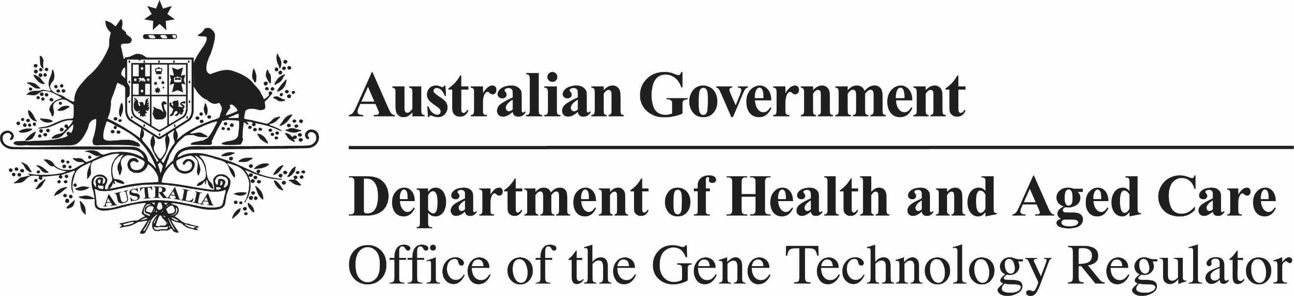

Invitation to comment on a field trial of genetically modified canola (DIR 215)
The Gene Technology Regulator is assessing an application from Miruku Australia Pty Ltd to conduct a field trial of canola genetically modified for dairy protein production. The trial is proposed to take place at up to 1 hectare in 2025 and increasing to a maximum of 20 sites of up to 15 hectares each in 2029. Maximum total planting area proposed is 436 hectares over the 5 years of the trial. Sites will be in NSW, Vic, WA and SA. The plants grown in this field trial would not be used for commercial human food or animal feed.
The Regulator has prepared a Risk Assessment and Risk Management Plan (RARMP) for this application and welcomes written submissions relating to the protection of human health and safety and the environment prior to making a decision on whether to issue the licence. The consultation RARMP and related information can be obtained via the consultation hub or from the contacts below. Submissions should reference DIR 215 and be submitted via the hub or email by 13 May 2025.
Office of the Gene Technology Regulator
MDP 54 GPO Box 9848 CANBERRA ACT 2601
Telephone: 1800 181 030 OGTR Website
E-mail: ogtr@health.gov.au

