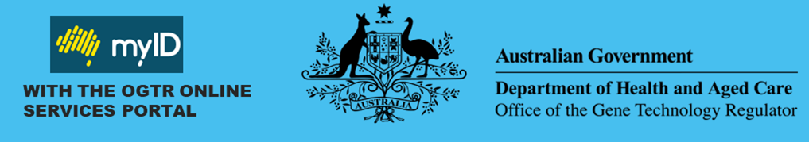

**What is myID and why does the OGTR require myID to access the portal?**

myID is an authentication system that allows you to prove who you are online. Possessing a myID makes it easier to verify your identity and securely sign in to participating government online services, such as the **OGTR Online Services Portal**. It provides greater security for our users accessing their application data and helps the OGTR to ensure authorised users are making requests. myID is used across many different government agencies and services. More information can be found [here.](https://www.myid.gov.au/online-services-you-can-use)

**Privacy & Security**

myID requires your consent to share personal details with the Department of Health and Aged Care. The OGTR only collects information required to perform our regulatory functions. Your myID email will be used solely to associate your professional contact details with your myID account. Information such as your date of birth will not be used, received, or stored by the OGTR. The myID app uses encryption as well as the security features in your device, such as fingerprint, face, or password. This is to protect your identity and help stop other people accessing your information.

**What will you need to set up your myID?**

|  |  |
| --- | --- |
| **A smart device** | **A personal email address** |
| The myID app is compatible with most smart devices and is only available from the Apple App Store or Google Play. | As it’s your personal Digital Identity, your identity documents will be linked to the email you choose. It **should not** be a shared or work  email address. |

**Choosing your identity strength**

To [establish a myID](https://www.myid.gov.au/how-set-myid) you must set up an identity strength level. The OGTR Online Services Portal requires **‘Basic’** identity strength. However, myID accounts with ‘Standard’ identity strength or higher allow access to most other participating government online services. For a ‘Basic’ identity strength, only personal details need to be entered. The strength you have on your account is indicated under your name in the app. While it may look like you need to supply further information, this is only required to reach a stronger identity strength. More information on identity strength can be found [here](https://www.myid.gov.au/how-set-myid#identity-strength) -.