

The Biology of   
*Cicer arietinum* L. (chickpea)

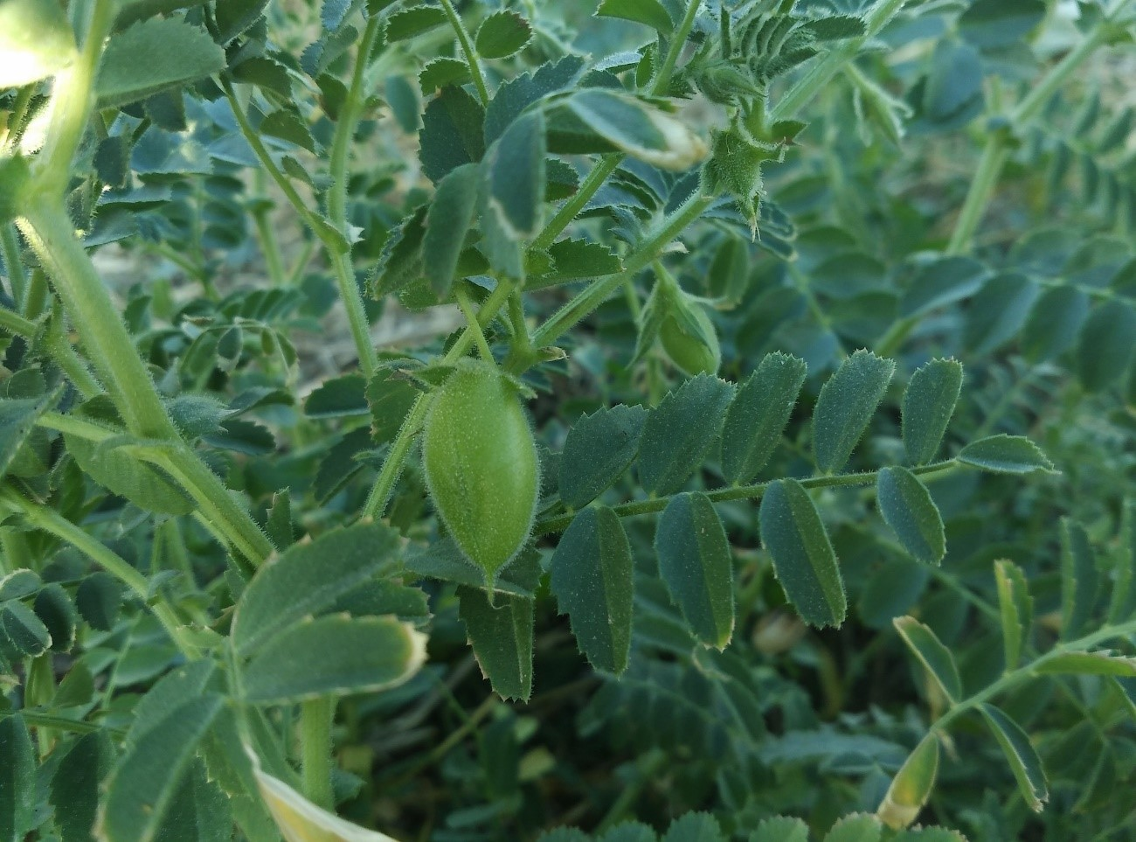

Version 1: March 2019

This document provides an overview of baseline biological information relevant to risk analysis of genetically modified forms of the species that may be released into the Australian environment.

**For information on the Australian Government Office of the Gene Technology Regulator visit our** [**website**](http://www.ogtr.gov.au)**.**

[THIS PAGE HAS BEEN LEFT INTENTIONALLY BLANK]

# Table of Contents

Table of Contents iii

ABBREVIATIONS v

Preamble..... 1

Section 1 Taxonomy 1

Section 2 Origin and Cultivation 3

2.1 Centre of diversity and domestication 3

2.2 Production and commercial uses 4

2.3 Cultivation in Australia 4

2.3.1 Commercial propagation 4

2.3.2 Scale of cultivation 7

2.3.3 Cultivation practices 7

2.4 Crop improvement 10

2.4.1 Breeding 10

2.4.2 Genetic modification 12

Section 3 Morphology 13

3.1 Plant morphology 13

3.2 Reproductive morphology 14

Section 4 Development 16

4.1 Reproduction 16

4.1.1 Asexual reproduction 16

4.1.2 Sexual reproduction 16

4.2 Pollination and pollen dispersal 17

4.2.1 Pollen 17

4.2.2 Pollination 18

4.2.3 Outcrossing rates 18

4.3 Fruit/seed development and seed dispersal 19

4.3.1 Fruit and seed development 19

4.3.2 Seed dispersal 21

4.4 Seed dormancy and germination 22

4.4.1 Dormancy and longevity 22

4.4.2 Germination 22

4.4.3 Persistence in seed banks 23

Section 5 Biochemistry 23

5.1 Toxins 24

5.1.1 Antinutritional factors 24

5.1.2 Mycotoxins 25

5.2 Allergens 25

5.3 Beneficial phytochemicals 26

5.3.1 Use in traditional medicines 26

Section 6 Abiotic Interactions 26

6.1 Soil properties 26

6.1.1 Nutrient requirements 26

6.1.2 Salinity 27

6.2 Temperature requirements and tolerances 27

6.2.1 Cold and frost 28

6.2.2 Heat stress 28

6.3 Water stress 28

6.3.1 Drought 28

6.3.2 Waterlogging 28

6.4 Other abiotic stresses 29

6.4.1 Herbicide damage 29

6.4.2 Low light 29

Section 7 Biotic Interactions 29

7.1 Weeds 29

7.2 Pests and diseases 29

7.2.1 Pests 29

7.2.2 Diseases 30

7.3 Symbionts 32

7.3.1 Rhizobia 32

7.3.2 Arbuscular mycorrhizal fungi 32

Section 8 Weediness 33

8.1 Weediness status on a global scale 33

8.2 Weediness status in Australia 33

8.3 Weediness in agricultural ecosystems 34

8.4 Weediness in natural ecosystems 34

8.5 Control measures 34

Section 9 Potential For Vertical Gene Transfer 35

9.1 Intraspecific crossing 35

9.2 Natural interspecific crossing 35

9.3 Interspecific crossing under experimental conditions 35

Summary..... 36

References 37

Appendix 1 Weed Risk Assessment 47

Cover photo: Patricia Maine (via [Pixabay](https://pixabay.com/en/chickpeas-legumes-plant-orchard-2689498/))

ABBREVIATIONS

ABARES Australian Bureau of Agricultural and Resource Economics and Sciences  
ALUM Australian land use and management  
APVMA Australian Pesticides and Veterinary Medicines Authority  
ASA Australian Seeds Authority  
BOM Bureau of Meteorology  
DoEE Department of the Environment and Energy  
DPI Department of Primary Industries  
DPIRD Department of Primary Industries and Regional Development  
dS Decisiemens  
ECSE Electrical conductivity of a saturated soil extract  
F1 First generation  
FAOSTAT Food and Agriculture Organization of the United Nations  
GI Glycaemic index  
GM Genetically modified  
GRDC Grains Research & Development Corporation  
ha Hectare  
ha-1 Per hectare  
IARI Indian Agricultural Research Institute  
ICAR Indian Council of Agricultural Research  
ICARDA International Center for Agricultural Research in Dry Areas  
ICRISAT International Crops Research Institute for the Semi-Arid Tropics  
IP Intellectual property  
IUIS International Union of Immunological Societies  
kt Kilotonne  
m-2 Per square metre   
MoEF&CC Ministry of Environment, Forest and Climate Change  
NCBI National Center for Biotechnology Information  
NRCS National Resources Conservation Service  
NSW New South Wales   
OECD Organisation for Economic Co-operation and Development  
PBA Pulse Breeding Australia  
PBR Plant Breeders Rights  
Qld Queensland  
RGB Royal Botanic Gardens  
SA South Australia  
spp. Species  
SSD Single seed descent  
Tas. Tasmania  
Tb, Tc, To Base temperature, ceiling temperature, optimum temperature  
USDA United States Department of Agriculture  
Vic. Victoria  
WA Western Australia  
WHO World Health Organization  
WRA Weed risk assessment

Preamble.....

This document describes the biology of *Cicer arietinum* L. (chickpea), with particular reference to the Australian environment, cultivation and use. Information included relates to the taxonomy and origins of cultivated chickpea, general descriptions of its morphology, reproductive biology, biochemistry, and biotic and abiotic interactions. This document also addresses the potential for gene transfer to closely related species. The purpose of this document is to provide baseline information about the parent organism for use in risk analysis of genetically modified (GM) chickpeathat may be released into the Australian environment.

In this document, the word ‘chickpea’ is used to refer to *C. arietinum*.

Chickpea is a short annual leguminous plant, which has been cultivated for many millennia. In Australia chickpea is grown as a grain legume, with the majority of the crop exported for human consumption. Lower quality seed is used for stock feed. Chickpea is not native to Australia and related species of *Cicer* are not present in Australia. The major centre for chickpea production in Australia is in southern Queensland and northern New South Wales, where it is grown as dryland or irrigated crops. Chickpea is also grown in Victoria, South Australia and Western Australia.

* 1. Taxonomy

Chickpea (*Cicer arietinum* L.) is an annual herbaceous legume belonging to the family *Leguminosae* (also known as *Fabaceae* or *Papilionaceae*), subfamily *Papilionoideae* (*Faboideae*) and the monogeneric tribe *Cicereae* Alef. (Table 1; van der Maesen et al., 2007). It is the only cultivated species in the genus *Cicer*, which contains both annual and perennial species. The 43 species of *Cicer* are further divided into four sections. Chickpea belongs to section Monocicer, along with the annual species *C. bijugum*, *C. cuneatum, C. echinospermum, C. judaicum, C. pinnatifidum*, *C. reticulatum* and *C. yamashitae* (van der Maesen, 1987). Cultivated chickpeas fall into two major groups, desi and kabuli, that have different phenotypic characteristics and end uses (Figure 1).

The common name chickpea is derived from the genus name *Cicer*. The plant was known as *Chich* or *Chich pea* in 18th century English (Hale, 1758). The similarity of the chickpea seed shape to the head of a ram (*aries* in Latin) is thought to be the origin of the species name *arietinum* (van der Maesen, 1987). Chickpea is commonly known as *garbanzo* in Spanish-speaking countries and the US, and *chana* or (*Bengal*) *gram* in India.

The species of *Cicer* fall into different gene pools, as defined by Harlan and de Wet (1971), according to their ability to cross with *C. arietinum* (Table 2). Placement of the species of section Monocicer into either primary, secondary or tertiary gene pools varies considerably between researchers; and will likely continue to change over time based on the results of further crossing experiments.

Table 1 Taxonomic hierarchy of chickpea*.*

| **Taxon** | **Nomenclature** | **Comment** |
| --- | --- | --- |
| Kingdom | Plantae |  |
| Phylum | Tracheophyta | Vascular plants |
| Class | Magnoliopsida |  |
| Order | Fabales |  |
| Family | Leguminosae | [= Fabaceae or Papilionaceae] |
| Subfamily | Papilionoideae | [= Faboideae] |
| Genus | *Cicer* |  |
| Section | Monocicer | Annual species |
| Species | *arietinum* |  |

Higher level classifications according to Ruggiero et al. (2015). Lower level classifications according to van der Maesen et al. (2007).

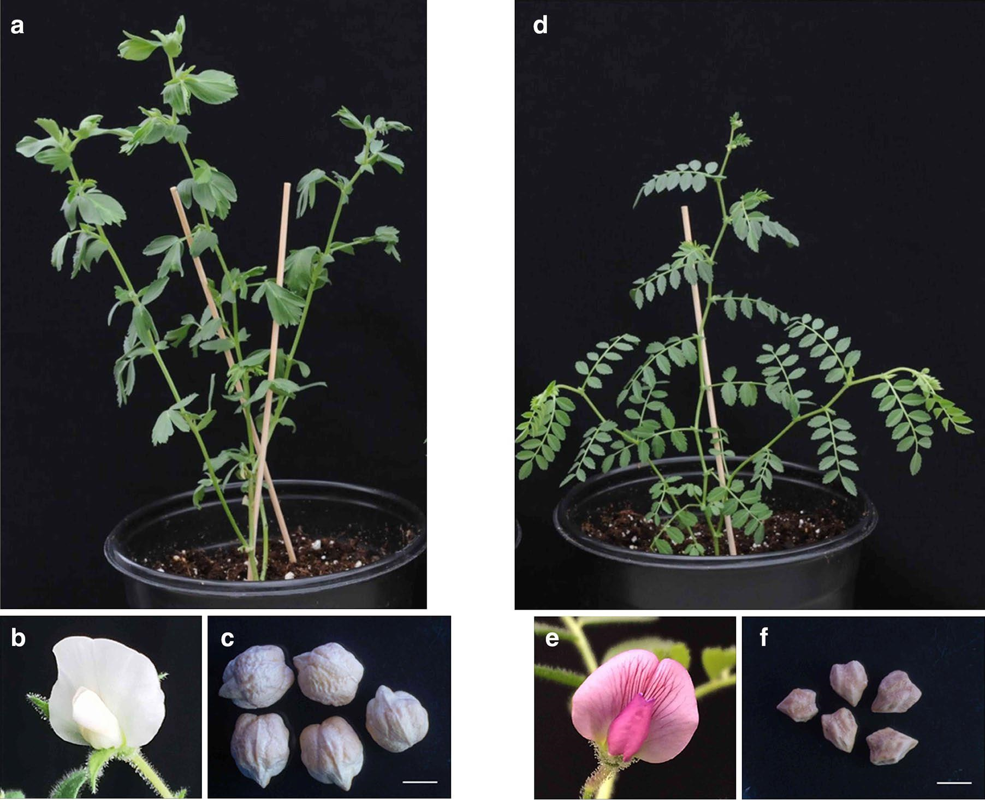

Figure 1 Phenotypic variation in chickpea.   
a-c) Kabuli chickpea with simple leaves, white flower and large seeds. d-f) Desi chickpea with compound leaves, purple flower and small seeds. *Bars* 5 mm. Reproduced from Kalve and Tadege (2017) under [Creative Commons](https://creativecommons.org/licenses/by/4.0/) (cropped image).

Table 2 Chickpea gene pools

| Species | Gene poola | Chromosome numberb | Distributionc |
| --- | --- | --- | --- |
| *C. arietinum* (chickpea) | Primary | 2n=16 | Widespread in cultivation, including Australia |
| *C. reticulatum* (wild progenitor) | Primary | 2n=16 | Turkey |
| *C. echinospermum* | Primary | 2n=16 | Iraq, Turkey |
| *C. bijugum* | Secondary | 2n=16 | Iran, Iraq, Syria, Turkey |
| *C. judaicum* | Secondary | 2n=16 | Israel, Lebanon |
| *C. pinnatifidum* | Secondary | 2n=16 | Armenia, Iraq, Syria, Turkey |
| *C. chorassanicum* | Tertiary | 2n=16 | Afghanistan, Iran |
| *C. cuneatum* | Tertiary | 2n=16 | Egypt, Ethiopia, Saudi Arabia |
| *C. yamashitae* | Tertiary | 2n=16 | Afghanistan |

a Croser et al. (2003); b Ocampo et al. (1992); c van der Maesen et al. (2007).

According to Croser et al. (2003), the primary gene pool contains the wild annual progenitor, *C. reticulatum*, and *C. echinospermum.* These species produce viable hybrids with chickpea. Members of the secondary gene pool (*C. bijugum*, *C. judaicum* and *C. pinnatifidum*) can be hybridised with chickpea, but there is some sterility in the F1 generation. Members of the tertiary gene pool (*C. chorassanicum*, *C. cuneatum* and *C. yamashitae*) are extremely difficult to cross with chickpea, if at all, and produce sterile hybrids.

*Cicer* *anatolicum* is closely related to the species in the chickpea primary gene pool and is considered by some to be the wild perennial progenitor (Croser et al., 2003).

The majority of *Cicer* spp. occur in Asia or Eastern Europe, with two exceptions: *C. canariense* is found on the Canary Islands, and *C. cuneatum* in Egypt, Ethiopia and Saudi Arabia (van der Maesen et al., 2007). The range of *Cicer* does not extend to Australia.

* 1. Origin and Cultivation
     1. Centre of diversity and domestication

The centre of origin of chickpea is in the Fertile Crescent around modern-day Turkey and Syria (Redden and Berger, 2007). This is inferred from archaeological records and the current distribution of wild ancestors of chickpea. The wild annual progenitor of chickpea, *C. reticulatum*, occurs only in a small region in eastern Turkey (Berger et al., 2003). The proposed wild perennial progenitor, *C. anatolicum*, is found in Turkey, Armenia, northwest and western Iran, and northern Iraq.

Chickpea was part of an assemblage of crops (including wheat, barley, peas and lentils) that was domesticated in the Fertile Crescent around 10,000 years ago (Abbo et al., 2003b). The first archaeological record of chickpea occurs in the Early Neolithic period around 8290–8750 BC at Tell el-Kerkh in north-west Syria (Tanno and Willcox, 2006). The seeds are smaller than present day chickpea cultivars and are thought to be at an intermediate stage of domestication between *C. reticulatum* and *C. arietinum*.

Neolithic remains of chickpea are found at sites in Syria, Turkey, Jordan, Palestine and Greece (Redden and Berger, 2007). In the Bronze Age the archaeological range of chickpeas moves to Israel, Iraq, Pakistan, India, Crete and Egypt. During the Iron Age chickpeas first appear in Cyprus and Ethiopia, and are also found in Israel, Iraq and India.

Unlike the ancestors of many other crop species, the pods of *C. reticulatum* do not dehisce and shatter as soon as they are dry. Selection for modified seed dispersal was thus not a major step in chickpea domestication, although modern cultivars do have less tendency to shed pods and shatter seeds (Ladizinsky, 1979). Likewise, *C. reticulatum* does not tend to exhibit seed dormancy so there was little need for ancient farmers to select for non-dormant mutants during domestication (Abbo et al., 2003b).

A major step in the domestication of chickpea was selection against a vernalisation response, allowing crops to be sown in spring, instead of autumn. Abbo et al. (2003b) argue that this shift to summer cropping occurred around the early Bronze Age and allowed crops to avoid weather conditions that promote the development of ascochyta blight disease. In Mediterranean climates, however, increasing temperatures and terminal drought limit the growing season and yield of traditional spring-sown chickpea crops (Kumar and Abbo, 2001). In modern farming systems, chickpea cropping in Mediterranean climates has reverted to winter sowing, requiring greater ascochyta blight and weed control.

Further selection for variation in sensitivity to temperature and day length allowed chickpea to spread to different geographical and climatic environments (Kumar and Abbo, 2001; Berger et al., 2011).

Five centres of origin for chickpea were proposed by Vavilov (1951). These are now considered to be centres of diversity (van der Maesen, 1984):

* the Indian Centre, extending to Myanmar
* the Central Asiatic Centre, extending from northwest India to Uzbekistan
* the Near Eastern Centre, extending from Turkey to Turkmenistan (secondary centre; pea-shaped chickpeas)
* the Mediterranean Centre (a large-seeded group of chickpea)
* the Abyssinian Centre, extending from Eritrea to Somalia.

Chickpea was introduced to the American continents by Spanish and Portuguese migrants around 1500 (van der Maesen, 1972).

Chickpea accessions arrived in Australia from the 1890s onwards (Siddique and Sykes, 1997). Following trials in NSW and Qld, the first Australian chickpea crop was grown in 1979.

* + 1. Production and commercial uses

Chickpea is the world’s third largest pulse crop after beans (*Phaseolus vulgaris*) and peas (*Pisum sativum*). In 2016 around 12 million tonnes of chickpea were produced from 12.7 million ha across over 50 countries ([FAOSTAT website](http://www.fao.org/faostat/en/#data), accessed 27 November 2018). India is by far the largest producer and consumer of chickpea, accounting for 67% of total production and 36% of world imports in 2012–2016 (Figure 2, Figure 3). Australian chickpeas made up 6% of world production; while Myanmar, Turkey, Pakistan and Ethiopia together produced 16% of total production in 2012–2016. In recent years Australia was the largest exporter of chickpea. Almost all Australian grown chickpeas are exported, making up 46% of the world chickpea trade (Figure 3).

Chickpea production in Australia is dependent on expected returns relative to cereal crops and adequate rainfall (ABARES, 2018b). In 2016–17 Australian chickpea production peaked at 2.0 million tonnes from 1.1 million ha. Following reduced demand from India and low rainfall, production was forecast to drop to 0.28 million tonnes from 0.28 million ha in 2018-19 (Figure 4).

Chickpea is primarily grown for human consumption. At over 5 kg/capita/year, Turkey and India are the highest consumers of chickpea (Yadav et al., 2007). Chickpea is prepared in numerous different ways around the world. In India, the seeds of desi varieties are ground into a flour (known as *besan*) or split to produce dhal, green leaves and green seeds are used as a vegetable in cooking, and sprouted chickpeas are eaten at breakfast. In Turkey, whole mature chickpeas are used in cooking or eaten roasted as a snack. A type of tofu is made from chickpeas in Myanmar. The Middle Eastern foods *hummus* and *falafel*, usually prepared from kabuli chickpeas, are also widely consumed in Australia.

Chickpea is used in cosmetic preparations in India, where a paste containing chickpea flour is applied to the skin of babies to improve the complexion (Patil et al., 2001).

A small proportion of chickpeas and chickpea plants is used as animal feed (Yadav et al., 2007).

Chickpea has been used in traditional medicines since Roman times (see Section 5.3.1).

* + 1. Cultivation in Australia
       1. Commercial propagation

Chickpea is an annual legume that is propagated by seed. In Australia, chickpea is grown as a cool season crop, in rotation with other crops including cereals, oilseeds and cotton (Pulse Australia, 2016). Chickpeas are produced both as dryland and irrigated crops.

| Pie chart showing average annual production for India, Australia, Myanmar, Turkey, Pakistan, Ethiopia and Rest of world | Figure 2 Worldwide chickpea production quantity 2012–2016.  Average annual production over the five years 2012–2016: 12.3 million tonnes. Data source: [FAOSTAT website](http://www.fao.org/faostat/en/#data), accessed 27 November 2018. |
| --- | --- |
| Bar chart showing exported quantities of chickpea from 2012 - 2016 for Australia, Russian Federation, India, Mexico and Canada. | |
| Bar chart showing imported quantities of chickpea from 2012 - 2016 for India, Bangladesh, Pakistan, United Arab Emirates and Algeria. | |

Figure 3 Traded quantities of chickpeas for the top five exporting (a) and importing (b) countries 2012-2016.   
Data source: [FAOSTAT website](http://www.fao.org/faostat/en/#data), accessed 27 November 2018.

Desi varieties make up the majority (90–95%) of Australian chickpea production (Pulse Australia, 2016). Pulse Breeding Australia (PBA) develops desi and kabuli chickpea varieties suited to different Australian regions ([PBA website](https://grdc.com.au/research/trials,-programs-and-initiatives/pba), accessed 20 December 2018). Varietal traits differ for early vigour, time to flowering and maturity, plant height, lodging at maturity and resistance to ascochyta blight disease. End-point royalties, including breeder royalties, are collected for every tonne of chickpea at delivery.

Commercial seed production follows a seed certification scheme based on the rules and directives of the Organisation for Economic Co-operation and Development (OECD) Seed Schemes and International Seed Testing Association (OECD, 2018). The Australian Seeds Authority (ASA) Seed Certification Schemes follow the same rules as the OECD Seed Schemes ([ASA website](https://aseeds.com.au/), accessed 20 December 2018). The ASA administers the OECD and ASA Seed Certification Schemes in Australia, and accredits Certifying Agencies to deliver the certification schemes (Seed Services Australia, 2013). Certifying Agencies conduct crop inspections and seed testing, and issue official certified seed certificates.

Production of certified seed involves several steps. *Breeders’ seed* is sown to produce *Pre-Basic seed*. *Basic seed* is produced from Breeders’ or Pre-Basic seed (Seed Services Australia, 2013). Basic seed is the basis of all seed certification programs and is intended for the production of certified seed. *Certified seed* may be First Generation (C1; produced from Basic seed) or Second Generation (C2; produced from C1 seed). Certified seed is used for sowing crops and pastures.

Certification rules are defined for every crop (Seed Services Australia, 2013). For chickpea the paddock used to produce seeds must not have been sown to another chickpea crop for three years or two years, to produce Basic or Certified seed, respectively. The paddock must also not have been sown to any pulse crop in the previous year. Crops grown for seed certification have to be isolated from any contaminating pollen. The isolation distance for chickpea Basic and Certified seed production is 3 m. According to the ASA National Seed Quality Standards, certified chickpea seed must be at least 98% pure (by mass), have a minimum germination rate of 70% and have less than 15 contaminating seeds per kilogram (Seed Services Australia, 2013).

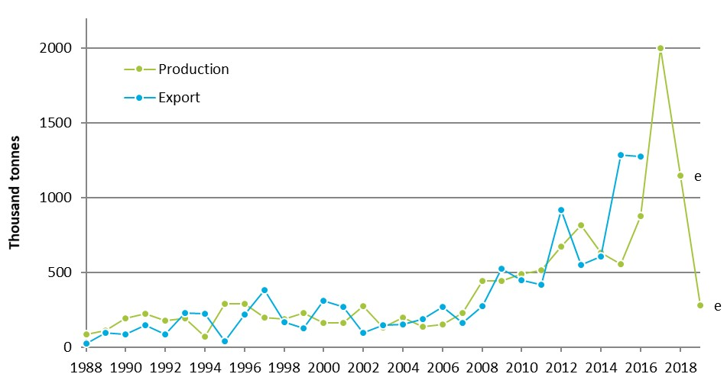

Figure 4 Australian chickpea production and export quantities.   
e, estimate. Data source: [FAOSTAT website](http://www.fao.org/faostat/en/#data) (accessed 27 November 2018) and ABARES (2019). Chickpea seed may be produced and exported in different years.

* + - 1. Scale of cultivation

Chickpea was first grown as a crop in Australia in the 1970s near Goondiwindi, Qld (Pulse Australia, 2016). The first commercial variety was a desi chickpea introduced to Australia from India (Siddique and Sykes, 1997). With the opening of export markets to the Indian subcontinent in the mid-1980s, chickpea production increased. Demand from India remains a major driver in Australian chickpea production (see Section 2.2).

Several factors, including phytophthora root rot and ascochyta blight disease, prevented the early expansion of chickpea production in Australia (GRDC, 2016a). Chickpea production increased substantially following the release of PBA HatTrick in 2009, a variety with increased disease resistance.

In recent years the scale of chickpea cultivation in Australia has fluctuated. Since 2013–14 chickpea production has ranged from 555 to 2004 kt from an area of 425,000 to 1,069,000 ha (ABARES, 2018a). Farm yields averaged 1.2–1.9 t ha-1.

Queensland and NSW are the largest producers of the chickpea in Australia (Figure 5). The major chickpea growing region extends from southern Qld to northern NSW (Figure 6). Chickpeas are also grown in central Qld, southern NSW, Vic., SA and WA, including a small area of kabuli chickpeas grown in the Ord River Irrigation Area in northern WA (Pulse Australia, 2016; GRDC, 2017b; ABARES, 2018b).

| Chart showing average chickpea production area for Qld, NSW, Vic, SA and WA. | Chart showing average chickpea production quantity for Qld, NSW, Vic, SA and WA. |
| --- | --- |

Figure 5 Australian state chickpea production area (left) and quantity (right).   
Five-year average to 2017–18. Data source: ABARES (2019).

* + - 1. Cultivation practices

Chickpea can be a permanent part of a crop rotation sequence, or may be grown as an opportunity crop in drier regions when there is a full soil moisture profile or when chickpea prices are high (Pulse Australia, 2016). When grown in rotation with cereals, chickpea provides a break in cereal disease lifecycles and can assist with management of grass weeds. Nitrogen-fixing legumes, such as chickpea, also improve yields in subsequent wheat crops (Armstrong et al., 1996). Inoculating with *Rhizobium* bacteria prior to sowing is recommended to ensure maximum yield (GRDC, 2017a).

A break of at least three years between chickpea crops is recommended to reduce the risk of ascochyta blight disease (NSW DPI, 2018). Chickpea should also be sown in fields that are at least 500 m from previous year’s chickpea crops. It is important to know the paddock history, as chickpea is susceptible to damage from residual herbicides, such as sulfonylureas, that are used to control weeds in previous crops or fallows (GRDC, 2017a). Emerging plants may be stunted or die if herbicide residues have not broken down, e.g. due to low rainfall or high soil pH.

In Australia, chickpea crops are grown as cool season crops, generally planted in late autumn/early winter, and harvested in late spring/early summer (Pulse Australia, 2015, 2016). In high rainfall areas of SA and Vic., the preferred sowing time for chickpea is August–September. Average daily maximum and minimum temperatures, and average rainfall, for representative towns in different chickpea growing regions is given in Table 3.

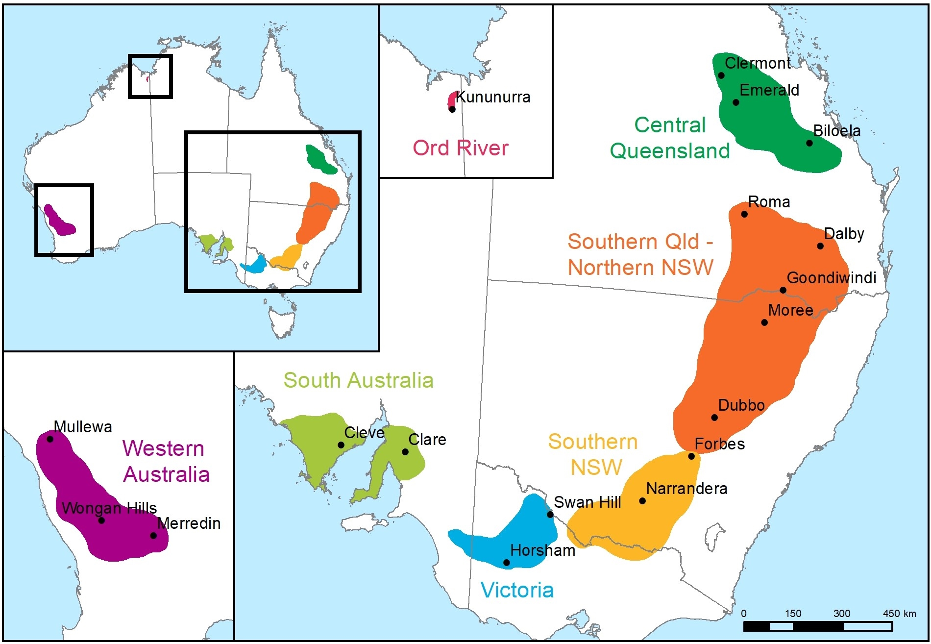

Figure 6 Chickpea growing regions in Australia.   
Data source: Pulse Australia (2016) and variety guides available via [Seednet website](https://www.seednet.com.au/products/chickpeas).

Table 3 Climatic data for Australian chickpea growing regions

| Town | Preferred sowing windowa | Average daily min/max temperature (°C) | | |  | Average rainfall (mm) | |
| --- | --- | --- | --- | --- | --- | --- | --- |
| At sowing | Winter | Spring |  | Annual | Winter  (% of annual) |
| Emerald, Qld | Apr-May | 15/28 | 10/24 | 17/31 |  | 561 | 70 (12%) |
| Moree, NSW | May-Jun | 7/21 | 5/19 | 13/28 |  | 583 | 101 (17%) |
| Narrandera, NSW | May-Jun | 5/17 | 4/15 | 9/24 |  | 434 | 115 (26%) |
| Horsham, Vic. | May | 5/18 | 3/14 | 6/22 |  | 374 | 118 (32%) |
| Clare, SAb | Aug-Sep | 4/16 | 4/14 | 8/21 |  | 556 | 199 (36%) |
| Wongan Hills, WA | May-Jun | 9/20 | 7/18 | 10/25 |  | 388 | 191 (49%) |
| Kununurra, WA | May | 19/33 | 15/31 | 23/38 |  | 726 | 5 (1%) |

a DPIRD (2015), Pulse Australia (2015), Pulse Australia (2016); b Spring sowing is recommended for high rainfall districts in south-eastern Australia. Data source: [BOM climate data](http://www.bom.gov.au/climate/data/index.shtml), accessed 20 December 2018.

Chickpea is grown in both dryland and irrigated production systems. A greater proportion of chickpea crops is irrigated when prices are high (K. Moore[1], personal communication, December 2018). However, chickpeas are now rarely irrigated in northern NSW, as irrigation has been shown to be of little assistance in increasing yield in normal seasons (G. Onus[2], personal communication, February 2019). Farmers may irrigate prior to sowing to establish a full soil moisture profile and, if necessary, irrigate prior to flowering or soil cracking to avoid waterlogging damage. Kabuli chickpeas grown during the dry season in the Ord River Irrigation Area usually receive eight irrigations from pre-sowing to the end of podding (DPIRD, 2014).

When soil moisture is present, seeds are sown at a depth of 5–7 cm (NSW DPI, 2018). Seeds may be sown as deep as 17.5 cm if surface soil moisture is inadequate. Suggested sowing rates range from 45–253 kg ha-1 to achieve plant densities of 20–45 plants m-2; target plant densities depend on growing region and yield potential due to water availability.

Treatment of chickpea seed with fungicide seed dressing prior to planting is recommended to protect against seed-borne ascochyta blight, botrytis grey mould and damping off (*Pythium* spp.) (NSW DPI, 2018). Phytophthora and fusarium root rot diseases can also be managed with seed treatments.

Fertilizer is often applied at sowing (GRDC, 2017a).

Chickpea development is described in Section 4. Seedlings emerge 6–30 days after sowing. Emergence takes longer under cool temperatures. Plants grow vegetatively for 12–16 weeks after sowing before flowering begins, depending on variety, location, sowing time and growing conditions. Kabuli varieties grown in the Ord River Irrigation Area flower around six weeks after sowing (DPIRD, 2015). Flowering progresses from the lower branches upwards. Seeds and pods mature around six weeks after flowering. Depending on environmental conditions, the growing period for chickpea crops ranges from 100–225 days (Summerfield and Roberts, 1985; as cited in Croser et al., 2003b).

Chickpea is a poor competitor with weeds. Weed management is required, especially during the seedling stage (see Section 7). Insect, nematode and vertebrate pests, diseases and viruses may also require management.

As an indeterminate crop, if chickpea crops do not reach maturity through terminal drought, herbicide application is used to desiccate crops when at least 90% of seeds have reached physiological maturity (GRDC, 2017a). Chickpea crops are usually not windrowed prior to harvest. In the Ord River Irrigation Area, chickpea crops are undercut 2.5 cm below the soil surface after the final irrigation, and harvested 1–2 weeks later (DPIRD, 2014). Chickpeas are best harvested when seed moisture content is 13–15% (GRDC, 2017a).

Chickpea harvest often occurs during hot, dry weather. The dust produced during chickpea harvest (Figure 7) is highly flammable and can settle around the engine bay of headers, with a high risk of ignition and header fires (Bowden, 2016). Chickpea crops produce a relatively low quantity of stubble biomass (Armstrong et al., 1996) and residues break down rapidly (Lefroy et al., 1995).

Harvested chickpeas may be stored in gastight sealed or non-sealed silos, storage bags or storage sheds on farm prior to delivery to a local silo (GRDC, 2017a). Silos are often fitted with aeration fans to modulate temperature and humidity. Application of diatomaceous earth or fumigation with phosphine is used to control insect pests in storage.

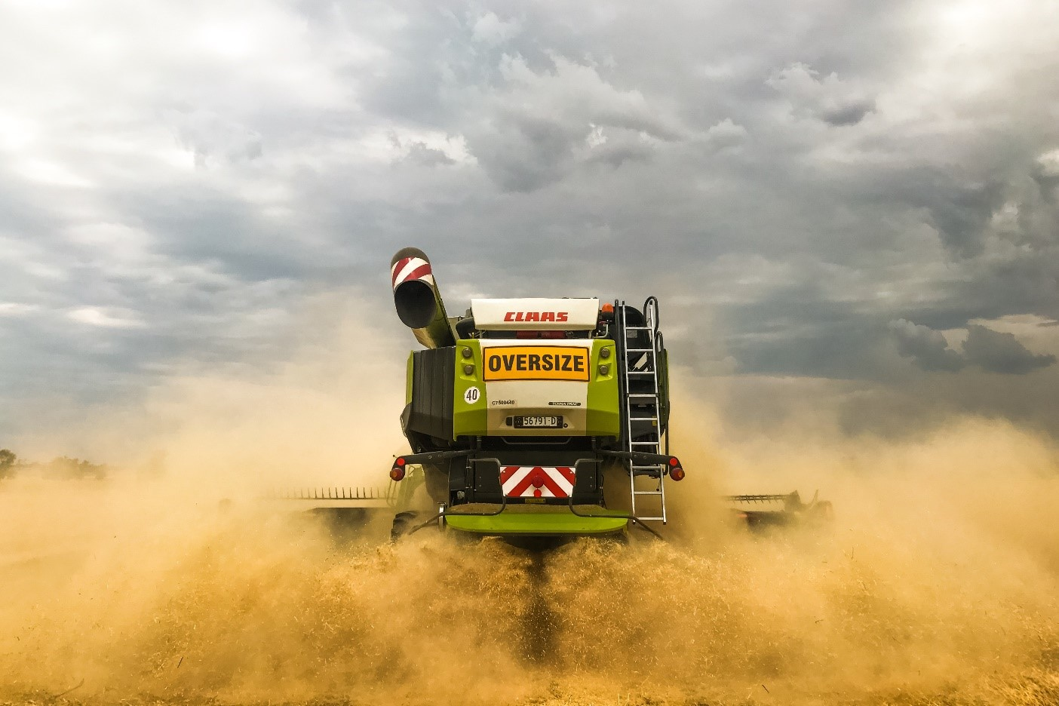

Figure 7 Chickpea dust and trash being spread from the back of a header during harvest.   
Photo: Kieran Shephard

* + 1. Crop improvement
       1. Breeding

The first modern chickpea breeding programs were established in India in the early 20th century (Singh, 1987). The first released cultivars were selected landraces, followed by cultivars bred by hybridisation. The Indian National Genebank contains 14,651 diverse accessions of chickpea (Figure 8). Many other countries have longstanding chickpea breeding and research programs. The International Crops Research Institute for the Semi-Arid Tropics (ICRISAT) and the International Center for Agricultural Research in Dry Areas (ICARDA) have been conducting breeding and research to improve chickpea for developing countries since the 1970s.

The first cultivar released in Australia in the 1970s was a desi chickpea originating in India (GRDC, 2012). Australian germplasm includes landraces and advanced breeding material from ICARDA, ICRISAT, India, Azerbaijan, Iran, Spain, Turkey, Russia, Ethiopia, Canada, Mexico and the US; locally developed lines; and accessions of the wild relatives *C. reticulatum* and *C. echinospermum* (Berger et al., 2004; Imtiaz et al., 2008).

Australian cultivars are usually developed by crossing two or more lines using controlled pollination, followed by single seed descent (SSD) ([IP Australia PBR database](http://pericles.ipaustralia.gov.au/pbr_db/), accessed 16 January 2019). Lines are tested in an ascochyta blight disease nursery at around the F5 generation, when lines are considered fixed. Promising lines are then included in yield trials. Pedigree seed is derived from generation F8 or F9.

In recent years breeding of chickpea varieties for Australian environments has been carried out by Pulse Breeding Australia, a joint venture between the Grains Research and Development Corporation (GRDC), Pulse Australia, and various state agriculture departments and universities (GRDC, 2012). End point royalties paid by farmers on delivery of harvested PBA varieties are returned to the GRDC and other agencies.

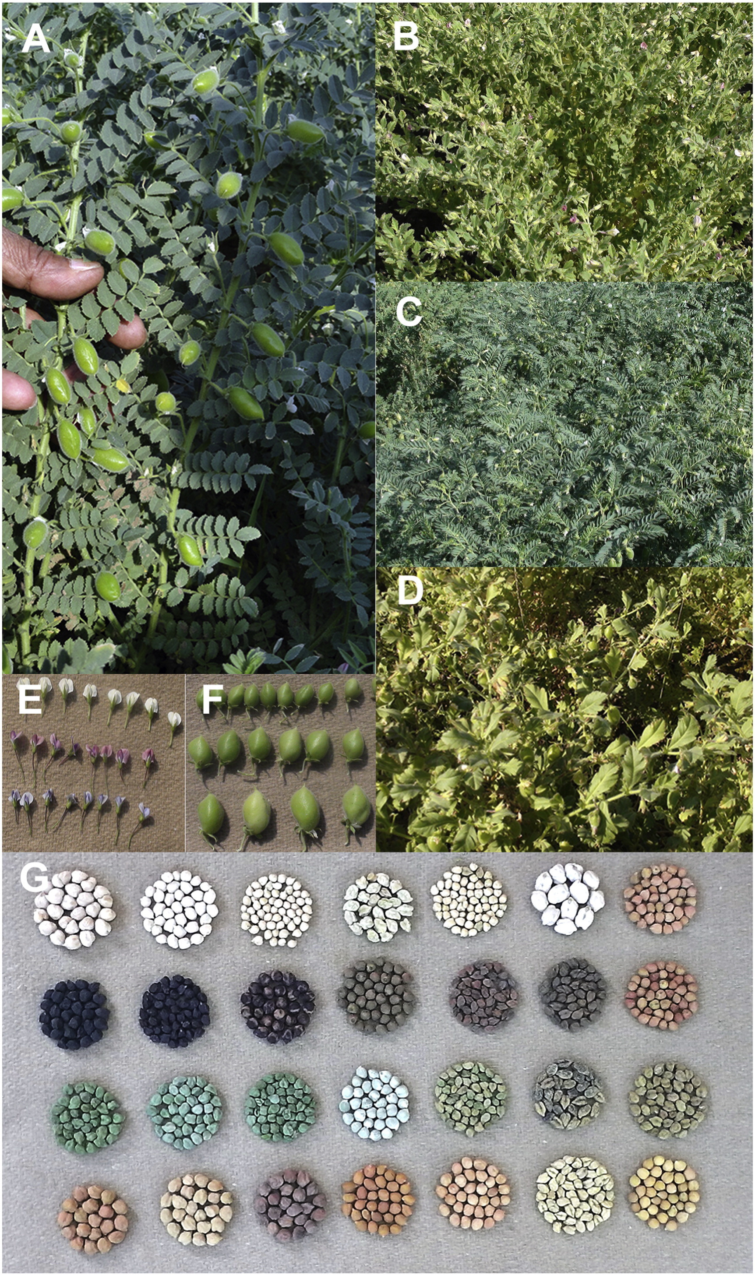

Figure 8 Morphological variability observed in desi chickpea germplasm in the Indian National Genebank at the ICAR-National Bureau of Plant Genetic Resources.  
A) Plant type; B–D) foliage and canopy; E) flower colour and size; F) pod size; and G) seed colour, size and shape. Reproduced from Archak et al. (2016) under [Creative Commons](https://creativecommons.org/licenses/by-nc-nd/4.0/).

The major focus of the Australian chickpea breeding program is the development of regionally adapted varieties with improved host resistance to ascochyta blight disease, as the pathogen continues to evolve more aggressive strains (GRDC, 2016a).

Other breeding objectives include:

* improved yield through early phenology and abiotic stress tolerance traits
* introgression of phytophthora root rot resistance from *C. echinospermum*
* selection for plant architecture traits that improve harvestability
* incorporation of herbicide tolerance traits, which are being developed using ethyl methanesulfonate (EMS) mutation
* increased kabuli seed size
* selection for botrytis grey mould resistance (GRDC, 2016a).

Wild relatives of chickpea have been identified with traits for increased resistance or tolerance to fungal diseases, insect pests and abiotic stresses (Croser et al., 2003). However, only hybrids between chickpea and *C. reticulatum* or *C. echinospermum* are routinely used in breeding programs, with the aim of introgressing desirable traits from the wild relatives into elite cultivars (Gaur et al., 2007). The desi variety ‘Pusa 1103’, released in India in 2005, was developed by crossing chickpea with *C. reticulatum* ([ICAR-IARI variety list](http://www.iari.res.in/index.php?option=com_content&view=article&id=1253&Itemid=951), accessed 18 January 2019).

Recent advances in chickpea breeding have been to shorten generation times, allowing multiple generations of chickpea to be grown within a year. This has been necessary as doubled haploid production, a technique used to generate homozygotes in the breeding of cereals and oilseeds, is not available for legumes (Croser et al., 2015). Four to six generations of SSD are generally required to fix alleles (Watson et al., 2018). Up to six generations of chickpea can be grown per year using the ‘speed breeding’ technique, in which plants are grown in a glasshouse with a 22 hour photoperiod and day/night temperatures controlled at 22/17 °C. Pods are harvested and dried six weeks after anthesis. In a similar accelerated SSD technique, six to eight generations of chickpea can be grown per year (Croser et al., 2015). Plants are grown with a 20 hour photoperiod and temperatures controlled at 24/22 °C. Immature seeds are harvested 16–18 days after anthesis and germinated using an IP-protected precocious germination technique.

Draft genome sequences of a kabuli and a desi line of chickpea were published by Varshney et al. (2013) and Jain et al. (2013), respectively. The draft genome of the wild progenitor of chickpea, *C. reticulatum* was published in 2017 (Gupta et al., 2017).

With the development of genomic tools in recent years, genomics-assisted breeding promises faster gains in crop improvement. For example, a high-throughput genotyping array allows data for 50,590 chickpea single nucleotide polymorphisms to be generated for a relatively low cost (Roorkiwal et al., 2018). This tool can be used to discover quantitative trait loci from phenotypic data for the selection of desirable traits in breeding.

Gene expression studies look at which genes are up- and down-regulated in plant tissues under particular conditions, with the aim of discovering genes that might be targeted in breeding programs, e.g. genes involved in the development of chickpea flowers, seeds, roots and nodules; or genes involved in drought tolerance (Kudapa et al., 2018).

* + - 1. Genetic modification

Genetic modification allows the integration of genes into chickpea, that cannot be introduced through conventional breeding (Kumar et al., 2018). *Agrobacterium*-meditated transformation is the most common method for the production of GM chickpea.

Genetic modification of chickpea was first attempted in the 1990s (McPhee et al., 2007). Since then, chickpea has been genetically modified for resistance to insect pests and abiotic stress tolerance. Several groups have integrated *cry* genes from *Bacillus thuringiensis* into the chickpea genome for resistance to pod borer, *Helicoverpa armigera* (Kumar et al., 2018)*.* A bean α-amylase inhibitor gene transformed into chickpea inhibits development of bruchid insect storage pests (Sarmah et al., 2004); however when the same gene was transformed into garden pea, a modified form of the protein with undesirable altered antigenicity was synthesised (Prescott et al., 2005). Overexpression of a mothbean gene involved in proline biosynthesis alters the accumulation of sodium ions in leaves and improves tolerance to salinity stress in chickpea (Ghanti et al., 2011). Overexpression of an *Arabidopsis thaliana* dehydration-responsive transcription factor gene alters chickpea root morphology and transpiration characteristics under water stress, improving tolerance to terminal drought conditions (Anbazhagan et al., 2015).

Attempts have also been made to improve the nutrient balance of chickpea seeds by increasing the concentration of the sulfur amino acids, cysteine and methionine. An increase in sulfur amino acid content was achieved, under certain nutrient conditions, by inserting a sunflower gene that expresses a sulfur-rich protein in seeds into the chickpea genome (Chiaiese et al., 2004).

* 1. Morphology
     1. Plant morphology

Chickpea is an annual plant that grows to approximately 20–100 cm in height (Cubero, 1987). Australian desi cultivars reach approximately 50–80 cm in height, depending on the growth environment (GRDC, 2016b).

There is considerable variation in the growth habit of chickpea, ranging from erect to prostrate. Most accessions have a semi-erect branching habit (Upadhyaya et al., 2002). Australian commercial cultivars are usually erect or semi-erect ([IP Australia PBR database](http://pericles.ipaustralia.gov.au/pbr_db/), accessed 16 January 2019).

Chickpea emergence is hypogeal. As the plumular shoot ascends from the seed, the first formed leaves are scales (Cubero, 1987). True leaves develop alternately from the shoot. The outer edge of leaflet blades is serrated. Chickpea leaf arrangement is typically pseudo-imparipinnate[3]. The first true leaves have 3–4 pairs of leaflets that extend from the rachis, but only one of the two terminal leaflets is formed (Figure 9). After the sixth node, fully formed leaves usually have 5–8 pairs of leaflets (GRDC, 2017a).

Primary branches emerge from the main shoot, often at the base of the plant (Cubero, 1987). The angle at which primary branches emerge determines the growth habit of the plant. Secondary branches emerge from primary branches, and bear most of the plant’s leaves and pods. Tertiary branches may also be formed.

All the above-ground surfaces of the chickpea plant, apart from the flower petals, are pubescent (Cubero, 1987). Hairs may be single-celled with no glands or multicellular glandular hairs that secrete malate and other acids (see Section 5.1 for more details on secreted acids).

Chickpea plants have an indeterminate growth habit, meaning that leaves, stems, flowers, pods and seeds can develop at the same time. The terminal bud remains vegetative even when the plant is in the reproductive stage (Pulse Australia, 2016).

The chickpea root system is deep and robust, with roots growing to a depth of 1–2 m (van der Maesen, 1972; Thomas et al., 1995; GRDC, 2017a). Lateral roots extend from a primary tap root (Figure 10). Close to the soil surface roots develop nodules through symbiosis with *Rhizobium* bacteria. These fix atmospheric nitrogen, which becomes available to the plant, in exchange for carbohydrates. The majority of nodules occur within the top 15 cm of soil (Loss et al., 1998).

A useful guide to scoring morphological characteristics of chickpea was compiled by Singh and Diwakar (1995).

| Drawing of a chickpea plant showing braches, leaves, flowers and a pod. | Figure 9 Chickpea plant morphology.  Image source: [RGB Kew](http://powo.science.kew.org/taxon/urn:lsid:ipni.org:names:486336-1), used under [Creative Commons](https://creativecommons.org/licenses/by/3.0/). Preliminary drawing of *Cicer arietinum* by John Curtis for Curtis's Botanical Magazine, 1822. |
| --- | --- |

* + 1. Reproductive morphology

Chickpea produces small pea-like flowers (Figure 11). Each zygomorphic[4] papilionaceous[5] flower (8–10 mm) has five petals: a large standard petal, two lateral wing petals and two fused keel petals (Kalve and Tadege, 2017). The flower contains ten diadelphous stamens (nine fused and one free; 6–8 mm) and a style (3–4 mm) with a slightly broadened stigma (Auckland and van der Maesen, 1980).

Petals of desi flowers are usually pink or purple, while kabuli flowers are white to cream in colour (Figure 1). In some environments, the chickpea plant produces a number of pseudo-flowers or ‘false’ flower buds prior to the onset of flowering (Khanna-Chopra and Sinha, 1987).

Papilionaceous flowers are evolutionarily adapted to pollination by bees and bumble bees (Leppik, 1966); however chickpea flowers are essentially self-pollinating (see Section 4.2).

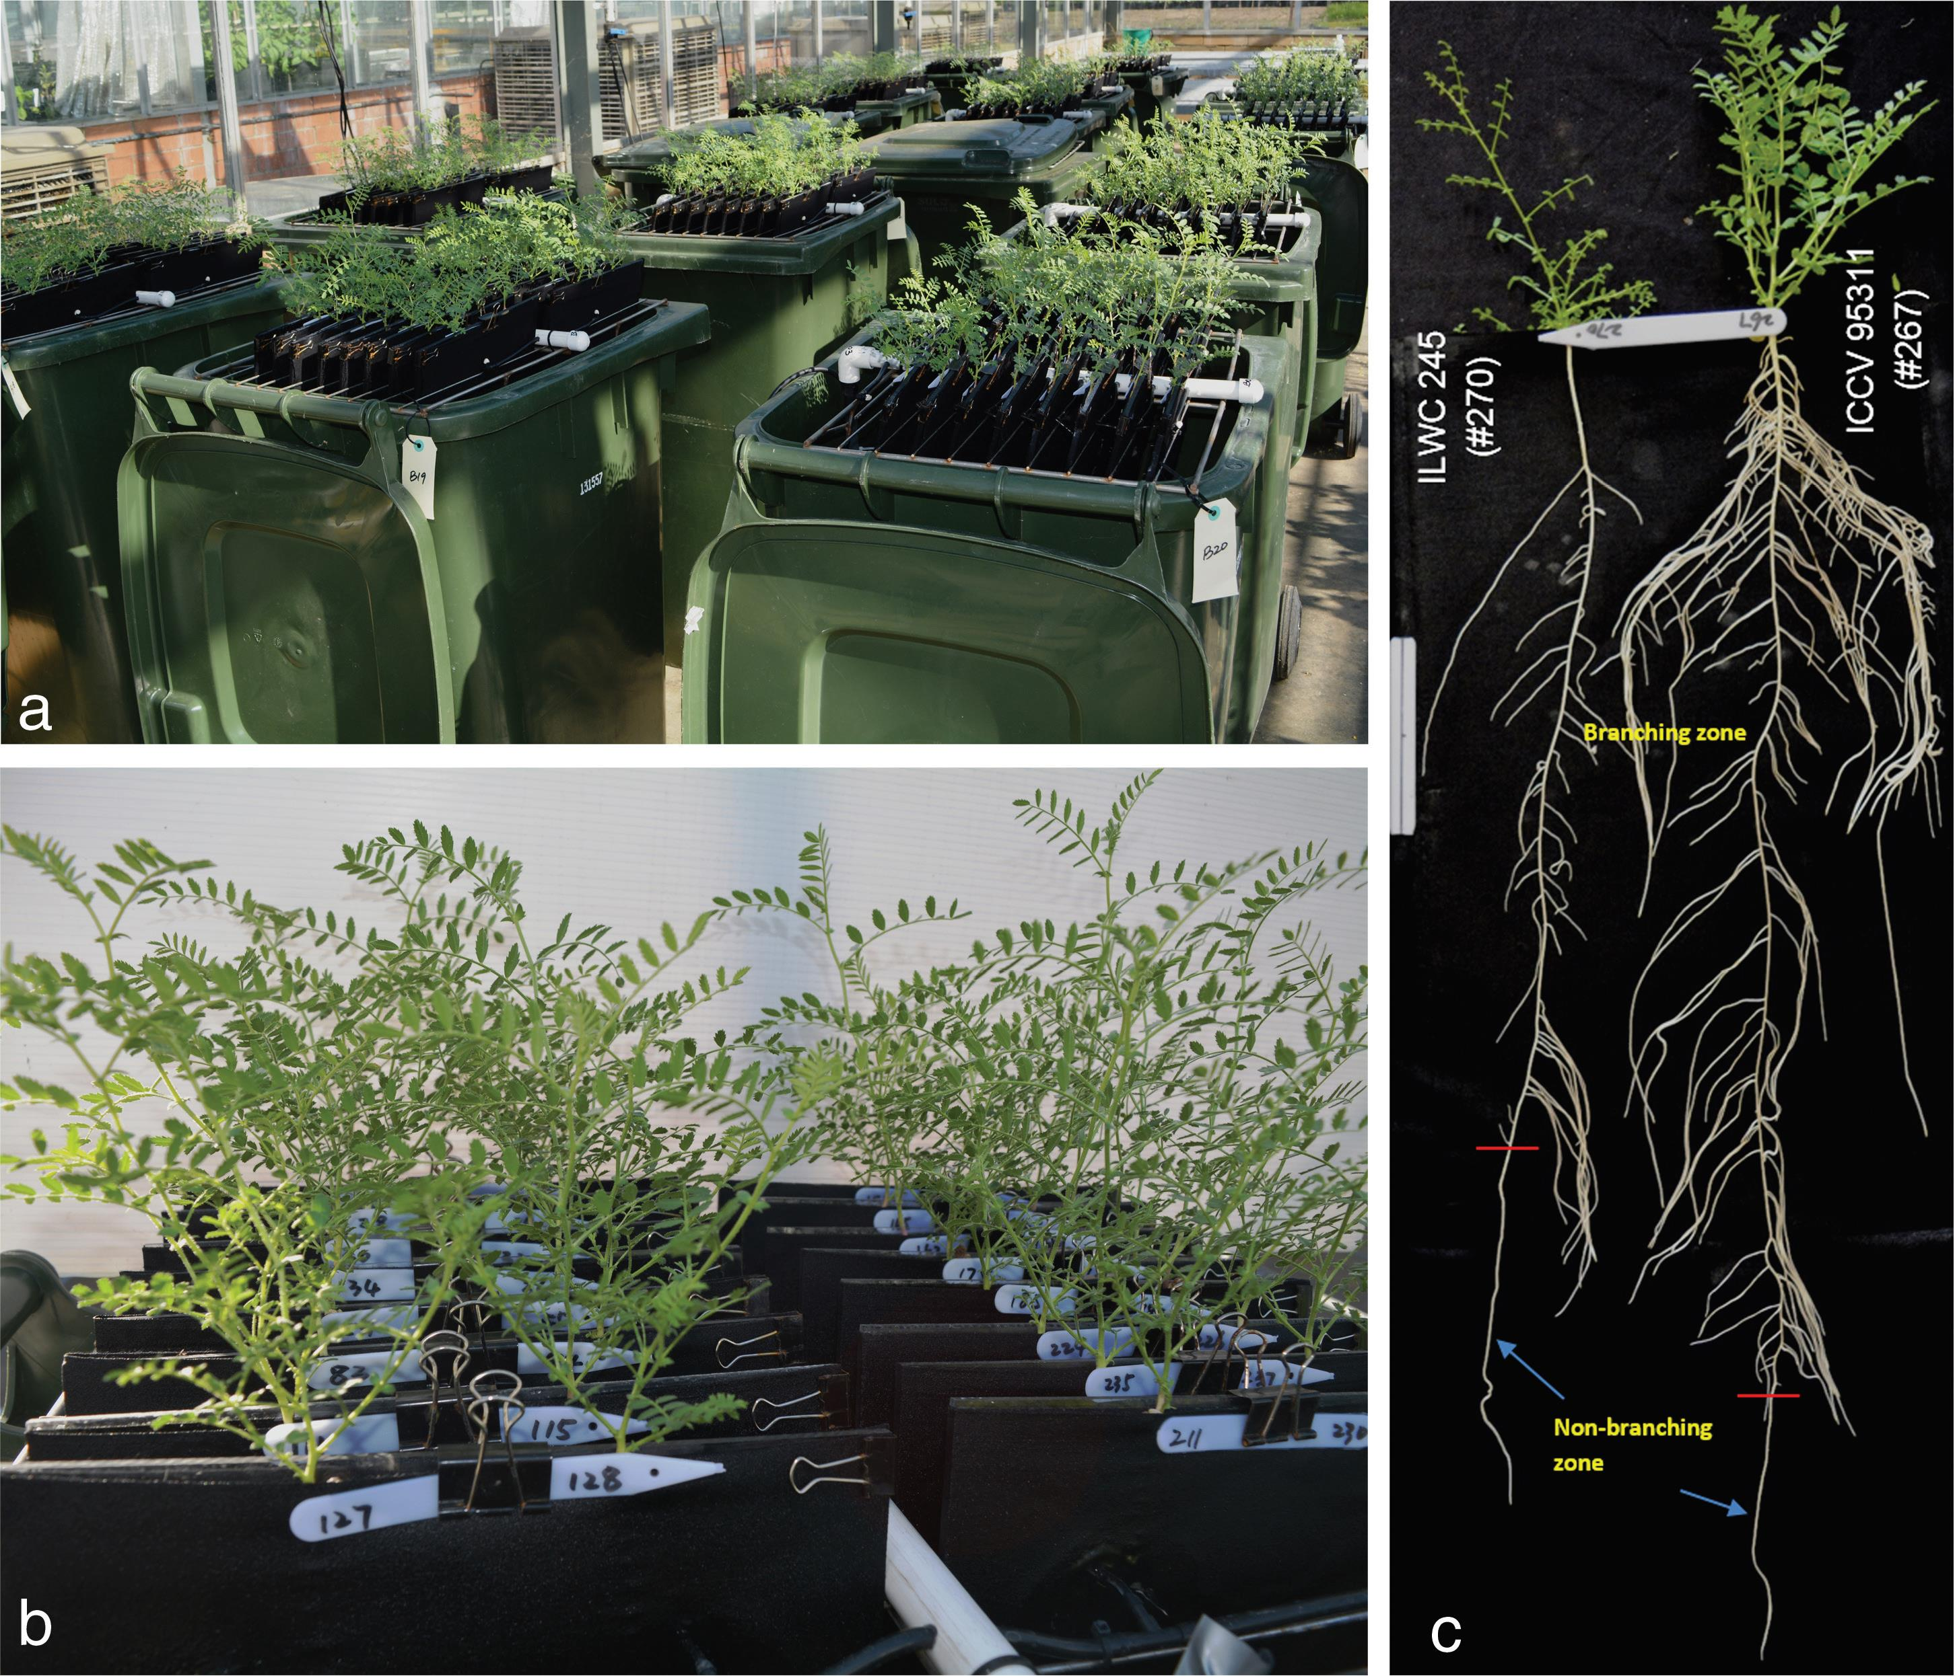

Figure 10 Genotypic variation in chickpea root architecture.   
Experimental layout (a) and close up view (b) of chickpea plants grown in a semi-hydroponic system. c) Contrasting root systems of *C. echinospermum* (left) and an Indian kabuli line (right) at 35 d; white tag on left side is 10 cm long. Reproduced from Chen et al. (2017) under [Creative Commons](https://creativecommons.org/licenses/by/4.0/).

| Photo of closed chickpea flower bud. | Photo of dissected chickpea flower bud with labels indicating standard petal, keel petal, style, pedicel, calyx, wing petals, anthers and stigma. |
| --- | --- |

Figure 11 Flower structure of chickpea.   
a) Closed flower bud. b) Dissected flower revealing different parts of the flower bud. *Bars* 1 mm. Reproduced from Kalve and Tadege (2017) under [Creative Commons](https://creativecommons.org/licenses/by/4.0/).

* 1. Development

After germination and emergence, chickpea plants grow vegetatively prior to entering the reproductive growth phase (Figure 12).

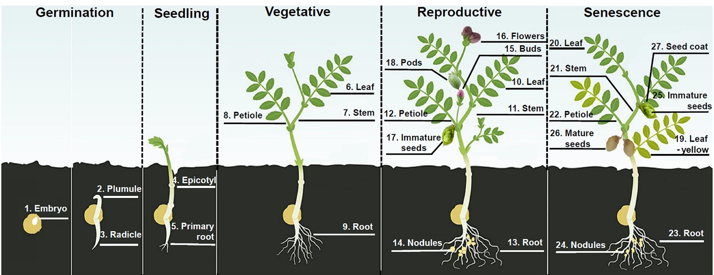

Figure 12 Major developmental stages of chickpea.   
Reproduced from Kudapa et al. (2018) under [Creative Commons](https://creativecommons.org/licenses/by/4.0/) (cropped image).

* + 1. Reproduction

In nature, chickpea plants reproduce sexually. Only in the laboratory has vegetative propagation of chickpea plants and relatives been reported.

* + - 1. Asexual reproduction

With human intervention it is possible to vegetatively propagate desi and kabuli chickpeas, wild *Cicer* species, and hybrid crosses between *C. arietinum* and wild species (Danehloueipour et al., 2006). Rooting rate is improved by taking cuttings from plants during the vegetative growth phase and by dipping cuttings into a plant growth regulator (indole butyric acid and naphthalene acetic acid) prior to planting into potting mix. Chickpea has also been vegetatively propagated using solution culture.

* + - 1. Sexual reproduction

Chickpea plants transition from vegetative growth to reproductive maturity with the onset of flowering. During the transition, the plant may produce some pseudo-flowers or ‘false’ flower buds (Khanna-Chopra and Sinha, 1987). The length of time until flowering depends on genotype × environment interactions. Although chickpea cultivars lack a vernalisation response (Berger et al., 2005), some cultivars are highly responsive to temperature and some exhibit photoperiod sensitivity. In a simulation of eight groups of chickpea germplasm grown in seven different regions, days to flowering ranged from 47–166 days (Berger 2011). In a survey of accessions in the Indian National Genebank desi germplasm collection, days to 50% flowering ranged from 29–145 days (Archak et al., 2016). Under Australian cropping conditions, chickpeas usually flower 90–110 days after sowing (GRDC, 2017a). Volunteer chickpea plants that grow during summer can flower earlier than chickpeas that are grown as a cool season crop in Australia, e.g. around 60 days after sowing (K. Moore, pers. comm., 2018; G. Onus, pers. comm., 2019).

Flowering in chickpea is indeterminate, starting at the lower nodes and continuing to the upper nodes until the whole plant matures (Loss et al., 1998). Pea-like flowers are borne at leaf axes and are usually single. Plants produce a large number of flowers, but only around 20–50% of flowers will develop into pods (Loss et al., 1998; MoEF&CC, 2016).

* + 1. Pollination and pollen dispersal
       1. Pollen

The chickpea flower goes through five stages of development: closed bud, hooded bud, half-open flower, fully open flower and fading flower, as shown in Figure 13 (Eshel, 1965; as cited in Auckland and van der Maesen, 1980).

The stigma is receptive to pollen over a three-day period from the hooded bud to the fully open flower stage (Kalve and Tadege, 2017).

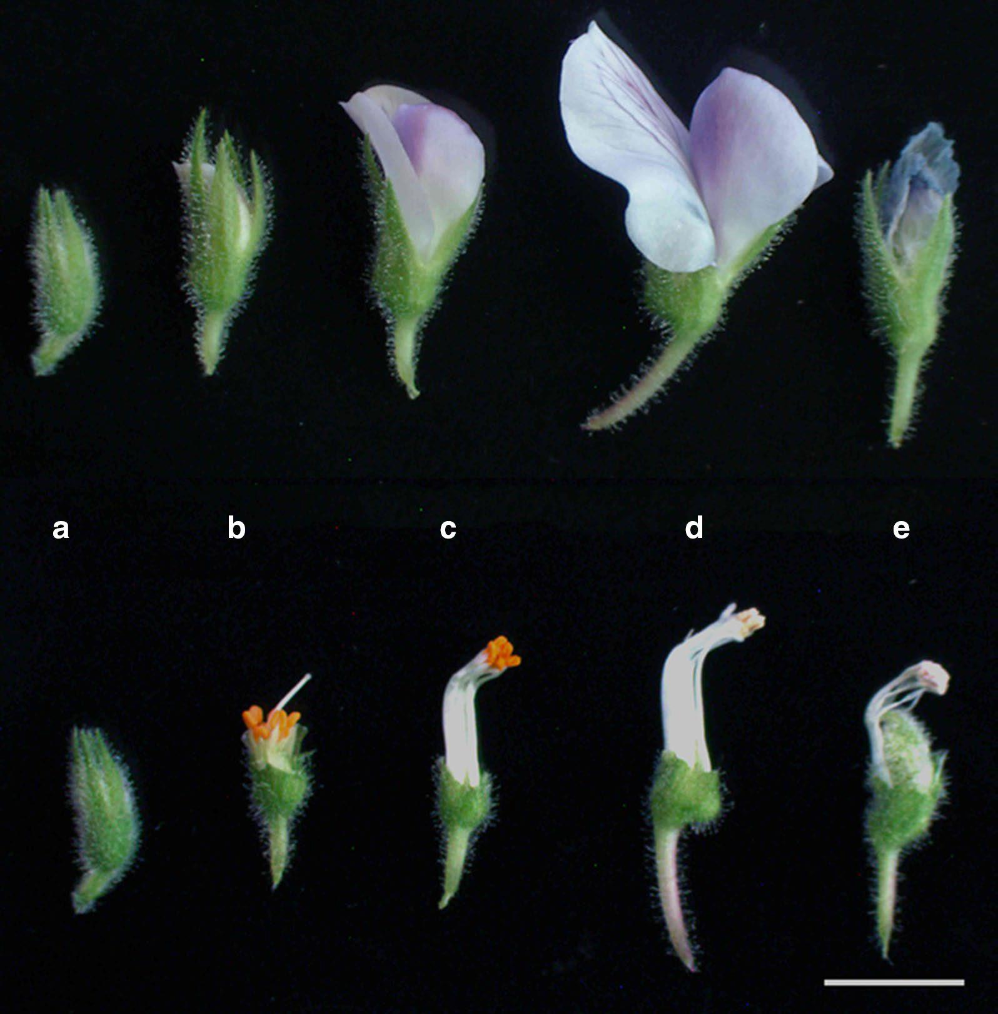

Figure 13 Five main stages of chickpea flower development.   
Petals and sepals are intact in the upper row and detached in the lower row. a) Day 0: closed bud, b) Day 1: hooded bud; when crossing, emasculation is done at this stage, c) Day 3: half opened flower; pollen is collected at this stage, d) Day 4: fully opened flower after self-pollination has occurred, e) Day 6: faded flower where petals are wilted and ovary starts to expand. *Bar* 5 mm. Reproduced from Kalve and Tadege (2017) under [Creative Commons](https://creativecommons.org/licenses/by/4.0/).

Pollen matures and anthers dehisce at the half-open flower stage, resulting in self-pollination. The keel petal remains closed at this stage, preventing the entry of foreign pollen. Mature pollen is yellow in colour and slightly sticky (Kalve and Tadege, 2017). Pollen remains viable for 24 hours, with the anthers shrivelling as the flower becomes fully expanded (Auckland and van der Maesen, 1980). Following pollination, pollen tubes form from the stigma to the ovule, with fertilization occurring 24 hours after pollination (Auckland and van der Maesen, 1980; Fang et al., 2010).

* + - 1. Pollination

Chickpea is predominantly self-pollinating, as pollination occurs 1–2 days before flower buds open (van der Maesen, 1972).

Insects are reported to visit chickpea flowers, but rarely mediate cross-pollination. Honey bees (*Apis* spp.), bumble bees (*Bombus* spp.) and wild bees are attracted to open chickpea flowers (van der Maesen, 1972; Tayyar et al., 1996). There is no evidence that insect pollination increases seed production in chickpea (Klein et al., 2007).

* + - 1. Outcrossing rates

Outcrossing rates in chickpea are very low. When outcrossing is observed in close plantings, rates are in the range of 0–1.9% (Table 4). An open-flower mutation increased the outcrossing rate to 5.9% (Srinivasan and Gaur, 2012). During seed production in India, isolation distances of 5–10 m are recommended to maintain the genetic purity of seeds (Gaur et al., 2010; MoEF&CC, 2016).

Using flower colour as an outcrossing marker, researchers in Iran sowed a row of white-flowered chickpea plants with two rows of purple-flowered plants 60 cm apart on either side (Niknejad and Khosh-Khui, 1972). Across three planting dates, the rate of cross-pollination was 1.58±0.43%. The authors noted that wild bees visited both white- and purple-flowered plants.

Experiments at ICRISAT in India studied natural outcrossing using different phenotypic markers. Plants were sown in rows 30 cm apart, with 10 cm between plants within each row. Observing the inheritance of simple or compound leaf shape, Gowda (1981) estimated an average outcrossing rate of 1.92%. Three lines, each carrying a different recessive marker (white flowers, simple leaves and twin flowers/pods) were sown in a matrix by van Rheenen et al. (1990). The authors noted a large overlap in flowering time between varieties and estimated average outcrossing at 0.08%.

Three different sowing layouts were used by Malhotra and Singh (1986) in an outcrossing experiment in Syria. A kabuli chickpea line with three recessive markers (white flowers, green stems and beige seeds) was sown alongside a desi chickpea line with corresponding dominant traits. Bees were released into the area for pollination and were observed in the chickpea plots. Recording flower, stem and seed colour, researchers did not find any evidence of outcrossing in the three treatments.

In Turkey, a row of pink-flowered desi chickpeas was sown every 10 rows between rows of white-flowered mutant kabuli lines, and as a border at the end of the block. Screening of the resulting F1 plants for flower colour revealed an outcrossing rate of 0% for 38 lines and 1.25% for one line (Toker et al., 2006).

Using leaf shape as a marker, nine simple-leafed lines were sown within a mixture of dominant compound-leafed lines over six different planting dates in the US (Tayyar et al., 1996). The overall outcrossing rate was estimated to be 0.138%. Bumble bees, honey bees and wild bees were observed visiting the chickpea flowers. Statistical analysis did not reveal an influence of genotype, environment or genotype × environment interactions on the rate of outcrossing.

Intra- and interspecific cross-pollination are considered in greater detail in Section 9.1.

Table 4 Outcrossing rates in chickpea

| Study | Outcrossing rate | Plant spacing (interrow x intrarow) |
| --- | --- | --- |
| Niknejad and Khosh-Khui (1972), Iran | 1.07–2.31%; average: 1.58% | 60 cm interrow |
| Gowda (1981), India | 0–4.22%; estimated average: 1.92% | 30 x 10 cm |
| Malhotra and Singh (1986), Syria | 0 | 30 x 10 cm 30 cm interrow 30–480 cm interrow |
| van Rheenen et al. (1990), India | 0–0.20%; estimated average: 0.08% | 30 x 10 cm |
| Tayyar et al. (1996), US | 0–1.43% per plant;  estimated average: 0.14% | 76 x 20 cm |
| Toker et al. (2006), Turkey | 38 lines: 0% 1 line: 1.25% | 45–225 cm interrow |
| Srinivasan and Gaur (2012), India | Open-flower mutant: 5.9% | 60 x 20 cm |

* + 1. Fruit/seed development and seed dispersal
       1. Fruit and seed development

Seed pods appear around 5–6 days after fertilization (Figure 14). The pod wall expands rapidly in the first two weeks after pod initiation (Loss et al., 1998). Seed filling proceeds at a slower pace, over 3–4 weeks, reaching maturity after about 6 weeks. The chickpea pod is inflated and seeds rattle within the pod when mature (Figure 15).

Chickpea seeds have a characteristic beak that covers the embryo (Cubero, 1987). Seeds of kabuli varieties tend to be large (100–750 mg), rounded, with thin cream-coloured seed coats (Figure 1). Desi chickpeas are smaller (80–350 mg), angular, with thicker darker seed coats (Knights and Hobson, 2016).

Chickpea seeds reach physiological maturity when seed moisture content drops to approximately 60% (Ellis et al., 1987). This coincides with desiccation-tolerance, meaning that seeds are able to germinate if they are harvested and rapidly dried at this stage. In the paddock, seeds are considered to have reached physiological maturity when moisture content is below 35%, seed colour begins to lighten and pod walls begin to yellow (GRDC, 2017a).

Chickpea pods contain between one and three seeds (Cubero, 1987). The number of pods and seeds per plant is highly variable. Plants with fewer pods per plant tend also to have fewer seeds per pod, whereas plants with many pods tend to have more seeds per pod. Cubero (1987) gave average ranges of 30–150 pods per plant and 20–240 seeds per plant, but noted that these figures are almost meaningless due to the large influence of the growing environment.

Chickpea biomass and yield are reduced when crops are sown outside the ideal sowing date range for a particular genotype, particularly in unirrigated environments (Saxena, 1987). This is due to sensitive phenological stages, e.g. flowering, occurring under stressful environmental conditions. Recommended planting times in Australia are between April and June, depending on region (Pulse Australia, 2016). Preferred sowing windows range in length from two to four weeks.

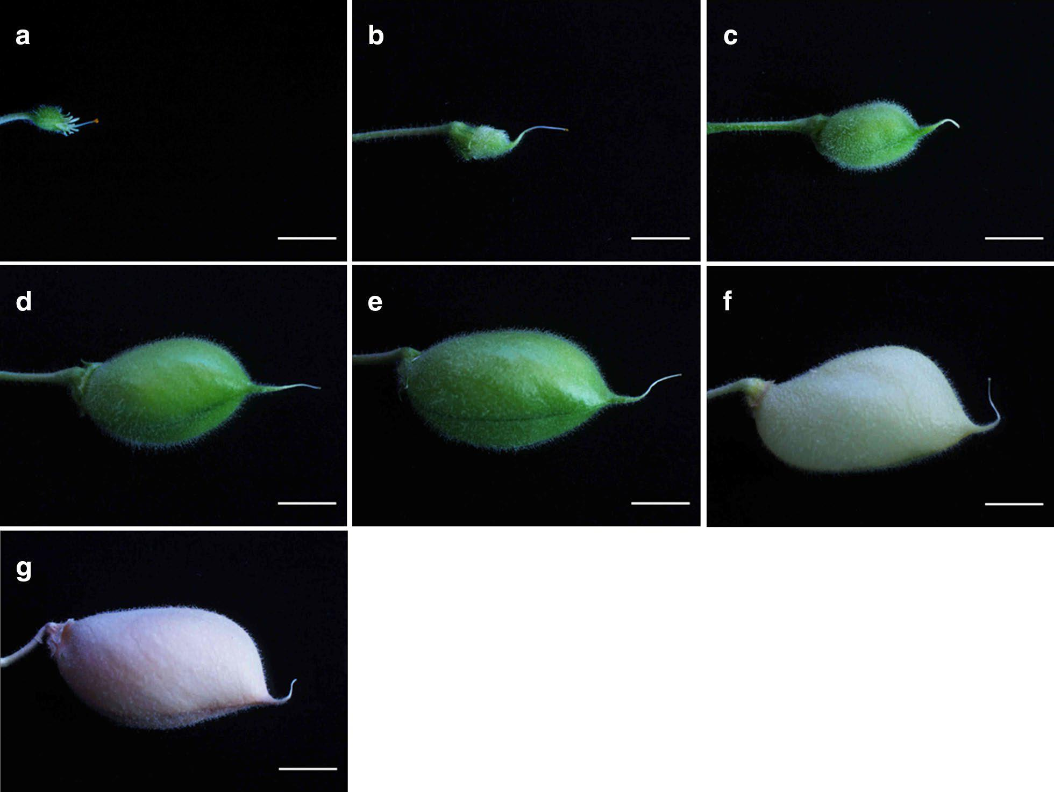

Figure 14 Pod development.   
a) Pollinated flower (petals and sepals removed for cross-pollination). b) Pod initiation 5 days post fertilization. c-f) Various stages of pod development. g) Mature pod. *Bars* 5 mm. Reproduced from Kalve and Tadege (2017) under [Creative Commons](https://creativecommons.org/licenses/by/4.0/).

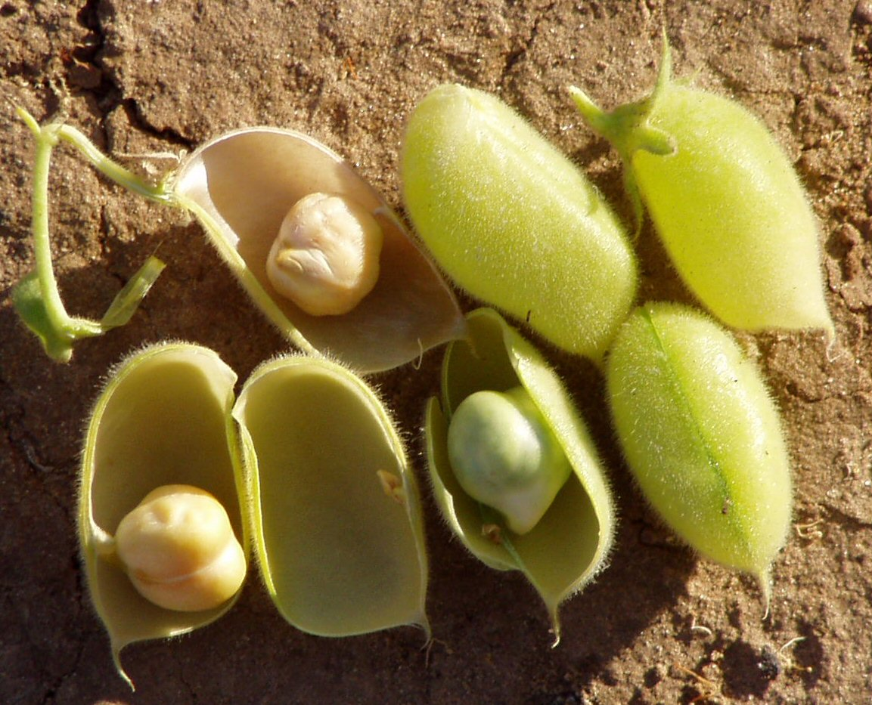

Figure 15 Chickpea pods.   
Photo: Eitan Ferman (via [Wikipedia](https://commons.wikimedia.org/w/index.php?curid=2167657)).

* + - 1. Seed dispersal

During chickpea production a large number of seeds remain in the field after harvest. Although cultivated chickpea varieties have non-dehiscent pods (van der Maesen, 1972), weathering can result in pods dropping, crop lodging, and unthreshed pods passing through the header (GRDC, 2017a). The short stature of chickpea plants can also make harvesting difficult, especially if the crop is grown on uneven ground. Chickpea harvest losses tend to be in the range of 5–30% (Loss et al., 1998; GRDC, 2017a).

Harvest loss due to pod drop and shattering was measured in an experiment with desi chickpeas grown in NSW and harvested early, on time or late (Cassells and Caddick, 2000). Losses ranged from 44–529 kg ha-1, equivalent to 27–309 seeds m-2.

*Humans*

Seeds are deliberately dispersed by people for cropping. Accidental dispersal may occur due to spillage during movement of seed on equipment for planting, at harvest or at post-harvest storage/handling facilities. Seed could be spilled during transport, but may also be dispersed if inadvertently transported on machinery, e.g. on muddy wheels. It is also possible for small quantities of seed to be transported in or on clothing, e.g. in pockets and cuffs, or on boots (especially muddy boots) of workers.

*Wind*

Chickpea trash (leaves, pods and stems) can be dispersed by wind, carrying pathogen spores (GRDC, 2017a); however the large and heavy seeds are not appreciably dispersed by average winds. Mature desiccated plants, whole pods or seeds could be dispersed by very strong winds, particularly if plant structures are weakened by weathering.

*Water*

No data is available on chickpea seed transport rates by water. It is likely that seed could be carried by heavy rains and flooding either shortly after planting or at harvest. Transported seed is likely to germinate because chickpea seed has little or no dormancy. However, chickpea is very sensitive to excess soil moisture through heavy rainfall or waterlogging (GRDC, 2017a). Waterlogged roots are unable to supply plants with nutrients and die due to a lack of oxygen. Wet weather and humid conditions also promote the development of ascochyta blight, phytophthora root rot, and sclerotinia root and stem rot, which can lead to plant death.

*Animals*

Secondary seed dispersal by animals may occur via transportation by ants, dung beetles or food-storing mammals and birds (Vander Wall et al., 2005).

Chickpea predation by pigs can be devastating in newly sown crops (GRDC, 2016b). Chickpea seeds may be dispersed in pig faeces (G. Onus, pers. comm., 2019).

Mice are particularly damaging to chickpea crops when present in plague numbers, digging up and eating chickpea seeds 2–3 days after planting, and eating emerging shoots (Coulston et al., 1993; Poole, 2011). Post-harvest dispersal (scattering) or hoarding of seeds by small mammals, i.e. rodents, is likely with predation of seeds present on the soil surface (Vander Wall et al., 2005).

Native animals may also feed on chickpea or move through crops. Overseas, birds are reported to feed on shallow-sown chickpeas in the field (van der Maesen, 1972); however there is limited information on predation by Australian bird species, such as cockatoos and galahs. These can be present in larger numbers but their ability to disperse viable chickpea seed is unknown. It was noted by G. Onus (pers. comm., 2019) that emus may move chickpea seeds in their beaks, but chickpeas had not been observed in emu droppings.

Chickpea stubble and grain remaining on the ground may be grazed by livestock after harvest (Loss et al., 1998). Whole chickpeas are used in animal production, particularly in ruminant feeds, as rumen fermentation inactivates many of the antinutritional secondary compounds present in the seed (Bampidis and Christodoulou, 2011). Chickpea can also be included in the diets of pigs, poultry and fish; but heat treatment, e.g. extrusion, is recommended to improve digestibility.

The viability of chickpea seed after passing through the digestive tract of different animals is poorly understood. A study on the passage of ten different legume seeds, not including chickpea, through bovine rumen found that ingested soft (germinable) seed was unlikely to be recovered from faeces in a viable state (Gardener et al., 1993). Soft seeds imbibe water in the digestive tract and become vulnerable to the digestive process. Large seeds (like chickpea) are also more prone to damage from chewing during ingestion and rumination than small seeds.

* + 1. Seed dormancy and germination
       1. Dormancy and longevity

Under natural conditions chickpea seeds remain viable from one season to the next (Auckland and van der Maesen, 1980). Under controlled storage conditions chickpeas remain viable for a relatively long period of time. Chickpea seeds with water content reduced to 4–8% have retained over 90% germination after 36 years in storage at 5 °C and -18 °C (Walters et al., 2005).

High moisture conditions, including rainfall after harvest, high temperatures and physical damage reduce seed viability (Loss et al., 1998). At 20 °C and approximately 18% moisture content, the viability of three chickpea seed lots reduced to 50% in 209–246 days (Ellis et al., 1982).

Dormancy is a mechanism by which viable seeds can avoid germinating during unfavourable conditions (Smýkal et al., 2014). Innate dormancy prevents seeds from germinating for a certain period of time after they become mature. Wild species of *Cicer* exhibit varying levels of innate seed dormancy (Singh and Ocampo, 1997); however, there is no evidence for dormancy in chickpea cultivars (MoEF&CC, 2016; K. Moore, pers. comm., 2018).

Physical dormancy through reduced permeability of the seed coat is a common phenomenon amongst legume species (Smýkal et al., 2014). This is often referred to as ‘hardseededness’, as seeds fail to imbibe.

Hardseed dormancy in chickpea appears to be restricted to germination under cool conditions. Poor crop establishment is a concern for farmers who sow chickpeas into cool soil. There is some evidence that warm storage temperatures prior to sowing into cool soil increases hardseededness. Storage of chickpeas at 23 °C and 16–27 °C, with moisture content of 7–8%, resulted in reduced germination and increased hardseededness when seeds were subsequently germinated at 5 °C, compared with seed stored at 5 °C (Frisbee et al., 1988). This physical dormancy was overcome by germinating seeds at 27 °C.

In some parts of Iran farmers practice ‘dormant sowing’ (Soltani et al., 2006). Chickpeas are sown late in autumn, when soil is cold, but not yet frozen. The rate of chickpea germination and development falls so low that seedlings do not emerge when temperatures fall below 4.5 °C. Crops emerge the following spring, around three weeks earlier than spring-sown crops. In the field, low temperatures reduce final emergence percentage due to increased susceptibility to seedling diseases.

* + - 1. Germination

Germination begins when seeds imbibe water (Bewley, 1997; Vessal et al., 2012). Solutes and low molecular weight metabolites leak from the seed into the surrounding solution. Respiration and protein synthesis resume. The radicle emerges and grows on seed reserves until the plant is able to photosynthesise.

Chickpea germination is hypogeal, with the cotyledons remaining inside the seed coat providing energy for the ascending shoot (GRDC, 2016b). Chickpeas can emerge from up to 15 cm deep, allowing crops to be sown into deeper soil moisture.

Under favourable temperature and moisture conditions, seeds germinate around 1–3 days after sowing (Sleimi et al., 2013). In laboratory experiments, greatest final germination percentages occurred at 10–15 °C[6] (Ellis et al., 1986), 15–25 °C (van der Maesen, 1972) or 20–25 °C (Sleimi et al., 2013) depending on cultivars used. In these studies chickpeas were able to germinate over a range of temperatures from 2–45 °C, although final germination percentage was usually reduced at temperature extremes.

Germination rate increases with increasing temperature. In experiments by Ellis et al. (1986) maximum germination rate occurred in the range of 25–35 °C, depending on genotype. Germination rate is reduced under limited water availability (Vessal et al., 2012). Under these conditions, smaller seeds are able to imbibe more water and proceed to germination more readily than larger seeds. This is thought to be due to the larger surface area to volume ratio of smaller seeds.

The length of time required for chickpea plants to emerge can be measured in thermal time. Chickpea emergence from 5 cm sowing depth takes six physiological days, or a thermal time of 94 °C days using a base temperature of 4.5 °C (Soltani et al., 2006). Under Australian field conditions, chickpeas usually emerge 7–30 days after sowing (Loss et al., 1998). Delayed emergence up to eight weeks after sowing has been observed in chickpea crops that were planted deep into marginal soil moisture (G. Onus, pers. comm., 2019).

* + - 1. Persistence in seed banks

Because of the importance of harvest losses (see Section 4.3.2), seed viability under field conditions is an important factor to predict the presence/number of volunteers[7] in subsequent crops.

Seeds lost at harvest can enter the soil seed bank[8] when they are buried by tillage (Gulden and Shirtliffe, 2009). Most seeds present in the seed bank will die, decompose or be eaten by predators (beetles, rodents and birds) before germination. Seed predation is greatest when seeds are buried at shallow depths. Attacks by pathogens such as bacteria and fungi are most frequent when seeds are buried deeper. Other mechanisms involved in seed mortality in the seed bank are lethal germination (when seedlings exhaust their reserves before reaching the soil surface) and desiccation. Dry seeds can remain viable for very long periods of time but desiccation tolerance is lost when seeds are subjected to frequent wetting/drying conditions prior to germination (Gulden and Shirtliffe, 2009).

Delayed germination is usually due to poor seed-soil contact and insufficient soil moisture around the seed (G. Onus, pers. comm., 2019). Most chickpea seeds left in the field through harvest losses germinate in the first 2–3 suitable rainfall events after harvest. In no-till situations seeds can lay at the soil surface for extended periods, germinating 12–18 months after harvest when conditions become suitable (G. Onus, pers. comm., 2019). Buried chickpea seeds can survive for several years if soil remains dry (K. Moore, pers. comm., 2018). In paddocks that have not received sufficient moisture for germination, i.e. during drought conditions, chickpeas can remain in the seed bank and germinate 2–3 years after the previous crop.

Dormancy can affect the persistence of seeds in soil, but as discussed in Section 4.4.1, chickpea has no or very little long-term seed dormancy which limits its persistence in seed banks.

* 1. Biochemistry

Chickpea plants are primarily grown to produce seeds for human consumption (Figure 16). The nutritional composition of chickpea seeds is summarised by Wood and Grusak (2007). In some regions green leaves, immature green pods and seeds, and sprouted seeds are also eaten (Yadav et al., 2007). Livestock graze on green crops, stubble and grain.

Chickpeas are considered a healthy food and contain many beneficial phytochemicals. The seeds also contain some antinutritional factors, which are usually reduced by cooking or other processing.

* + 1. Toxins

The chickpea plant does not produce acute toxins and its components are not considered to be toxic; however different parts of the plant produce irritants and antinutritional factors. Mycotoxins may accumulate during seed storage under high temperature and humidity if mycotoxigenic fungi are present.

Chickpea plants secrete acids from leaves, stems and pods, which protect the plant from insect predation. It is generally held that malic acid comprises over 90% of the exudate (van der Maesen, 1972; Khanna-Chopra and Sinha, 1987; GRDC, 2017a); however there appears to be considerable genotypic variation in the proportion of secreted acids. For example, in a collection of nine genotypes Narayanamma et al. (2013) found that the predominant component was either malic acid, oxalic acid or acetic acid, with fumaric acid and citric acid present at lower concentrations. Lazzaro and Thomson (1995) found that hydrochloric acid secreted by chickpea trichomes lowers the pH of secretions to <1. These acids are irritants, affecting the skin, eyes and respiratory tract of humans ([NCBI PubChem Compound database](https://www.ncbi.nlm.nih.gov/pccompound), accessed 22 January 2019).

Organic acids are also secreted from chickpea roots into the rhizosphere. Studying two desi genotypes, Wouterlood et al. (2004) found that malonate was present at the highest concentration, followed by citrate and malate. Malonate and citrate mobilise phosphorus into the soil solution, making the nutrient available to the plant. Malonate does not accumulate in the soil, as it is degraded by microbes (Wouterlood et al., 2006).

* + - 1. Antinutritional factors

Antinutritional factors affect the palatability, digestibility and nutritional quality of chickpea when consumed by monogastric animals. Many of these factors are reduced by processing, e.g. dehulling, soaking, germination, fermentation, cooking or extrusion (Muzquiz and Wood, 2007; Bampidis and Christodoulou, 2011).

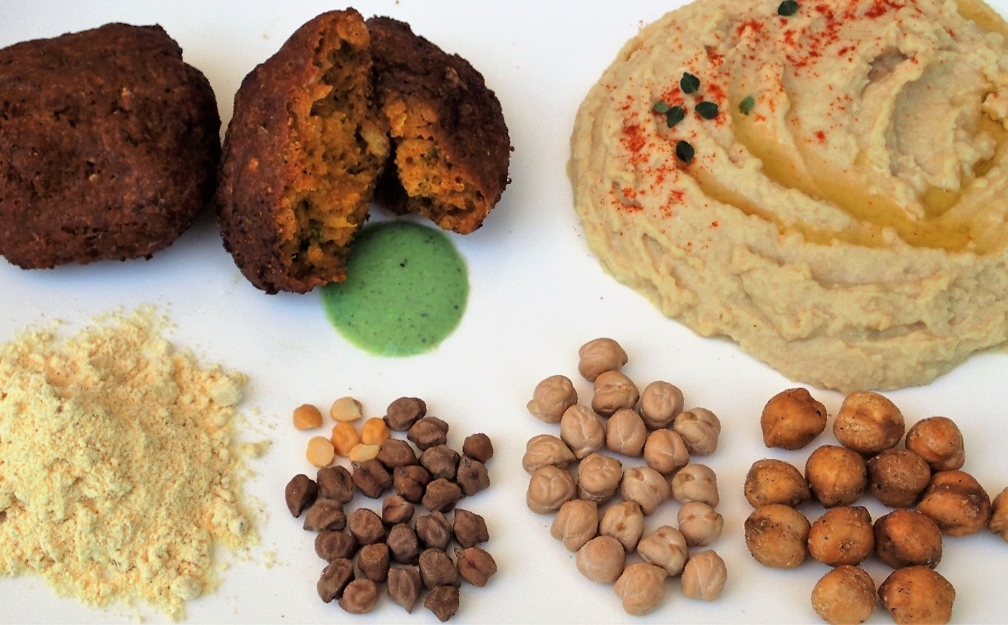

Figure 16 Examples of chickpea food products.   
Clockwise from bottom left: besan (desi chickpea flour), pakoras made with besan, hummus made with kabuli chickpeas, roasted kabuli chickpeas, kabuli chickpeas, desi chickpeas.  
Photo: Kathy Schneebeli.

Chickpea and other grain legumes contain several proteinaceous antinutritional factors (Muzquiz and Wood, 2007). Protease inhibitors bind and inhibit the digestive enzymes trypsin and chymotrypsin. Alpha-amylase inhibitors interfere with carbohydrate metabolism. Heating reduces trypsin and α‑amylase inhibitor activity (Williams and Singh, 1987).

Phytohaemagglutinins are lectins that can interfere with digestion by binding to cells in the gut wall (Muzquiz and Wood, 2007). Phytohaemagglutinins are found at low levels in chickpea; their activity is completely destroyed by cooking (Williams and Singh, 1987; Alajaji and El-Adawy, 2006).

Phytic acid binds essential minerals, reducing bioavailability (Muzquiz and Wood, 2007). Proteins, including digestive enzymes, may also be bound by phytic acid, reducing their activity. Phytic acid is reduced by cooking (Alajaji and El-Adawy, 2006).

Levels of the oligosaccharides stachyose, raffinose and verbascose are reduced by germination or by cooking when cooking water is discarded (Williams and Singh, 1987; Alajaji and El-Adawy, 2006). As flatulence factors these α-galactosides are undesirable; however they are beneficial to human health in their role as a source of dietary fibre and a prebiotic food source for bifidobacteria (Muzquiz and Wood, 2007).

Chickpeas and other legumes contain saponins, which can bind mucosal cells and interfere with nutrient uptake, as well as reduce palatability (Muzquiz and Wood, 2007; Jukanti et al., 2012). Saponins may have health benefits, including reduction of plasma cholesterol levels. Saponin concentration is reduced by cooking (Alajaji and El-Adawy, 2006).

Chickpeas contain low levels of tannins, compared with other legumes, and these are further reduced by cooking or removal of the seed coat in the preparation of dhal (Alajaji and El-Adawy, 2006; Muzquiz and Wood, 2007).

Cyanogenic glycosides are present only at trace levels (Williams and Singh, 1987; Jukanti et al., 2012).

* + - 1. Mycotoxins

Mycotoxins are metabolites produced by certain fungi when grain is stored under inappropriate conditions. High relative humidity, dew and temperatures over 25 °C promote the growth of storage fungi and the production of mycotoxins (Ramirez et al., 2018). The most common mycotoxins associated with stored chickpeas are aflatoxins (produced by *Aspergillus* spp.) and ochratoxin A (produced by *Aspergillus* and *Penicillium* spp.).

Altering seed biochemistry, e.g. through breeding, can change a cultivar’s susceptibility to fungal infection and mycotoxin production (Cleveland et al., 2003).

* + 1. Allergens

Allergic reactions to chickpea have been reported in several countries, including India and Spain (Patil et al., 2001; Martínez San Ireneo et al., 2008). It is thought that the higher prevalence of chickpea allergy in these countries may be linked to the relatively high dietary consumption of this legume.

Currently, no chickpea allergens are registered in the WHO/IUIS[9] Allergen Nomenclature database ([WHO/IUIS Allergen Nomenclature Sub-Committee](http://www.allergen.org/index.php), accessed 17 October 2018); however putative allergens have been identified. The globulin proteins 7S vicilin and 11S legumin are related to allergens in other leguminous species, including lentil and pea (Bar-El Dadon et al., 2014), and are members of the only seed storage protein classes able to resist gastrointestinal digestion (Ribeiro et al., 2017).

It has been noted that, in some regions, people with chickpea allergy are often also allergic to other legumes, and sometimes also to tree nuts (Barnett et al., 1987; Patil et al., 2001; Martínez San Ireneo et al., 2008; Bar-El Dadon et al., 2013). It is thought this is due to antibodies that recognise allergenic proteins of one species cross-reacting with similar proteins from other species.

* + 1. Beneficial phytochemicals

The health benefits of eating chickpeas have been recognised since Roman times. Chickpea is a good source of protein, dietary fibre, vitamins and minerals, along with non-nutritive beneficial compounds.

Chickpea is a source of high quality protein, particularly valuable to those that consume little meat. All essential dietary amino acids are obtained when chickpeas are eaten in combination with cereals, as chickpeas are only limited in methionine and cysteine (Wood and Grusak, 2007).

Compared with other pulses, chickpeas contain relatively high quantities of lipids, ranging from 2.9–8.8% (Wood and Grusak, 2007). However, chickpea lipid concentration is much lower than that of peanut and soybean, which are considered oilseeds. Polyunsaturated linoleic acid is the predominant fatty acid, followed by monounsaturated oleic acid. Linoleic acid is an essential fatty acid, which reduces serum cholesterol levels and is beneficial for heart health. Consumption of the major phytosterol in chickpeas, β-sitosterol, is linked to reduction in colon cancer and other health benefits (Jukanti et al., 2012).

The starch content of chickpeas is 30–57%. Starch is broken down to glucose through the action of α‑amylase and other digestive enzymes (Wood and Grusak, 2007). Resistant starch, oligosaccharides and other non-starch polysaccharides are dietary fibres that travel undigested through to the large intestine, where they are fermented by bacteria. Along with gases that result in flatulence, this produces short-chain fatty acids that are beneficial in the prevention of colorectal cancer (Jukanti et al., 2012).

The glycaemic index (GI) of chickpeas is low (Wood and Grusak, 2007). Low GI foods are beneficial in the management of diabetes.

Chickpeas are a good source of folic acid, thiamine (vitamin B1), pyridoxine (vitamin B6), phosphorus, iron, magnesium, and other vitamins and minerals (Wood and Grusak, 2007).

Chickpeas contain the isoflavones biochanin A and formononetin, which are metabolized to genistein and diadzein, respectively, and act as phytoestrogens (Wood and Grusak, 2007). A range of health benefits is attributed to these isoflavonoids, including prevention of hormone-related cancers, cardiovascular disease, osteoporosis and menopausal symptoms.

* + - 1. Use in traditional medicines

Chickpeas have been used to treat a vast range of health conditions for millennia. Chickpea is used in Uyghur traditional medicine to treat hypertension and diabetes, and in Ayurvedic medicine to treat disorders of the blood, skin and other organs (Jukanti et al., 2012). The Roman author, Pliny (AD 23–79), noted that preparations of chickpea seeds or leaves were beneficial in the treatment of menstrual and urinary disorders, warts and jaundice; and to soothe gout pains (Pliny, 1969). In traditional Persian medicine, chickpea is prescribed for cancer and other diseases, and is thought to increase libido and breastmilk production (Javan et al., 2017). In India, the acidic secretions of chickpea leaves were used in traditional preparations to treat indigestion and constipation (van der Maesen, 1972).

* 1. Abiotic Interactions
     1. Soil properties

Chickpea production is best suited to well-drained neutral to alkaline soils, from loams to self-mulching clays (GRDC, 2017a). Chickpea does not grow well in acid soils, sands, tight hard-setting clays, and soils that are saline, sodic or high in boron.

* + - 1. Nutrient requirements

Adequate nutrition is required for chickpea crops to achieve optimum yields. Every tonne of harvested desi chickpeas removes 33 kg nitrogen, 9 kg potassium, 3.2 kg phosphorus, 2 kg sulfur, 1.6 kg calcium, 1.4 kg magnesium, 34 g zinc, 34 g manganese and 7 g copper from the paddock (Mayfield et al., 2008). Trace concentrations of molybdenum and cobalt are also required to promote good rhizobial nodulation of roots (GRDC, 2017a). Boron is an essential micronutrient for chickpea growth; however, some alkaline soils in southern Australia contain boron at concentrations that are toxic to chickpea. Transient iron deficiency is often associated with waterlogging. Acid soils are unsuitable for chickpea production due to aluminium toxicity.

The chickpea plant is able to access atmospheric nitrogen via symbiotic nitrogen fixation; however, growers often apply additional nitrogen at planting (GRDC, 2017a). Chickpea also has enhanced access to soil phosphorus and zinc as a result of the acidic secretions released from roots and symbiotic colonisation of roots by arbuscular mycorrhizal fungi (Pulse Australia, 2016).

* + - 1. Salinity

Chickpea is more sensitive to salinity than other crops, such as wheat and canola (Flowers et al., 2010). In moderately saline soil (ECSE > 2.9 dS/m) chickpea growth is reduced as plants are unable to extract all available water from the soil due to salt toxicity (Sheldon et al., 2017).

Although nitrogen-fixing bacteria are relatively tolerant of salinity, the number and size of nodules formed under saline conditions is reduced (Flowers et al., 2010).

* + 1. Temperature requirements and tolerances

Chickpea cultivars vary in sensitivity to temperature and day length (photoperiod) for flower initiation, allowing the species to be adapted to a range of growing environments (Berger et al., 2011). In photoperiod sensitive cultivars, photoperiod sensitivity extends from the latter part of the vegetative growth phase, through flower bud initiation and into the full flower development phase (Daba et al., 2016).

The loss of vernalisation sensitivity is thought to be one of the key steps in chickpea domestication (Abbo et al., 2003a).

Optimal temperatures for growth and development in four kabuli cultivars were identified to develop a chickpea crop simulation model (Soltani and Sinclair, 2011). Cardinal temperatures[10] were calculated for different stages of plant development (Table 5). The rate of development drops to zero at temperatures below the base temperature (Tb) and above the ceiling temperature (Tc). The rate of development increases as temperatures approach optimum temperatures (To1, To2), and remains at a constant maximum level between To1 and To2.

Table 5 Cardinal temperatures for chickpea  
Source: Soltani et al. (2006) and Soltani and Sinclair (2011).

| Growth phase | Temperature (°C) | | | |
| --- | --- | --- | --- | --- |
| Tb | To1 | To2 | Tc |
| Sowing-emergence | 4.5 | 20 | 29 | 40 |
| Node production | 0 | 22a | | 31 |
| Other | 0 | 21 | 32 | 40 |

Tb, base temperature; To1, lower optimum; To2, upper optimum; Tc, ceiling temperature;   
a single optimum temperature

* + - 1. Cold and frost

Chickpea is tolerant of cool conditions during the vegetative growth phase. Desi varieties are able to germinate at soil temperatures of 5–7 °C, while kabuli varieties require warmer soil (12 °C) for effective germination (Pulse Australia, 2016).

Frosts occur when air temperature drops below 2 °C (GRDC, 2017a). Chickpea plants are tolerant of frost at the seedling stage and during late podding, as plants are able to recover from frost damage to leaves and stems.

A major constraint to chickpea production is cool temperatures at flowering. Flower abortion occurs when mean minimum temperatures fall below 15 °C (Toker et al., 2007; GRDC, 2017a). Pollen viability is reduced when plants are exposed to low temperature stress (3 °C) during two temperature-sensitive stages of pollen development at 9 and 4–6 days before anthesis (Clarke and Siddique, 2004). In genotypes that do not have chilling tolerance, low temperatures can also reduce fertilization by inhibiting the growth of pollen tubes in the style.

* + - 1. Heat stress

Chickpea is sensitive to heat stress during flowering and podding.

Extended periods of high temperature (day/night temperatures of 35/22 °C or higher) during flowering leads to an increased rate of plant development, along with reduced biomass and yield (Kaushal et al., 2013). The effect is more pronounced in heat sensitive lines. Heat stress impairs sucrose metabolism and transport to developing pollen grains, resulting in reduced pollen viability and germination. Pollen load on the stigma and stigma receptivity is also reduced.

High temperature stress (35/16 °C) during podding reduces biomass, number of seeds per plant and weight per seed (Wang et al., 2006).

* + 1. Water stress

It is recommended that chickpeas are grown in regions with rainfall greater than 350 mm or 450 mm, for desi and kabuli varieties, respectively (Pulse Australia, 2016). Water stress increases chickpea susceptibility to insect and pathogen attack (GRDC, 2017a).

* + - 1. Drought

The greatest impact of drought on yield occurs when moisture stress is experienced during flowering and podding (Khanna-Chopra and Sinha, 1987). Drought stress can occur intermittently through the growing season; however dryland chickpea crops most often experience terminal drought through depletion of stored soil moisture (Toker et al., 2007). Terminal drought reduces the production of flowers, pods and seeds per pod, especially on secondary branches; while flower, pod and seed abortion increases (Leport et al., 2006; Pang et al., 2017). The duration and rate of seed filling is reduced under terminal drought, leading to an overall decrease in seed weight and yield (Davies et al., 1999).

* + - 1. Waterlogging

Chickpeas are prone to waterlogging, especially during flowering and podding (Cowie et al., 1996). In irrigated crops, the application of water needs to be managed well to avoid waterlogging, e.g. irrigation and drainage should be completed within eight hours, and irrigation should be avoided during flowering and podding (GRDC, 2017a).

Waterlogging can lead to nutrient deficiency, such as potassium and iron deficiency, by interfering with absorption and translocation (GRDC, 2017a). Nitrogen fixation by rhizobia is also very sensitive to waterlogging.

Plant mortality following waterlogging increases with increasing stage of development. Symptoms of waterlogging appear within two days of flooding (GRDC, 2017a). Roots die as a result of anoxia; photosynthesis decreases and leaf chlorosis appears four days after flooding. Plants begin to shed leaves after six days.

* + 1. Other abiotic stresses
       1. Herbicide damage

Chickpea crops are susceptible to damage from unintended exposure to herbicides, either present as residues in soil at planting and emergence, or via spray drift (GRDC, 2017a). Herbicide residues in soil become a problem during dry seasons, when inadequate moisture inhibits microbial breakdown of residual herbicides. Extreme temperatures and high pH can also reduce herbicide break down. Spray drift damage occurs when nearby paddocks are sprayed with herbicide when it is very windy or still, particularly when an inversion layer is present.

* + - 1. Low light

Low light intensities, as experienced during cloudy weather, has been shown to affect chickpea yield by reducing the number of pods per plant, number of seeds per pod and average seed weight (van der Maesen, 1972). The greatest impact of shading on yield occurs at the start of flowering, peaking at approximately 20 days after flowering (Lake and Sadras, 2014; Sadras and Dreccer, 2015).

The effect of low light on yield is exacerbated under well-watered conditions, which promotes vegetative growth (Verghis et al., 1999). The limited supply of photosynthetic assimilates is diverted from seed development to vegetative growth, resulting in a higher rate of aborted pods and seeds.

* 1. Biotic Interactions
     1. Weeds

Chickpea is a poor competitor with weeds, when compared with crops such as wheat, barley, oilseed rape, faba beans and field peas (Whish et al., 2002). Chickpea yield losses of over 80% are recorded in fields with uncontrolled weeds (Frenda et al., 2013; GRDC, 2017a). The critical period for controlling weeds in chickpea is during the seedling stage and into flowering, as chickpea plants are slow to emerge and grow. Uncontrolled weed growth during this period leads to a greater than 10% reduction in yield. Overseas studies have shown that the critical weed-free period is around 17–60 days after emergence, depending on the environment (Mohammadi et al., 2005; GRDC, 2017a).

Broad-leafed weeds are particularly problematic in chickpea crops, as they cannot be easily controlled with herbicides (GRDC, 2017a). Grass weeds can often be controlled with selective herbicides. Important weeds in eastern Australian chickpea crops include common sowthistle (*Sonchus* *oleraceus*), wild oats (*Avena* spp.) and turnip weed (*Rapistrum rugosum*) (Osten et al., 2007).

Canopy closure is generally associated with reduced weed competition. Increased plant density is a suggested method in the integrated weed management toolbox; however it is also noted that the open structure of the chickpea canopy reduces its ability to compete with weeds (GRDC, 2017a). No difference in weed competition was found in experiments with chickpeas grown on narrow or wide rows (Whish et al., 2002).

Pre-emergence herbicides are the most common method of weed control for chickpeas in eastern Australia, followed by post-emergent herbicides (Osten et al., 2007). Inter-row cultivation and higher seeding rates are used less frequently. Sheep grazing may also be used to control some weeds, e.g. volunteer peas, in chickpea crops, as chickpeas are less palatable than peas (GRDC, 2017a).

* + 1. Pests and diseases
       1. Pests

*Insects*

The major insect pest in Australian chickpea is the native budworm, *Helicoverpa punctigera*, which reduces grain yield and quality when present during podding and grain-filling (GRDC, 2017a). Other insect pests are less attracted to chickpea, compared with other pulse crops, due to the chickpea plant’s acidic secretions. Red-legged earth mite, lucerne flea, cutworms and aphids can cause damage during the emergence and seedling stages.

Aphid control is important as they are the main vectors of viruses (see Section 7.2.2). The likelihood of aphid infestation is reduced by ensuring optimum plant density to reduce gaps in plant stands, as some species of aphid are attracted to plants next to bare soil (GRDC, 2017a; NSW DPI, 2018).

Insecticides are used to control insect pests in crops when numbers exceed an economic threshold (GRDC, 2017a).

Storage pests, such as cowpea bruchids, are controlled with good hygiene, fumigation or controlled atmosphere treatment (GRDC, 2017a).

*Nematodes*

The major nematode pests in Australian chickpeas are root lesions nematodes (*Pratylenchus* spp.). The predominant species are *P. thornei* in the northern region of eastern Australia; *P. thornei* and *P. neglectus* in the southern region of eastern Australia; and *P. neglectus*, *P. quasitereoides*, *P. thornei* and *P. penetrans* in WA (GRDC, 2016b, 2017a, b).

Chickpea is also susceptible to root-knot nematodes (*Meloidogyne* spp.), cyst-forming nematodes (*Heterodera* spp.) and reniform nematodes (*Rotylenchulus reniformis*) (Castillo et al., 2008).

There are varietal differences in resistance to *P. thornei* and *P. neglectus*, but none are completely resistant. Some varieties are tolerant to these nematodes, i.e. able to yield well when nematodes are present (NSW DPI, 2018). Nematode management includes farm hygiene, crop rotation and long fallows; no nematicides are registered for use in Australia (GRDC, 2017a).

*Vertebrates*

In Australia, pigs, kangaroos, emus, brush-turkeys (in central Qld) and mice are the major vertebrate pests in chickpea crops (K. Moore, pers. comm., 2018). Feral pigs and mice damage crops by digging up and eating germinating seeds and shoots (Coulston et al., 1993; Poole, 2011; GRDC, 2016b). Kangaroos often graze young chickpea crops, particularly when other food sources are unavailable during droughts (G. Onus, pers. comm., 2019). Shallow-sown seed can also be predated by birds (van der Maesen, 1972).

* + - 1. Diseases

*Fungi and oomycetes*

Chickpea is susceptible to several fungal diseases. The major disease of chickpea in Australia and world-wide is ascochyta blight (*Ascochyta rabiei*) (GRDC, 2016b, 2017a, b). Other important fungal diseases are botrytis grey mould (*Botrytis cinerea*), and sclerotinia stem and crown rot (*Sclerotinia* spp.). Phytophthora root rot is caused by a fungus-like oomycete (*Phytophthora medicaginis*). Root rot diseases caused by *Fusarium*, *Rhizoctonia* and *Pythium* spp. occur occasionally under wet conditions.

Ascochyta blight develops rapidly when plants are wet for several hours (Pande et al., 2005). The pathogen infects the aerial parts of plants, growing through leaves, stems, flowers and pods (Figure 17). Plant tissues are disintegrated by toxins and cell-wall degrading enzymes. The disease is spread to neighbouring plants via air-borne and water-borne (splashing onto nearby plants) transmission of spores. When chickpea debris remains on the soil surface, *A. rabiei* can survive in infected material for many months. Varying levels of genetic resistance to ascochyta blight is available in chickpea germplasm for breeding into commercial varieties (Pande et al., 2005). The pathogen continues to evolve to overcome varietal resistance, such that ascochyta blight resistance ratings need to be revised over time (NSW DPI, 2018). The disease can also be managed with fungicides; however, registered fungicides are protectants only, i.e. they cannot eradicate an established infection (GRDC, 2013a).

NSW DPI (2018) recommendations for management of ascochyta blight are:

* Do not grow chickpea crops in paddocks that grew chickpea in the previous three years. A four-year break is recommended by Hawthorne et al. (2012).
* Avoid paddocks with a history of lucerne, medics, phytophthora root rot, sclerotinia or waterlogging.
* Select paddocks that are at least 500 m distant from a previous year’s chickpea crop.
* Grow varieties with improved resistance.
* Remove volunteers.
* Treat all sowing seed with a registered fungicide.
* Apply fungicide before the first post-emergent rain event, even for varieties with improved resistance. All varieties should also be sprayed prior to rainfall events during podding (Ford et al., 2018).
* Plant on wider row spacing (≥66 cm) to improve airflow and canopy drying after rain or dew, and to improve fungicide penetration into the canopy later in the season.

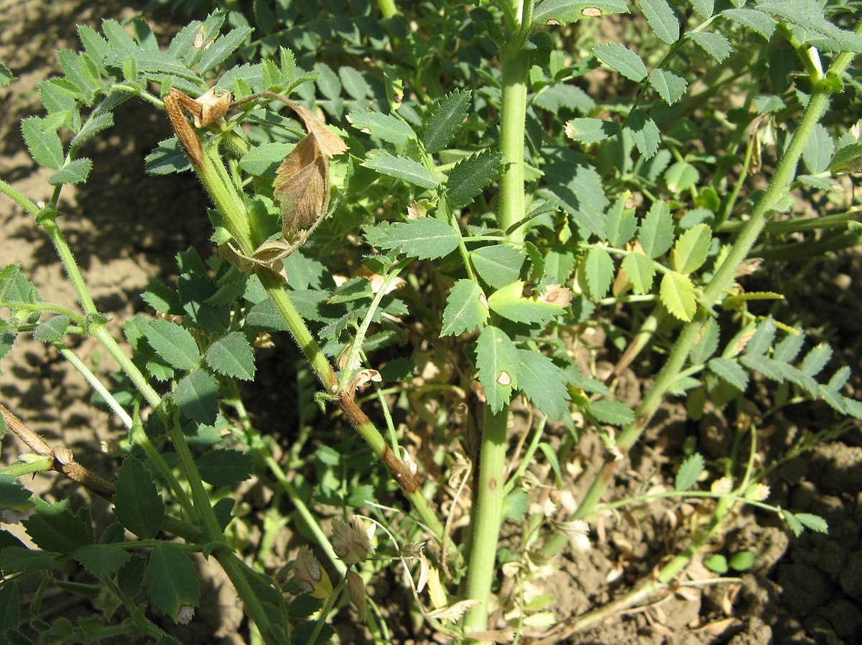

Figure 17 Chickpea plant with lesions on leaves and stems caused by ascochyta blight disease.   
Photo: Weidong Chen (via [Wikipedia](https://commons.wikimedia.org/wiki/File:Didymella_rabiei_(Chickpea_ascochyta_blight_fungus).jpg#file)).

Botrytis grey mould develops in closed, wet canopies when temperatures are above 15 °C (Ryley et al., 2015). Lesions develop on the plant stem, with a grey mycelial ‘fuzz’ appearing under humid conditions. Seedling death can occur when chickpeas are sown into infected residues. *Botrytis cinerea* has a broad host range, including weeds. The primary disease management strategy is to avoid sowing into paddocks with high inoculum load, through weed and stubble management, and appropriate crop rotation. Application of foliar fungicides for disease control is usually not required outside central Qld.

Sclerotinia stem and crown rot is caused by three species: *Sclerotinia sclerotiorum*, *S. minor* and *S. trifoliorum* (GRDC, 2016b). The resting structures of sclerotinia, sclerotia, usually germinate directly and invade plants through the roots or at the base of the plant (NSW DPI, 2018). Under moist conditions apothecia may form on the soil surface; these release air-borne spores that infect aerial tissues. *Sclerotinia* spp. have a wide host range, although not including cotton or cereals, and their sclerotia are able to survive in soil for over 10 years (GRDC, 2016b). Crop rotation and using disease-free seed are recommended management options to reduce the risk of sclerotinia development.

Phytophthora root rot is a production constraint in northern NSW and Qld (GRDC, 2016b). The disease develops when infested soil is saturated with water, allowing oospores to germinate and produce zoospores that encyst on plant roots. These produce hyphae that invade and destroy plant roots. Symptoms of phytophthora root rot can be confused with waterlogging. Other hosts of *P. medicaginis* include lucerne, medics and leguminous weeds. Oospores can survive in soil for over 10 years. Disease management includes avoiding high risk paddocks, i.e. those with recent phytophthora infections and prone to waterlogging, and selecting varieties with increased resistance (NSW DPI, 2018).

*Viruses*

The most important viral diseases of chickpea are those spread by aphids (Schwinghamer et al., 2009; NSW DPI, 2018). Luteoviruses are transmitted persistently by aphids, and include *Beet western yellows virus*, *Bean leafroll virus* and *Subterranean clover redleaf virus*. Non-persistently transmitted viruses include *Cucumber mosaic virus* and *Alfalfa mosaic virus*. Thrips and leafhoppers also transmit viruses. Virus control measures focus on reducing aphid infestation and removing sources of infection, e.g. weeds.

* + 1. Symbionts
       1. Rhizobia

Chickpea plants form symbioses with rhizobia, bacteria that infect root hairs to form nitrogen-fixing nodules (Kantar et al., 2007). The atmospheric nitrogen fixed by rhizobia becomes available to the growing plant and also to subsequent crops. Rhizobia use photosynthetic carbon assimilated by the host plant.

Rhizobial symbionts of chickpea belong to the genus *Mesorhizobium* (Kantar et al., 2007). In Australia, commercial inoculants for chickpea contain *M. ciceri*, which is specific to chickpea (GRDC, 2013b). *Mesorhizobium ciceri* does not naturally occur in Australia.

Soil properties, environmental conditions and the presence of compatible hosts influence the proliferation and persistence of rhizobia in a paddock (Kantar et al., 2007). Inoculation is recommended every time a leguminous crop is sown, as rhizobial populations can decline in soil over time and rhizobial communities can become less effective at fixing nitrogen, compared with commercial strains (GRDC, 2013b).

The effect of chickpea residues on the yield of a subsequent wheat crop was shown to be comparable to that of field pea and albus lupin, but less effective than residues of narrow leaf lupin (Armstrong et al., 1996).

* + - 1. Arbuscular mycorrhizal fungi

Chickpea is considered highly dependent on root colonisation with arbuscular mycorrhizal fungi (AMF), which facilitate the extraction of phosphorus and zinc from the soil (Pulse Australia, 2016). In central Qld, low mycorrhizal colonisation (18±7% of root length) of chickpea resulted in poor crop growth after a long fallow, compared with healthy crop growth with high mycorrhizal colonisation (73±6%) after a short fallow (Thompson, 1987).

* 1. Weediness
     1. Weediness status on a global scale

An important indicator of potential weediness of a particular plant is its history of weediness in any part of the world and its taxonomic relationship to declared weeds (Panetta, 1993; Pheloung, 2001).

During the early stages of growth, chickpea is a poor competitor with weeds (Loss et al., 1998). Chickpea requires human intervention to colonise environments and is only found in cultivated areas (van der Maesen, 1984). Other species of *Cicer* are able to colonise disturbed habitats and natural areas; however these are not present in Australia.

Globally, the weed risk rating of chickpea is considered to be low (Randall, 2017). No species of *Cicer* are listed as weeds in the US ([USDA NRCS noxious weed lists](https://plants.usda.gov/java/noxiousDriver), accessed 25 October 2018).

* + 1. Weediness status in Australia

Chickpea has been reported as naturalised in natural and agricultural ecosystems in Australia, but is not considered an important enough problem weed to warrant control at any location (Groves et al., 2003).

In 2000/2001 a rating system was applied to weeds of natural and agricultural ecosystems in Australia (Groves et al., 2003). The weeds or naturalised non-native flora of Australia, were categorised on a scale from 0 (indicated naturalised but the population no longer exists or removed) to 5 (indicating naturalised and a major problem at four or more locations within a State or Territory). Chickpea was classified as a category 1 weed of agricultural ecosystems and as a category 1 weed of natural ecosystems in Australia (Groves et al., 2003).

The [Weed Risk Assessment system](http://www.agriculture.gov.au/biosecurity/risk-analysis/weeds/system/weed_risk_assessment) used by the Australian Government Department of Agriculture, and Water Resources is based on the questions listed by Pheloung (2001) to determine the weediness potential of plants. Chickpea scores are low for most questions, with a few exceptions:

* Broad climate suitability. Although there is relatively little genetic diversity within chickpea, the species is cultivated across a broad range of climate types, including arid zones (Sani et al., 2018).
* Unpalatable to grazing animals. The acidic exudates of chickpea plants make them unpalatable, such that grazing animals can be used to control more palatable weeds in chickpea crops (Loss et al., 1998).
* Grows on infertile soil. Chickpea has an increased ability to mobilise and extract phosphorus from the soil through the production of acidic root exudates (Wouterlood et al., 2004) and symbiotic associations with AMF (GRDC, 2017a). Chickpea is able to fix atmospheric nitrogen through symbiosis with *Rhizobium* bacteria; however, these are generally not present or persistent in Australian soils (GRDC, 2017a).

The Australian Government Department of the Environment and Energy does not include any species of *Cicer* in its National weeds lists ([DoEE website](http://www.environment.gov.au/biodiversity/invasive/weeds/weeds/lists/index.html), accessed 26 October 2018).

Related species of *Cicer* are not known to occur in Australia ([Atlas of Living Australia occurrence record download](https://doi.org/10.26197/5bd23eb48890d) on 26 October 2018). A small number of chickpea specimens have been collected outside cultivation in Australia. Atlas of Living Australia occurrence records include a specimen collected from cleared cattle-grazing land in Qld (1989); a specimen collected from a roadside in SA (1989); a chickpea plant growing spontaneously in a vegetable garden in Vic., possibly introduced via turkey manure (1993); and a specimen collected from river flats in WA (2013).

* + 1. Weediness in agricultural ecosystems

Chickpea is unlikely to become a weed under current agricultural conditions. It is considered a category 1 weed of agricultural ecosystems in Australia, specifically in SA. A category 1 weed denotes it is naturalised and may be a minor problem but not considered important enough to warrant control (Groves et al., 2003). Chickpea is not considered an agricultural weed in Qld, NSW, Vic., Tas., WA and the NT (Groves et al., 2003).

Chickpea seed may be inadvertently dispersed into neighbouring fields or non-agricultural areas by wind, water and animals (see Section 4.3.2). It is also deliberately and inadvertently spread by humans during transport and on farming equipment.

Chickpea volunteers are most often found in the following situations:

* summer fallows in paddocks that grew chickpea crops the previous winter
* summer mungbean crops planted after a chickpea crop
* winter cereal crops planted in the autumn/winter following a chickpea crop
* paddocks that had a chickpea crop up to 2–3 years earlier but did not receive sufficient moisture for seeds to germinate due to drought conditions (K. Moore, pers. comm., 2018).

The number of chickpea volunteers depends on losses during harvest and conditions allowing germination in the subsequent fallow. In northern NSW, volunteer numbers could potentially reach 40 plants m-2, but are usually closer to 0.5–2 plants m-2 (G. Onus, pers. comm., 2019). Germination can be induced by tillage, which improves seed-soil contact particularly for seeds on the soil surface, and by irrigation if soil moisture levels are deficient. Chickpea seeds can remain in the seed bank for several years if conditions for germination are not met (see Section 4.4.3).

Volunteers are rarely seen outside of areas that were planted to chickpea, e.g. along fence lines around paddocks (G. Onus, pers. comm., 2019). Chickpea seeds that are spilled from trucks during transport are eaten by wildlife or germinate if conditions allow. Seeds germinating at the soil surface rarely grow into viable plants, but can possibly progress to set seed under very good conditions (G. Onus, pers. comm., 2019).

In an agricultural setting, chickpea volunteers are undesirable as they host aphids and the pathogens that cause ascochyta blight, botrytis grey mould and phytophthora root rot, which can affect subsequent crops (see Section 7.2).

Chickpea volunteers will set seed when conditions allow (K. Moore, pers. comm., 2018; G. Onus, pers. comm., 2019). Usually, however, volunteer chickpeas are controlled by herbicides, cultivation or grazing; or succumb to hot, dry conditions often experienced over summer (G. Onus, pers. comm., 2019). Volunteer populations are unlikely to persist as chickpea is a poor competitor and is easily controlled by standard agricultural practices and standard roadside weed control measures.

* + 1. Weediness in natural ecosystems

In Australia, chickpea is classified as a category 1 weed in natural ecosystems, meaning it is naturalised and may be a minor problem but not considered important enough to warrant control at any location (Groves et al., 2003).

* + 1. Control measures

Chickpea is a poor competitor with weeds so chickpea volunteer survival and fecundity is expected to be low in competitive subsequent crops such as barley or wheat. Chickpea volunteers are usually controlled with herbicides (K. Moore, pers. comm., 2018). A range of herbicides from several different chemical groups is registered for the control of chickpea volunteers ([APVMA PubCRIS database](https://portal.apvma.gov.au/pubcris), accessed 26 October 2018). Under dry conditions volunteers are controlled by cultivation (K. Moore, pers. comm., 2018).

* 1. Potential For Vertical Gene Transfer

Vertical gene transfer is the transfer of genetic material from parent to offspring by reproduction. Reproduction may occur by sexual or asexual means. Gene transfer can be intraspecific, interspecific or intergeneric. This section deals with gene transfer by sexual reproduction only, as chickpea does not reproduce asexually.

* + 1. Intraspecific crossing

Vertical gene transfer is the transfer of genetic information from an individual organism to its progeny. In flowering plants vertical gene transfer mainly occurs via pollen dispersal and cross pollination between related sexually compatible plants. Intraspecific crossing refers to fertilisation between *C. arietinum* chickpea plants. Although bees visit chickpea flowers, chickpea is predominantly self-pollinating (see Section 4.2.2).

Chickpea plants are rarely reported to grow outside of cultivation in Australia (see Section 8.2). Thus, it is highly unlikely that crosses between cultivated chickpea and feral chickpea could occur in Australia.

There is no information on intraspecific outcrossing of chickpea in Australia. Worldwide, studies show that outcrossing rates are very low. Overseas, chickpea breeding lines have been developed with an open flower trait, which are expected to have higher outcrossing rates (Srinivasan and Gaur, 2012). Summaries of these studies are provided in Section 4.2.3.

* + 1. Natural interspecific crossing

Natural interspecific crossing is unlikely in chickpea, and has not been reported, as plants in genus *Cicer* are almost entirely self-pollinating (van der Maesen, 1987). Evolution of domesticated chickpeas is thought to be the result of mutation and selection.

The two other species in the chickpea primary gene pool, *C. reticulatum* and *C. echinospermum*, only occur in Turkey and Iraq (Table 2). Fertile crosses between chickpea and the other members of the primary gene pool have been produced through manual crossing (see Section 9.3).

There is no potential for natural interspecific crosses in Australian between *C. arietinum* and other *Cicer* species, as these are not known to occur in Australia.

* + 1. Interspecific crossing under experimental conditions

In order to understand the evolutionary history of chickpea, Ladizinsky and Adler (1976) carried out a combination of interspecific crosses between *C. arietinum* and the two species in the chickpea primary gene pool[11], *C. reticulatum* and *C. echinospermum*. Several chickpea hybrids with *C. reticulatum* had had a similar rate of pollen fertility and seed set as the parental lines. Chickpea was also able to hybridise with *C. echinospermum*, but the hybrid offspring produced very few seeds.

The primary gene pool species are now routinely used in chickpea breeding programs. Interspecific crosses allow disease and stress resistance, and other beneficial traits to be transferred from wild *Cicer* species to chickpea. Hybrid crosses between chickpea and *C. echinospermum* showed increased resistance to phytophthora root rot, compared with chickpea cultivars (Knights et al., 2008). Hybrids of chickpea with *C. reticulatum* and *C. echinospermum* are being crossed with chickpea cultivars in an effort to introgress resistance to root-lesion nematodes (Thompson et al., 2011).

The three species in the chickpea secondary gene pool, *C. bijugum*, *C. judaicum* and *C. pinnatifidum*, have been successfully hybridised with chickpea (e.g. Verma et al., 1990). Likewise, hybrids have been produced between chickpea and two members of the chickpea tertiary gene pool, *C. cuneatum* and *C. yamashitae* (e.g. Singh et al., 1999).

Chickpea has not been successfully crossed with the tertiary gene pool species *C. chorassanicum* (Croser et al., 2003). There are also no reports of successful crosses between chickpea and other species of *Cicer*, or with species from other genera.

Summaries of interspecific crossing under experimental conditions were published by Croser et al. (2003) and Ohri (2016). Crossing chickpea with wild relatives outside the primary gene pool is challenging. Barriers to hybridisation can be pre-zygotic or post-zygotic, with post-zygotic being more difficult to overcome. Pre-zygotic barriers include problems with pollen germination and pollen tube growth. Post-zygotic barriers include chromosomal and cytoplasmic incompatibilities (Croser et al., 2003).

Crosses between chickpea and other species, apart from *C. reticulatum*, require specialised techniques to produce hybrids (Sharma et al., 2013). Application of growth hormones around pollinated flower buds prevents premature pod abscission in crosses with *C. echinospermum* (Singh et al., 2015). Techniques used in secondary and tertiary gene pool crosses include embryo rescue, ovule culture and tissue culture. In embryo rescue, for example, embryos that would normally be aborted are placed onto a nutrient medium that allows the embryo to proceed to maturity and germination (Croser et al., 2003)

Increased yield through heterosis has been reported in hybrids with members of the chickpea primary gene pool, e.g. references within Croser et al. (2003). Chickpea F1 hybrids with *C. reticulatum* and *C. echinospermum*, had increased numbers of pods per plant and increased seed yield per plant (Singh et al., 2015).

Summary.....

This document provides baseline information about chickpea, *Cicer arietinum* L. The information included describes chickpea uses and extent of cultivation in Australia; provides an overview of agronomic practices and environmental conditions necessary for chickpea cultivation; describes chickpea morphology, development and biochemical characteristics; estimates the weediness potential for chickpea; and evaluates the probability of gene flow from chickpea. The purpose of this baseline information is to inform risk analyses of genetically modified forms of the species that may be released into the Australian environment.

References

ABARES (2016). The Australian Land Use and Management Classification Version 8. (Canberra: Australian Bureau of Agricultural and Resource Economics and Sciences).

ABARES (2018a). Australian commodities: March quarter 2018. (Canberra: Australian Bureau of Agricultural and Resource Economics and Sciences).

ABARES (2018b). Australian crop report: September 2018. (Canberra: Australian Bureau of Agricultural and Resource Economics and Sciences).

ABARES (2019). Australian crop report: February 2019. (Canberra: Australian Bureau of Agricultural and Resource Economics and Sciences).

Abbo, S., Berger, J., and Turner, N.C. (2003a). Evolution of cultivated chickpea: four bottlenecks limit diversity and constrain adaptation. Functional Plant Biology *30*, 1081-1087.

Abbo, S., Shtienberg, D., Lichtenzveig, J., Lev-Yadun, S., and Gopher, A. (2003b). The chickpea, summer cropping, and a new model for pulse domestication in the ancient Near East. The Quarterly Review of Biology *78*, 435-448.

Alajaji, S.A., and El-Adawy, T.A. (2006). Nutritional composition of chickpea (*Cicer arietinum* L.) as affected by microwave cooking and other traditional cooking methods. Journal of Food Composition and Analysis *19*, 806-812.

Anbazhagan, K., Bhatnagar-Mathur, P., Vadez, V., Dumbala, S.R., Kishor, P.B.K., and Sharma, K.K. (2015). *DREB1A* overexpression in transgenic chickpea alters key traits influencing plant water budget across water regimes. Plant Cell Reports *34*, 199-210.

Archak, S., Tyagi, R.K., Harer, P.N., Mahase, L.B., Singh, N., Dahiya, O.P., Nizar, M.A.*, et al.* (2016). Characterization of chickpea germplasm conserved in the Indian National Genebank and development of a core set using qualitative and quantitative trait data. The Crop Journal *4*, 417-424.

Armstrong, E.L., Heenan, D.P., Pate, J.S., and Unkovich, M.J. (1996). Nitrogen benefits of lupins, field pea, and chickpea to wheat production in south-eastern Australia. Australian Journal of Agricultural Research *48*, 39-48.

Auckland, A.K., and van der Maesen, L.J.G. (1980). Chickpea. In Hybridization of Crop Plants, W.R. Fehr, and H.H. Hadley, eds. (Madison, Wisconsin, US: American Society of Agronomy and Crop Science Society of America).

Bampidis, V.A., and Christodoulou, V. (2011). Chickpeas (*Cicer arietinum* L.) in animal nutrition: a review. Animal Feed Science and Technology *168*, 1-20.

Bar-El Dadon, S., Pascual, C.Y., Eshel, D., Teper-Bamnolker, P., Paloma Ibáñez, M.D., and Reifen, R. (2013). Vicilin and the basic subunit of legumin are putative chickpea allergens. Food Chemistry *138*, 13-18.

Bar-El Dadon, S., Pascual, C.Y., and Reifen, R. (2014). Food allergy and cross-reactivity-chickpea as a test case. Food Chemistry *165*, 483-488.

Barnett, D., Bonham, B., and Howden, M.E. (1987). Allergenic cross-reactions among legume foods—an in vitro study. Journal of Allergy and Clinical Immunology *79*, 433-438.

Berger, J., Abbo, S., and Turner, N.C. (2003). Ecogeography of annual wild *Cicer* species: the poor state of the world collection. Crop Science *43*, 1076-1090.

Berger, J.D., Buck, R., Henzell, J.M., and Turner, N.C. (2005). Evolution in the genus *Cicer*—vernalisation response and low temperature pod set in chickpea (*C. arietinum* L.) and its annual wild relatives. Australian Journal of Agricultural Research *56*, 1191-1200.

Berger, J.D., Milroy, S.P., Turner, N.C., Siddique, K.H.M., Imtiaz, M., and Malhotra, R. (2011). Chickpea evolution has selected for contrasting phenological mechanisms among different habitats. Euphytica *180*, 1-15.

Berger, J.D., Turner, N.C., Siddique, K.H.M., Knights, E.J., Brinsmead, R.B., Mock, I., Edmondson, C.*, et al.* (2004). Genotype by environment studies across Australia reveal the importance of phenology for chickpea (*Cicer arietinum* L.) improvement. Australian Journal of Agricultural Research *55*, 1071-1084.

Bewley, J.D. (1997). Seed germination and dormancy. The Plant Cell *9*, 1055-1066.

Bowden, P. (2016). Avoiding harvester fires. (Pulse Australia).

Cassells, J.A., and Caddick, L.P. (2000). Influence of harvest time on yield and seed quality of desi type chickpeas. In Australian Postharvest Technical Conference, 1-4 August 2000, E. Wright, H. Banks, and E. Highley, eds. (Adelaide, Australia), pp. 199-205.

Castillo, P., Navas-Cortés, J.A., Landa, B.B., Jiménez-Díaz, R.M., and Vovlas, N. (2008). Plant-parasitic nematodes attacking chickpea and their *in planta* interactions with rhizobia and phytopathogenic fungi. Plant Disease *92*, 840-853.

Chen, Y., Ghanem, M.E., and Siddique, K.H.M. (2017). Characterising root trait variability in chickpea (*Cicer arietinum* L.) germplasm. Journal of Experimental Botany *68*, 1987-1999.

Chiaiese, P., Ohkama-Ohtsu, N., Molvig, L., Godfree, R., Dove, H., Hocart, C., Fujiwara, T.*, et al.* (2004). Sulphur and nitrogen nutrition influence the response of chickpea seeds to an added, transgenic sink for organic sulphur. Journal of Experimental Botany *55*, 1889-1901.

Clarke, H.J., and Siddique, K.H.M. (2004). Response of chickpea genotypes to low temperature stress during reproductive development. Field Crops Research *90*, 323-334.

Cleveland, T.E., Dowd, P.F., Desjardins, A.E., Bhatnagar, D., and Cotty, P.J. (2003). United States Department of Agriculture—Agricultural Research Service research on pre‐harvest prevention of mycotoxins and mycotoxigenic fungi in US crops. Pest Management Science *59*, 629-642.

Coulston, S., Stoddart, D.M., and Crump, D.R. (1993). Use of predator odors to protect chick-peas from predation by laboratory and wild mice. Journal of Chemical Ecology *19*, 607-612.

Cowie, A.L., Jessop, R.S., and MacLeod, D.A. (1996). Effects of waterlogging on chickpeas I. Influence of timing of waterlogging. Plant and Soil *183*, 97-103.

Croser, J., Ribalta, F., Navarro, M.P., Munday, C., Nelson, K., Edwards, K., Castello, M.*, et al.* (2015). Accelerated Single Seed Descent (aSSD)–a novel breeding technique to speed attainment of homozygosity. Paper presented at: 2nd International Symposium on Agricultural Technology (ISAT) (Pattaya, Thailand).

Croser, J.S., Ahmad, F., Clarke, H.J., and Siddique, K.H.M. (2003). Utilisation of wild *Cicer* in chickpea improvement — progress, constraints, and prospects. Australian Journal of Agricultural Research *54*, 429-444.

Cubero, J.I. (1987). Morphology of the chickpea. In The Chickpea, M.C. Saxena, and K.B. Singh, eds. (Wallingford, UK: CAB International), pp. 35-66.

Daba, K., Warkentin, T.D., Bueckert, R., Todd, C.D., and Tar’an, B. (2016). Determination of photoperiod-sensitive phase in chickpea (*Cicer arietinum* L.). Frontiers in Plant Science *7:478*, 1-10.

Danehloueipour, N., Yan, G., Clarke, H.J., and Siddique, K.H.M. (2006). Successful stem cutting propagation of chickpea, its wild relatives and their interspecific hybrids. Australian Journal of Experimental Agriculture *46*, 1349-1354.

Davies, S.L., Turner, N.C., Siddique, K.H.M., Leport, L., and Plummer, J.A. (1999). Seed growth of desi and kabuli chickpea (*Cicer arietinum* L.) in a short-season Mediterranean-type environment. Australian Journal of Experimental Agriculture *39*, 181-188.

DPIRD (2014). High value kabuli chickpea production in the Ord River Irrigation Area - post planting guide. (WA Department of Primary Industries and Regional Development).

DPIRD (2015). High value kabuli chickpea production in the Ord River Irrigation Area - pre planting guide. (WA Department of Primary Industries and Regional Development).

Ellis, R.H., Covell, S., Roberts, E.H., and Summerfield, R.J. (1986). The influence of temperature on seed germination rate in grain legumes: II. Intraspecific variation in chickpea (*Cicer arietinum* L.) at constant temperatures. Journal of Experimental Botany *37*, 1503-1515.

Ellis, R.H., Hong, T.D., and Roberts, E.H. (1987). The development of desiccation-tolerance and maximum seed quality during seed maturation in six grain legumes. Annals of Botany *59*, 23-29.

Ellis, R.H., Osei-Bonsu, K., and Roberts, E.H. (1982). The influence of genotype, temperature and moisture on seed longevity in chickpea, cowpea and soya bean. Annals of Botany *50*, 69-82.

Eshel, Y. (1965). Studies on flowering, seed setting and ripening of chickpeas (*Cicer arietinum* L.). PhD thesis (Hebrew University).

Fang, X., Turner, N.C., Yan, G., Li, F., and Siddique, K.H.M. (2010). Flower numbers, pod production, pollen viability, and pistil function are reduced and flower and pod abortion increased in chickpea (*Cicer arietinum* L.) under terminal drought. Journal of Experimental Botany *61*, 335-345.

Flowers, T.J., Gaur, P.M., Gowda, C.L.L., Krishnamurthy, L., Samineni, S., Siddique, K.H.M., Turner, N.C.*, et al.* (2010). Salt sensitivity in chickpea. Plant, Cell & Environment *33*, 490-509.

Ford, R., Moore, K., Sambasivan, P., Mehmood, Y., Hobson, K., Walela, C., Brand, J.*, et al.* (2018). Why adhering to integrated *Ascochyta rabiei* management strategy is now more important than ever to sustain a profitable chickpea industry. In Grains Research Update (Goondiwindi, Qld: Grains Research & Development Corporation), pp. 171-176.

Frenda, A.S., Ruisi, P., Saia, S., Frangipane, B., Di Miceli, G., Amato, G., and Giambalvo, D. (2013). The critical period of weed control in faba bean and chickpea in Mediterranean areas. Weed Science *61*, 452-459.

Frisbee, C.C., Smith, C.W., Wiesner, L.E., and Lockerman, R.H. (1988). Short term storage effects on dormancy and germination of chickpea (*Cicer arietinum*). Journal of Seed Technology *12*, 16-23.

Gardener, C.J., McIvor, J.G., and Jansen, A. (1993). Passage of legume and grass seeds through the digestive tract of cattle and their survival in faeces. Journal of Applied Ecology *30*, 63-74.

Gaur, P.M., Gowda, C.L.L., Knights, E.J., Warkentin, T., Açikgöz, N., Yadav, S.S., and Kumar, J. (2007). Breeding achievements. In Chickpea Breeding and Management, S.S. Yadav, R.J. Redden, W. Chen, and B. Sharma, eds. (Wallingford: CAB International), pp. 391-416.

Gaur, P.M., Tripathi, S., Gowda, C.L.L., Ranga Rao, G.V., Sharma, H.C., Pande, S., and Sharma, M. (2010). Chickpea seed production manual (Patancheru, Andhra Pradesh, India: International Crops Research Institute for the Semi-Arid Tropics (ICRISAT)).

Ghanti, S.K.K., Sujata, K.G., Kumar, B.M.V., Karba, N.N., Janardhan Reddy, K., Rao, M.S., and Kishor, P.B.K. (2011). Heterologous expression of *P5CS* gene in chickpea enhances salt tolerance without affecting yield. Biologia Plantarum *55*, 634-640.

Gowda, C.L.L. (1981). Natural outcrossing in chickpea. International Chickpea Newsletter *5*, 6.

GRDC (2012). An Economic Analysis of GRDC Investment in the National Chickpea Breeding Program. (Australia: Grains Research and Development Corporation).

GRDC (2013a). Chickpea disease management fact sheet: Minimising chickpea disease risk through integrated disease management (Northern Region). (Australia: Grains Research and Development Corporation).

GRDC (2013b). Rhizobial inoculants fact sheet: Harvesting the benefits of inoculating legumes (Northern, Southern and Western Regions). (Australia: Grains Research and Development Corporation).

GRDC (2016a). Final Report: PBA Chickpea - National Breeding Program. (Australia: Grains Research and Development Corporation).

GRDC (2016b). GRDC GrowNotes Chickpea Northern Region. (Australia: Grains Research and Development Corporation).

GRDC (2017a). GRDC GrowNotes Chickpea Southern Region. (Australia: Grains Research and Development Corporation).

GRDC (2017b). GRDC GrowNotes Chickpea Western Region. (Australia: Grains Research and Development Corporation).

Groves, R.H., Hosking, J.R., Batianoff, G.N., Cooke, D.A., Cowie, I.D., Johnson, R.W., Keighery, G.J.*, et al.* (2003). Weed categories for natural and agricultural ecosystem management (Bureau of Rural Sciences, Canberra).

Gulden, R.H., and Shirtliffe, S.J. (2009). Weed seed banks: biology and management. Prairie Soils and Crops Journal *2*, 46-52.

Gupta, S., Nawaz, K., Parween, S., Roy, R., Sahu, K., Kumar Pole, A., Khandal, H.*, et al.* (2017). Draft genome sequence of *Cicer reticulatum* L., the wild progenitor of chickpea provides a resource for agronomic trait improvement. DNA Research *24*, 1-10.

Hale, T. (1758). A Compleat Body of Husbandry, Vol 2 (London).

Harlan, J.R., and de Wet, J.M.J. (1971). Toward a rational classification of cultivated plants. Taxon *20*, 509-517.

Hawthorne, W., Davidson, J., McMurray, L., Hobson, K., Lindbeck, K., and Brand, J. (2012). Chickpea Disease Management Strategy (Pulse Australia).

Imtiaz, M., Materne, M., Hobson, K., van Ginkel, M., and Malhotra, R.S. (2008). Molecular genetic diversity and linked resistance to ascochyta blight in Australian chickpea breeding materials and their wild relatives. Australian Journal of Agricultural Research *59*, 554-560.

Jain, M., Misra, G., Patel, R.K., Priya, P., Jhanwar, S., Khan, A.W., Shah, N.*, et al.* (2013). A draft genome sequence of the pulse crop chickpea (*Cicer arietinum* L.). The Plant Journal *74*, 715-729.

Javan, R., Javadi, B., and Feyzabadi, Z. (2017). Breastfeeding: a review of its physiology and galactogogue plants in view of traditional Persian medicine. Breastfeeding Medicine *12*, 401-409.

Jukanti, A.K., Gaur, P.M., Gowda, C.L.L., and Chibbar, R.N. (2012). Nutritional quality and health benefits of chickpea (*Cicer arietinum* L.): a review. British Journal of Nutrition *108*, S11-S26.

Kalve, S., and Tadege, M. (2017). A comprehensive technique for artificial hybridization in chickpea (*Cicer arietinum*). Plant Methods *13:52*, 1-9.

Kantar, F., Hafeez, F.Y., Shivakumar, B.G., Sundaram, S.P., Tejera, N.A., Aslam, A., Bano, A.*, et al.* (2007). Chickpea: *Rhizobium* management and nitrogen fixation. In Chickpea Breeding and Management, S.S. Yadav, R.J. Redden, W. Chen, and B. Sharma, eds. (Wallingford: CAB International), pp. 179-192.

Kaushal, N., Awasthi, R., Gupta, K., Gaur, P., Siddique, K.H.M., and Nayyar, H. (2013). Heat-stress-induced reproductive failures in chickpea (*Cicer arietinum*) are associated with impaired sucrose metabolism in leaves and anthers. Functional Plant Biology *40*, 1334-1349.

Khanna-Chopra, R., and Sinha, S.K. (1987). Chickpea: physiological aspects of growth and yield. In The Chickpea, M.C. Saxena, and K.B. Singh, eds. (Wallingford, UK: CAB International), pp. 163-189.

Klein, A.-M., Vaissière, B.E., Cane, J.H., Steffan-Dewenter, I., Cunningham, S.A., Kremen, C., and Tscharntke, T. (2007). Importance of pollinators in changing landscapes for world crops. Proceedings of the Royal Society B: Biological Sciences *274*, 303-313.

Knights, E., and Hobson, K. (2016). Chickpea overview. In Reference Module in Food Science (Elsevier).

Knights, E.J., Southwell, R.J., Schwinghamer, M.W., and Harden, S. (2008). Resistance to *Phytophthora medicaginis* Hansen and Maxwell in wild *Cicer* species and its use in breeding root rot resistant chickpea (*Cicer arietinum* L.). Australian Journal of Agricultural Research *59*, 383-387.

Kudapa, H., Garg, V., Chitikineni, A., and Varshney, R.K. (2018). The RNA-Seq-based high resolution gene expression atlas of chickpea (*Cicer arietinum* L.) reveals dynamic spatio-temporal changes associated with growth and development. Plant, Cell & Environment *41*, 2209-2225.

Kumar, J., and Abbo, S. (2001). Genetics of flowering time in chickpea and its bearing on productivity in semiarid environments. In Advances in Agronomy (Academic Press), pp. 107-138.

Kumar, M., Yusuf, M.A., Nigam, M., and Kumar, M. (2018). An update on genetic modification of chickpea for increased yield and stress tolerance. Molecular Biotechnology *60*, 651-663.

Ladizinsky, G. (1979). Seed dispersal in relation to the domestication of Middle East legumes. Economic Botany *33*, 284-289.

Ladizinsky, G., and Adler, A. (1976). The origin of chickpea *Cicer arietinum* L. Euphytica *25*, 211-217.

Lake, L., and Sadras, V.O. (2014). The critical period for yield determination in chickpea (*Cicer arietinum* L.). Field Crops Research *168*, 1-7.

Lazzaro, M.D., and Thomson, W.W. (1995). Seasonal variation in hydrochloric acid, malic acid, and calcium ions secreted by the trichomes of chickpea (*Cicer arietinum*). Physiologia Plantarum *94*, 291-297.

Lefroy, R.D.B., Konboon, Y., and Blair, G.J. (1995). An *in vitro* perfusion method to estimate rates of plant residue breakdown and associated nutrient release. Australian Journal of Agricultural Research *46*, 1467-1476.

Leport, L., Turner, N.C., Davies, S.L., and Siddique, K.H.M. (2006). Variation in pod production and abortion among chickpea cultivars under terminal drought. European Journal of Agronomy *24*, 236-246.

Leppik, E.E. (1966). Floral evolution and pollination in the Leguminosae. Annales Botanici Fennici *3*, 299-308.

Loss, S., Brandon, N., and Siddique, K. (1998). The chickpea book: a technical guide to chickpea production, Vol 9-1998 (Perth: Department of Agriculture and Food, Western Australia).

Malhotra, R.S., and Singh, K.B. (1986). Natural cross pollination in chickpea. International Chickpea Newsletter *14*, 4-5.

Martínez San Ireneo, M., Ibáñez, M.D., Fernández-Caldas, E., and Carnés, J. (2008). In vitro and in vivo cross-reactivity studies of legume allergy in a Mediterranean population. International Archives of Allergy and Immunology *147*, 222-230.

Mayfield, A., Day, T., Day, H., Hawthorne, W., McMurray, L., Rethus, G., Turner, C.*, et al.*, eds. (2008). Grain Legume Handbook (Riverton, South Australia: The Grain Legume Handbook Committee).

McPhee, K.E., Croser, J., Sarmah, B., Ali, S.S., Amla, D.V., Rajesh, P.N., Zhang, H.B.*, et al.* (2007). Development of transgenics in chickpea. In Chickpea Breeding and Management, S.S. Yadav, R.J. Redden, W. Chen, and B. Sharma, eds. (Wallingford: CAB International), pp. 458-473.

MoEF&CC (2016). Biology of *Cicer arietinum* (Chickpea). (New Delhi: Government of India, Ministry of Environment, Forest and Climate Change).

Mohammadi, G., Javanshir, A., Khooie, F.R., Mohammadi, S.A., and Zehtab Salmasi, S. (2005). Critical period of weed interference in chickpea. Weed Research *45*, 57-63.

Muzquiz, M., and Wood, J.A. (2007). Antinutritional factors. In Chickpea Breeding and Management, S.S. Yadav, R.J. Redden, W. Chen, and B. Sharma, eds. (Wallingford: CAB International), pp. 143-166.

Narayanamma, V.L., Sharma, H.C., Vijay, P.M., Gowda, C.L.L., and Sriramulu, M. (2013). Expression of resistance to the pod borer *Helicoverpa armigera* (Lepidoptera: Noctuidae), in relation to high-performance liquid chromatography fingerprints of leaf exudates of chickpea. International Journal of Tropical Insect Science *33*, 276-282.

Niknejad, M., and Khosh-Khui, M. (1972). Natural cross-pollination in gram (*Cicer arietinum* L.). Indian Journal of Agricultural Sciences *42*, 273-274.

NSW DPI (2018). Winter crop variety sowing guide 2018 (NSW Department of Primary Industries).

Ocampo, B., Singh, K.B., Venora, G., Errico, A., and Saccardo, F. (1992). Karyotype analysis in the genus *Cicer*. Journal of Genetics and Breeding *46*, 229-240.

OECD (2018). OECD seed schemes 2018: OECD schemes for the varietal certification or the control of seed moving in international trade. (Organisation for Economic Co-operation and Development).

Ohri, D. (2016). Genetic resources of chickpea (*Cicer arietinum* L.) and their utilization. In Gene Pool Diversity and Crop Improvement, V.R. Rajpal, S.R. Rao, and S.N. Raina, eds. (Springer), pp. 77-104.

Osten, V.A., Walker, S.R., Storrie, A., Widderick, M., Moylan, P., Robinson, G.R., and Galea, K. (2007). Survey of weed flora and management relative to cropping practices in the north-eastern grain region of Australia. Australian Journal of Experimental Agriculture *47*, 57-70.

Pande, S., Siddique, K.H.M., Kishore, G.K., Bayaa, B., Gaur, P.M., Gowda, C.L.L., Bretag, T.W.*, et al.* (2005). Ascochyta blight of chickpea (*Cicer arietinum* L.): a review of biology, pathogenicity, and disease management. Australian Journal of Agricultural Research *56*, 317-332.

Panetta, F.D. (1993). A system of assessing proposed plant introductions for weed potential. Plant Protection Quarterly *8*, 10-14.

Pang, J., Turner, N.C., Khan, T., Du, Y.-L., Xiong, J.-L., Colmer, T.D., Devilla, R.*, et al.* (2017). Response of chickpea (*Cicer arietinum* L.) to terminal drought: leaf stomatal conductance, pod abscisic acid concentration, and seed set. Journal of Experimental Botany *68*, 1973-1985.

Patil, S.P., Niphadkar, P.V., and Bapat, M.M. (2001). Chickpea: a major food allergen in the Indian subcontinent and its clinical and immunochemical correlation. Annals of Allergy, Asthma & Immunology *87*, 140-145.

Pheloung, P.C. (2001). Weed risk assessment for plant introductions to Australia. In Weed Risk Assessment, R.H. Groves, F.D. Panetta, and J.G. Virtue, eds. (Melbourne: CSIRO Publishing), pp. 83-92.

Pliny (1969). Natural History, Volume VI: Books 20-23; translated by W. H. S. Jones (Cambridge, MA: Harvard University Press).

Poole, L. (2011). Mice eat grain crops. Rural Online (Australian Broadcasting Corporation). Published: 15 June 2011.

Prescott, V.E., Campbell, P.M., Moore, A., Mattes, J., Rothenberg, M.E., Foster, P.S., Higgins, T.J.V.*, et al.* (2005). Transgenic expression of bean a-amylase inhibitor in peas results in altered structure and immunogenicity. Journal of Agricultural and Food Chemistry *53*, 9023-9030.

Pulse Australia (2015). Chickpea production: southern and western region.

Pulse Australia (2016). Chickpea production: northern region.

Ramirez, M.L., Cendoya, E., Nichea, M.J., Zachetti, V.G.L., and Chulze, S.N. (2018). Impact of toxigenic fungi and mycotoxins in chickpea: a review. Current Opinion in Food Science *23*, 32-37.

Randall, R.P. (2017). A Global Compendium of Weeds, 3rd edn (Perth, Western Australia).

Redden, R.J., and Berger, J.D. (2007). History and origin of chickpea. In Chickpea Breeding and Management, S.S. Yadav, R.J. Redden, W. Chen, and B. Sharma, eds. (Wallingford: CAB International), pp. 1-13.

Ribeiro, I.C., Leclercq, C.C., Simões, N., Toureiro, A., Duarte, I., Freire, J.B., Chaves, M.M.*, et al.* (2017). Identification of chickpea seed proteins resistant to simulated *in vitro* human digestion. Journal of Proteomics *169*, 143-152.

Roorkiwal, M., Jain, A., Kale, S.M., Doddamani, D., Chitikineni, A., Thudi, M., and Varshney, R.K. (2018). Development and evaluation of high‐density Axiom®*CicerSNP* Array for high‐resolution genetic mapping and breeding applications in chickpea. Plant Biotechnology Journal *16*, 890-901.

Ruggiero, M.A., Gordon, D.P., Orrell, T.M., Bailly, N., Bourgoin, T., Brusca, R.C., Cavalier-Smith, T.*, et al.* (2015). A higher level classification of all living organisms. PLOS ONE *10*, e0119248.

Ryley, M., Moore, K., Cumming, G., and Jenkins, L. (2015). Chickpea: managing Botrytis grey mould. (Pulse Australia).

Sadras, V., and Dreccer, M.F. (2015). Adaptation of wheat, barley, canola, field pea and chickpea to the thermal environments of Australia. Crop and Pasture Science *66*, 1137-1150.

Sani, S.G.A.S., Chang, P.L., Zubair, A., Carrasquilla-Garcia, N., Cordeiro, M., Penmetsa, R.V., Munis, M.F.H.*, et al.* (2018). Genetic diversity, population structure, and genetic correlation with climatic variation in chickpea (*Cicer arietinum*) landraces from Pakistan.  *11:170067*, 1-11.

Sarmah, B.K., Moore, A., Tate, W., Molvig, L., Morton, R.L., Rees, D.P., Chiaiese, P.*, et al.* (2004). Transgenic chickpea seeds expressing high levels of a bean α-amylase inhibitor. Molecular Breeding *14*, 73-82.

Saxena, M.C. (1987). Agronomy of chickpea. In The Chickpea, M.C. Saxena, and K.B. Singh, eds. (Wallingford, UK: CAB International), pp. 207-232.

Schwinghamer, M., Knights, E., and Moore, K. (2009). Virus control in chickpea–special considerations. (Pulse Australia).

Seed Services Australia (2013). Seed certification manual. (Urrbrae, Australia: Division of Primary Industries & Resources South Australia (PIRSA)).

Sharma, S., Upadhyaya, H., Varshney, R., and Gowda, C.L.L. (2013). Pre-breeding for diversification of primary gene pool and genetic enhancement of grain legumes. Frontiers in Plant Science *4:309*, 1-14.

Sheldon, A.R., Dalal, R.C., Kirchhof, G., Kopittke, P.M., and Menzies, N.W. (2017). The effect of salinity on plant-available water. Plant and Soil *418*, 477-491.

Siddique, K.H.M., and Sykes, J. (1997). Pulse production in Australia past, present and future. Australian Journal of Experimental Agriculture *37*, 103-111.

Singh, F., and Diwakar, B. (1995). Chickpea Botany and Production Practices (Patancheru, India: International Crops Research Institute for the Semi-Arid Tropics (ICRISAT)).

Singh, K.B. (1987). Chickpea breeding. In The Chickpea, M.C. Saxena, and K.B. Singh, eds. (Wallingford, UK: CAB International), pp. 127-162.

Singh, K.B., and Ocampo, B. (1997). Exploitation of wild *Cicer* species for yield improvement in chickpea. Theoretical and Applied Genetics *95*, 418-423.

Singh, M., Kumar, K., Bisht, I.S., Dutta, M., Rana, M.K., Rana, J.C., Bansal, K.C.*, et al.* (2015). Exploitation of wild annual *Cicer* species for widening the gene pool of chickpea cultivars. Plant Breeding *134*, 186-192.

Singh, N.P., Singh, A., and Asthana, A.N. (1999). Studies on inter-specific crossability barriers in chickpea. Indian Journal of Pulses Research *12*, 13-19.

Sleimi, N., Bankaji, I., Touchan, H., and Corbineau, F. (2013). Effects of temperature and water stresses on germination of some varieties of chickpea (*Cicer arietinum*). African Journal of Biotechnology *12*, 2201-2206.

Smýkal, P., Vernoud, V., Blair, M.W., Soukup, A., and Thompson, R.D. (2014). The role of the testa during development and in establishment of dormancy of the legume seed. Frontiers in Plant Science *5:351*, 1-19.

Soltani, A., Robertson, M.J., Torabi, B., Yousefi-Daz, M., and Sarparast, R. (2006). Modelling seedling emergence in chickpea as influenced by temperature and sowing depth. Agricultural and Forest Meteorology *138*, 156-167.

Soltani, A., and Sinclair, T.R. (2011). A simple model for chickpea development, growth and yield. Field Crops Research *124*, 252-260.

Srinivasan, S., and Gaur, P.M. (2012). Genetics and characterization of an open flower mutant in chickpea. Journal of Heredity *103*, 297-302.

Srinivasan, S., Gaur, P.M., and Rao, B.V. (2006). Relationships of pinnate (fern) and simple (unifoliate) leaf traits with seed yield and seed size in kabuli chickpea. International Chickpea and Pigeonpea Newsletter *13*, 7-9.

Summerfield, R.J., and Roberts, E.H. (1985). *Cicer arietinum*. In Handbook of Flowering, Vol 1, A.H. Halevy, ed. (Boca Raton, Florida: CRC Press), pp. 92-99.

Tanno, K., and Willcox, G. (2006). The origins of cultivation of *Cicer arietinum* L. and *Vicia faba* L.: early finds from Tell el-Kerkh, north-west Syria, late 10th millennium B.P. Vegetation History and Archaeobotany *15*, 197-204.

Tayyar, R., Federici, C.V., and Waines, G.J. (1996). Natural outcrossing in chickpea (*Cicer arietinum* L.). Crop Science *36*, 203-205.

Thomas, Fukai, S., and Hammer, G.L. (1995). Growth and yield response of barley and chickpea to water stress under three environments in southeast Queensland. II. Root growth and soil water extraction pattern. Australian Journal of Agricultural Research *46*, 35-48.

Thompson, J.P. (1987). Decline of vesicular-arbuscular mycorrhizae in long fallow disorder of field crops and its expression in phosphorus deficiency of sunflower. Australian Journal of Agricultural Research *38*, 847-867.

Thompson, J.P., Reen, R.A., Clewett, T.G., Sheedy, J.G., Kelly, A.M., Gogel, B.J., and Knights, E.J. (2011). Hybridisation of Australian chickpea cultivars with wild *Cicer* spp. increases resistance to root-lesion nematodes (*Pratylenchus thornei* and *P. neglectus*). Australasian Plant Pathology *40*, 601.

Toker, C., Canci, H., and Ceylan, F.O. (2006). Estimation of outcrossing rate in chickpea (*Cicer arietinum* L.) sown in autumn. Euphytica *151*, 201-205.

Toker, C., Lluch, C., Tejera, N.A., Serraj, R., and Siddique, K.H.M. (2007). Abiotic stresses. In Chickpea Breeding and Management, S.S. Yadav, R.J. Redden, W. Chen, and B. Sharma, eds. (Wallingford: CAB International), pp. 474-496.

Upadhyaya, H.D., Ortiz, R., Bramel, P.J., and Singh, S. (2002). Phenotypic diversity for morphological and agronomic characteristics in chickpea core collection. Euphytica *123*, 333-342.

van der Maesen, L.J.G. (1972). *Cicer* L., a monograph of the genus, with special reference to the chickpea (*Cicer arietinum* L.), its ecology and cultivation. PhD thesis (Wageningen University).

van der Maesen, L.J.G. (1984). Taxonomy, distribution and evolution of the chickpea and its wild relatives. In Genetic Resources and Their Exploitation—Chickpeas, Faba beans and Lentils (Springer), pp. 95-104.

van der Maesen, L.J.G. (1987). Origin, history and taxonomy of chickpea. In The Chickpea, M.C. Saxena, and K.B. Singh, eds. (Wallingford, UK: CAB International), pp. 11-34.

van der Maesen, L.J.G., Maxted, N., Javadi, F., Coles, S., and Davies, A.M.R. (2007). Taxonomy of the genus *Cicer* revisited. In Chickpea Breeding and Management, S.S. Yadav, R.J. Redden, W. Chen, and B. Sharma, eds. (Wallingford: CAB International), pp. 14-46.

van Rheenen, H.A., Gowda, C.L.L., and Janssen, M.G. (1990). Natural cross-fertilization in chickpea (*Cicer arietinum* L.). Indian Journal of Genetics and Plant Breeding *50*, 329-332.

Vander Wall, S.B.V., Kuhn, K.M., and Beck, M.J. (2005). Seed removal, seed predation, and secondary dispersal. Ecology *86*, 801-806.

Varshney, R.K., Song, C., Saxena, R.K., Azam, S., Yu, S., Sharpe, A.G., Cannon, S.*, et al.* (2013). Draft genome sequence of chickpea (*Cicer arietinum*) provides a resource for trait improvement. Nature Biotechnology *31*, 240.

Vavilov, N.I. (1951). The origin, variation, immunity and breeding of cultivated plants; translated from the Russian by K. Starr Chester. In Chronica Botanica, F. Verdoorn, ed. (Waltham, Massachusetts, US: The Chronica Botanica Co., ), pp. 1-366.

Verghis, T.I., McKenzie, B.A., and Hill, G.D. (1999). Effect of light and soil moisture on yield, yield components, and abortion of reproductive structures of chickpea (*Cicer arietinum*), in Canterbury, New Zealand. New Zealand Journal of Crop and Horticultural Science *27*, 153-161.

Verma, M.M., Sandhu, J.S., Rraar, H.S., and Brar, J.S. (1990). Crossability studies in different species of *Cicer* (L.). Crop Improvement *17*, 179-181.

Vessal, S., Palta, J.A., Atkins, C.A., and Siddique, K.H.M. (2012). Development of an assay to evaluate differences in germination rate among chickpea genotypes under limited water content. Functional Plant Biology *39*, 60-70.

Virtue, J.G. (2008). SA weed risk management guide. (Adelaide: Government of South Australia: Department of Water, Land and Biodiversity Conservation).

Walters, C., Wheeler, L.M., and Grotenhuis, J.M. (2005). Longevity of seeds stored in a genebank: species characteristics. Seed Science Research *15*, 1-20.

Wang, J., Gan, Y.T., Clarke, F., and McDonald, C.L. (2006). Response of chickpea yield to high temperature stress during reproductive development. Crop Science *46*, 2171-2178.

Watson, A., Ghosh, S., Williams, M.J., Cuddy, W.S., Simmonds, J., Rey, M.-D., Asyraf Md Hatta, M.*, et al.* (2018). Speed breeding is a powerful tool to accelerate crop research and breeding. Nature Plants *4*, 23-29.

Whish, J.P.M., Sindel, B.M., Jessop, R.S., and Felton, W.L. (2002). The effect of row spacing and weed density on yield loss of chickpea. Australian Journal of Agricultural Research *53*, 1335-1340.

Williams, P.C., and Singh, U. (1987). Nutritional quality and the evaluation of quality in breeding programmes. In The Chickpea, M.C. Saxena, and K.B. Singh, eds. (Wallingford, UK: CAB International), pp. 329-356.

Wood, J.A., and Grusak, M.A. (2007). Nutritional value of chickpea. In Chickpea Breeding and Management, S.S. Yadav, R.J. Redden, W. Chen, and B. Sharma, eds. (Wallingford: CAB International), pp. 101-142.

Wouterlood, M., Cawthray, G.R., Scanlon, T.T., Lambers, H., and Veneklaas, E.J. (2004). Carboxylate concentrations in the rhizosphere of lateral roots of chickpea (*Cicer arietinum*) increase during plant development, but are not correlated with phosphorus status of soil or plants. New Phytologist *162*, 745-753.

Wouterlood, M., Lambers, H., and Veneklaas, E.J. (2006). Rhizosphere carboxylate concentrations of chickpea are affected by soil bulk density. Plant Biology *8*, 198-203.

Yadav, S.S., Longnecker, N., Dusunceli, F., Bejiga, G., Yadav, M., Rizvi, A.H., Manohar, M.*, et al.* (2007). Uses, consumption and utilization. In Chickpea Breeding and Management, S.S. Yadav, R.J. Redden, W. Chen, and B. Sharma, eds. (Wallingford: CAB International), pp. 72-100.

Appendix 1 Weed Risk Assessment

**Species:** *Cicer arietinum* L. (chickpea)

**Relevant land uses:**

1. Intensive[12] uses (ALUM[13] classification 5),

2. Production from dryland agriculture (ALUM classification 3.3.8 Pulses)

3. Production from irrigated agriculture (ALUM classification 4.3.8 Irrigated pulses)

Although chickpea was rated as category 1 weed of natural ecosystems by Groves et al. (2003), chickpea is only found in cultivated areas worldwide (see Section 8.1) and rarely outside agricultural or intensive use areas in Australia (see Section 8.2). Thus, nature conservation areas (ALUM classification 1.1) will not be considered as a relevant land use.

**Background:** In Australia, chickpea is cultivated in most states of Australia under irrigated or dryland conditions. Domesticated cultivars are grown to produce seed for human and animal consumption.

**This WRA is for non-GM chickpea volunteers in the land use areas identified above.** Reference is made to chickpea as a cultivated crop only to inform its assessment as a volunteer.

The Weed Risk Assessment (WRA) methodology is adapted from the Australian/New Zealand Standards HB 294:2006 National Post-Border Weed Risk Management Protocol. The questions and ratings (see table) used in this assessment are based on the South Australian Weed Risk Management Guide (Virtue, 2008). The terminology is modified to encompass all plants, including crop plants.

Weeds are usually characterised by one or more of a number of traits, these including rapid growth to flowering, high seed output, and tolerance of a range environmental conditions. Further, they cause one or more harms to human health, safety and/or the environment.

Chickpea has been grown globally for centuries, without any reports that it is been become a serious weed. It lacks many common weedy characteristics. In Australia, Groves et al. (2003) consider chickpea to be a category 1 weed of natural ecosystems[14]. Chickpea is a recognised as a naturalised weed of agricultural systems in Australia, with a category 1 classification in SA (Groves et al., 2003). Globally, the weed risk rating for chickpea is low (Randall, 2017).

Unless cited, information in this weed assessment is taken from the document *The Biology of* Cicer arietinum *L. (chickpea)*.

| **Invasiveness questions** | ***Cicer arietinum* L. (chickpea)** |
| --- | --- |
| **1. What is chickpea’s ability to establish amongst existing plants?** | **Rating: Low in all relevant land uses**  Chickpea is a domesticated crop plant that is only found in cultivation. After harvest, volunteer chickpea plants may emerge in *dryland and irrigated cropping areas* over subsequent months. The species is poorly competitive and rarely reported outside of cultivation in Australia. Thus, chickpea seems to have a limited ability to invade and establish in undisturbed *intensive use* areas. |
| **2. What is** **chickpea’s tolerance to average weed management practices in the land use?** | **Rating: Low in all relevant land uses**  In agricultural land uses, chickpea volunteers are well controlled in subsequent crops or along field margins by control methods such as herbicide application and tillage. Chickpea volunteers in *intensive use areas* are not known to sponsor self-perpetuating feral populations. Typically, such volunteers are killed by management practices (e.g. herbicide treatment or slashing/mowing), thereby limiting their potential to reproduce. |
| **3. Reproductive ability of chickpea in the land use:** | |
| **3a. What is the time to seeding in the land uses?** | **Rating: < 1 year in all relevant land uses**  Chickpea grows to maturity, with harvestable seed, in 14–32 weeks in agricultural systems. Volunteer chickpea might be expected to achieve maturity slightly later, due to sub-optimal growth conditions; however this is still within a single year. Viable seeds may remain in the seed bank for 2–3 years. |
| **3b. What is the annual seed production in the land use per square metre?** | **Rating: Low to medium in all relevant land uses**  A conservative estimate of annual seed production can be arrived at by combining data from the scientific literature, where seed yields of greater than 1000 seeds m-2 are likely in intensive agricultural conditions[15]. However, volunteer chickpea will not reach these seed yields, as optimum yields are only obtained with human intervention, e.g. weed control, as chickpea is a poor competitor with weeds. It is likely that annual seed production would be low to medium (less than 1000 seeds m-2) in all relevant land uses. |
| **3c. Can chickpea reproduce vegetatively?** | Under natural conditions, chickpea cannot reproduce by vegetative propagation. |

|  |  |
| --- | --- |
| **4. Long distance seed dispersal (more than 100m) by natural means in land uses** | |
| **4a. Are viable plant parts dispersed by flying animals (birds and bats)?** | **Rating: Unlikely in all relevant land uses**  Chickpeas are eaten by birds; however there is no evidence that flying animals play a role in the dispersal of chickpea seeds. |
| **4b. Are viable plant parts dispersed by wild land based animals?** | **Rating: Unlikely to Occasional in all relevant land uses**  Chickpea seed is predated by a range of wild flightless land based animals, including pigs, kangaroos, emus, brush-turkeys and mice. The large non-dormant seed is likely to be damaged by chewing or rendered non-viable by the digestive process following imbibition in the digestive tract.  Chickpea seed does not have adaptations for dispersal on the exterior of animals, e.g. hooks or spines. Chickpea seed may be transported if attached to animals by mud; however due to the large size of the seed, this is not expected to be frequent.  There is no evidence that wild animals play a role in chickpea dispersal. |
| **4c. Are viable plant parts dispersed by water?** | **Rating: Occasional in all relevant land uses**  Dispersal of viable chickpea seed by water might be possible, e.g. through flooding or irrigation run-off, but no data is available. |
| **4d. Are viable parts dispersed by wind?** | **Rating: Unlikely in all relevant land uses**  Chickpea seeds are unlikely to be transported long distances by wind due to their size and weight, except perhaps during severe wind storms. |
| **5. Long distance seed dispersal (more than 100m) by human means in land uses:** | |
| **5a. How likely is deliberate spread via people?** | **Rating: Common in/from dryland and irrigated cropping and intensive land uses**  Chickpea is a crop species that is purposely cultivated for the production of seeds. Chickpea seeds are primarily used as a human food and may also be used in animal feeds, and are distributed commercially for these purposes.  Chickpea seeds are deliberately transported for cultivation in *dryland and irrigated cropping* *areas* and to *intensive land use* areas for processing and use in animal production. |

|  |  |
| --- | --- |
| **5b. How likely is accidental spread via people, machinery and vehicles?** | **Rating: Occasional in dryland and irrigated cropping areas and intensive land uses**  In *dryland and irrigated cropping* *areas* chickpea seed may be accidently dispersed by people, machinery, and vehicles. For instance, seed may be spilled as part of the agricultural supply chain – leading to volunteers on roadsides, around seed stores, or areas adjacent to seed handling facilities. Seed can remain on machinery after harvesting. |
| **5c. How likely is spread via contaminated produce?** | **Rating: Unlikely in/from all relevant land use areas**  Chickpea crops in *dryland and irrigated cropping areas* are often grown in rotation with other crops, such as cereals, oilseeds and other grain legumes. Chickpea is a poor competitor with other plants and growth of volunteer chickpea in rotation crops is easily controlled with weed management procedures for these crops. Thus, chickpea is unlikely to set seed and contaminate subsequent crops. |
| **5d. How likely is spread via domestic/farm animals?** | **Rating: Occasional in all relevant land uses**  Chickpea seed does not have adaptations for dispersal on the exterior of animals, e.g. hooks or spines. Chickpea seed may be transported from field to field within the hooves of animals, or attached to hooves by mud. Due to the large size of the seed, this is not expected to be frequent.  Whole chickpea is used in stockfeed. Dispersal of viable legume seeds by ingestion and then later excretion has been reported for livestock. Chickpea cultivars lack appreciable primary seed dormancy. Seed passing through the digestive tract would imbibe and be subjected to the digestive process, thus rarely remaining intact and viable upon excretion. |

| **Impact questions** | ***Cicer arietinum* L. (chickpea)** |
| --- | --- |
| **6. Does chickpea reduce the establishment of desired plants?** | **Rating: Reduces establishment by < 10% in all relevant land uses**  Chickpea is a poor competitor with other plants, so volunteer chickpea survival and fecundity is expected to be low in following crops. Chickpea is susceptible to a range of herbicides; those commonly used on following crops are likely to further reduce chickpea volunteers.  In *intensive use areas*, such as along roadsides, desired species may range from native flora to introduced trees, bushes and shrubs. Such areas are often managed, for either aesthetic or practical reasons (e.g. maintaining driver visibility) by the removal of larger trees and invasive weeds. Chickpea would be treated as a weed and managed accordingly. |

|  |  |
| --- | --- |
| **7. Does chickpea reduce the yield or amount of desired plants?** | **Rating: Reduces yield/amount by < 10% in all relevant land uses**  Chickpea is not considered to threaten agricultural productivity or native biodiversity in Australia. The poor competitiveness of chickpea volunteers would likely lead to negligible reduction of yield or desired plants in relevant land uses.  Chickpea volunteers are hosts for diseases of legume crops, such as ascochyta blight. If high numbers of chickpea volunteers were present in *dryland and irrigated cropping areas* this may lead to an increase in disease incidence and reduce yields in subsequent chickpea or legume crops. |
| **8. Does chickpea reduce the quality of products or services obtained from the land use?** | **Rating: Low in all relevant land uses**  Chickpea has a low impact on both the establishment and yield/amount of desired species and thus there is no expectation that chickpea would reduce the quality or characteristics of products, diversity or services available from the relevant land use areas. |
| **9. What is the potential of chickpea to restrict the physical movement of people, animals, vehicles, machinery and/or water?** | **Rating: Low in all relevant land uses**  Chickpea plants are short and produce relatively little biomass, and chickpea stubble breaks down quickly. Thus, the potential for chickpea to restrict the physical movement of people, animals or water would be low. |
| **10. What is the potential of chickpea to negatively affect the health of animals and/or people?** | **Rating: Low in all relevant land uses**  Chickpeas are considered a healthy food for humans, and are also used in animal feeds. Some people are allergic to chickpea seeds. Antinutritional factors are present in low concentrations. Mycotoxins may be produced in seeds that become infected with certain soil-borne fungi. The low expected density of volunteer chickpea limits the amount that may be ingested. |

|  |  |
| --- | --- |
| **11. Major positive and negative effects of chickpea on environmental health in the land use** | |
| **11a. Does** **chickpea provide food and/or shelter for pathogens, pests and/or diseases in the land use?** | **Rating: Major negative effects in dryland or irrigated cropping use  Minor negative effects in intensive use areas**  Chickpea is susceptible to a range of pathogens, including those that cause ascochyta blight, botrytis grey mould, sclerotinia stem and crown rot, and phytophthora root rot. Chickpea is also susceptible to pests, including *Helicoverpa punctigera*, nematodes and aphids. Infected chickpea volunteers in *dryland or irrigated cropping use* areas may act as a reservoir of these pathogens and pests that can infect crops in subsequent years.  In crop rotation regimes, chickpea can provide a disease break for cereals and other crops, and this would constitute a positive effect. It is unlikely that chickpea volunteers would have this major positive effect because volunteer densities are expected to be low due to standard weed management practices.  In *intensive use* areas the density of chickpea volunteers is expected to be low and thus may have only minor or no effect. |
| **11b. Does chickpea change the fire regime in the land use?** | **Rating: Minor or no effect in all relevant land uses**  Chickpea residue is highly flammable, but the number, density and biomass of chickpea volunteers is expected to be low for all relevant land uses, and would not be expected to affect fire regimes. |
| **11c. Does chickpea change the nutrient levels in the land use?** | **Rating: Minor or no effect in all relevant land uses**  Chickpea crops fix nitrogen when seeds are inoculated with *Rhizobium* prior to sowing, increasing the nitrogen content of field soil for the subsequent crop. Volunteer plants germinate from uninoculated seeds, so nodulation and nitrogen fixation is expected to be reduced. Furthermore, the number and density of chickpea volunteers is expected to be low for all relevant land uses, and would not be expected to affect nutrient levels substantially. |
| **11d. Does the species affect the degree of soil salinity in the land use?** | **Rating: Minor or no effect in all relevant land uses**  The number and density of chickpea volunteers is expected to be low for all relevant land uses, and would not be expected to affect soil salinity. |
| **11e. Does the species affect the soil stability in the land use?** | **Rating: Minor or no effect in all relevant land uses**  The number and density of chickpea volunteers is expected to be low for all relevant land uses, and would not be expected to affect soil stability. |

|  |  |
| --- | --- |
| **11f. Does the species affect the soil water table in the land use** | **Rating: Minor or no effect in all relevant land uses**  Chickpea roots can extend down to approximately two metres in the soil. Depletion of water from the soil can result in less water being available for subsequent crops. However, the number and density of chickpea volunteers is expected to be low for all relevant land uses, and would not be expected to affect the soil water table. |
| **11g. Does the species alter the structure of nature conservation by adding a new strata level?** | **Rating: Minor or no effect in all relevant land uses**  Chickpea grows to a height of approximately one metre, which is similar to native Australian grasses. The number and density of chickpea volunteers is expected to be low for all relevant land uses, and would not be expected to add a new strata level. |

1. Kevin Moore is a Senior Plant Pathologist at NSW Department of Primary Industries.
2. Garry Onus is a Senior Agronomist at Landmark, Moree.
3. Most chickpea cultivars have pinnate leaves. A simple unifoliate leaf shape mutation has been bred into some kabuli varieties, as seen in Figure 1 (Srinivasan et al., 2006).
4. Zygomorphic flowers have only one plane of symmetry.
5. Papilionaceous flowers are legume flowers that resemble a butterfly.
6. This temperature effect was seen in two of five genotypes.
7. Volunteers are unwanted plants in succeeding crops emerging from the soil seed bank.
8. A seed bank is defined by Gulden and Shirtliffe (2009) as a place where seeds remain until germination.
9. World Health Organization and International Union of Immunological Societies
10. Cardinal temperatures are minimum, maximum and optimum temperatures for plant growth.
11. According to Croser et al. (2003).
12. *Intensive use* includes areas of intensive horticulture or animal production, areas of manufacture or industry, residential areas, service areas (e.g. shops, sportsgrounds), utilities (e.g. electricity, gas, water), areas of transportation and communication (e.g. along roads, railways, ports, airports), mine sites and waste management areas.
13. ALUM refers to the [Australian Land Use and Management classification system version 8](http://www.agriculture.gov.au/abares/aclump/land-use/alum-classification) published October 2016 (ABARES, 2016).
14. Category 1 weeds are characterised as naturalised and may be a minor problem but not considered important enough to warrant control at any location.
15. A high average farm yield of 1.9 t ha-1(ABARES, 2018a) with a low seed weight of 100 mg (Knights and Hobson, 2016) produces 1900 seeds m-2.